Justin Phillips

cs372 summer 2020

project 4 client/server chat

1. I ran my program in pycharm by just using that nice run feature. I used python 3

2.screen shots

this is the server chat window

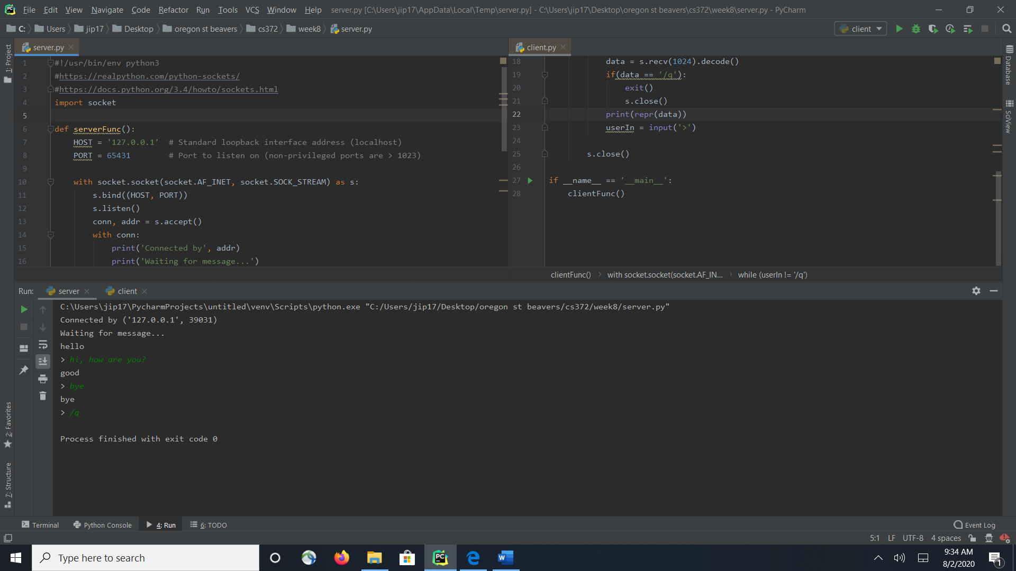

this is the client side of the chat window

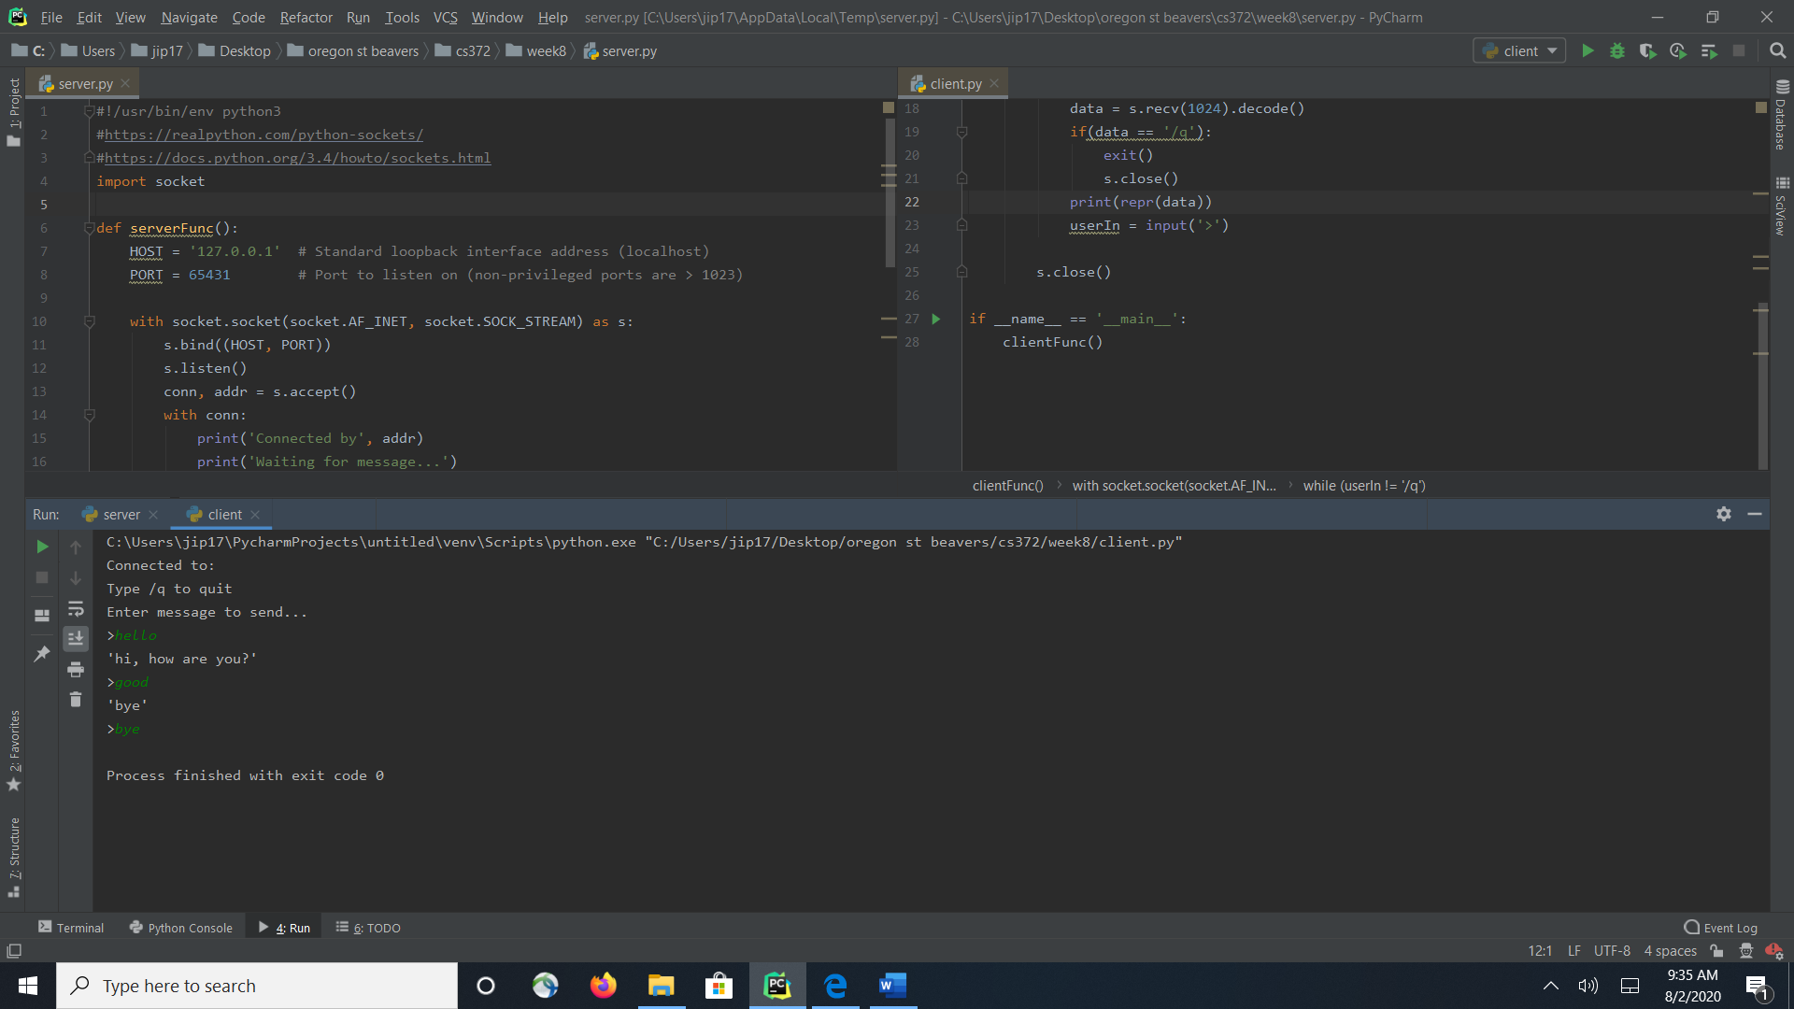

2. Comments I usually use vs code but for some reason I was having a issue with it port and host. I already had pycharm from cs 362( I think) so I fired it up and it ran no problem.