1. The program creates an ArrayList which stores the game grid where the tiles are generated. After the generation of the tiles(wall, floor, stair, opened door, closed door, opened chest, closed chest and sanitiser) the entities (player and monster-” customer ”) will spawn on the floor tiles. Both entities can walk only on floor tiles or opened door tiles, a player can open a closed door tile by interacting with it.

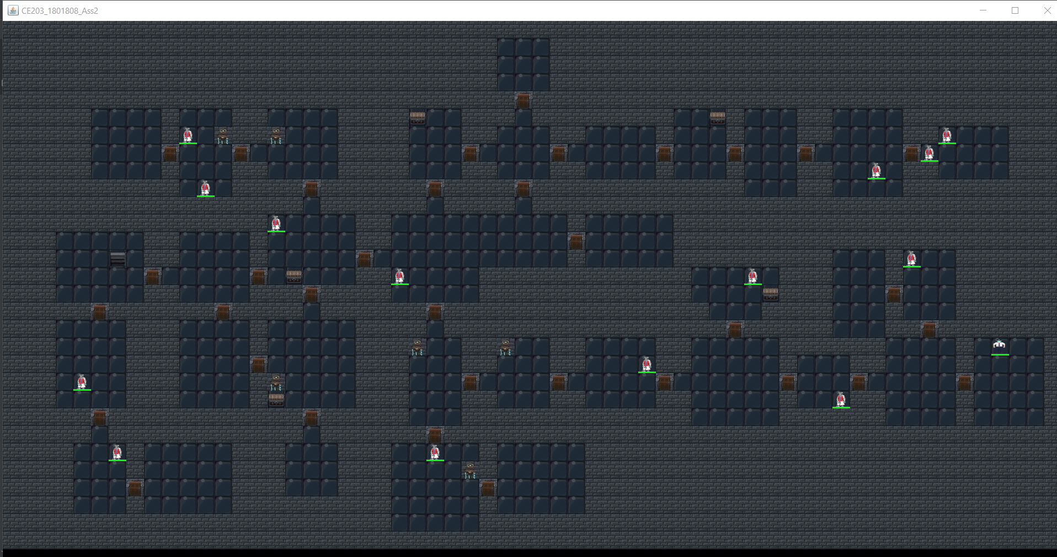

This is the grid after the generation and spawning of the entities (Player entity is on down right most room)

B)

All entities are instances of the Entity class, they inherit health (int variable), and 2D position (position x and y). In the previous screenshot is visible that each entity displays a health bar, the health bar will update after each encounter-type interaction of the player with the “customers”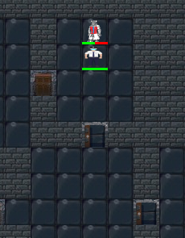

In the above picture the player has interacted with 2 doors and with the “customer” , changing its health bar value by either calling the hitMonster or the convinceMonster function.

c) 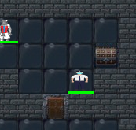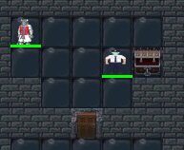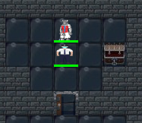 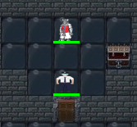

In the above screenshots we can see the player and the tiles before and after those are being modified by a KeyListener event. The player has pressed e next to the chest (right most tile) which changed from closed chest tile to a open chest tile and the same to the door (middle down most tile). The door tiles can change between closed and opened but the chests cannot (once you open and take the loot theres no reason why it should close).

Interacting with chests will result in a score increase and the next three stats increases based on rng:

Toilet paper collected (currency which I Haven’t implemented yet), masks collected and handsanitiser collected.

Pressing the Escape key during gameplay will open a menu frame where the user can choose to either save the score and leave the game or check the current score

The user cannot interact with the grid in any way through the mouse, only by the keys, so I created the combat in such way to take part in the gameplay. The combat is turn based in a new window as following: 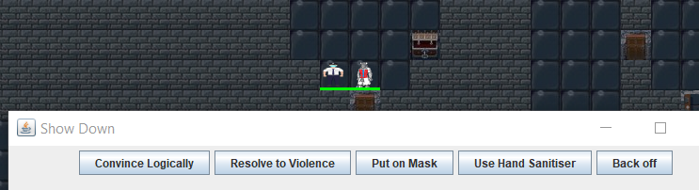

The 5 buttons do the following:

“Convince Logically” calls the convinceMonster function which decreases the monster’s health by 50 (half of its max health).

“Resolve to Violence” calls the hitMonster and the hitPlayer functions, the first decreasing the monster’s health by 25 and the second decreases the player’s health by 150.

“Put on Mask” increases the player’s health by calling healPlayer(int i) function with i being set to 150.

“Use Hand Sanitiser” increases the player’s health by calling healPlayer(int i) function with I being randomized between 15 and 40.

“Back off” ends the encounter prematurely.

Convincing a monster to leave will result in a score increase and the number of monsters convinced incrementing by 1.

Killing a monster to leave will result in a score increase and the number of monsters killed incrementing by 1.

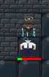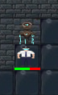

In the above to screenshots is shown the effect of the player’s interaction with the sanitiser tile, when interacted with the sanitiser tile will call the healPlayer function. It doesn’t change any proprieties and can be used indifinetly. Interacting with the sanitizer tile will also increase score.

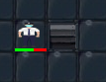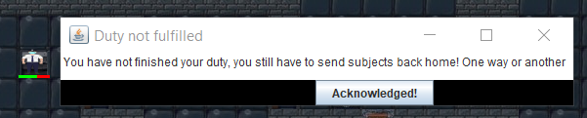

Interacting with the stair tile if not all the “customers” have been dealt with will result in this error message.

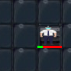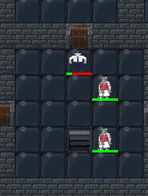

After all the monsters are dealt with the interaction with the stair tile will result in the increasing of the score and the number of levels cleared, both are stats which can be found in hall of fame or current score.

D)

Each time the player interacts with something the statistics of the current gameplay are held into an 1d array called statistics. If the player choses to press the button Save and Exit the statistics will be saved in a text file (if the score stat is high enough to be in the first 5). The stats also save at the moment when the player dies or if he exits the game, exiting the game after pressing play can only be done by pressing the Save and Exit button is pressed, which is the only way of exiting the game after the Start Game button is pressed in the start menu. Pressing the Current Score button will show the current stats in a new frame as following: 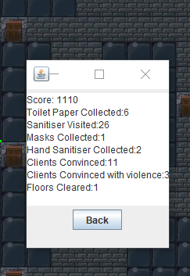

The 5 highest scores can be seen by pressing the Hall of Fame button:

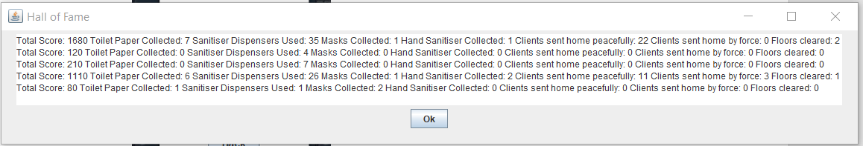

There are some remnants of my attempt to test the code , mostly many sout querys.