REPORT

Project of IS

GTT parking system

Paolo Caleffi

Filippo Castrogiovanni

Andrea Cuiuli

Alessio Valenti

**INDEX**

* Context
  + - GTT presentation and main goals
    - GTT organizational structure

Improvement scope and KPI definition

AS IS

* + - Processes descriptions
      * Ticket distribution
      * Ticket checking
      * Parking maintenance and money collection
    - KPI evaluation
* TO BE
  + - Processes description and major changes
      * Ticket distribution
      * Ticket checking
      * Parking maintenance and money collection
    - KPI evaluation
* Transition phase
* Expected effects
* Conclusion

**CONTEXT**

**GTT Presentation and main goals**

The GTT local transport company employs 5,500 personnel and transports 200 million passengers every year.

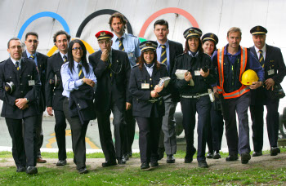

The group manages the following public transport networks:

* The Turin **urban and suburban networks** (1 metro, 8 tram lines and 83 bus lines operating 200 km of tramline network and 1,200 km of bus network)
* The **out-of-town bus network** (80 bus lines operating 3,600 km)
* The **rail network** (2 lines in concession covering 79 km and 1 line managed on behalf of the Italian Railway company, Trenitalia, covering 36 km).

The **local public transport** **service** provides urban and suburban transport services in Turin and in other 26 nearby towns. The system has 44.26 million km operated each year by 1,215 buses and 240 trams.

The **out-of-town bus service** is used by 13.5 million passengers a year and includes 320 buses connecting to 220 towns and operating 11.3 million km each year in the provinces of Turin and Alessandria, Asti and Cuneo to the south. The train service stops in 33 towns in the province of Turin, carries 5 million passengers per year and operates 38 carriages for a total of 1.25 million km annually.

GTT also operates the **“blue line” parking spaces** (48,168 parking slots), closed and covered car parks for an overall total of 5.237 parking slots.

In addition, the company manages a number of **tourist services** including the Sassi-Superga rack tramway, the Mole Antonelliana panoramic lift and the boat service along the River Po.

**GTT Organizational structure**

**Divisional Managers**

**Functional Managers**

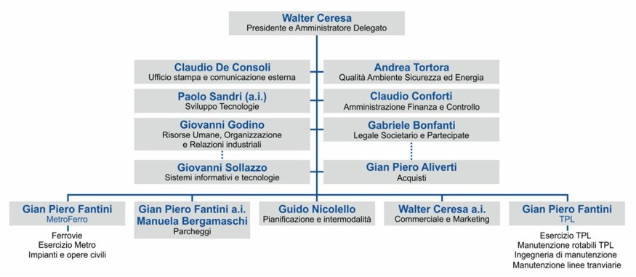

Departments are organized by separating each of functional areas and managing them independently of the others. At the same time each product group falls within the reporting structure of an executive, that person oversees everything related to that particular product.

The [matrix structure](https://en.wikipedia.org/wiki/Matrix_management) groups employees by both functional and divisional. This structure can combine the best of both separate structures.

### Map of the “blue zone" parking area

Parking is allowed inside the blue lines against payment only on weekdays with the exception of special periods during the year. The prices depend on the parking zone and calendar time. The area includes the city center and a wide surrounding area.

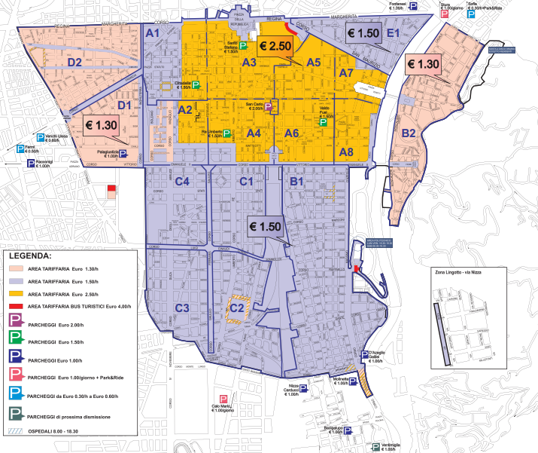

**IMPROVEMENT SCOPE AND KPI DEFINITION**

We defined 12 KPIs divided into four main groups: 4 General, 5 Efficiency, 1 Service and 2 Quality.

The 4 general KPIs are:

* N_TK that is the number of ticket issued per year
* N_TU that is the number of ticket machines
* N_TV that is the number of ticket vendors
* N_NO_TK that is the number of car parked without ticket per year

The 5 Effiency KPIs are:

* C_TK that represent the cost of issuing a ticket, this cost is influenced by lot of things like the cost of the paper and the ink, the cost of having personnel, the distribution cost etc.…
* C_C represent the cost of controlling cars to check if they have a valid ticket on, this cost is influenced mostly by the fact that we need personnel to do this check.
* C_NO_TK that represent the loss of revenue caused by N_NO_TK. The more cars parked without ticket the higher the loss.
* C_M that represent the cost of maintenance (this cost is the sum of the costs to recharge the paper and the ink, to repair broken machines and to fix malfunction in the machine, to repaint blue lines and to repair broken parking signals).
* C_R_M that represent the cost to retrieve money from the ticket machines, this cost is influenced mostly by the fact that we need personnel to do this operation.

The 1 Service KPI is:

* L_TK that is the lead time for the client to buy a ticket and go back to car to put it on.

The 2 Quality KPIs are:

* E_TK that represent errors in the tickets
* P_C_NO_TK that represent the precision of the C_NO_TK.

Our goal is to improve these KPIs for the following processes:

* Ticket distribution
* Ticket checking
* Parking maintenance and money collection

**AS IS**

**PROCESS DESCRIPTION**

**FUNCTIONAL VIEW**

**Class diagram**

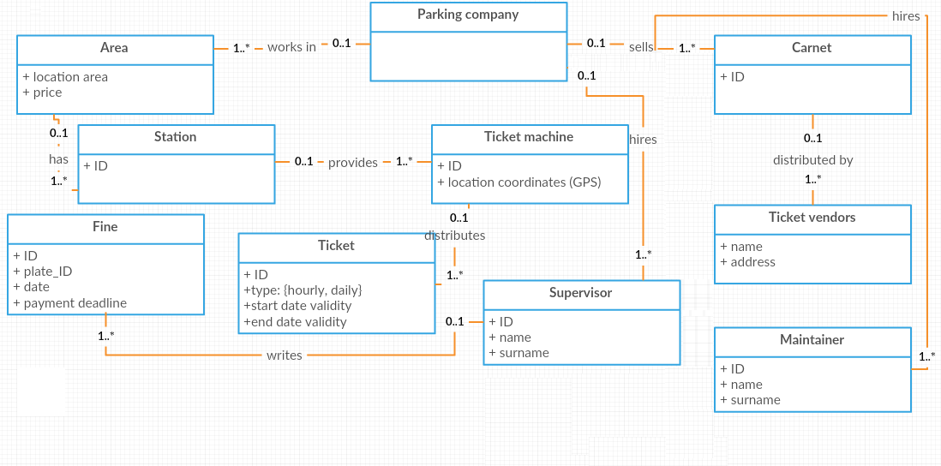

*The parking company GTT pays employees (on the right) as maintainers (dealing with maintenance but also with money collection), or as supervisors who could write fines related to certain vehicles in a certain date.*

*The company supplies carnet to ticket vendors.*

*The company acts in different areas (each one with a different location and ticket price), in which*

*there are several ticket machines, which distribute ticket (of different types, valid for a certain time interval).*

**Use Case diagram**

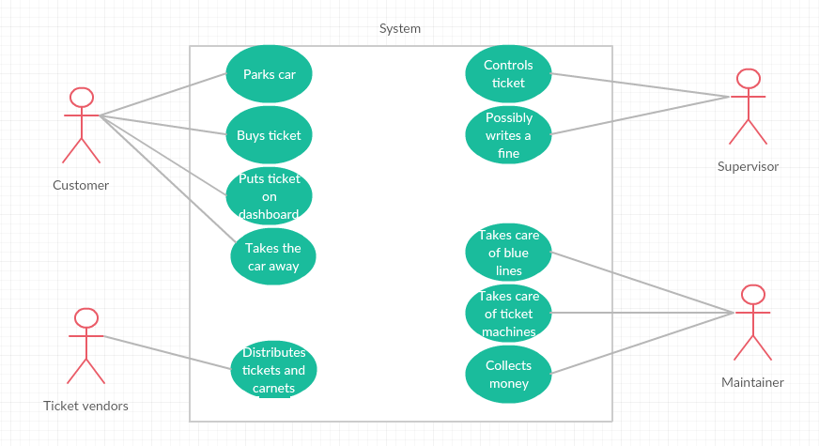

*There are four different actors interacting with the system:*

* *customer, who parks the car, buys the ticket, put in on the dashboard of his car, take the car away at the end*
* *ticket vendors, who distributes single tickets and carnets*
* *supervisor, who controls tickets in the cars and eventually writes a fine*
* *maintainer, who deals with blue stripes (repainting them if necessary, for instance) and ticket machines (by controlling its job correctness). Nowadays, the money collector is a role taken by an employee that is different than the maintainer, but we can keep this assumption for sake of simplicity during this analysis.*

**Ticket distribution**

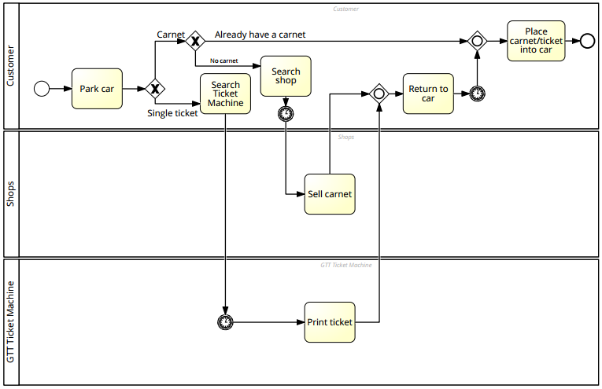

Once the customer finds a spot and park the car, he has two choices to pay for the parking: one-time ticket or a carnet.

Both requires to leave the car, purchase and then get back to put it on the car, unless the customer already has a previously bought carnet with remaining tickets.

This can take some time to search a vendor shop or a ticket machine and in the latter case the customer is usually forced to pay for more time than he require to park because of the minimum fee to pay in order to get the ticket and/or to be sure to get back to the car before the expiring time.

Carnet can be purchased with pocket money or credit card.

One-time tickets can be bought using mainly pocket money, which limits even more the definition of the precise moment in which the ticket will expire, forcing the customer to always bring with him a lot of coins; other payment methods exists, e.g. cellphone credit, but are not widespread.

The customer will then leave take care of his business and return to the car, leaving the parking spot.

This process is based on ticket machine, which consumes electricity, ink and paper, and carnet, still paper.

**Ticket checking**

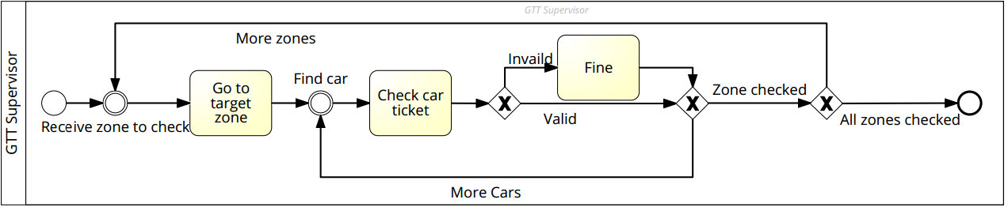

While at work, supervisor have a schedule to follow to check tickets in specific areas.

He moves toward a specific area and start checking tickets on every car, sequentially, until he checks every car.

If a car has a missing or expired ticket/carnet, he leaves a fine on the car.

This process is based on fines, essentially paper, and the work of the supervisor, which is error prone by nature and can lead to fines accounted to the wrong customer.

Moreover, the schedule is build up blindly, not knowing at all where there is a higher concentration of abusive parked car, and this is clearly an inefficient method.

**Parking maintenance and money collection**

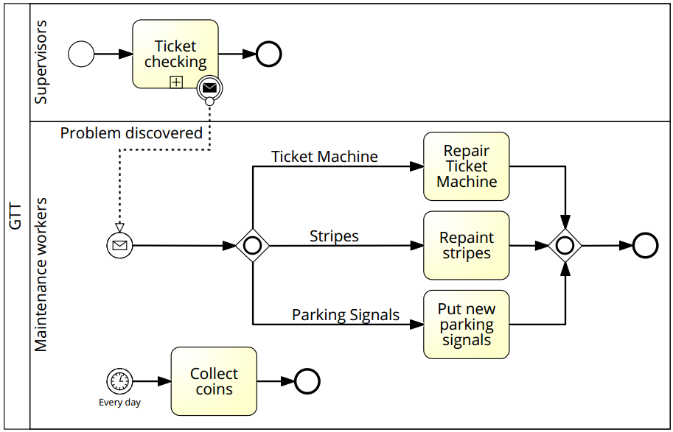

While supervisors do their job, they signals problems to the maintenance department.

These problems can be of three main kind: ticket machine problem, stripes problem, parking signal problem.

After acknowledging the problem, a specific maintenance worker is appointed to resolve it.

In addition, a money collector will have to empty the ticket machines from all the coins.

**KPI EVALUATION**

|  |  |
| --- | --- |
| **KPI name** | **Evaluation** |
| N_TK | Can be measure |
| N_TU | Lots of ticket machines to cover most zones |
| N_TV | Lots of ticket vendors to cover (with ticket machines) all possible zones |
| N_NO_TK | Really hard to measure and the measure is anyway unreliable |
| C_TK | Relatively high because lot of things make this cost higher (personnel, distribution, vendors, paper and ink etc.…) |
| C_C | High cost because there must be lot of supervisor that must be paid. |
| C_NO_TK | Hard to measure for the same reason of N_NO_TK, anyway should be high because the controls are not very good. |
| C_M_M | High cost |
| C_R_M | High cost, personnel must be paid to retrieve money from machines |
| L_TK | Minutes (up to 5-15 minutes if you have to find the machine or you have to queue in the vendor) |
| E_TK | Errors in tickets can occur. |
| P_C_NO_TK | The precision of C_NO_TK is really bad because it’s hard to measure and the controls are not very good so you don’t know how much you are losing in reality. |

**TO BE**

**PROCESS DESCRIPTION AND MAJOR CHANGES**

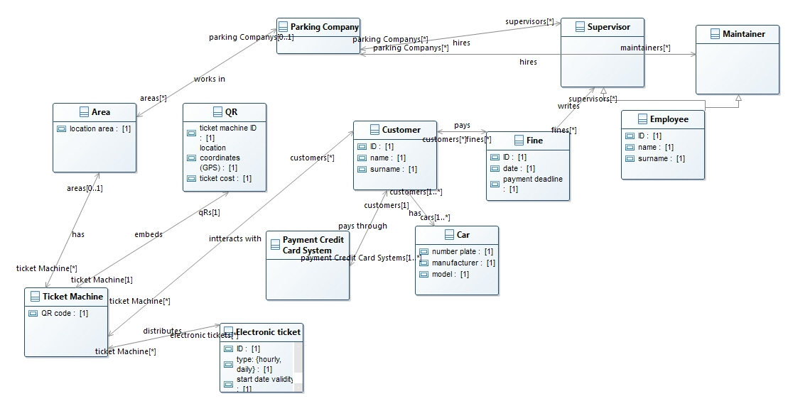

The paper ticket will be substituted by electronic ticket managed via smartphone’s application, so that ticket vendors and carnets will be deleted from the processes.

Actually an app will be developed in two flavours: for customers and for supervisors.

For **customers**: the app creates an account for the user, either via classic login or through social network.

Each account is associated with a credit card on which ticket cost is accredited: in this way we grant per minute ticket accounting and an easy payment method.

Customers could have also the possibility to use the “get free spots number” feature, implementable starting from the knowledge of the number of busy park spots in an area (based on the number of electronic tickets).

Once returned, he stops the time count and the system calculates the due price, accrediting it on the user credit card.

For **supervisors**: supervisors' account are inserted by the GTT company and have access to a second version of the app.

During the day-by-day work, if the car inspected has never been inserted into the system, a physical fine is deployed on the car.

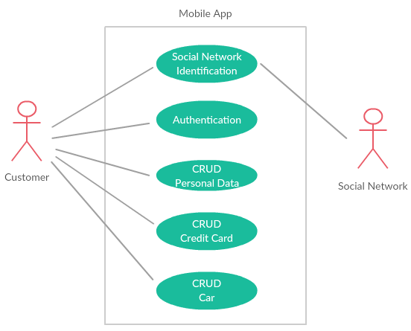

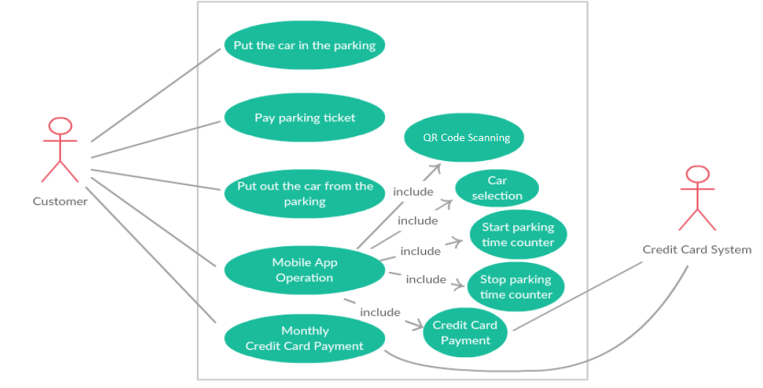

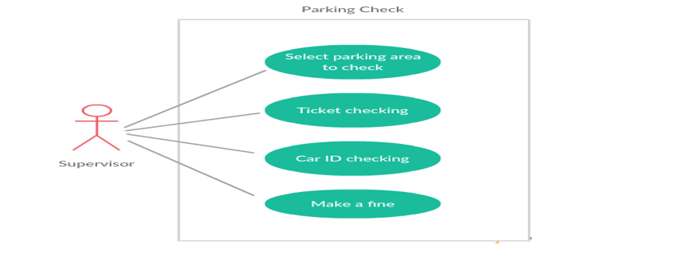**Ticket distribution**

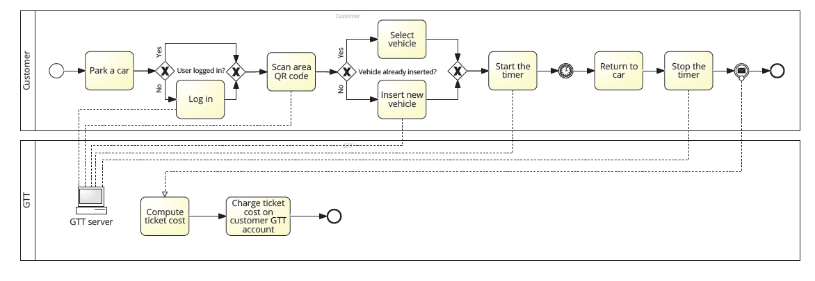

Using the app, the customer can see where in which areas there are more probability to find an empty spot.

Once the customer finds the spot and parks the car, he scans the QR code on the parking signals, which identify the pricing zone.

He inserts the license plate of the parked car (or selects it from a pre-inserted car description) and starts the time count.

Once returned, he stops the time count and the system calculates the due price, accrediting it on the user credit card.

This process is based on the customer's smartphone and GTT server.

**Ticket checking**

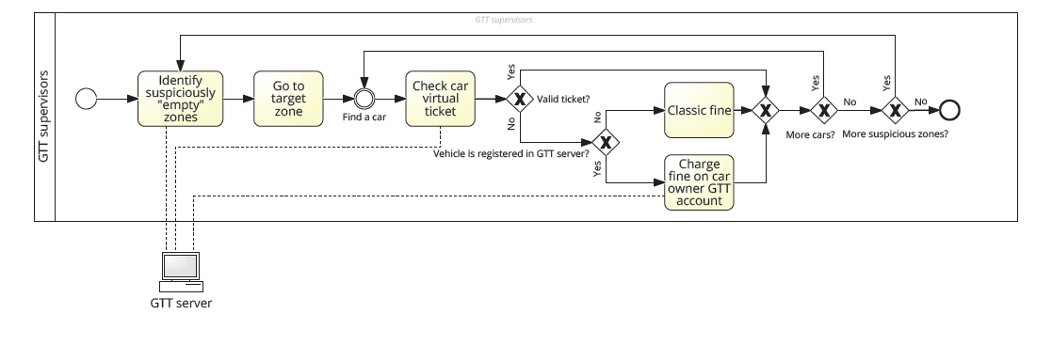

Using the app, the supervisor can see in which areas the number of active electronic ticket is suspiciously low compared to the number of parking spots.

Using this tool, the fixed schedule for area checking can be left apart moving to a more flexible and dynamic one.

When the supervisor reach the wanted area, he starts checking cars one by one.

He inserts the car license plate in the app, manually or scanning with the smartphone camera, and get latest tickets associated with that car: if there is no active ticket, a fine is issued on the user account.

If the car has never been inserted into the system, a physical fine is deployed on the car as fallback.

This process is based on the supervisor's smartphone and occasionally on paper (physical fines).

**Parking maintenance and money collection**

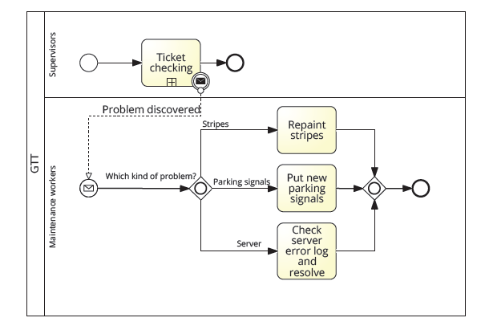

While supervisors do their job, they signals problems to the maintenance department.

These problems can be of three main kind: server problem, stripes problem, parking signal problem.

After acknowledging the problem, a specific maintenance worker is appointed to resolve it.

**KPI EVALUATION**

|  |  |
| --- | --- |
| **KPI name** | **Evaluation** |
| N_TK | May Increase with the help of the app to find free spots |
| N_TU | No more Tickets Machines |
| N_TV | No more ticket vendors because everything will be electronic |
| N_NO_TK | May decrease due to the app helping controllers, but uncertain. |
| C_TK | Highly Decrease  (no more ticket to print, less personnel and no vendors) |
| C_C | Slightly decrease (less personnel) |
| C_NO_TK | Decrease if N_NO_TK decrease. |
| C_M | Decrease because there is no more maintenance cost for the ticket machines, but now there is the cost for the maintenance of the server |
| C_R_M | No more cost for retrieving money from ticket machines |
| L_TK | Decrease (with the use of electronic payment) |
| E_TK | Errors in tickets should disappear |
| P_C_NO_TK | Probably unchanged.  However, the app should help supervisors controlling tickets. |

**TRANSITION PHASE**

The old and new systems can easily coexists, gradually abandoning the first one (and in this sense the first advantages are taken already in the transition phase: do not replace broken ticket machines, less money to collect, less ink and paper, etc.).

Initially discounts could be deployed in order to persuade customers to download the app and register, so that as time goes by most of the customers will start to use the electronic tickets instead of the physical one.

Tickets vendors will continue to sell paper tickets until they finish all of them, then there will be no more ticket vendors.

**EXPECTED EFFECTS**

The most important effect regards:

* the decrement of raw materials (ink, paper, etc.)
* the decrement of the number of the employees (both supervisors and maintainers) of the company, because their work hours are reduced (the job of collecting money will be deleted after the transition)
* collection of sensitive information on the customer for marketing purpose

**CONCLUSION**

We can conclude that the TO BE situation is definitely better with respect to the AS IS.

In effect, some costs will decrease and the cost of the investment regarding the IS may re-gained quite quickly.

Moreover, the overall service will certainly improve, while the information that will be collected about the customer behaviour will be very useful for data mining and in the analysis of future goals at strategic level.