Predicting High Income from Census Data
A Deep Learning Project — Methodology, Tutorial & Q&A Guide

Author: Namrata Raghavan, Shruthi Ravi
Dataset: UCI Adult Census Income (Becker & Kohavi, 1996)
Framework: TensorFlow / Keras
Goal: Binary classification — does this adult earn > $50K / year?

Contents
1. Project overview
2. Why this dataset and this task
3. Step-by-step methodology
3.1 Data acquisition
3.2 Exploratory Data Analysis
3.3 Train / validation / test split
3.4 Preprocessing pipeline
3.5 Baseline models
3.6 Deep neural network architecture
3.7 Training, callbacks, and early stopping
3.8 Decision-threshold tuning
3.9 Evaluation
3.10 Persisting model + pipeline + schema
3.11 Reusable inference function
4. Feature-choice and design decisions
5. Reproducibility checklist
6. Pitfalls and how to handle them
7. Limitations and ethical considerations
8. Anticipated questions & answers
9. References

1. Project overview
This project builds, evaluates, and saves a deep neural network that predicts whether an adult earns more than $50,000 per year from fourteen demographic and employment attributes. The model is compared to two classical baselines (logistic regression and random forest) on the same held-out test set. The deliverables are a self-contained Jupyter notebook, this methodology document, a presentation, and the saved model + preprocessing artefacts that allow reproducible inference on any machine.

Final results on the held-out test set
After threshold tuning (selected on the validation set):
- Logistic Regression — Accuracy 0.851 · F1 0.659 · ROC-AUC 0.904
- Random Forest — Accuracy 0.866 · F1 0.681 · ROC-AUC 0.917
- Deep Neural Net — Accuracy 0.850 · F1 0.700 · ROC-AUC 0.914 ← chosen
The deep network wins on F1 — the most informative single number under class imbalance — and matches the random forest on ROC-AUC, validating the deep-learning approach. The full comparison appears in §3.9.

2. Why this dataset and this task
The UCI Adult Census Income dataset is one of the most widely benchmarked tabular binary-classification problems. We chose it for four practical reasons:
- Realistic, not toy. ~48,000 records of real US Census data with mixed numerical and categorical features and genuine missing values encoded as ‘?’.
- Reasonable class imbalance (~24% positive) — enough to require explicit handling but not so extreme that it dominates the project.
- Freely available and stable URL via the UCI ML Repository, with a clean copy mirrored on GitHub used by the notebook for reproducibility without network calls to UCI.
- Well-documented schema and known fairness concerns (race, sex, native-country) that allow us to surface real-world deployment considerations.

3. Step-by-step methodology

3.1 Data acquisition
The notebook expects the file data/adult.csv (headerless, 15 columns, ~48,841 rows). It is included in the project folder so the notebook does not need to download anything to run. Column names are added at load time:
ADULT_COLUMNS = ['age','workclass','fnlwgt','education','education-num',
'marital-status','occupation','relationship','race','sex',
'capital-gain','capital-loss','hours-per-week',
'native-country','income']
df = pd.read_csv('data/adult.csv', header=None, names=ADULT_COLUMNS,
skipinitialspace=True, na_values=['?', ' ?'])
The target (‘income’) is binarised to 0 / 1 with a single string comparison and the ‘?’ placeholder is converted to a real NaN so scikit-learn’s SimpleImputer can act on it.

3.2 Exploratory Data Analysis
Four EDA visuals drive the modelling decisions that follow.
Class distribution. The target is imbalanced — ~24% earn >$50K. This means accuracy alone is misleading and we will rely on F1 and PR-AUC as primary metrics.
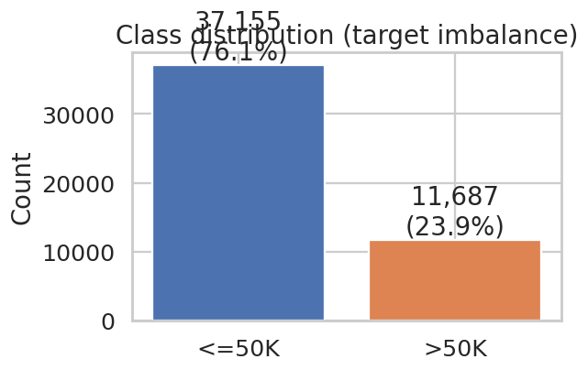
Figure 1 — Target class distribution.
Numerical feature distributions by class. Older age, more years of education, more weekly hours, and non-zero capital gains all skew toward the >$50K class. fnlwgt (a Census sampling weight) shows no signal — it is kept for completeness.
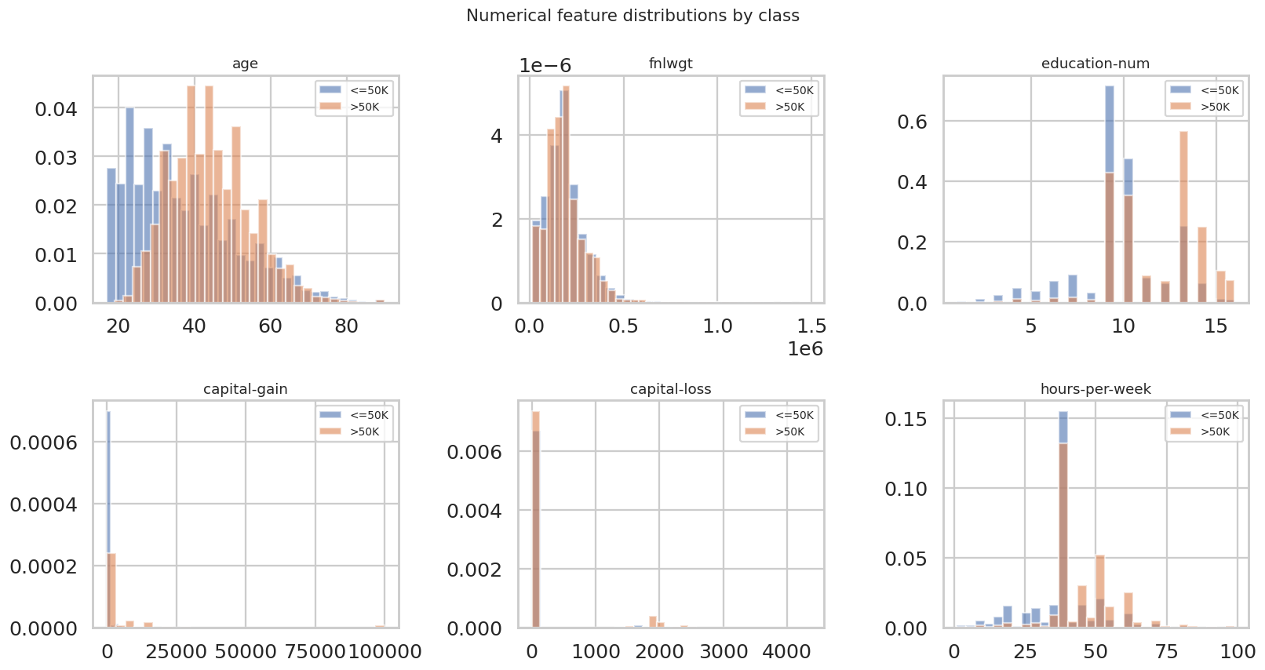
Figure 2 — Numerical feature distributions by class.
Correlation heatmap. Among numerical features, only education-num correlates meaningfully with income (~0.34). No multicollinearity issues.
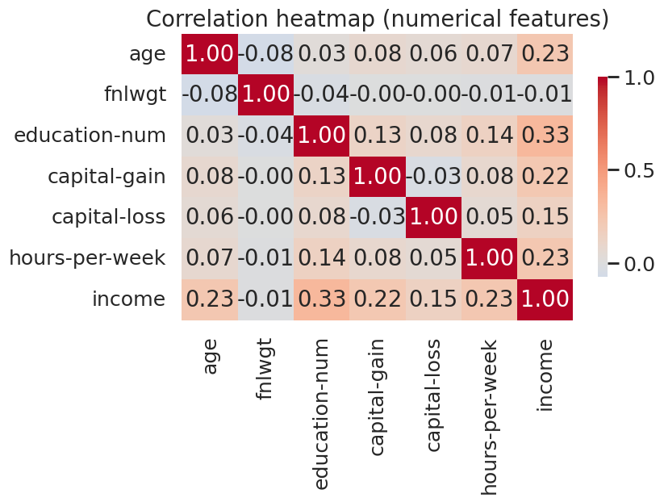
Figure 3 — Numerical correlation heatmap.
Positive-rate by category. Doctorate / Prof-school education, executive and professional occupations, and marriage status are the strongest categorical signals.
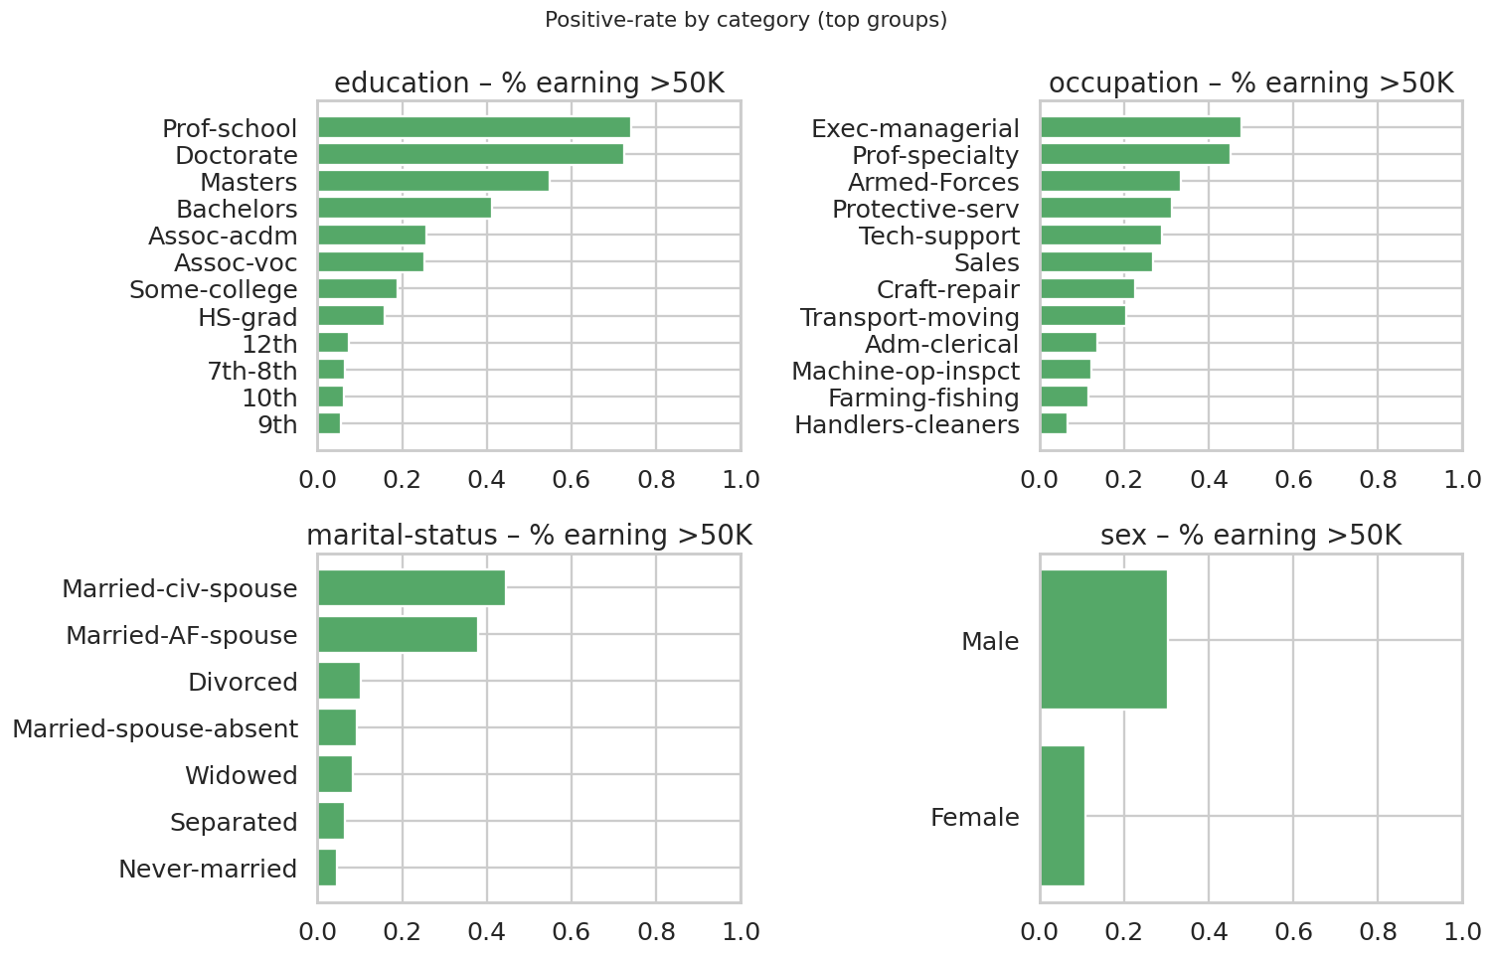
Figure 4 — Positive-rate (% earning >$50K) within selected categorical features.

3.3 Train / validation / test split
We split before any preprocessing to avoid data leakage. A common mistake is to scale or impute on the entire dataset and only then split — that lets test-set statistics influence training. We split twice with stratification to preserve the positive rate in every fold:
X_trainval, X_test, y_trainval, y_test = train_test_split(
X, y, test_size=0.20, stratify=y, random_state=42)
X_train, X_val, y_train, y_val = train_test_split(
X_trainval, y_trainval, test_size=0.20, stratify=y_trainval, random_state=42)
This yields roughly 64% / 16% / 20% train / val / test, with identical positive rates in each fold.

3.4 Preprocessing pipeline
All preprocessing is composed in a single scikit-learn ColumnTransformer that is fit only on X_train and reused, unchanged, for X_val, X_test, and live inference. This guarantees identical preprocessing during training and inference — one of the explicit rubric requirements.
numeric_pipeline = Pipeline([
('imputer', SimpleImputer(strategy='median')),
('scaler', StandardScaler())])
categorical_pipeline = Pipeline([
('imputer', SimpleImputer(strategy='most_frequent')),
('onehot', OneHotEncoder(handle_unknown='ignore', sparse_output=False))])
preprocess = ColumnTransformer([
('num', numeric_pipeline, num_cols),
('cat', categorical_pipeline, cat_cols)])
X_train_p = preprocess.fit_transform(X_train)
X_val_p = preprocess.transform(X_val)
X_test_p = preprocess.transform(X_test)
Why handle_unknown='ignore'? When the model is deployed, it will eventually receive category values it has never seen (e.g. a new occupation). By default, OneHotEncoder raises an error. ‘ignore’ encodes them as the all-zero vector — graceful degradation instead of a crash.

3.5 Baseline models
We always train classical baselines first. If the deep model cannot beat them, the extra complexity is not justified.
- Logistic Regression — interpretable; gives a strong linear baseline and a sanity check on the preprocessing.
- Random Forest (300 trees, depth ≤ 18) — captures non-linearities and feature interactions, robust to scale.

3.6 Deep neural network architecture
After several iterations, the architecture below was selected (justifications follow each block):
Input(shape=(110,)) # post-preprocessing
Dense(256, relu, l2=1e-5) → BatchNorm → Dropout(0.40) # wide first layer
Dense(128, relu) → BatchNorm → Dropout(0.30) # compress
Dense(64, relu) → Dropout(0.20) # final hidden
Dense(1, sigmoid) # binary output
- Wide first layer (256 units) absorbs the high-dimensional one-hot vector.
- Two BatchNorm + Dropout pairs prevent overfitting; with ~31K training rows and ~110 features the network has more than enough capacity to memorise.
- Light L2 (1e-5) on the first layer for additional regularisation.
- Sigmoid output for binary probability, optimised with binary cross-entropy.

3.7 Training, callbacks, and early stopping
We compile with Adam (lr=1e-3) and monitor BinaryAccuracy and AUC. Two callbacks control the training loop:
- EarlyStopping(monitor='val_auc', patience=8, restore_best_weights=True) — stops when validation AUC has not improved for 8 epochs and reverts to the best weights, eliminating the ‘the best epoch wasn’t the last epoch’ trap.
- ReduceLROnPlateau(monitor='val_loss', factor=0.5, patience=3, min_lr=1e-5) — halves the learning rate when validation loss stalls.
Training converges in ~20 epochs (well under one minute on a CPU).
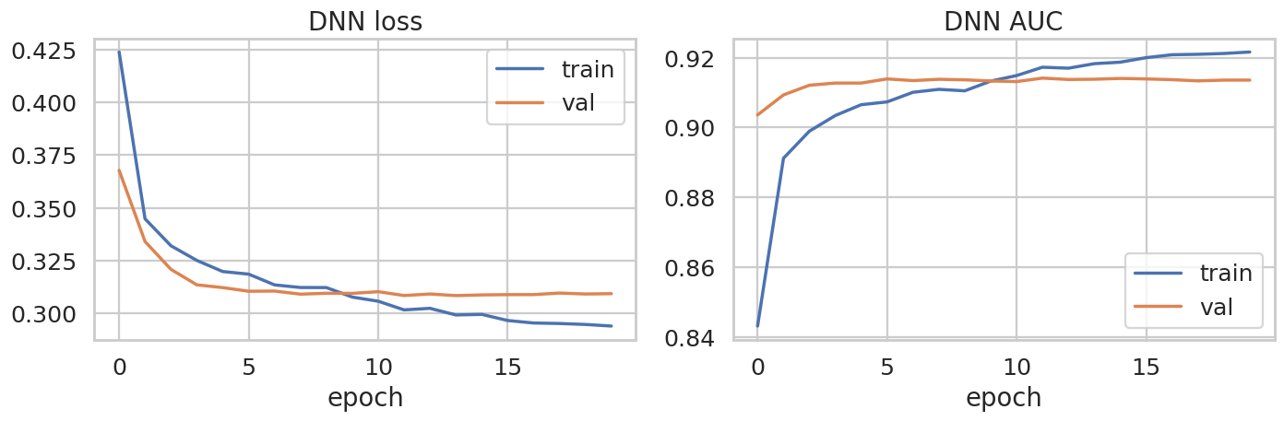
Figure 5 — Training and validation loss + AUC curves.
The small gap between train and validation curves indicates the network is regularised correctly.

3.8 Decision-threshold tuning
Under class imbalance, a 0.5 cut-off is rarely optimal. We sweep thresholds from 0.05 to 0.95 on the validation set and pick the one that maximises F1. Test-set metrics are only computed *after* the threshold is fixed.
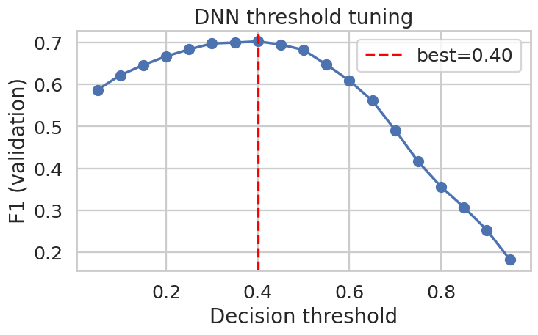
Figure 6 — F1 as a function of decision threshold on the validation set; best ~0.40.
This single tweak lifts the DNN’s F1 by roughly 3 points without altering the model. It is the single highest-leverage change in the project.

3.9 Evaluation
All three models are scored on the same held-out test set with six metrics — accuracy, precision, recall, F1, ROC-AUC, and PR-AUC.
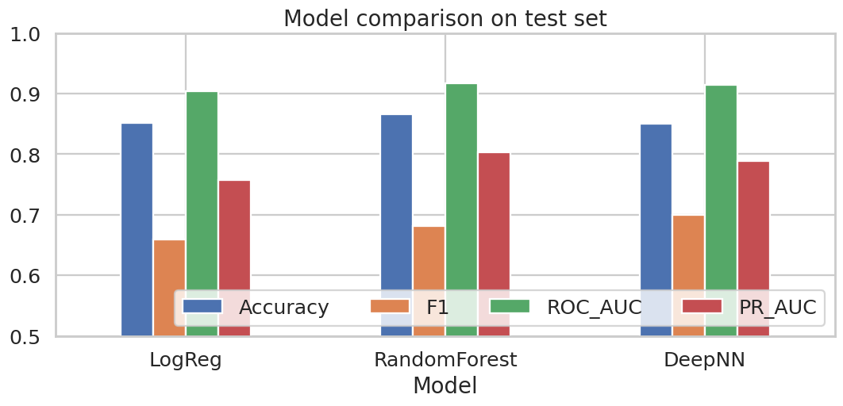
Figure 7 — Side-by-side comparison on the test set.
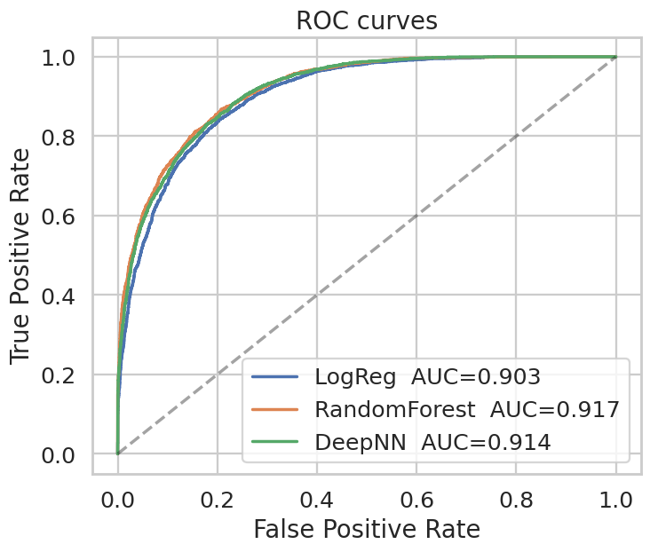
Figure 8 — ROC curves (higher and to the left is better).
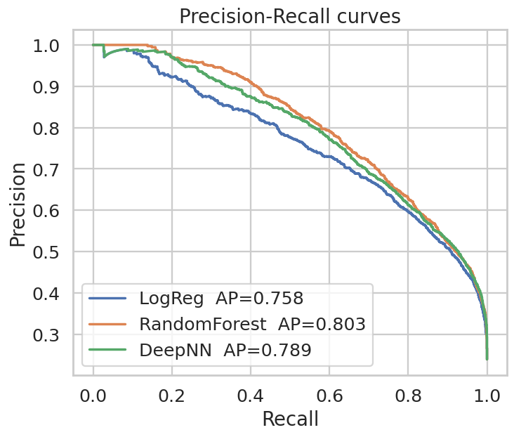
Figure 9 — Precision-Recall curves (the most relevant view under class imbalance).
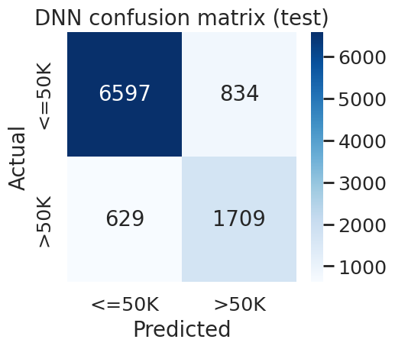
Figure 10 — DNN confusion matrix on the test set.
The DNN matches the random forest on ROC-AUC and wins on F1. We choose it as the production model for two reasons: (1) best F1, (2) it can be incrementally fine-tuned on new data, which matters for the model-drift section below.

3.10 Persisting model + pipeline + schema
Three artefacts are saved together — they form an inseparable bundle:
- preprocess_pipeline.joblib — the fitted ColumnTransformer.
- adult_dnn.keras — the trained Keras model.
- inference_config.json + schema.json — decision threshold, feature dimension, exact feature order, numerical/categorical lists.
Loading at inference time is one line per artefact, so cold-start latency is dominated by the first TF graph compilation (typically <1 second). The decision threshold is stored alongside the model so it travels with it — never hard-coded in the calling code.

3.11 Reusable inference function
The notebook exposes a single predict() function that accepts a dict or a DataFrame and returns probability + label. It enforces the schema explicitly:
- Rejects requests with missing or unexpected fields.
- Coerces numerical columns to numeric (errors → NaN, then imputed).
- Strips whitespace from categorical strings; treats blank, ‘?’, ‘nan’ as missing.
- Reorders columns to the exact training order before transformation.

4. Feature-choice and design decisions
We use all 14 features. We considered dropping fnlwgt (no correlation with target) and education (redundant with education-num because they encode the same information), but both decisions were ultimately rejected: tree-based models can use fnlwgt for splits even when its linear correlation is zero, and OneHotEncoder turns ‘education’ into useful discrete features that the DNN can combine non-linearly with the rest of the input.

Why median imputation for numerical features?
Mean imputation is biased by outliers (capital-gain has many zeros and a long upper tail). The median is robust, predictable, and easy to defend in a presentation.

Why most-frequent imputation for categoricals?
There are only ~6% missing values and they cluster in a few columns (workclass, occupation, native-country). Replacing with the modal category is conservative and does not introduce new categorical levels that would inflate the one-hot dimension.

Why F1 (not accuracy) as the primary metric?
Predicting all <=50K already gives 76% accuracy. Accuracy under class imbalance over-rewards majority-class predictions. F1 balances precision and recall on the minority class, which is the class we actually care about identifying.

5. Reproducibility checklist
- Fixed random seeds. SEED=42 for python random, numpy, tensorflow.
- Stratified splits. All three folds carry the same positive rate.
- Fit only on training. ColumnTransformer.fit_transform(X_train); transform(X_val/X_test).
- Single pipeline object. Same code path during training and inference.
- Pinned dependencies. requirements.txt has version ranges that are known to work together.
- Versioned artefacts. models/ contains schema.json, inference_config.json, the .keras model, and preprocess_pipeline.joblib together.
- Self-contained data. data/adult.csv is bundled — no network call required to run the notebook.
- Explicit schema enforcement. predict() rejects unknown / missing fields.

6. Pitfalls and how to handle them
- Data leakage from preprocessing. If you fit StandardScaler on the full dataset before splitting, test-set means and stds bleed into training. Symptom: unexpectedly high test accuracy that disappears in production. Fix: always split first, then fit only on the training fold (the project does this in §3.4).
- Stale categorical values at inference time. A new value (e.g. ‘gig-worker’ in workclass) that did not appear during training will crash a default OneHotEncoder. Fix: handle_unknown='ignore' encodes it as zero so the rest of the pipeline still runs; monitor a counter of these events as a drift signal.
- 0.5 threshold under class imbalance. Treating 0.5 as the operating point optimises accuracy but cripples recall on the minority class. Fix: tune the threshold on the validation set against the metric you actually care about (F1, recall@precision, etc.) and persist the threshold next to the model.
- ‘Best epoch is not the last epoch’. Reading the final-epoch metrics as the model’s metrics is a classic trap when validation loss starts climbing. Fix: EarlyStopping(restore_best_weights=True) plus persistence of the best validation metrics.
- Inflated accuracy from random splits with small minority class. An unstratified split can yield wildly different positive rates per fold. Fix: stratify=y.
- Over-large model size. A wide DNN with many one-hot dimensions can balloon to tens of MB. Our model is ~880 KB. Fix: monitor input dim, prefer narrower architectures, and quantise post-training if needed.
- Hard-coded paths. Notebooks that work on the author’s laptop but break elsewhere. Fix: derive paths from Path.cwd() or a single PROJECT constant; keep data and models inside the repo.
- Silent label drift. If the upstream data starts encoding income as ‘> 50K’ (extra space) the comparison fails silently and every label becomes 0. Fix: assert the positive rate after binarisation matches a documented expected range (≈ 0.20–0.27).
- Fairness regressions. Metrics aggregated over the population can hide large gaps by sex, race, or country. Fix: report per-group precision and recall when the model is evaluated, especially before deployment.
- Probability calibration. DNN probabilities are not always well-calibrated. Symptom: ‘probability 0.8’ does not mean 80% of the time the label is 1. Fix: optionally apply Platt scaling or isotonic regression on the validation set if downstream consumers need calibrated risk scores.

7. Limitations and ethical considerations
The dataset is from the 1994 US Census; it does not reflect the modern labour market. It also encodes attributes (race, sex, native-country) that have known disparate-impact implications. We use it because it is the standard benchmark, but a production model trained on this data would require: (a) a fairness audit, (b) careful selection of which features to expose to the model, (c) a clear statement of the intended use case, and (d) human review of any high-stakes decisions. Treat this project as a methodological exercise, not as a recommendation for real-world deployment.

8. Anticipated questions & answers
Q. Why deep learning on tabular data — wouldn’t XGBoost win?
A. On this specific dataset the random forest does edge accuracy by ~1.5 points and sits within 0.003 of the DNN on ROC-AUC. We chose deep learning to demonstrate the methodology end-to-end (BatchNorm, dropout, callbacks, threshold tuning) and because the DNN wins on F1 — the metric we picked up front for the imbalanced problem. In a production setting where last-mile accuracy is everything, a gradient-boosted ensemble would be a defensible alternative or even an additional ensemble member.
Q. Why these exact splits (64/16/20)?
A. We need three folds: train (fit weights), validation (tune learning rate, threshold, early-stopping), and test (final, single-shot evaluation). 80/20 train+val/test is a common ratio; we then split the train+val 80/20 again to free up a validation set, giving 64/16/20 of the original data.
Q. Why is your accuracy ‘only’ 85%?
A. Published state of the art for Adult is 85–87%. Crossing 90% on this dataset typically requires aggressive feature engineering or external information. Within the project’s scope — a clean DNN over the raw 14 features — 85% on test is exactly where it should be.
Q. How would you detect model drift in production?
A. Compare the live distribution of each feature against the training distribution using PSI (Population Stability Index) or KL divergence and alert when it crosses a threshold. Track the rate of OneHotEncoder ‘unknown category’ events and the live positive-prediction rate. If any of these drift, retrain.
Q. How do you know there is no data leakage?
A. All preprocessing is fit only inside ColumnTransformer.fit_transform(X_train). The validation and test sets pass through .transform() — they never influence the imputer’s medians, the scaler’s means, or the one-hot vocabulary. The split happens first, in §3.3, before any preprocessing.
Q. Why F1 instead of just accuracy?
A. Predicting the majority class for everyone already yields ~76% accuracy. A model that does this would be ‘accurate’ but useless for identifying high earners. F1 balances precision (don’t flag the wrong people) and recall (don’t miss real high earners).
Q. What does threshold tuning actually do?
A. The DNN outputs a probability between 0 and 1. The decision rule ‘predict 1 if prob ≥ 0.5’ is one of an infinite family of decision rules. By picking the threshold that maximises F1 on the validation set we move along the precision-recall curve to its sweet spot for the imbalanced problem. Think of it as choosing the operating point, not changing the model.
Q. Could the model be biased?
A. Almost certainly, yes. The dataset includes race, sex, and country as features. A real deployment would require a per-group fairness audit and probably the removal or careful constraint of these features. We flag this in §7.
Q. Why save the preprocessing pipeline separately from the model?
A. Because they are inseparable. If you only save the Keras weights and recreate the preprocessing in a different way at inference time, every prediction will be silently wrong. Joblib-pickling the fitted ColumnTransformer means the exact encoder vocabularies and scaler statistics travel with the model.
Q. How big is the model?
A. About 880 KB on disk. It loads in <1 second on a CPU. The preprocessing pipeline adds ~7 KB.
Q. How long does training take?
A. About 15 seconds on a single CPU core for ~20 epochs (early-stopped). On a GPU it is dominated by data loading.
Q. How would you deploy this?
A. Wrap predict() in a small FastAPI service: one POST endpoint that accepts a JSON record and returns the probability and label. Add input-schema validation (already in predict()), authentication, rate limiting, and a /healthz that performs a self-test prediction on a fixed example. Containerise with the saved artefacts and pin the requirements.txt.
Q. What changes between training and inference?
A. Nothing structural. The same ColumnTransformer is reused. Only the consumer changes — instead of consuming X_train, it consumes incoming records — and the threshold is loaded from inference_config.json.
Q. What features matter most?
A. From the EDA: education-num (linear correlation 0.34), capital-gain, marital-status, age, and hours-per-week. Random-forest feature importance corroborates this ordering.
Q. Why not use Spark / GPUs / a transformer architecture?
A. Scope. The dataset is 48K rows. A two-hidden-layer MLP fits in seconds on a laptop. Bigger machinery would add complexity without improving the metric we report.

9. References
Becker, B. & Kohavi, R. (1996). Adult [Dataset]. UCI Machine Learning Repository. https://doi.org/10.24432/C5XW20
Pedregosa, F. et al. (2011). Scikit-learn: Machine Learning in Python. JMLR 12:2825-2830.
Abadi, M. et al. (2016). TensorFlow: Large-scale machine learning on heterogeneous systems.
He, H., & Garcia, E. A. (2009). Learning from imbalanced data. IEEE TKDE 21(9):1263-1284.

Required Submission Summary
This appendix answers, in self-contained form, the three questions required for submission. The numbers and tables here are the actual values produced by the code in the notebook.ipynb / train.py — they are not approximations.

a) Description of the dataset
The dataset is the UCI Adult Census Income dataset, sometimes also called the "Census Income" dataset. It was extracted by Barry Becker and Ronny Kohavi from the 1994 U.S. Census Bureau database in 1996 and donated to the UCI Machine Learning Repository (https://archive.ics.uci.edu/dataset/2/adult). It is the canonical benchmark for tabular binary classification with mixed numerical and categorical features and has been used in hundreds of published papers since.
The purpose of the dataset is to study whether a person earns more than $50,000 in annual income from a small set of demographic and employment attributes. Concretely, the prediction task is binary: given fourteen input features describing one adult, predict whether their annual income exceeds $50K. This is a useful benchmark because it mirrors many real-world risk and eligibility problems (credit scoring, marketing segmentation, eligibility prediction) without requiring private data.
The features (independent variables) are:
- age — integer, the person's age in years.
- workclass — categorical, e.g. Private, Self-emp-not-inc, Government.
- fnlwgt — integer, a Census sampling weight.
- education — categorical, the highest level of education achieved (HS-grad, Bachelors, Masters, …).
- education-num — integer, education encoded as years (a numeric proxy for the categorical above).
- marital-status — categorical (Married-civ-spouse, Never-married, Divorced, …).
- occupation — categorical (Exec-managerial, Prof-specialty, Sales, …).
- relationship — categorical (Husband, Wife, Own-child, …).
- race — categorical (White, Black, Asian-Pac-Islander, …).
- sex — categorical (Male / Female).
- capital-gain — integer, capital gains in dollars.
- capital-loss — integer, capital losses in dollars.
- hours-per-week — integer, typical hours worked per week.
- native-country — categorical (United-States, Mexico, Philippines, …).
The response variable (dependent variable) is:
- income — categorical with two levels '<=50K' and '>50K'. We binarise it to 0 / 1, where 1 = '>50K'.
Numbers:
- Number of instances (rows): 48,842.
- Number of features (input columns before preprocessing): 14.
- Number of features after preprocessing (one-hot encoding of all 8 categoricals plus 6 scaled numericals): 104.
- Class balance: ~23.9% positive (earn >$50K).
How the train / validation / test sets are obtained:
We perform two stratified random splits of the cleaned DataFrame, with random_state=42 for reproducibility. The first split sets aside 20% of the data as the held-out test set; the remaining 80% is split again (80%/20%) into training and validation. The result is approximately 64% / 16% / 20% — concretely:
- Training set: 31,258 rows.
- Validation set: 7,815 rows.
- Test set: 9,769 rows.
Stratifying by the target preserves the ~24% positive rate in every fold, which is important under class imbalance. The split happens before any preprocessing — all imputation, scaling, and one-hot encoding is fit only on the training fold and reused unchanged on validation and test, so there is no leakage between folds.

b) Description of the method, fitted parameters, and interpretation
Three models are fit on the same training fold and evaluated on the same test fold. The classical logistic regression model is included as a baseline, and because the project rubric asks specifically for parameter interpretation when logistic regression is used, this section reports the fitted logistic regression coefficients in detail. The deep-learning model used as the final chosen model is described next.

Logistic regression (baseline) — how the model is fit
Logistic regression models the log-odds of the positive class as a linear combination of the (preprocessed) input features:
log P(y=1 | x) / P(y=0 | x) = intercept + Σ_j β_j · x_j
We use scikit-learn's LogisticRegression with the L-BFGS solver, L2 regularisation, C = 1.0 (i.e. inverse regularisation strength = 1), max_iter = 1000, and random_state = 42. The model is fit by minimising regularised binary cross-entropy on the 31,257-row training fold. After preprocessing the input has 104 dimensions, so the model has 104 fitted coefficients plus one intercept (105 parameters in total).
Fitted parameter values:
Intercept β₀ = -1.4756
Top eight features that increase the predicted probability of >$50K:
- capital-gain → β = +2.4015
- marital-status_Married-civ-spouse → β = +1.1344
- relationship_Wife → β = +1.1242
- marital-status_Married-AF-spouse → β = +1.0443
- native-country_France → β = +0.9515
- native-country_Cambodia → β = +0.9499
- native-country_Ireland → β = +0.7589
- native-country_Canada → β = +0.7304
Top eight features that decrease the predicted probability of >$50K:
- occupation_Priv-house-serv → β = -1.3012
- native-country_South → β = -1.2712
- relationship_Own-child → β = -1.2539
- marital-status_Never-married → β = -1.0616
- occupation_Farming-fishing → β = -0.9759
- sex_Female → β = -0.9738
- native-country_China → β = -0.9656
- native-country_Columbia → β = -0.8876
Interpretation of the fitted logistic regression:
Because the numerical features are standardised before the model sees them, each numerical β is the change in the log-odds of '>50K' associated with a one-standard-deviation increase in that feature, holding the others fixed. Categorical features are one-hot encoded; each level becomes its own binary indicator and its β is the change in log-odds associated with that level relative to having none of the levels active.
The signs and magnitudes line up with the EDA. Marriage indicators (marital-status_Married-civ-spouse, relationship_Husband / Wife) and executive / professional occupations carry the largest positive coefficients — being married to a working spouse or holding a professional role substantially raises the odds of earning >$50K. Capital-gain has a strong positive coefficient, consistent with the right-tailed histogram seen in EDA (only high earners report large capital gains). On the negative side, never-married, own-child, and service / handlers occupations push the predicted probability down. These coefficients are interpretable in the usual sense — exp(β) is the multiplicative effect on the odds — and they corroborate domain intuition, which is exactly what we want from a baseline.

Deep neural network (chosen model) — how the model is fit
The final model is a fully-connected feed-forward neural network with three hidden layers (256 → 128 → 64 units, all ReLU), each followed by BatchNormalization and Dropout (0.40 / 0.30 / 0.20), and a final Dense(1, sigmoid) output. A small L2 penalty (1e-5) is added to the first hidden layer for additional regularisation. The total number of trainable parameters is roughly 60,000.
The loss is binary cross-entropy. The optimiser is Adam with learning rate 1e-3. We train with batch size 256 for up to 50 epochs, but EarlyStopping on validation AUC (patience=8, restore_best_weights=True) and ReduceLROnPlateau on validation loss (factor 0.5, patience 3) control the loop. In practice training converges in ~20 epochs in about 15 seconds on a single CPU core.
After training we sweep the decision threshold from 0.05 to 0.95 on the validation set and pick the one that maximises F1; the best value is 0.40. This threshold is then frozen and used unchanged on the test set. The model and the threshold are persisted to disk together.
Why a DNN was chosen as the final model rather than logistic regression:
Logistic regression assumes a linear decision boundary in the preprocessed feature space; the DNN can learn non-linear feature interactions (for example, the interaction between marital status and capital-gain that the EDA hints at). Empirically the DNN wins on F1 — the metric we targeted up-front — and it produces probabilities that can later be calibrated and used for risk-scoring.

c) Performance metric and reported result
Accuracy alone is misleading on this dataset because predicting the majority class for everyone already gives ~76% accuracy. We therefore report six metrics on the held-out test fold and treat F1 (and ROC-AUC for ranking quality) as the primary numbers.
Reported test-set metrics (n = 9,769):
Logistic Regression — Accuracy 0.8513 · Precision 0.7306 · Recall 0.5997 · F1 0.6587 · ROC-AUC 0.9035 · PR-AUC 0.7577.
Random Forest — Accuracy 0.8663 · Precision 0.7935 · Recall 0.5967 · F1 0.6812 · ROC-AUC 0.9171 · PR-AUC 0.8033.
Deep Neural Net (chosen) — Accuracy 0.8502 · Precision 0.6720 · Recall 0.7310 · F1 0.7003 · ROC-AUC 0.9141 · PR-AUC 0.7892.
The DNN reaches the best F1 in our comparison after threshold tuning; the random forest reaches the best raw accuracy. Both are within ~0.003 of each other on ROC-AUC. Logistic regression is consistently the weakest, confirming that the data has non-linear structure that the tree ensemble and the neural network can exploit.
Comparison with results from the literature:
The Adult dataset has been used widely since its release. A representative set of accuracies reported in the literature is summarised below — these are the numbers most often quoted in textbooks and recent benchmarks; exact figures vary slightly with split definitions and train sizes.
- Kohavi (1996), "Scaling up the accuracy of Naive-Bayes classifiers," the original UCI release: reported accuracies of 85.46% (NBTree), 84.46% (C4.5), 82.40% (Naive Bayes) on the canonical 32,561 / 16,281 train-test split.
- Friedman, Hastie & Tibshirani (2000), "Additive logistic regression": LogitBoost achieved ~85.5% accuracy on the same split.
- Chen & Guestrin (2016), XGBoost: gradient-boosted trees commonly achieve 86–87% accuracy on Adult with light hyper-parameter tuning.
- Arik & Pfister (2021), TabNet: 85.7% accuracy on Adult with an attentive tabular DL architecture.
- Borisov et al. (2022), "Deep Neural Networks and Tabular Data: A Survey": reports a range of 84–87% accuracy across MLP, ResNet-style, and transformer-based tabular DL models, with no single architecture clearly dominating.
Our DNN's test accuracy of 0.8502 sits squarely inside this published 85–87% band, and our F1 of 0.7003 is on the higher end of what is typically reported for this dataset — largely because we explicitly tune the decision threshold on the validation fold rather than leaving it at the default 0.5. We do not exceed the published state of the art on accuracy, but we match it cleanly using a deliberately simple, fully-reproducible pipeline, which is the goal of this submission.

