Republic of the Philippines

**CENTRAL LUZON STATE UNIVERSITY**

Science City of Muñoz, Nueva Ecija

OFFICE OF THE VICE PRESIDENT FOR ACADEMIC AFFAIRS

**ANNEX A. LOCAL UNDERGRADUATE INTERNSHIP PLAN**

1. **INTRODUCTION**

The internship program for the information technology department is created to give you opportunities for networking, mentorship, and real-world work experience. It will provide the chance to work on actual projects, gain knowledge from seasoned experts, and form connections with possible companies. The intern may be allocated to a project that is linked to their field of study, such as web development, software engineering, network administration, and data science, where the internship program's concepts are used.

It might be linked with a mentor who has expertise working in the IT industry. The mentor could offer advice on the intern's work, respond to inquiries, and assist the intern in strengthening their talents. The internship program could involve measurable learning objectives, such acquiring a new skill, finishing a project, or gaining knowledge in a certain IT field.

Throughout the effectivity of Internship Program, the Student-Interns shall be assigned to specific or varied areas and venues under the supervision of the Host Training Establishment (HTE). The Student-Interns shall be given actual work experience in the HTE’s operations and functions that will cover web development, software engineering, network administration and data science or other similar fields.

1. **GOALS/OBJECTIVES**

The exposure to the different work situations is provided to enable the student intern experience and observe the practical application of theories learned in the school.

At the end of the internship program, the intern should be able to:

1. Identify key positions in the industry and related operations to their corresponding tasks and responsibilities;
2. Define the standard operational procedure in each of the department assigned;
3. Identify and operate the equipment, facilities, and lay-out design in each of the department assigned (for actual OJT programs);
4. Perform required skills and techniques necessary in the execution of operational procedures of the assigned tasks in accordance with existing workplace, health, and safety standards; and
5. Analyze and evaluate operational procedure in each assigned task and recommend any appropriate course of action to be taken to improve procedures.
6. Provide students the opportunity to acquire practical knowledge, skills and desirable attitudes and values in reputable establishments/industries.
7. Promote competitiveness of students through their training to give them insights of the various corporate use of technologies, management strategies, and organizational behaviors’.
8. Enhance the students’ work competencies and discipline as they relate to people in the workplace to instill the importance of human relations in the working environment.
9. Develop a positive attitude, self-confidence, and motivation required of a responsible professional to handle new challenges and complex tasks.
10. Provide opportunities to learn from and network with experienced professionals.
11. Strengthen and enrich the BSIT program thru the documented experiences of students in their OJT.
12. **REQUIREMENTS OF THE PROGRAM**
    1. **DOCUMENTARY REQUIREMENTS**
13. Documentary requirements by the Information Technology curricular program are the following:

* Request Letter for Recommendation Letter from the Department
* Application Letter
* Resume
* Signed Recommendation Letter by the Department
* Acceptance Letter or Certificate of Acceptance
* Medical Certificate
* OJT Schedule of Activities
* Weekly Report
* Certificate of Completion
* Daily Time Record
* Certificate of Completion
* IT Field Practice Narrative Report

1. The specific requirements of the HTE are the following:

* Application Letter
* Resume
* Acceptance Letter or Certificate of Acceptance
* Parent’s/Guardian’s Consent Form
* Medical Certificate
* Internship Contract
* OJT Schedule of Activities
  1. **ORIENTATION AND BRIEFING**

After the application period, orientation and pre-internship seminars shall be organized by CLSU. Training expectations, guidelines, rules and regulations, course requirements shall be discussed and explained to the interns through or in addition to an open forum that shall provide a venue for clarification on certain issues.

* 1. **SCHEDULE OF ACTIVITIES**

The intern’s working hours are from 8:00 to 5:00 with a lunch break from 12:00 to 1:00 from Monday to Friday.

|  |  |  |  |  |
| --- | --- | --- | --- | --- |
| Obj. No. | Week No. | Nature of Activity or Task | Expected Outputs | Deadlines  (MM/DD/YYYY) |
| 1 | 1 | * Office observation * Have identification cards made and biometrics registration * OJT requirements completion | For interns to properly adjust to the office atmosphere | 02/08/2024 |
|  | 2 | * Meetings with OJT coordinator, adviser and supervisor * Project Orientation (Completion of Student Organization Unit (SOU) Module in OSA-Portal) | To properly introduce the staff to the interns; To inform the interns about their project | 02/16/2024 |
|  | 3 | * System development * Sytem Debugging * Meeting with OJT supervisor | To develop ongoing SOU website project | 02/23/2024 |
|  | 4 | * System development * Meeting with OJT supervisor * Update the system’s UI | To further improve website functionalities | 03/01/2024 |
|  | 5 | * Client testing * Update the capstone documentation | For a thorough client testing; updated capstone documentation. | 03/8/2024 |
|  | 6 | * System development * Implement features as asked by the client | To continuously develop the project; successful implementation of client-requested features. | 03/15/2024 |
|  | 7 | * Client Meeting * Introduce the SOU website to the SO Presidents | To host a productive client meeting; effectively introduce the SOU website to the Student Organization Presidents | 03/22/2024 |
|  | 8 | * Enhance the system * Capstone adviser consultation * Revise capstone paper | To receive guidance and advice from the capstone adviser for documentation revisions. | 03/26/2024 |
|  | 9 | * Upload system to a hosted server * Enhance the system * User evaluation of the system | To successfully upload the system to a hosted server; improve the system; and conduct user evaluations of the system. | 04/05/2024 |
|  | 10 | * Enhance the system * UI improvements suggested by capstone supervisor | To identify and resolve system issues; implement user interface enhancements. | 04/12/2024 |
|  | 11 | * Finsishing the system * Capstone paper revisions * Capstone adviser consultation | To finish the project and achieve properly crafted capstone paper | 04/19/2024 |
|  | 12 | * Capstone defense preparation * Capstone paper revisions | To make sure the interns are properly equipped to present their project to the panels. | 04/26/2024 |
|  | 13 | * Meeting with IMPU developers for the web application integration * Capstone defense | To finalize the web application for a proper merge of the CLSU-OSA portal modules. | 05/3/2024 |
| 2 | 14-15 | Integration of SOU Web Application into CLSU-OSA Portal | Enhanced integration between SOU and IMPU modules in the CLSU-OSA Portal. | 05/17/2024 |

**Mode of Implementation: Face-to-face**

* 1. **PERFORMANCE**

The culmination of the internship program is the evaluation of the student intern performance. The intern will be rated based on the following criteria and performance indicators:

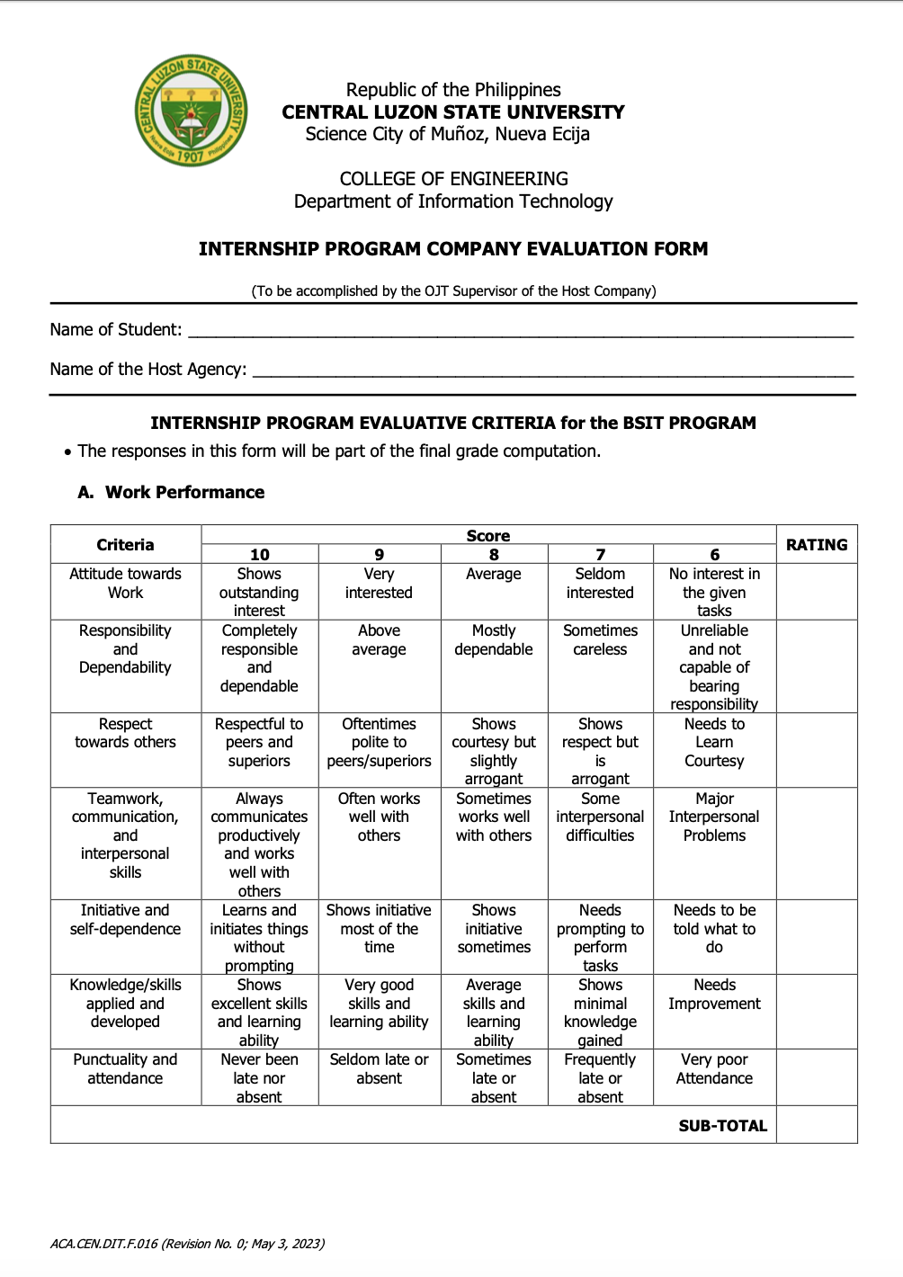

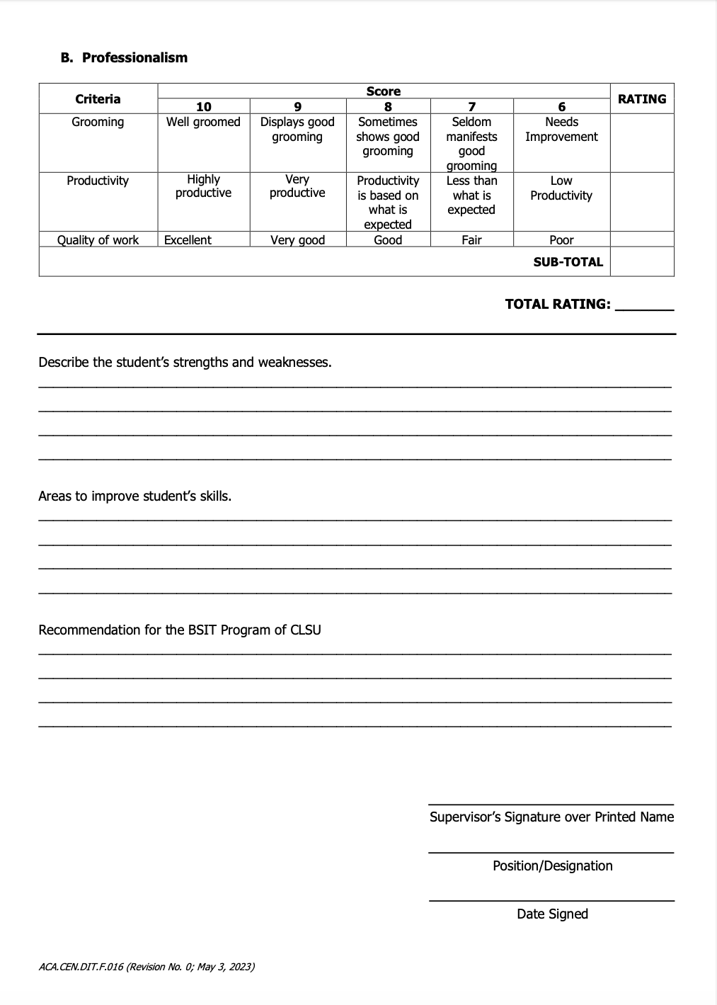

* 1. **CERTIFICATION**

A *Certificate of Completion* shall be issued by the HTE to the undergraduate intern after the completion of the designated number of internship hours. The certification shall at least bear the company/institution’s seal, the student-intern’s name and special designation (if any) and signed by the HTE’s authorized representative.

**Prepared by:**

|  |  |  |
| --- | --- | --- |
| MR. AMIR LEDESMA |  |  |
| Student Intern’s Supervisor from HTE |  | Date Signed |
| ASST. PROF. EVELYN A. VILLANUEVA |  |  |
| HEI Faculty-in-Charge or Internship Coordinator |  | Date Signed |

**Conforme:**

|  |  |  |
| --- | --- | --- |
| DANICA M. BILANDRES |  |  |
| Student Intern |  | Date Signed |

|  |  |  |
| --- | --- | --- |
| CATHERINE L. PALLARCA |  |  |
| Student Intern |  | Date Signed |