CASE STUDY : SERVERLESS EVENT-DRIVEN AUTOMATION WITH AWS
Duration : 5 Hours

- Project Description
  - Background
In the era of modern cloud computing, serverless and event-driven architectures have become optimal solutions for building applications that are highly scalable, cost-effective, and easy to manage. This project aims to implement a fully serverless automated order processing system using the latest AWS services, eliminating the complexity associated with traditional infrastructure management. By leveraging managed cloud services, the system can automatically scale based on demand while ensuring high availability and operational efficiency.
Through the adoption of an event-driven approach, every stage of the order lifecycle is triggered by events, enabling seamless integration between services and real-time processing. This architecture allows organizations to focus on business logic rather than infrastructure concerns, reduce operational overhead, and accelerate application development. As a result, the proposed solution provides a robust, flexible, and future-ready platform for handling automated order processing in a cloud-native environment.
  - Task
As a Cloud Engineer, you are tasked with building a complete serverless order processing system with the following specifications:
TASK LIST:
- Log in to the AWS Management Console using your class account.
- Set up the infrastructure using AWS CloudFormation or manual configuration.
- Configure the VPC according to the specified requirements.
- Set up Amazon S3 for file storage and static assets.
- Deploy AWS Lambda functions to handle business logic processing.
- Configure Amazon RDS for data persistence.
- Create AWS Step Functions for workflow orchestration.
- Set up Amazon EventBridge for event-driven automation.
- Configure Amazon API Gateway to expose RESTful endpoints.
- Deploy the frontend application using AWS Amplify.
- Implement a CI/CD pipeline using GitHub Actions.
- Verify that the application is accessible from the public network and that all features function correctly.
  - Technical Details
- Region default: Virginia (us-east-1)
- Service prefix: Semua nama layanan harus diawali dengan lks-
- Source code repository: https://github.com/yourorg/serverless-order-system.git
- OS untuk EC2: Amazon Linux 2023 (jika diperlukan)
- Sistem harus: Menangani asynchronous order processing dengan email notifications
- Runtime Lambda: Python 3.13
- Database: PostgreSQL 15.x
- SPESIFICATION SYSTEM
  - Functional Requirements
- Order Processing System:
- Create new orders through the frontend application
- View the list of orders with pagination support
- View detailed information for a specific order
- Update the order status
- Delete or cancel an order
- Track the workflow status in real time
- Automated Workflow:
- Automatic order validation
- Simulated payment processing
- Inventory stock updates
- Send confirmation notifications
- Handle error scenarios gracefully
- Scheduled Tasks:
- Automatically generate daily reports
- Check inventory stock on an hourly basis
- Trigger custom events
- Monitoring & Notifications:
- Mail notifications for all critical status pending
- CloudWatch monitoring dashboard
- Error alerts via SNS
  - Non-Functional Requirements
- Performance:
- API response time < 2 seconds
- Lambda cold start < 5 seconds
- Concurrent processing more than 1000 orders
- Scalability:
- Auto-scaling with load
- Handle traffic spike without downtime
- Database connection pooling
- Reliability:
- 99.9% availability
- Automated backup for database
- Disaster recovery capabilities
- Security:
- API authentication with API keys
- Database di private subnet
- Encryption at rest dan in transit
- IAM least privilege principle
- ARCHITECTURE DIAGRAM
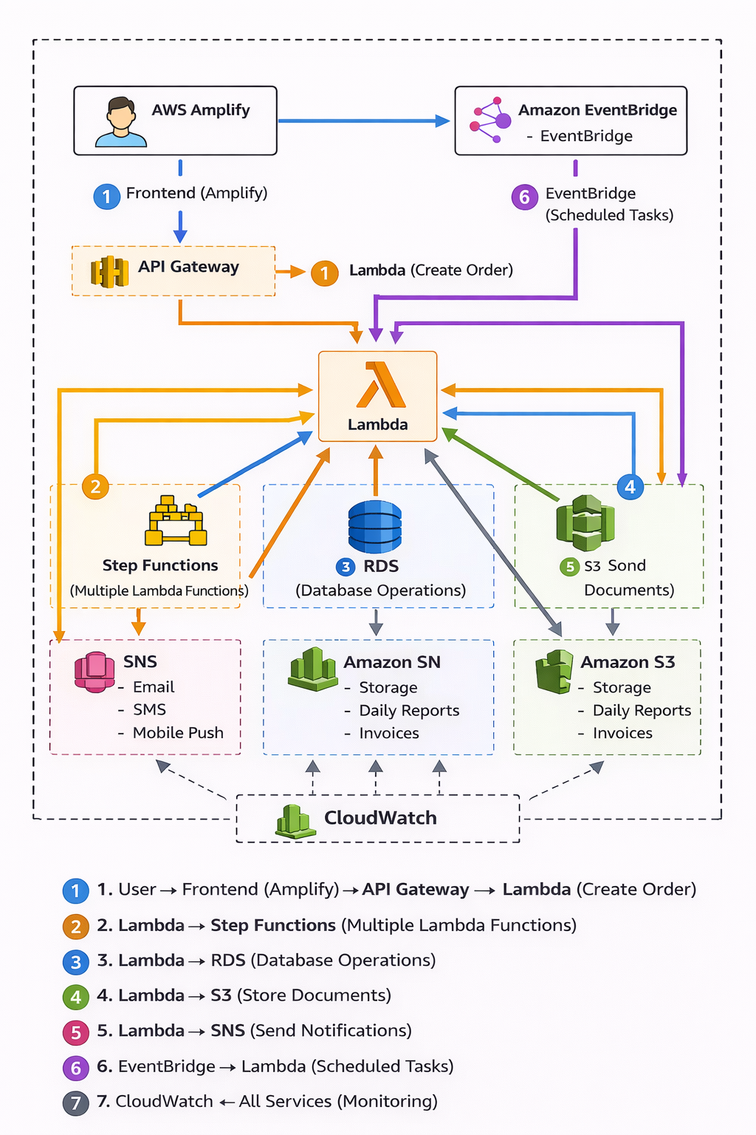

- Implementation using Terraform
Use Terraform to provision and manage all infrastructure components, including (but not limited to) networking resources, Amazon S3 buckets, Amazon RDS, AWS Lambda functions, ensuring the entire environment is defined as Infrastructure as Code (IaC).
- Networking and Security
- Virtual Private Cloud (VPC)
You need to configure a Virtual Private Cloud (VPC) with a CIDR block of 20.1.0.0/20 and an IPv6 /56 range provided by Amazon, give the name is lks-vpc-serverless. The VPC should include two public subnets with IPv4 CIDR ranges 20.1.0.0/25 and 20.1.1.0/25, as well as two private subnets with IPv4 CIDR ranges 20.1.11.0/25 and 20.1.12.0/25. All subnets must be using IPV6 /64. Additionally, you must create two route tables: one for public subnets and one for private subnets.
- Security Group
You are required to configure Security Groups to control inbound traffic for different components of the infrastructure, follow this instruction:
- Create a Security Group, give named is lks-sg-lambda, the description is security for lambda function, no need inbound.
- Create a Security Group, give named is lks-sg-rds, the description of security for RDS and open port 5432 from lks-sg-lambda.
- Create a Security Group, give named is lks-sg-vpc-endpoint, the description of security for vpc endpoint, open port HTTP and HTTPS from CIDR 20.1.0.0/16
- VPC Endpoint
You need create vpc endpoint for this service:
  - S3 Gateway Endpoint (com.amazonaws.us-east-1.s3)
  - EventBridge Interface Endpoint (com.amazonaws.us-east-1.events)
  - Step Functions Interface Endpoint (com.amazonaws.us-east-1.states)
  - SNS Interface Endpoint (com.amazonaws.us-east-1.sns)
- S3 Bucket
You need to create a S3 bucket, the function bucket is order Documents and Application Logs. Follow the instructions on below:
- S3 Bucket Order Documents
Give the name is lks-orders-yourname-2026, enabled the versioning and setting the lifecycle rules for transition to intelligent-tiering after 30 days, transition to glacier after 90 days and delete permanently after 365 days. Setting the bucket policy allow to all and setting the CORS to allow frontend access.
- S3 Bucket Application logs
Give the name is lks-logs-yourname-2026, setting the lifecycle rules for transition to intelligent-tiering after 7 days, delete permanently after 90 days.

- Relation Database Service (RDS)
The database configuration is designed to support the Order Management system using a managed relational database service on AWS. The database engine used is PostgreSQL version 15.x, ensuring high performance, reliability, and compatibility with modern SQL features. The DB instance is identified as lks-rds-orders and runs on the db.t3.micro instance class, which is suitable for lightweight workloads and development or training environments. Storage is provisioned at 20 GB using the gp3 volume type to provide consistent performance and cost efficiency.
From a networking and security perspective, the database is deployed within the lks-vpc-serverless VPC and configured to use private subnets only, ensuring that the database is not directly exposed to the public internet. Public access is disabled, and access control is enforced through the lks-sg-rds security group, which restricts inbound connections to trusted resources such as Lambda functions running within the same VPC. The database is created with the name ordersdb, using dbadmin as the master username and a predefined master password TechnoCloud2026!. To support data protection and recovery, automated backups are enabled with a retention period of 7 days.
For database schema initialization, a dedicated Lambda function named lks-lambda-init-db is used. This function is responsible for automatically creating the required database structures, including the customers, orders, order_items, and inventory tables. In addition, it defines the necessary indexes and constraints to maintain data integrity and optimize query performance. Optionally, the function can also insert sample data to facilitate testing and validation of the Order Management system during initial deployment.
- Lambda Function
Lambda Functions focuses on deploying six AWS Lambda functions, all implemented using Python 3.13, to support the end-to-end Order Management system. Each function is configured with specific memory and timeout settings based on its responsibility, ensuring efficient resource utilization and reliable execution across the workflow.
- The first function, Order Management (lks-lambda-order-management), serves as the core business logic handler for order processing. It is allocated 512 MB of memory with a 30-second timeout and is attached to private subnets within a VPC to securely access backend resources such as Amazon RDS. This function uses environment variables to configure database connectivity (RDS endpoint, database name, username, and password), define the target Amazon S3 bucket for order-related storage, and reference the AWS Step Functions state machine ARN for orchestration.
- The second function, Process Payment (lks-lambda-process-payment), is responsible for handling payment-related logic. It is configured with 512 MB of memory and a 30-second timeout, providing sufficient capacity to interact with external payment services or perform transaction validation as part of the order lifecycle.
- The third function, Update Inventory (lks-lambda-update-inventory), manages stock updates after an order is processed. This function is optimized for lightweight operations with 256 MB of memory and a 15-second timeout, ensuring fast and efficient inventory adjustments in the database.
- The fourth function, Send Notification (lks-lambda-send-notification), handles customer or system notifications such as order confirmations or status updates. It is configured with 256 MB of memory and a 10-second timeout, reflecting its simple and time-sensitive execution requirements.
- The fifth function, Generate Report (lks-lambda-generate-report), is designed for more resource-intensive tasks such as data aggregation and report generation. To support these operations, it is allocated 1024 MB of memory with a 60-second timeout, allowing it to process larger datasets and generate reports in formats such as Excel.
- The sixth function, Init Database (lks-lambda-init-db), is used during initial deployment or maintenance phases to initialize the database schema. It is configured with 512 MB of memory and an extended 300-second timeout, enabling it to create tables, indexes, constraints, and optionally insert sample data without interruption.
To standardize dependencies and reduce package duplication, a shared Lambda Layer named lks-layer-dependencies is created and attached to all Lambda functions. This layer includes commonly used libraries such as psycopg2-binary, boto3, requests, pandas, and openpyxl, ensuring consistent runtime environments and simplifying maintenance across the entire serverless application.
- Implementation without Terraform
- Step Function
Step Functions involves defining an AWS Step Functions state machine to orchestrate the end-to-end order processing workflow in a reliable and scalable manner. The state machine is named lks-stepfunctions-order-workflow and uses the Standard workflow type, which is suitable for long-running, auditable, and fault-tolerant business processes. Use the IAM role is LabRole assigned to this state machine, granting the required permissions to invoke the associated Lambda functions securely.
The workflow begins with the ValidateOrder step, which invokes the Order Management Lambda function to validate incoming order data, ensure data completeness, and perform initial business rule checks. Once the order is validated, the workflow proceeds to ProcessPayment, where the Process Payment Lambda function is executed to handle payment authorization and processing.
After the payment step, the workflow enters a PaymentChoice state, which evaluates the value of paymentStatus returned by the previous Lambda execution. Based on this condition, the state machine determines the next action, allowing different execution paths for successful payments, failed payments, or pending states.
If the payment is successful, the workflow continues to UpdateInventory, invoking the Update Inventory Lambda function to adjust stock levels accordingly. Once inventory updates are completed, the state machine transitions to SendConfirmation, which triggers the Send Notification Lambda function to deliver order confirmation messages or status updates to the customer or relevant systems.
Throughout the workflow, error handling and fallback paths are defined to gracefully manage failures at each stage. These mechanisms ensure that errors are captured, retries are applied when appropriate, and compensating actions or notifications can be executed, thereby improving the overall resilience and reliability of the order processing system.
- EventBridge
EventBridge focuses on configuring Amazon EventBridge rules to enable event-driven automation and scheduled tasks within the Order Management system. These rules allow the system to respond to time-based schedules as well as custom business events in a decoupled and scalable manner.
The first rule, Daily Report, is created with the name lks-eventbridge-daily-report and uses a scheduled expression of cron(59 23 * * ? *), which triggers the rule daily at 23:59 UTC. This rule targets the lks-lambda-generate-report Lambda function, enabling the system to automatically generate daily operational or transaction reports without manual intervention.
The second rule, Order Status Events, is named lks-eventbridge-order-status and is configured using an event pattern to capture custom application events related to order status changes (such as order created, paid, shipped, or failed). When such events are published to EventBridge, this rule routes them to the lks-lambda-send-notification Lambda function, ensuring that notifications are sent in near real time based on order lifecycle updates.
The third rule, Low Stock Alert, is defined with the name lks-eventbridge-low-stock and uses a scheduled expression of rate(1 hour), causing it to run every hour. This rule targets a custom Lambda function responsible for checking inventory levels. If low stock conditions are detected, the function can trigger alerts or follow-up actions, helping to maintain inventory availability and prevent stock shortages.
- API Gateway
API Gateway covers the setup of Amazon API Gateway as the main entry point for external clients to interact with the Order Management system. The API is named lks-api-orders and is configured with a Regional endpoint type, allowing low-latency access within the selected AWS region while maintaining high availability. The API is deployed to a stage named production, which represents the stable, live environment for consuming applications.

Several RESTful endpoints are defined to support full order lifecycle management.
GET | /orders | List Orders
POST | /orders | Create New Order
GET | /orders/{id} | Get order details
PUT | /orders/{id} | Update order
DELETE | /orders/{id} | Delete order
GET | /status{id} | Check workflow status
To secure and control API usage, an API security configuration is applied using a Usage Plan named lks-usage-plan. This plan enforces a rate limit of 1,000 requests per second with a burst limit of 2,000 requests, protecting backend resources from sudden traffic spikes. A monthly quota of 100,000 requests is also defined to manage long-term consumption. Access to the API is authenticated using an API Key named lks-api-key, ensuring that only authorized clients can invoke the API endpoints under the defined usage constraints.
- Deploy to Amplify
Deploy Frontend with AWS Amplify focuses on delivering a web-based user interface for the Order Management system using a fully managed frontend hosting and CI/CD service. An AWS Amplify application is created with the name lks-amplify-order-app and is connected directly to a GitHub repository, enabling automatic builds and deployments whenever changes are pushed. The application is configured to deploy from the main branch and uses a Static HTML/CSS/JavaScript framework, making it lightweight, fast, and easy to maintain. Custom build and deployment steps are defined through a tailored amplify.yml file to meet the specific needs of the project.
The frontend application provides several key features to support operational and monitoring activities. It includes a dashboard with statistical summaries to give users a quick overview of system performance and order metrics. An order creation form is available for submitting new orders, while an orders management table allows users to view, update, and manage existing orders efficiently. The application also features a reports section for accessing generated reports, as well as system status monitoring to track the health and progress of backend workflows.
To enable seamless integration with backend services, the Amplify application is configured with environment variables. The API_ENDPOINT variable points to the Amazon API Gateway URL used by the Order Management API, while API_KEY is used to authenticate requests under the defined usage plan. The AWS_REGION variable is set to us-east-1, ensuring that frontend requests are correctly routed to the appropriate AWS region. This configuration allows the frontend to securely and reliably communicate with the serverless backend infrastructure.

- Simple Notification Service (SNS)
Setup Amazon SNS focuses on configuring Amazon Simple Notification Service (SNS) to deliver real-time notifications related to the Order Management system. An SNS topic named lks-sns-order-notifications is created as a centralized communication channel for distributing messages to multiple subscribers in a scalable and reliable manner.
The SNS topic is configured with email subscriptions, including handi@seamolec.org, allowing key stakeholders and system administrators to receive important notifications directly in their inboxes. Once subscribed and confirmed, these recipients will be automatically notified whenever relevant events occur within the system.
The notification types published to this SNS topic include order confirmations, payment status updates, inventory alerts, system error notifications, and report completion messages. By integrating SNS with Lambda functions and other AWS services, the system ensures timely delivery of critical information, improves operational awareness, and enables faster response to issues or business events.

- CloudWatch
Configure CloudWatch focuses on implementing monitoring, logging, and alerting to ensure the reliability, performance, and observability of the serverless Order Management system. Amazon CloudWatch is used as the centralized service for collecting logs, tracking metrics, and visualizing system health across all integrated AWS components.
For CloudWatch Logs, log groups are created for all Lambda functions, as well as for AWS Step Functions and Amazon API Gateway, ensuring that execution details, errors, and request traces are fully captured. A log retention policy of 7 days is applied uniformly to all log groups, balancing operational visibility with cost efficiency and log lifecycle management.
Several CloudWatch Alarms are configured to proactively detect abnormal conditions and potential system issues. Alarms are set to trigger when the Lambda error rate exceeds 5 errors within 5 minutes, when API Gateway returns more than 10 client-side (4XX) errors in 5 minutes, and when Step Functions experience more than 3 execution failures within 10 minutes. In addition, an alarm monitors Amazon RDS CPU utilization, triggering when usage exceeds 80% for a continuous period of 5 minutes, helping to identify performance bottlenecks at the database layer.
To provide a unified operational view, a CloudWatch Dashboard named lks-dashboard-serverless is created. This dashboard includes visual widgets displaying Lambda performance metrics, API Gateway request and error statistics, Step Functions execution status, and RDS resource metrics. Together, these monitoring configurations enable real-time visibility, faster troubleshooting, and more effective operational decision-making for the entire system.
- Implement CI/CD Pipeline
Implement CI/CD Pipeline describes the setup of an automated deployment pipeline using GitHub Actions to ensure consistent, reliable, and repeatable delivery of application updates. The CI/CD workflow is defined in the file .github/workflows/lks-deploy.yml, which orchestrates testing, deployment, and notification steps whenever changes are pushed to the repository.
The workflow consists of several structured jobs. The test-lambda job runs unit tests to validate Lambda function logic before any deployment occurs, helping to catch errors early in the pipeline. Once tests pass, the deploy-lambda job updates the code for all relevant AWS Lambda functions, ensuring that backend logic remains in sync with the latest source changes. The deploy-stepfunctions job then updates the AWS Step Functions state machine definition, allowing workflow logic and orchestration changes to be deployed automatically. For the frontend, the deploy-frontend job triggers an AWS Amplify build and deployment, ensuring that UI updates are published seamlessly. Finally, the notify job sends deployment status notifications, providing visibility into whether the pipeline execution succeeded or failed.
To support secure automation, several GitHub Secrets are required by the workflow. These include AWS credentials for authenticating deployment actions, the Amplify App ID to trigger frontend builds, and the API Gateway ID to manage and update API configurations. By implementing this CI/CD pipeline, the system achieves faster delivery cycles, reduced manual intervention, and improved deployment reliability across all components.
- Testing & Verification
- Testing & Verification focuses on validating that all components of the Order Management system function correctly, both individually and as an integrated solution. This phase ensures that the system meets functional requirements, performs reliably, and behaves as expected under real-world usage scenarios. For API Testing, all exposed endpoints are tested using tools such as Postman or curl. This includes verifying request and response formats, authentication using API keys, pagination behavior, and proper handling of success and error cases across all order-related operations.
- Workflow Testing is conducted to validate the end-to-end order processing flow orchestrated by AWS Step Functions. This testing ensures that orders progress correctly through validation, payment processing, inventory updates, and notification steps, including correct branching behavior for different payment statuses and proper execution of error-handling paths.
- Event Testing covers both scheduled events and custom events configured in Amazon EventBridge. Scheduled rules are tested to confirm that reports and inventory checks run at the expected times, while custom events are validated to ensure that order status changes correctly trigger downstream actions such as notifications.
- For Frontend Testing, all user interface features are verified, including the dashboard, order creation form, order management table, reports section, and system status monitoring. This ensures correct data rendering, user interactions, and seamless communication with backend APIs.
- Finally, Integration Testing validates that all services—API Gateway, Lambda functions, Step Functions, EventBridge, SNS, RDS, and the Amplify-hosted frontend—work together as a cohesive system. This testing phase confirms data consistency, event flow, error handling, and overall system stability before production use.

