Project description

1. Introduction

  - Historical development of Pychron

Pychron (Python + Chronology) is the brainchild of PI Jake Ross, who during his PhD independently began developing noble gas mass spectrometry data acquisition and data reduction software using the Python programming language. Co-PI’s Heizler and McIntosh weighed the desires of Jake to develop a new application versus pursuing the conversion of the highly evolved MassSpec application (written and supported by Dr. Al Deino, Berkeley Geochronology Center) for use with our new multi-collector ARGUS VI mass spectrometers. We cautioned Jake about undertaking such a massive project while trying to complete the research chapters of his dissertation. We also partially fought our own philosophical battle about whether our lab and the community as a whole required new software to accommodate the development of new generation multi-collector mass spectrometers that have been delivered to laboratories around the world.
Following the delivery of the ARGUS VI instruments to NM Tech we quickly discovered that using the Thermo Scientific software “Qtegra” was not a viable option for us for a variety of reasons. We were so familiar and entrenched in MassSpec after nearly 20 years of operation that we did not want to convert to a manufacturer-supplied program that could not be easily modified in-house, and that could not export data or interact with our SQL database. Therefore, we initially contracted Al Deino to modify a version of MassSpec to operate the Argus VI. PI Ross’s role in this process was to write a remote invocation server (named RemoteControlServer), embedded in Qtegra, which allowed third-party software, such as MassSpec, to control the mass spectrometer. The resulting four-way fusion of MassSpec, RemoteControlServer, Qtegra, and a primitive version of Pychron was an adequate product for collecting data on the ARGUS VI that allowed us to store both MAP and ARGUS data in a single database. However, problems continued to arise each time we conceived and implemented new data acquisition ideas or added new devices and capabilities to our expanding facility. Although we have significant experience modifying the MassSpec code, the lack of an adequate version control system, API (Application Programming Interface) or developer guide, made it arduous to implement and test modifications, and avoid the introduction of bugs and errors. It was also not practical to involve Al Deino with our constant needs to make adjustments and modifications so that we could get the best performance from the ARGUS VI instruments. In such a rapidly evolving environment of learning the characteristic peculiarities of multi-collection, constructing new extraction lines, and adding devices, co-PI’s Heizler and McIntosh recognized the need for in-house software development that could yield immediate results. PI Ross filled this need with a herculean effort of code development, concurrent with completion of two large research projects in Antarctica for his PhD.
For the last two years, we have been exclusively using Pychron to operate and collect data from our two ARGUS VI multi-collector mass spectrometers. Pychron is modified on a nearly daily basis to accommodate our continuous growth and evolution of ideas for data acquisition and data reduction. Although we currently continue to use MassSpec for most of our data reduction needs, we are nearing a stage in which we expect to transition to Pychron for data reduction as well as data collection. This proposal seeks to further develop Pychron’s functionality and documentation, ensuring its effective and efficient use and sustainability at NMGRL and to prepare for relatively easy dissemination to any facility seeking a new software platform or wanting to incorporate elements of the Pychron suite.

1.2 Why the necessity for another software package?

The New Mexico Geochronology Research Laboratory (NMGRL) and the entire ⁴⁰Ar/³⁹Ar geochronology community would not be where they are today without Al Deino’s MassSpec software (BGC, 2014). The influence of this software cannot be overemphasized in the evolution of our science, especially in its ability to quickly and easily manipulate large volumes of data in flexible and complex fashions. MassSpec is designed with the noble gas scientist in mind and far exceeds any company-delivered argon geochronology software. It has been important in providing many laboratories a common platform for data collection and reduction. Although MassSpec has been vital to many laboratories, there are other important and valuable software options in our community. Most notable is ArArCalc, written by Dr. Anthony Koppers currently at Oregon State University (Koppers, 2002). This Excel based software is used in numerous geochronology labs throughout the world and is well liked and well supported. Our understanding is that Anthony is developing ArArSuite that will now conduct data acquisition for the ARGUS VI multi-collector instruments at OSU. There are several other codes in our community that have mostly been developed in-house and principally used by only that individual lab. For instance, the Lehigh University code, Labspec, developed by Dr. Bruce Idleman, is available to others but not supported by Lehigh except for providing limited advice. The University of Wisconsin (and perhaps others) has partially adapted this code, but also uses in-house software as well, coupled with ArArCalc.
Although a variety of software options are currently available to the ⁴⁰Ar/³⁹Ar community, we feel there is room for more options as well as for improving existing options. We seek to develop Pychron into a fully functional, flexible, extensible, and user-friendly package that will benefit the NMGRL and also provide a new option to the broader community. The Python programing language has many advanced features and is backed by a large and growing development community. Pychron leverages these features towards construction of a powerful and sustainable package that can potentially be expanded well outside the immediate needs of the ⁴⁰Ar/³⁹Ar community. Many current discussions and workshops at or in conjunction with NSF facilities (EARTHTIME, Earthcube, NROS, Earthchem) have cited the need for improved and sustainable software for geochronology (e.g., Singer et al., 2014; NROS, 2013) We feel that Pychron has the potential to help meet this need. However, even if Pychron does not become widely distributed, it will still benefit the entire ⁴⁰Ar/³⁹Ar community, as it will help compare data reduction methods, algorithms, and output values between Pychron and other software packages. To our knowledge, ArArCalc and MassSpec have not been systematically or comprehensively compared relative to each other. We will establish comparability between Pychron and these two common data reduction packages for the benefit of the entire argon geochronology community. We welcome comparison with other software packages to help broaden consistency in the community.

  - Goals and objectives

The ultimate goal of further Pychron development is to create a sustainable and robust software suite that is freely available to interested members of the argon geochronology community. We hope that Pychron will eventually become a viable platform for future expansion not only at NMGRL, but also other laboratories in the noble gas community. We envisage an efficient community development effort with significant collaboration among laboratories that results in a flexible, full-featured and maintainable product.
In order to move toward our ultimate goal, the proposed work has seven specific objectives detailed in section three that can be broadly grouped into two categories; 1) additional functionality, and 2) improved sustainability. Additional functionality will include advancement and maturation of Pychron’s data reduction capabilities as well as interfacing with NMGRL’s MAP215-50 mass spectrometer. Sustainability will include improving the integrity and quality of the existing codebase, production of high quality documentation resources and implementation of a comprehensive automated testing suite.

2. Software in ⁴⁰Ar/³⁹Ar geochronology

Software automation of hardware and robust, efficient, and flexible data reduction packages have had a profound impact on the quality and quantity of argon isotopic data. Most argon labs are automated, in some cases running nearly 24-7 and producing large datasets in relatively short intervals. Especially because of MassSpec, and now Pychron, the NMGRL is able to serve multiple professionals and students conducting highly variable research projects that encompass geochronology and thermochronology studies from around the world. Coupled with numerous collaborative NSF funded projects and individual client-based projects, the NMGRL dates on the order of a thousand samples per year. This effort requires many thousand isotopic analyses and reduction of large datasets that can only be accomplished with efficient data acquisition and data reduction software packages. As mentioned, for our own needs and for eventual broader distribution we have developed Pychron and below elaborate on our choice of the Python programing language, version control and the current state of Pychron.

2.1 Pychron

Pychron is a fully featured data acquisition and processing software suite under development at the NMGRL over the last five years. For the last two years, Pychron has been used to acquire data from our two new Thermo Scientific ARGUS VI mass spectrometers. During that period Pychron has collected more than 35,000 analyses and proven to be a powerful and flexible platform for isotopic data collection. The data reduction application is currently in development and is nearing its first beta release for distribution within NMGRL.
As discussed above, two fundamental aspects of Pychron make it both a sustainable and flexible option for the argon geochronology community, 1) the Python programming language and 2) embrace of popular software development techniques such as a Distributed Version Control System (Git/GitHub).

2.2 Why Python?

The Python programming language is an ideal choice for scientific programming for a variety of reasons. Python is a high-level object-oriented scripting language that is both easy to learn and understand for novices and also powerful and capable for the most advanced users. Python has become increasingly popular as a teaching tool and now is the most widely used programming language for introductory computer science courses at universities in the United States (Guo, 2014). Its idiomatic approach results in clean, easily comprehendible code that is ideal for rapid prototyping as well as for the creation of robust sustainable libraries. The scientific python community is large and active, providing many high quality libraries that greatly enhance Python’s capabilities (Jones et al., 2001). One of the most widely used and fundamental scientific libraries is Numpy, which provides powerful handling of numerical data.
A common complaint about a high level dynamic programming language, such as Python, is that its execution speed is “too slow.” However, numerous options exist to overcome this unlikely barrier should it become an issue, mainly in the form of open-source third party optimization libraries, (e.g., Numpy, Scipy) which allow calculations to be performed at or near C programing language speeds. Our current applications have not been negatively impacted by execution speed.

2.3 Why Git/GitHub?

Version control systems are an essential component of the developmental process for any distributed, collaborative project (Yeates, 2013). Version control provides multiple advantages, including 1) version tracking, 2) team coordination and 3) an easy mechanism for distribution. For Pychron development we choose to use the highly popular version control tool, Git, in conjunction with the equally popular service GitHub. One of Git’s most popular and unique features is its branching model, allowing developers to rapidly create, merge and delete multiple independent versions of their code. Git’s branching model allows a developer to seamlessly switch between multiple versions, identify differences between two branches and merge two branches together to incorporate changes from both. Git is also an example of a distributed version control system, meaning that every developer has a full clone of the code repository. The distributed nature of Git has multiple advantages over a centralized system, specifically speed and robustness. Since all computations are performed locally, Git is extremely fast, eliminating the need to be in constant communication with a centralized server. Each developer also has a full back up of the code, eliminating the chances of a single point of failure, such as a crash or corruption event on a centralized server (Chacon, 2009).
GitHub is a popular service for hosting Git repositories, providing many tools for collaboration and communication among developers. It has become the de facto location for hosting open-source projects and data with over 6.7 million users contributing to 14.9 million repositories as of August 2014 (GitHub, 2014).

2.4 Current state of Pychron

2.4.1 Hardware interface

Pychron is capable of interfacing with a variety of hardware devices using popular communication protocols, such as RS232, RS485, Modbus, GPIB and TCP/UDP. Drivers for numerous classes of devices have been developed and provide access to a diverse group of hardware products commonly used in argon geochronology labs. These range from simple standalone devices such as modular Digital-to-Analog converters, to complex integrated systems such as Photon Machines CO₂, diode and UV lasers. Table 1 provides a comprehensive list of devices that are controllable by Pychron.

Table 1. Pychron controllable devices
Device | Function/Description
Argus VI multi-collector mass spec. | Isotope measurement
Photon Machines Fusions CO₂ Laser | Sample fusion and step heating
Photon Machines Fusions Diode Laser | Sample step heating & Laser Furnace
Photon Machines UV Laser | In situ laser ablation
Watlow EZZone | PID controller
Mikron Pyrometer | Indirect temperature measurement
Kerr motion controller | Servo and stepper motor control
Newport 301 motion controller | Multi-axis motion controller
Aerotech Unidex 511 | Multi-axis motion controller
Agilent 34970a | Data acquisition/Switching unit
DPi32 | Temperature and process monitor
M1000 | Analog-to-Digital converter
Arduino microcontroller | Open source microcontroller
Granville-Phillips 358 | Micro-Ion gauge controller
FerrUPS | Uninterruptible Power Supply (UPS)
ThermoRack | Solid state chiller
ProXR | Expandable relay control
Terra Nova 751 | Ion pump controller
Canopus ADVC-110 | Video digitizer

Pychron uses a “Distributed Control” paradigm, involving a network of multiple independent inexpensive computers each dedicated to controlling one major component of the argon laboratory (Figure 1). Each component in the “Distributed Control” system has a public API that is served locally or on a LAN by a “remote control” instance. This model allows for a great degree of flexibility during both development and operation. Delegating control to multiple applications facilitates independent development of each subsystem. It also allows laboratories to use a mix of hardware and software that best serves their needs. For example, users may wish to use Pychron to control their valves and/or lasers and use MassSpec to act as a master application delegating control and coordinating data collection. This model was pursued initially in NMGRL’s recent laboratory upgrade, prior to switching entirely to Pychron for data acquisition and hardware control.
The distributed control model makes it easy to share expensive components, such as integrated laser systems, between multiple interconnected extraction lines and mass spectrometers. Other important shared components used at NMGRL are the two standard gas reservoirs and pipettes each with different isotopic compositions. These pipettes facilitate easy and periodic intercalibration between the two ARGUS VI instruments. Access to the shared components is accomplished using a simple semaphore protocol. This feature eliminates the requirement for duplicate extraction devices, UHV extraction lines and standard pipettes, allowing multiple master applications to access the shared component as soon as they are available.
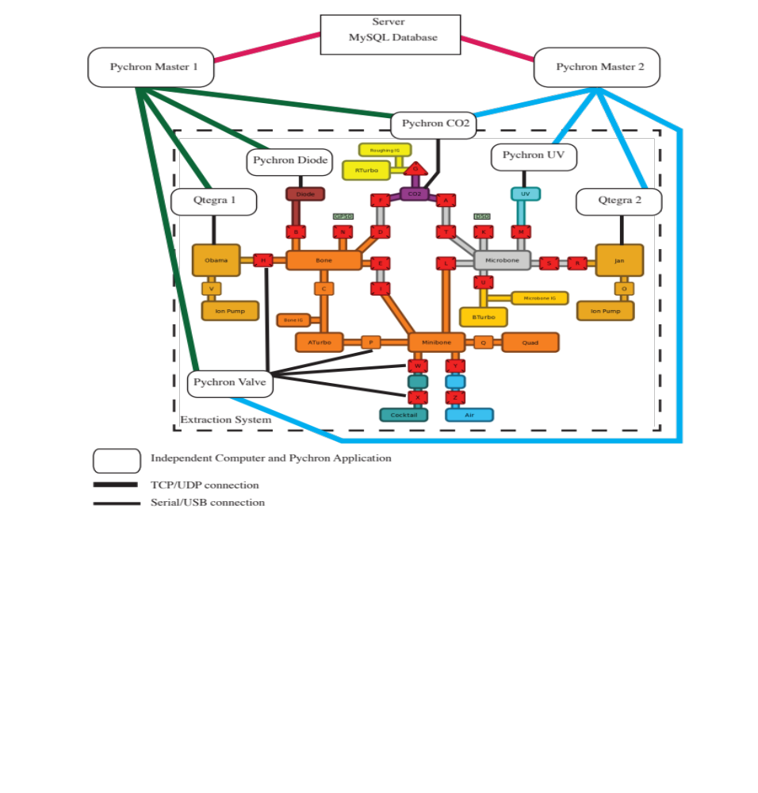
Figure 1. Distributed Control and extraction system at NMGRL. A dedicated computer and application independently controls each hardware component, such as a mass spectrometer or laser. Applications communicate and interact with one another via a Local Area Network (LAN) using the TCP or UDP protocols. For visual clarity only some of the connections between Pychron Valve and the valves are displayed.

2.4.2 Data Acquisition

All components in our distributed control scheme are centrally controlled by two master Pychron applications (one for each ARGUS VI) that perform and coordinate the necessary data collection procedures. Preprogrammed sequences, called PyScripts, are stored on each master computer and are used to flexibly interact with the hardware components, for example firing a laser or manipulating UHV valves. PyScripts are pure Python scripts augmented with a set of Pychron specific commands and variables. Because PyScripts are pure Python, all the power of Python is included by default. Users can modify PyScripts with Python control structures, such as if-else conditionals, and for and while loops. The use of standard Python syntax means that a custom parser is not necessary. Using Python’s built-in parser and abstract syntax tree generator, complicated patterns are readily added by any user familiar with the Python language. No longer is there a need to learn an esoteric, typically fragile, built-in scripting language, such as is used by current software solutions. Pychron contains numerous features of a true scripting language, such as nested conditionals and control structures, variable assignment and function declaration. Importantly, these features come built-in with PyScripts and are robustly implemented as core components of the Python Language Services.

2.4.3 Data persistence

Pychron saves analyses to multiple locations and in multiple formats. During data collection, the raw isotopic data is continuously saved locally to an HDF5 file using the PyTables package (Alted et al., 2002). Following the completion of the analysis, raw and minimally processed data is uploaded to primary and secondary MySQL databases located on one or more dedicated servers. SQLAlchemy, the well known, efficient, and high performance Python SQL toolkit and Object Relational Mapper (Bayer, 2006), provides the interface to the databases. Currently only the MassSpec schema is implemented as a secondary database, but provided with the required information other database formats can be added. In addition to the central databases, Pychron saves a metadata log locally to a lightweight SQLite database (Sqlite, 2014) for redundancy and recovery of analyses that failed to successfully save to the central database, if, for example, network connectivity was lost during the saving process.

2.4.4 Data Processing

To accomplish the necessary post-processing steps, Pychron uses a significantly different workflow compared to other argon geochronology software products such as MassSpec, Isoplot and ArArCalc. Pychron uses Graphical User Interfaces (GUI) and procedures more commonly encountered in software Integrated Development Environments (IDE) than typically encountered in the other noble gas data processing software. For example, when constructing analysis plots, such as ideograms, a majority of the user interaction occurs with a single “Task’’ window. A Task window consists of a configurable and movable set of “Panes” and an “Editor Area”. The most used pane is the “Browser,” which allows the user to quickly navigate and filter the available analyses. The “Editor Area” provides context specific “Editor” tabs for viewing the selected dataset. A “Controls” pane that is linked to the selected editor allows the user to interact with the editor and control what is displayed or how to proceed with data processing. Graphical editors have a comprehensive set of controls accessible from the “Plot Options” pane, allowing the user to configure the appearance and visibility of all graphical elements. Pychron keeps a granular record of all of data processing choices so that not only are the decisions recorded for traceability but the user also has the ability to revert to any point within the processing history. When the user is satisfied with the result for an analysis or group of analyses, she may define an “interpreted age” for the set. The interpreted age may represent the best estimate for the eruption age of a given sample, or the time at which the sample cooled below a given temperature. Along with the numerical age, error and age type, metadata such as the set of analyses used to calculate the age, the MSWD, an average K/Ca value, etc. are stored in the database. For publication and dissemination, groups of interpreted ages are later exported to PDF and/or Excel, both as summary and analysis tables.

2.5 Pychron’s contribution to NMGRL and argon community

Pychron’s flexible and rapidly modifiable software ecosystem has greatly enhanced NMGRL’s ability to do high quality science quickly and efficiently. Developing Pychron in parallel to building a new lab based on the ARGUS VI multicollectors provided an ideal environment to integrate hardware and software advances. This process facilitated efficient advances in analytical protocols and testing of various routines to achieve ultra-high precision data that is leading to geochronology advances (Heizler, 2011; Heizler, 2012; Heizler et al., 2014; Ross, 2014; McIntosh et al., 2014).
Recently the NMGRL hosted the traveling gas bottle experiment known informally as the “smoking from the same pipe” experiment. Drs. Brent Turrin and Sidney Hemming accompanied the NSF-sponsored Rutgers University-built pipettes (Argon Pipette Intercalibration System, APIS) to New Mexico and helped facilitate multiple experiments on our three mass spectrometers. Numerous conversations among the NMGRL staff and our visitors elucidated some important aspects of argon geochronology and static mass spectrometry. We had long discussions about equilibration duration and estimating “time zero”, the point which defines the y-axis intercept for regression of our isotope intensity data relative to the time when gas from the extraction system first begins to enter the mass spectrometer (Figure 2). When evaluating time zero, we discussed the trade-offs required to achieve gas equilibration between the extraction system and the mass spectrometer versus the effects of immediate fractionation of gas by the mass spectrometer when the ions are accelerated by a high voltage electron bombardment source. This also led to e-mails to the noble gas network to obtain information on the variation among different laboratories for selection of equilibration duration and time zero. The outcome of this communication was that there is no consensus among laboratories and that issues related to these procedures are probably responsible for some systematic interlaboratory dispersion. Because Pychron monitors and records the intensity time information during gas inlet, PI Ross was able to extract how gas ratios were evolving during inlet and it appears from Figure 2 that ratio stabilization occurs well before intensity stabilization. Therefore regression of isotopic ratios with respect to gas inlet time could prove to be a more accurate and reproducible method for age calculation compared to the currently used procedure of regressing individual isotope intensities. Our version of MassSpec can do some ratio-based data manipulation, but we seek to fully develop this method with Pychron. 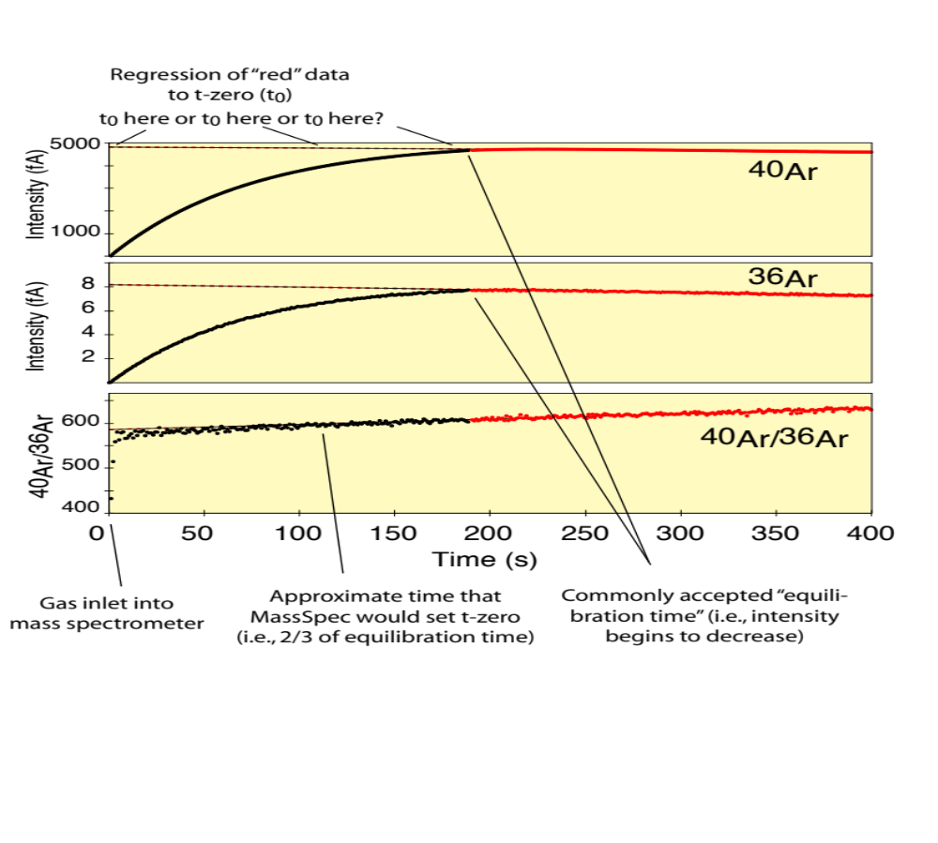

Figure 2. Intensity-time plot tracking gas evolution of argon during equilibration from the extraction line into the mass spectrometer. The gas evolution rate from the extraction line into the mass spectrometer is intentionally slowed by restricting the inlet valve to have low conductance in order to better demonstrate various concepts such as choice of time zero and equilibration duration. As argon enters the mass spectrometer (black curve) the ion intensities begin to increase as molecules from extracted sample gas are ionized in the source and accelerated to the detectors. The ⁴⁰Ar/³⁶Ar ratio increases steeply due to mass dependent fractionation where lighter ³⁶Ar will enter the mass spectrometer more quickly than heavier ⁴⁰Ar. Most argon geochronology labs define equilibration time to equal the time when peak intensity begins to decrease (transition from black to red data), in this case, about 180 seconds after the inlet valve is opened. Commonly, a curve is fit to the data collected after equilibration and projected to a “time-zero” (t₀) intercept that represents the intensity used for age calculation. A survey on the noble gas network revealed significant variation in the choice of t₀. Most common t₀ choices were: 1) at inlet opening, 2) 2/3 of the equilibration time and 3) at equilibration. Cases can be made for both choices 1 and 2, however 3 seems undesirable because isotope fractionation by the mass spectrometer will certainly have occurred (note climbing ⁴⁰Ar/³⁶Ar values with time) leading to erroneous age calculations. For the ARGUS VI, Helix MC and 5-collector Noblesse mass spectrometers a continuous record of gas evolution is available if recorded for all argon isotopes and therefore isotope ratio evolution can be easily monitored for the entire gas evolution. This is less straightforward for single collector mass spectrometers and is mainly why the argon community that is dominated by single detector mass spectrometers has relied on fitting individual isotopes and then calculating isotope ratios from t₀ intercepts. We seek to add ratio-fitting functionality to Pychron and incorporate ratio-based age calculations as well. Even in this extreme and purposeful demonstration of slow equilibration, it is visually obvious and likely more mathematically robust to use ratio regression as this approach reduces sensitivity to age (ratio) calculation relative to choice of t₀ in comparison to regressing individual isotope intensities that have strong dependence on choice of t₀.
From our informal noble gas network survey, labs reported equilibration times between about 5 and 60 seconds, and as mentioned, there are variable philosophies on choice of t₀. Longer equilibration times (i.e., low conductance components between extraction lines and mass spectrometers) are not desirable due to difficulty in accurately determining t₀, however, for labs reporting very short equilibration times it must be established that equal gas pressure between extraction line and mass spectrometer has been achieved else fractionated isotopes will be used to calculate inaccurate ages. Using the added functionality of Pychron, we will be able to rigorously evaluate procedures for determining equilibration time, choice of t₀ and age sensitivity to ratio-based and single-isotope based regressions. Our goal is to reduce, and ultimately mitigate, the unacceptably high age variability currently prevalent between ⁴⁰Ar/³⁹Ar labs.

The simple fact that PI Ross chose to record the gas evolution during the inlet procedure is a good example of why multiple software packages and developers are important to the advancement of our science. Having this enlightening data allows us to mine a first-order influence on age sensitivity relative to time zero choices for both ratio and peak intensity evolutions. PI Ross’s fresh perspective on data collection and processing led to a potentially significant advancement in our understanding of interlaboratory dispersion.

3. Work Plan and Specific Objectives

Our work plan focuses on adding functionality to Pychron and improving its documentation and sustainability. We believe our timeline is achievable based on the pace of development of Pychron during the past few years. PI Ross will be the primary developer and dictate the internal design of Pychron, including the look and feel of the program, organization of the codebase and general coding style. However, incorporation of ideas from a variety of sources, from students to geochronology professionals, particularly Co-PI’s Heizler and McIntosh, will be used to enhance and smooth Pychron’s user experience and workflow.

3.1 Adding functionality to Pychron

3.1.1 Ratio intensity regressions and age calculations

As discussed in Section 2.5, ratio intensity regressions have the potential to be a powerful technique for argon geochronology and the investigation of experimentally induced artifacts. Therefore a considerable effort will be dedicated to adding ratio intensity regressions and ratio-based age calculations to Pychron’s data reduction capabilities.

3.1.2 Data version control

We make many objective and subjective choices during data reduction sessions and therefore we need to be diligent in our understanding as to whether or not these choices lead to significant age variations that can influence our geological interpretations. A valuable feature of MassSpec is the wide range of variables that can be manipulated quickly (e.g. regression fit types, blank handling routines, fits for intercalibrating detectors, etc.) that allows the user to efficiently evaluate sensitivity of data to various data handling methods. We have followed this model of flexibility for Pychron, but seek to retain data reduction sessions for the ease of graphically displaying and comparing these sessions. Currently, new choices imposed on MassSpec derived data result in overwriting the previous choices and thus it is cumbersome to track data reduction sessions that may have many steps towards yielding a preferred age. We will develop a means to save individual data reduction sessions so that we can readily evaluate and compare results. This will ensure we are better equipped to understand systematic biases in final age determinations that are related solely to choices that can be subjective. Additionally, this will provide an efficient teaching tool for students learning the intricacies of data reduction methods. Students will quickly be able to change various parameters and in a simple fashion be able to numerically and graphically compare changes to apparent ages and error estimates that result from their choices. This will lead to a more intimate understanding of data that is all too often lacking in our current “black box” automated facilities. Lastly, this innovation should prove very useful when tracking the results of the traveling pipettes. When multiple labs begin producing data from APIS, the expectation is that all participants will have access to all data for manipulation. Very quickly there will be many variations produced by each individual and without adequate means to track procedures it will be difficult to fully understand measurement dispersion between labs versus the effects of variable data reduction procedures. The APIS data will provide an excellent test bed for Pychron, and Pychron design will benefit from dealing with multiple perspectives from multiple scientists.

3.1.3 Data reduction workflow

Although Pychron data acquisition code is relatively mature, Pychron’s data reduction workflow has only been moderately evaluated by co-PI McIntosh. The acceptance of Pychron data reduction capabilities will partially hinge on how intuitive and consistent the procedures appear to users. The Pychron data reduction beta testing is ready to expand to the entire NMGRL staff and students and PI Ross will undoubtedly be inundated with suggestions to improve workflow, file browsing, graphical displays and overall functionalities. When sticking points with common themes become evident, PI Ross will be tasked to make code adjustments accordingly. An iterative process is expected towards production of a smooth and intuitive workflow to make Pychron a more useful program for multiple types of users.

3.1.4 Interface with NMGRL’s MAP system

Pychron is currently only controlling NMGRL’s new ARGUS VI mass spectrometers and extraction systems, however its modular design means that interfacing with NMGRL’s MAP215-50 mass spectrometer and extraction system is readily achievable. Interfacing with the MAP will demonstrate Pychron’s flexibility and adaptability within our lab thereby readying it for application to a variety of mass spectrometers and isotopic systems. This added functionality may also prove useful to some of the numerous other noble gas laboratories using MAP mass spectrometers. In addition to hardware interfacing with the MAP, Pychron will be enhanced to import non-database MAP legacy data.

3.2 Enhance sustainability

3.2.1 Improve integrity and quality of existing codebase

Pychron has been growing and developing rapidly over the last five years. Occasionally, consistent coding style and nomenclature was sacrificed in favor for fast release of new features. Therefore, an important objective for long term sustainability is to improve the consistency of terms, naming and coding style used throughout Pychron’s codebase. Standardizing the codebase is a continuous process that will involve improvement of code that doesn’t conform to current coding style, and removal of superfluous, antiquated or unused sections. In conjunction with the expanded documentation a well organized and consistent codebase will make Pychron easy to comprehend and increase the ease with which new developers will be able to use it as a platform for future expansion.
Pychron’s automated unit testing suite will also be expanding throughout the development process. These tests ensure the reproducibility and accuracy of Pychron’s main numerical algorithms across multiple versions and releases adding a high level of confidence to the results Pychron produces.

3.2.2 Documentation

Accurate, up-to-date documentation is critical for any software project and we will use part of the next year to greatly improve the documentation for both developers and end users. Two documents are currently being developed: a user guide and a developer guide. Early versions of these documents already exist and are automatically assembled using the popular open source documentation tool Sphinx from simple reStructuredText files and hosted at ReadTheDocs.org. The documentation is available in an online format as HTML and offline as PDF or EPUB documents (http://pychron.readthedocs.org/en/latest/). The documentation is rebuilt automatically whenever a change is made. All versions of documentation are preserved and available for users wishing to use legacy versions of Pychron.
The user guide will include information for end users on the configuration and operation of Pychron. The guide will be divided into two main sections: 1) acquisition and 2) processing. Section 1 will include basic information on the many configuration options available for Pychron, as well as how to write and modify PyScripts, and assemble a sequence of runs for automated analysis. Section 2 will cover the processing of isotopic data including: the fitting of peak intensity versus time evolutions, blank and detector intercalibration handling, and construction of visualizations, such as ideograms, age spectra and time series. In addition to including basic and in-depth information, both sections will have tutorials providing step-by-step instruction for specific tasks.
The developer guide will provide information for developers wishing to modify Pychron for other laboratories, and to collaborate and contribute to the Pychron project. It will include a general roadmap for Pychron development, examples of the required coding style, information on how to contribute and communicate with the Pychron community and specific details on how to implement new features, such as adding support for new hardware devices. In addition to a developer guide, a published API will be available to developers, detailing the inputs, outputs, function and purpose of various software functions.
PI Ross will be primarily responsible for writing the documentation, with help from our proposed student workers and with feedback from the NMGRL staff. A student worker will also work to expand the published API documentation.

3.2.3 Systematic software testing suites using a standard dataset

Perhaps the most immediately significant benefit to the argon geochronology community will be the verification and comparison of output results between Pychron, MassSpec and ArArCalc. We seek to define a procedure for comprehensive systematic comparison of the results produced by these software groups. The results will be displayed online as a test matrix indicating general comparability of the three products as well as the specific tests that pass or fail. Tests will be run automatically any time changes are made to Pychron and published to the GitHub repository. Eventually, but beyond the scope of this proposal, we hope to collaborate with MassSpec and ArArCalc developers to allow for automated testing when their product changes. Legacy tests of previous versions will always be available and will provide users with a fast and easy method to verify that the version they are using yields accurate results. To accomplish the systematic testing we will assemble comprehensive standard data sets of raw isotopic data and expected outcomes following data processing, including everything from t-zero intercepts to final weighted mean or plateau ages. This dataset will be written in XML and freely available from its own GitHub repository. The dataset will encompass the wide range of isotopic ratios commonly encountered in argon geochronology. These will include data from variable geological materials that have different sensitivities to correction-related factors such as age, mineral composition and radiogenic yield. Supporting data sets that include analyses of air and interfering reaction correction factor materials (K-glass, CaF₂, KCl) will also be validated. Co-PI’s Heizler and McIntosh will be involved in the selection of a set of analyses used for the standard dataset. We anticipate that once the fields are defined, anyone can test their in-house algorithms and we will welcome a broad audience towards a utopian goal of universal agreement.

3.2.4 Streamlined installation and update mechanisms

A streamlined installation and update mechanism is in development to ease the distribution and maintainability of Pychron in the future. A simple application will be provided that installs Pychron, all of its dependencies, and a default configuration environment, allowing even the most novice users to begin using Pychron quickly and without frustration.
A built-in update mechanism using Git will be finalized, allowing users to seamlessly migrate among multiple versions using either a command-line tool or graphical interface.

3.2.5 Publication

A manuscript detailing Pychron’s functionality and data processing algorithms will be submitted to a peer-reviewed journal, such as Computers and Geoscience or Journal of Open Research Software.

3.2.6 Travel to other laboratories

The large amount of coding and documentation writing for this project will be supplemented with at least two visits to other argon geochronology laboratories. These visits will provide opportunities to discuss details of future software development both for Pychron and products developed elsewhere. We feel it is most logical to interact with Al Deino at the Berkeley Geochronology Center and Anthony Koppers at OSU who have developed and distributed their own software packages for noble gas mass spectrometry and can provide valuable insight into potential collaboration between Pychron and their software. We have had several informal discussions with these folks and plan to travel directly to their facilities for direct communications that are bound to improve Pychron and help provide synergistic program development for all. We also expect to obtain feedback from other developers, most notably Dr. Bruce Idleman at Lehigh. Bruce has been developing code since the early 1980’s and can provide valuable insight on development and also on how to avoid pitfalls.

4. Expected Outcomes

The expected outcomes for the proposed work follow directly from our goals and specific objectives. We except to have a fully functioning data acquisition and processing package that is open-source, free and available for expansion, modification, and collaboration within the community. To ensure ease of use and community involvement we will make available multiple sources of information including a manuscript published in a peer-reviewed journal, and extensive documentation in the form of user and developer guides, as well as a comprehensive API. A website dedicated to Pychron and its development will be integrated with the GitHub repository and the existing NMGRL website, providing easy access to the source code, documentation and related information. A standard XML dataset of argon isotopes and metadata along with the expected output values will be available and distributed to all developers interested in validating their software.

5. Workshop

Toward the end of the funding period, we plan to host a small two-day workshop for about 10 geochronology software developers, potential users and perhaps decision makers. We have had several communications with colleagues who have shown interest in Pychron, but more importantly, in the broader issues of software sustainability, transparency and traceability within the geochronology community. At last year’s geochronology-focused NSF sponsored Earthcube meeting in Madison, WI, attended by co-PI Heizler, there was much discussion about software and databases. Great conversations have not yet led to tangible results but a significant need for software development was noted (Singer et al., 2014). We intend to focus this proposed workshop on both the philosophy and mechanics used to develop future products that better serve the geochronology community. The intention of the workshop is in part to jump start collaboration among software developers in the noble gas community and also to introduce other potential end users to the full capabilities of Pychron. We are hopeful to attract others outside of the noble gas community that are currently developing and providing geochronology software, that addresses problems similar to the challenges to the noble gas community. Although we seek to be inclusive, we stress that for now a fairly small group will create a nucleus of ideas that can be shared with the broader community and NSF. We will communicate the outcomes of our ideas from the workshop directly with NSF program directors thereby helping NSF to make broad and informed decisions that will best serve the geochronology community.

6. Broader Impacts

Below we describe how this proposal meets the five broad categories for merit review outlined by NSF-EAR.

6.1 Advance discovery and understanding while promoting teaching, training and learning.

Undergraduate students from the NM Tech computer science department are currently participating in the development of Pychron and this will continue. These students will gain direct experience in geoscience and scientific computing. They will also provide valuable and new perspectives with different skill sets that can help enhance Pychron development. There are many current parts of Pychron that can be parsed out to students for improvement as well as room to create new functionality. Students will learn programing within a real-world application with ultimate improvement of the STEM skills that will enhance their potential for future employment. Finally, student workers will allow early career PI Ross to develop and enhance his managerial and advisory skills.

6.2 Broaden participation of underrepresented groups:

All research and education activities at New Mexico Tech have a disproportionately high impact on minority students. NMT is a “Hispanic-serving” institution (25% of active students are Hispanic), and also has a significant percent of Native American students (3% of undergraduates). New Mexico Tech was also found by the NSF to rank 15th nationwide in “baccalaureate-origin” institutions for doctoral recipients in science and engineering between 1997 and 2006, and was one of the few public institutions in the top 50 ranking. Given the high percentage of Hispanic students at NMT, this small school has a disproportionately large effect on producing Hispanic scientists and engineers. Based on these statistics it is very likely we will be able to employee a student from an underrepresented group.

6.3 Enhance infrastructure for research and education:

This entire proposal is based on enhancement of infrastructure. Pychron is infrastructure development for the geochronology community that will improve research and scientific outcomes and can be utilized as an effective education tool. Pychron has and will continue to help improve the quality and quantity of argon geochronology at NMGRL, and has strong potential to be useful at other laboratories. RemoteControlServer, developed by PI Ross, is part of Pychron and has been widely distributed to other laboratories. It provides a critical interface between lab specific geochronology software and the Thermo Scientific Qtegra package. This effort builds a strong infrastructure relationship between academia and industry.

6.4 Broad dissemination to enhance scientific and technical understanding:

Dissemination of Pychron outside of the NMGRL is a major goal of this proposal. We will broaden community involvement through GitHub, which has excellent potential to embrace multiple developers to improve and build the Pychron project. We do not feel that a single PI-supported software can sustain the needs of the geochronology community and we seek to capture a variety of developer skill sets with GitHub, a supported and organized version-control mechanism. Systematic testing to insure accurate comparability between mainstream ⁴⁰Ar/³⁹Ar software packages will require outreach to other developers and will lead to enhanced technical understanding for geochronology providers and consumers.
We will share software code, development strategies and ideas with any interested parties at noble gas laboratories outside of NMGRL. The flexible and extensible design of Pychron, together with our proposed construction of detailed user and developer guides, will make it relatively easy for personnel at other laboratories to add new hardware and different experimental procedures.

6.5 Benefits to society:

We feel that categories 6.1 through 6.4 all record significant benefits to society, but in addition we recognize others. These include our proposed workshop that will have outcomes that are valuable to decision makers in shaping scientific needs within NSF budgetary constraints. Gaining focused insight from a nucleus of geochronologists that can be disseminated to stakeholders for input and comment will potentially lead to a path of sustainability.
From a pure research perspective, advancement of argon geochronology directly benefits society as a whole, providing important time constraints to studies of societally relevant problems, including volcanic hazards, global climate change, and economic geology.
Lastly, this proposal is the first submittal to NSF by recent PhD, Dr. Jake Ross. The requested one-year of Post Doctoral funding will help Dr. Ross in this critical early development period by providing opportunities for him to work collaboratively with a diverse group of members of the noble gas community. In the course of this work, PI Ross will become familiar with managing an NSF-funded research project and performing the required grant-related tasks. This experience will likely help PI Ross obtain permanent employment that will benefit the economic and human resources of our society.

7. Results of prior NSF funding

William C. McIntosh: (EAR-1050188 “Collaborative Research: Caldera magmatism from the inside-out: A geochronologic and geochemical investigation of plutonic and volcanic rocks in three contrasting caldera system; $111,421; 3/2011-3/2013). This collaborative research by NMT and UNC used new U/Pb and Ar/Ar ages and existing geochemistry of volcanic and plutonic rocks to assess models for caldera magmatism. Rio-Grande-rift faulting exposes abundant subcaldera plutons at three caldera systems (Mt. Aetna-central CO, Questa-northern NM, and Organ-southern NM). Results challenge the common view that silicic caldera-forming melts are generated via fractionation in upper crustal magma chambers and that plutonic rocks represent the nonerupted complementary residues left behind by caldera-forming silicic eruptions. The 34.3 Ma Badger Creek erupted from the Mt. Aetna caldera. Only a small-volume ring dike and an intracaldera stock are temporally and chemically linked the caldera-forming event. All other intrusions were emplaced during pre- or postcaldera magmatism. The 25.4 Ma Amalia Tuff erupted from the Questa caldera. Similar to the Mt. Aetna system, only small-volume, geochemically similar intrusions located at the top of the intrusive suite are the same age as the Amalia Tuff. The remaining intrusions were emplaced ~100 ka to > 6 Ma after the caldera-forming event. None of the exposed plutonic rocks at the Questa and Mt. Aetna caldera systems are interpreted to represent the nonerupted, mafic roots of a caldera magma chamber. This suggests that these silicic melts were generated at deeper crustal levels, rather than in situ fractionation in the upper crust. The 36.0 Ma compositionally zoned Squaw Mountain Tuff erupted from the Organ caldera. U/Pb and Ar/Ar biotite ages of the Organ Needle pluton, which was previously interpreted to be the less-fractionated part of the Organ caldera-forming magma chamber, are indistinguishable from the caldera-forming ignimbrite, indicating that some silicic melts are generated via differentiation in the upper crust. The broader impacts of this study are (1) caldera plutonism is a prolonged event and therefore calderas may remain a source of geothermal energy for several Ma after collapse, (2) comparison of U/Pb and Ar/Ar ages for rapidly cooled rocks suggest that the recent intercalibration of the two methods by Kuiper et al (2008) is accurate, and (3) numerous NMT and UNC students were trained as part of this collaborative research.

1 Ph.D. dissertation, 1 postdoctoral researcher, 1 undergraduate research assistant, 3 peer-reviewed journals, 6 abstracts/presentations at conferences and/or universities.

Publication highlights:

Mills, R.D., and Coleman, D.S., 2013, Temporal and chemical connections between plutons and ignimbrites from the Mount Princeton magmatic center: Contributions to Mineralogy and Petrology, v. 165, p. 961-980.
Rosera, J.M., Coleman, D.S., and Stein, H.J., 2013, Re-evaluating genetic models for porphyry Mo mineralization at Questa, New Mexico: Implications for ore deposition following silicic ignimbrite eruption: Geochemistry, Geophysics, Geosystems, v. 14, p. 787-805.
Zimmerer, M.J., and McIntosh, W.C., (2012a). The geochronology of volcanic and plutonic rocks at the Questa caldera: Constraints on the origin of caldera-related silicic magmas: Geological Society of American Bulletin, v. 124, p. 1394-1408.
Zimmerer, M.J., and McIntosh, W.C., (2012b). An investigation of caldera-forming magma chambers using the timing of ignimbrite eruptions and pluton emplacement at the Mt. Aetna caldera complex: Journal of Volcanology and Geothermal Research, v. 245/246, p. 128-148.
Zimmerer, M.J. and McIntosh, W.C., (2013). Geochronologic evidence of upper crustal in situ differentiation: silicic magmatism at the Organ caldera complex, Geosphere, v. 9, p. 155-169.

Matthew Heizler and William McIntosh: (EAR 0723256 – “MRI: Acquisition of Ar/Ar Facilities at NM Tech”, $576,615, Supplement $104,746, 6/1/2009; Expired 01/31/2012). Although this award was made in 2007, arrival of equipment did not begin in earnest until December 2010. There was a major delay between funding and purchase due to the transitional takeover of GVI by Thermo-Fisher Scientific, but we are very pleased that we chose to wait rather than purchase the Nu Instruments Noblesse mass spectrometer. For our purposes the ARGUS VI is the most versatile. In total this award provided the funding for a complete overhaul of the NMGRL. These funds coupled with state and private funding allowed for acquisition and construction of new analytical equipment, including two, low-volume (~630 ml) ARGUS VI mass spectrometers, extraction lines, and three lasers. The new facilities have been extensively tested and we now have a comprehensive operational understanding of the ARGUS VI mass spectrometers (Heizler, 2011; 2012; Heizler et al., 2014).
One ARGUS VI mass spectrometer is the ‘workhorse’, dedicated to relatively large samples, mafic minerals, and groundmass concentrates. The workhorse instrument has a larger extraction line with sufficient gettering designed to clean up gas from these somewhat difficult samples. The second ARGUS VI is dedicated to clean, small beam analyses such as Quaternary sanidine, tiny crystals and in situ analyses. This ultra-clean, ARGUS VI is coupled with a low-volume (<100 ml) extraction line. By minimizing “dirty” samples and large beams, both the extraction line and the mass spectrometer remain very clean. Backgrounds at mass 37 though 40 are less than 5e-19 moles and amazingly mass 36 is at or below 1e-20 moles. The sensitivity of the ‘ultra-clean’ mass spectrometer is 1.2e-3 A/Torr, running at a trap current of 175 μA. The ion counting multiplier at mass 36 yields a noise of ~1 count per minute and remains quiet because it never measures radioactive ³⁷Ar. Pulse counting dead time is not an issue because 36 ion beams are typically less than 100 cps and masses 40-37 are measured on either 10¹³ or 10¹² Ohm Faraday detectors with < 0.01 fA noise levels. For extremely small beams we can peak hop on the ion counter. We have been extensively involved in testing the prototype (now product) 10¹³ Ohm Faradays and have a working technical relationship with the mass spectrometry division of Thermo-Fisher Scientific.
The design and construction of the new laboratory provided an exciting workplace to educate graduate students. Students have been highly involved in all aspects of the facility upgrade. It was during this construction time that then PhD candidate Jake Ross began developing his Python-based code to interface the Thermo Qtegra and Berkeley Geochronology Center’s MassSpec software.
Our new lab is running efficiently and we continue to learn from and to be sometimes perplexed by the complex world determined from ultra high precision measurements (Heizler et al., 2014). We are just now getting new and exciting data into the literature. Numerous abstracts have been presented at AGU, GSA and other conferences and several papers are now in review (1 GSA Bulletin, 3 Geosphere). Below we list our recent graduate theses and dissertations that include data obtained from our new multi-collector mass spectrometers.

Gaston, Lisa, 2014, ⁴⁰Ar/³⁹Ar Muscovite Thermochronology and Geochronology of New Mexico Pegmatites, New Mexico Tech M.S. thesis
Mason, Iain, 2013, ⁴⁰Ar/³⁹Ar Chronostratigraphy of late Cretaceous early Paleocene Rocks of the San Juan Basin, NM., M.S. independent study thesis.
Morris, Rebecca, 2014, ⁴⁰Ar/³⁹Ar Geochronology of Laramide Intrusions and Mineralization at Chilito, Arizona, New Mexico Tech, M.S. independent study thesis.
Nybo, John, 2014, ⁴⁰Ar/³⁹Ar Geochronology of the Navajo Volcanic Field, New Mexico Tech M.S. thesis.
Riggins, Annie 2014, Origin of the REE-bearing Episyenites in the Caballo and Burro Mountains, New Mexico, New Mexico Tech M.S. thesis.
Ross, J. 2014, Geochronology of Southern McMurdo Sound, Antarctica and development of Pychron: A ⁴⁰Ar/³⁹Ar data collection and processing software suite, New Mexico Tech Ph.D. dissertation.

