🚀 Zenodo Duplicator – User Manual
This tool is designed to rapidly create draft records on the Zenodo (RDM environment) platform using a existing JSON file from Zenodo.
1. Preparation Before First Use
For the program to function correctly, the following files must be located in the same folder as the .exe file:
- token.txt: A text file containing your personal Zenodo access token.
  - Get yours here: https://zenodo.org/account/settings/applications/
  - 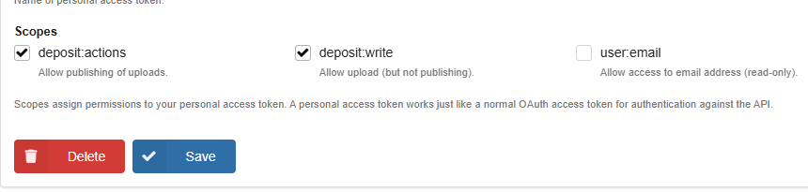

2. Prepare original JSON
- Download or copy metadata of existing record in JSON format

3. Run the program
- Import metadata from file or clipboard

4. Submission or review
Before uploading, you have two options:
- 🚀 CREATE ZENODO RECORD: Sends the metadata to Zenodo.
- 📄 Create TXT (Preview): Generates a payload_preview.txt file where you can see the exact code (JSON) to be sent. Use this to verify that authors are correctly split and grants are mapped properly.

