INTRODUCTION TO MACHINE LEARNING
(NPFL054)
A template for Homework #2

Name: Jiří Klepl
School year: 2019/2019

- Provide answers for the exercises.
- For each exercise, your answer cannot exceed one sheet of paper.

1.1 Multiple linear regression

We can see that some p values are significantly below alpha (5 %) so we can reject the null hypothesis.
Furthermore from the p values we can assume the most significant dependencies are origin, year and weight (all being 3-star) and then displacement which is 2-star. The rest isn’t really that significant. The least contributing factor is acceleration.

1.2 Polynomial regression

We chose the worst parameter as we can tell by the seemingly random distribution of the value pairs of acceleration and mpg and so the approximations given by polynomial regression are kinda terrible which we can confirm by r^2 values which are really low (0 meaning no correlation and 1 meaning total correlation).
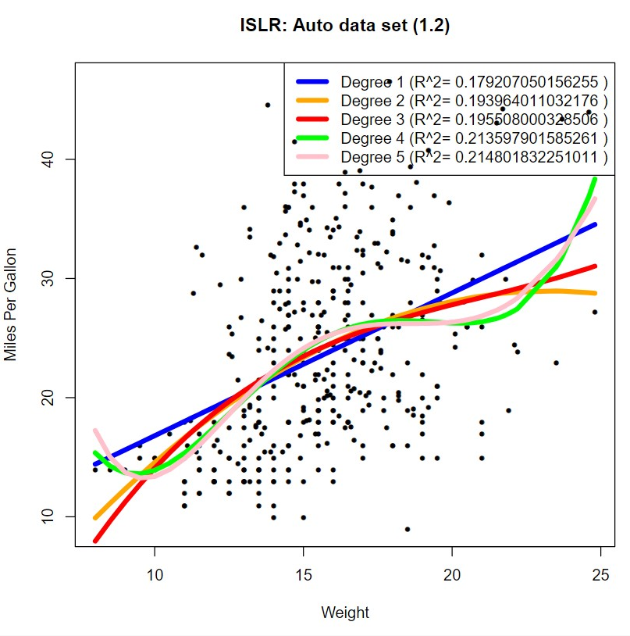
2.1 Binary attribute mpg01 and its entropy

The resulting entropy 1 was expected as median is defined as the value of the middle element and entropy 1 is given by uniform distribution with two possible values.
2.3 Trivial classifier accuracy

Accuracy (2.3): 0.551282051282051

It was expected to be somewhere around 0.5 as the trivial classifier gives trivial predictions.
2.4 Logistic regression – training and test error rate, confusion matrix, Sensitivity, Specificity, interpretation

This time the p values are somewhat different and the most significant parameter seems to be year, second being weight and all others don’t correlate with mpg that much.

2.5 Logistic regression – threshold 0.1 and 0.9, confusion matrix, Precision, Recall, F1-measure, interpretation

2.5 results:
Testing with treshold: 0.1
Training error rate (2.4a): 0.0923566878980892
Testing error rate (2.4b): 0.192307692307692
Testing sensitivity (2.4b): 0.7
Testing specificity (2.4b): 1
Testing precision (2.5a): 1
Testing recall (2.5a): 0.7
Testing F1-measure (2.5a): 0.823529411764706

Testing with treshold: 0.9
Training error rate (2.4a): 0.0859872611464968
Testing error rate (2.4b): 0.141025641025641
Testing sensitivity (2.4b): 1
Testing specificity (2.4b): 0.796296296296296
Testing precision (2.5a): 0.685714285714286
Testing recall (2.5a): 1
Testing F1-measure (2.5a): 0.813559322033898
2.6 Decision tree algorithm – training and test error rate, cp parameter

Best cp is 0 as we can see in the script, all other cps give terrible trees

