|  |
| --- |
| Module 11 – Apache Spark Streaming |
| In-Class Demo |

|  |
| --- |
|  |



© Brain4ce Education Solutions Pvt. Ltd.

### **Step 1:** Create a developer account of Twitter and then create a new app inside it. Once you do this use the credentials for your project.

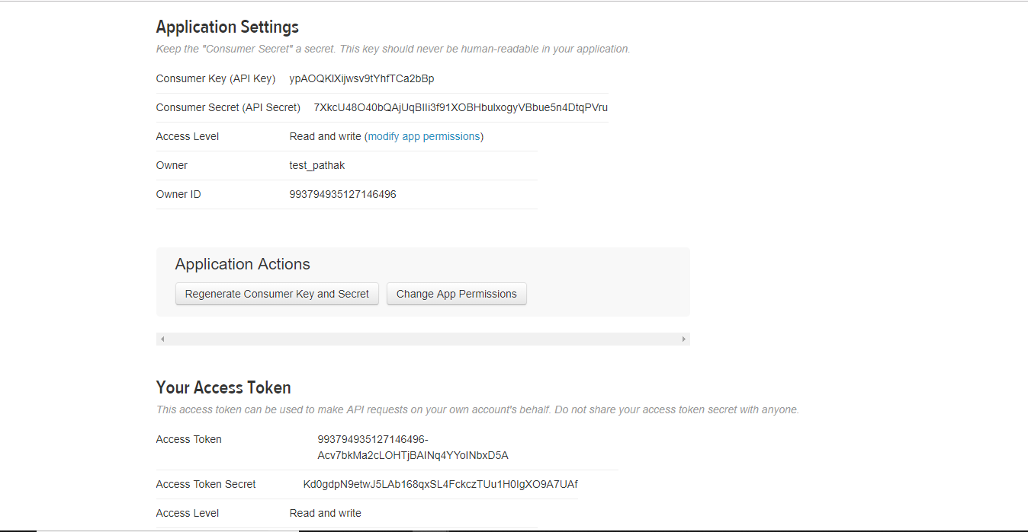

### **Step 2:** Copy these credentials inside twitter_config.py file and save on your ftp. The file has been uploaded on LMS.

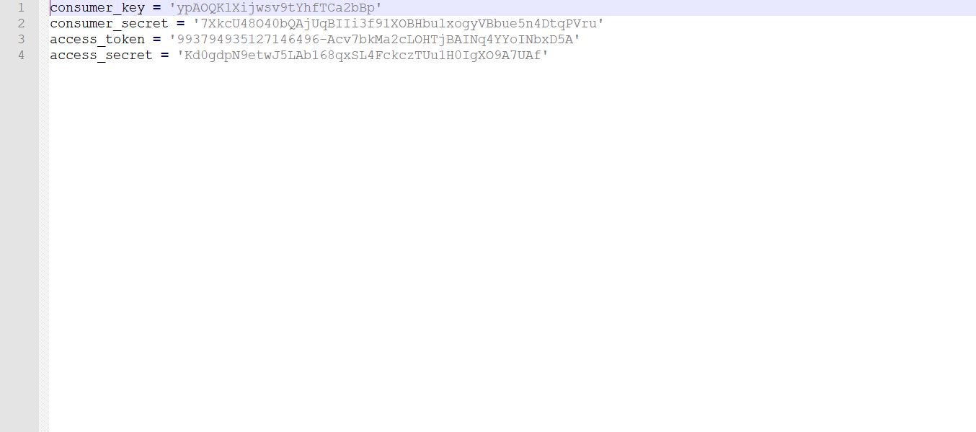

### **Step 3:** Create a tweet_listener.py file and upload the same on ftp. The file has been uploaded on LMS.

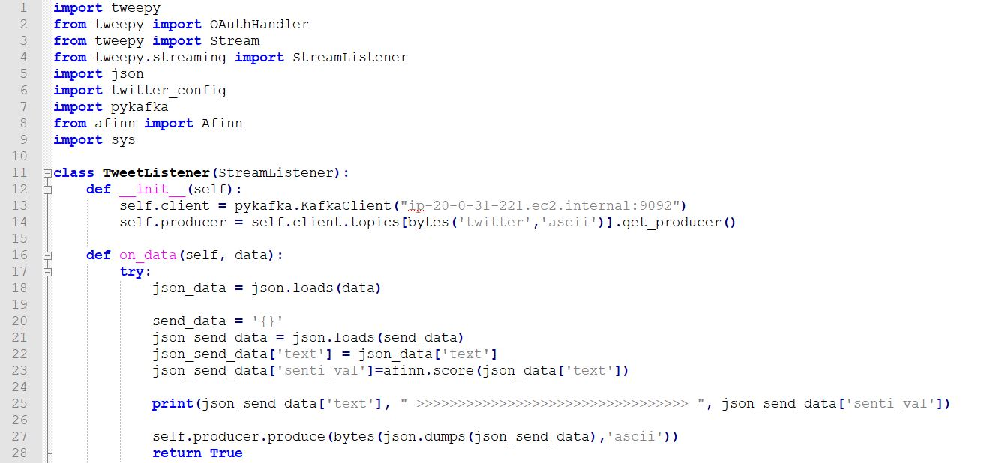

Enter the host name of active kafka client. You can find the same from Cloudera manager.

### **Step 4:** Create a tweet_analyzer.py file and upload the same on ftp. The file has been uploaded on LMS.

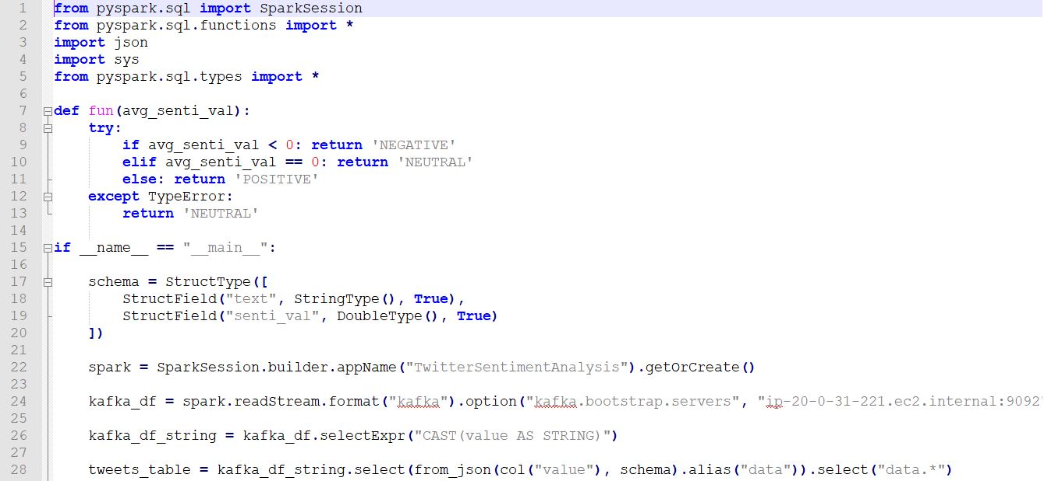

Enter the host name of active kafka client. You can find the same from Cloudera manager.

### **Step 5:** Run the command ***export PATH=/usr/local/anaconda/python3/bin/:$PATH*** on the web console.

### 

### **Step 6:** Run the command ***spark2-submit PATH_OF_FILE/tweet_listener.py “Name of keyword”*** on the web console. Here *Games* is the keyword. As soon as you run the command you can see the tweets on console.

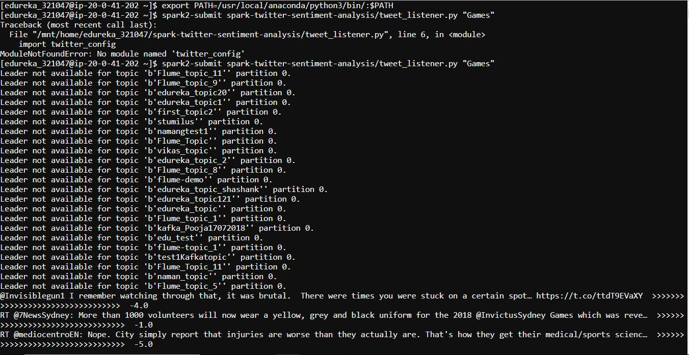

### **Step 7:** Run the command ***export SPARK_KAFKA_VERSION=0.10*** on the web console.

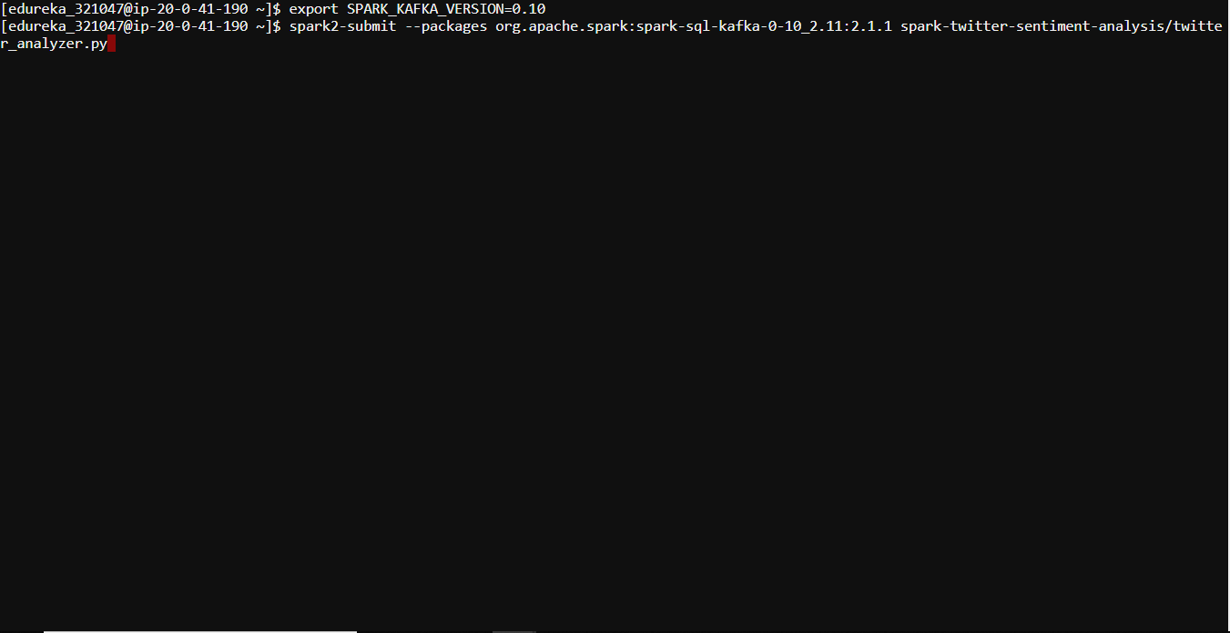

**Step 8:** Run the command ***spark2-submit --packages org.apache.spark:spark-sql-kafka-0-10_2.11:2.1.1 PATH_OF_FILE/tweet_analyzer.py*** on the web console



**Step 9:** As soon as you run the command you will be able to see the twitter json output stream along with its prediction and sentiment value.

