**Machine Learning Engineer Nanodegree**

**Capstone Project**

Jiri Manak  
August 15th, 2017

**I. Definition**

**Project Overview**

A purchase of a house is usually one of the largest investments in life of most people. For proper personal finance planning a knowledge of property prices is the first step towards this goal.

The price of a house is determined by a number of features. The number of square meters, number of rooms and house location are the common attributes. Anyhow, the price of the house can be influenced by some specific features. For a buyer, it would be interesting to know not only an average price of the property with required attributes, but also which features influence the price most. Comparing the features which have the strongest impact on the price with the personal preferences allows the buyer to make a tradeoff between the dream house and their budget.

**Problem Statement**

We have a collection of data about houses which have already been sold. Based on this data, can we predict how much my dream house will cost? Or a property owner may ask: „How much is my house worth? “

This problem can be solved by a predictive regression model which will be able to predict the price of an unsold house. The task is to create such a model.

Possible techniques can be decision tree models, linear regression and neural networks.

The second goal is to create a list of the features sorted by their importance to influence the price of the house.

The third goal is to compare results from different regression models.

**Datasets and Inputs**

Collecting data from the usual sources such as web portals, advertisements and real estate agencies offerings will be an enormous task. Therefore, for the purpose of this project I will use data publicly available on Kaggle: House Prices: Advanced Regression Techniques.

https://www.kaggle.com/c/house-prices-advanced-regression-techniques

This collection consists of 1462 data points for training and 1461 data points for testing. Data points for testing are delivered without labels and are supposed to be submitted to the Kaggle for a competition with other data analysts.

**Metrics**

To stay compatible with Kaggle metrics I will evaluate the model on RMSE.

* **Root-Mean-Squared-Error (RMSE)** - the logarithm of the predicted value and the logarithm of the observed sales price.

$$RMSD=\sqrt{\frac{\sum_{i=1}^{n}{{( \ln\left({\hat{y}}_{i})-{ln⁡(y}_{i}\right) )}^{2}}}{n}}$$

where ${\hat{y}}_{i}$ is predicted value of observation *i* of regression dependable variable $y_{i}$ computed for $n$ different predictions

For evaluation and comparison of different models I will also use

* **R^2 score – coefficient of determination –** which isa proportion of the variance in the dependent variable that is predictable from the independent variable. An R2 of 0 means that the dependent variable cannot be predicted from the independent variable. An R2 of 1 means the dependent variable can be predicted without error from the independent variable.

$R^{2}=1- \frac{{SS}_{E}}{{SS}_{T}}$ ${SS}_{E }= \sum_{i}{{{(y}_{i}- {\hat{y}}_{i})}^{2} }$ ${SS}_{T }= \sum_{i}{{{(y}_{i}- \overline{y})}^{2} }$

where ${\hat{y}}_{i}$ is predicted value of observation *i* of regression dependable variable $y_{i}$ computed  
for $n$ different predictions

<https://en.wikipedia.org/wiki/Coefficient_of_determination>

<http://stattrek.com/statistics/dictionary.aspx?definition=coefficient_of_determination>

The disadvantage of the metric based on ‘mean error’ is that the score also depends on the absolute size of predicted values. For example, if I recalculate the house prices from US dollars to Japanese yen – which is approximately 1:109 and therefore the house prices in yen will be nominally more than hundred times higher, it will also return larger mean error score for the same model.

Advantage of R2 score is that the value is always between 0 and 1, therefore it always delivers consistent view how good is the model, which is independent from the absolute value of the predicted variable. R2 score delivers the same results, also if values in data set were transformed (scaled, unskewed) without the need of inverse transformation. This is the reason why I also use R2 score metrics in model evaluation.

**II. Analysis**

**Data Exploration**

#### Features

There are almost 80 features for each record which describe each house from more aspects. Description of the features is delivered with the data in separate file. Partial information are visible on following web page:

https://www.kaggle.com/c/house-prices-advanced-regression-techniques/data

#### Sale Price

‘SalePrice’ as a sale price of the house is the target variable. I will finde and train a model which will be able to predict this value based on specified features.

The basic statistics of the sale price:

*Maximum price: $755,000.00*

*Minimum price: $34,900.00*

*Mean price: $180,921.20*

*Median price $163,000.00*

*Standard deviation of prices: $79,415.29*

The distribution of ‘SalePrice’ deviates from normal distribution, it shows skewness to the left (towards lower prices) which is not a surprise, because maximal price of a house has no limits, but something like ‘smallest’ usable house does exist.

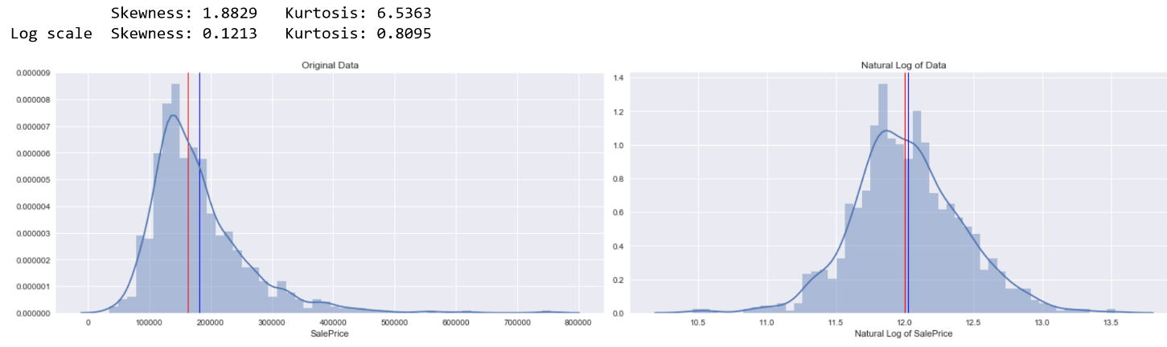

#### Categorical and Continuous values

Simple request on data type stated, that thera are 27 features which are numerical and 43 are categorical.

The features describing measurable attributes as for example square footage are described by continues values, or it can hold number specifying of a number of objects.

Typical continues variable features are for example:

* GrLivArea – Above grade (ground) living area square feet
* LotArea: Lot size in square feet
* BsmtFinSF1: Type 1 finished square feet
* TotalBsmtSF: Total square feet of basement area
* PoolArea: Pool area in square feet
* Fireplaces: Number of fireplaces

There is also a number of categorical values which can hold one value from specified set of values.

Typical categorical varibales are Overal Quality

* KitchenQual: Kitchen quality
* FireplaceQu: Fireplace quality
* Functional: Home functionality rating

#### Missing Data

Exploring the data by looking for missing values shows that there is a quite a large number of missing data. Anyhow, in data description it is stated, that values are usually missing if the object doesn’t exist. For example, a pool. If property has a pool, then feature ‘PoolSF’(pool square footage) is filled out with a number of pools area in square feet. In case there is no pool, then the feature value isn’t filled out. In this case I can simply replace missing value by zero. For categorical features I can use value *‘None’*.

There are really only few features in dataset with missing values. These values were replaced by the most frequent values for particular feature in the dataset.

#### Outliers

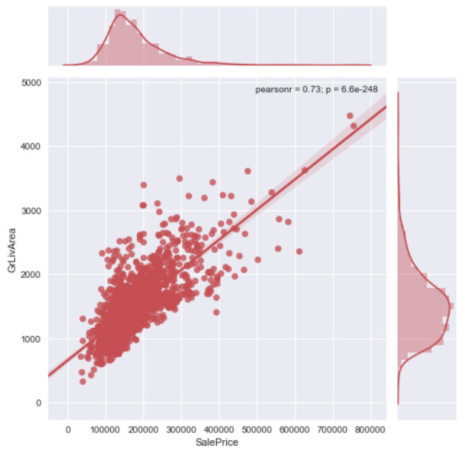There are more possible ways how to identify outliers. Removing them might by risky because it can influence the model in negative way. Therefore, I will take a conservative approach. Correlation graph of ‘GrLiveArea’ with respect to ‘SalePrice’ shows two data points in upper left corner indicating large living area with unusual low price. I have identified these data points as outliers.

Figure 1. Without outliers

Figure 2. With outliers

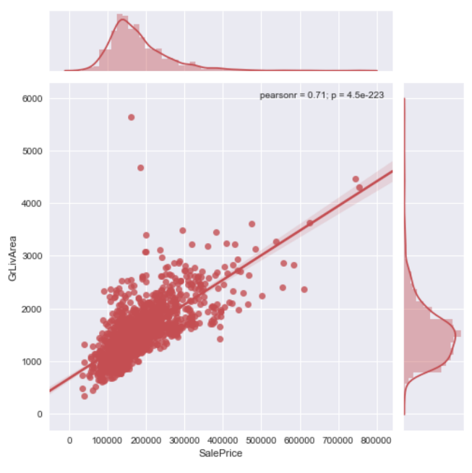

**Exploratory Visualization**

Basic data investigation shows features correlation with respect to SalePrice. Graph shows that there is a number of features which correlates with SalePrice.

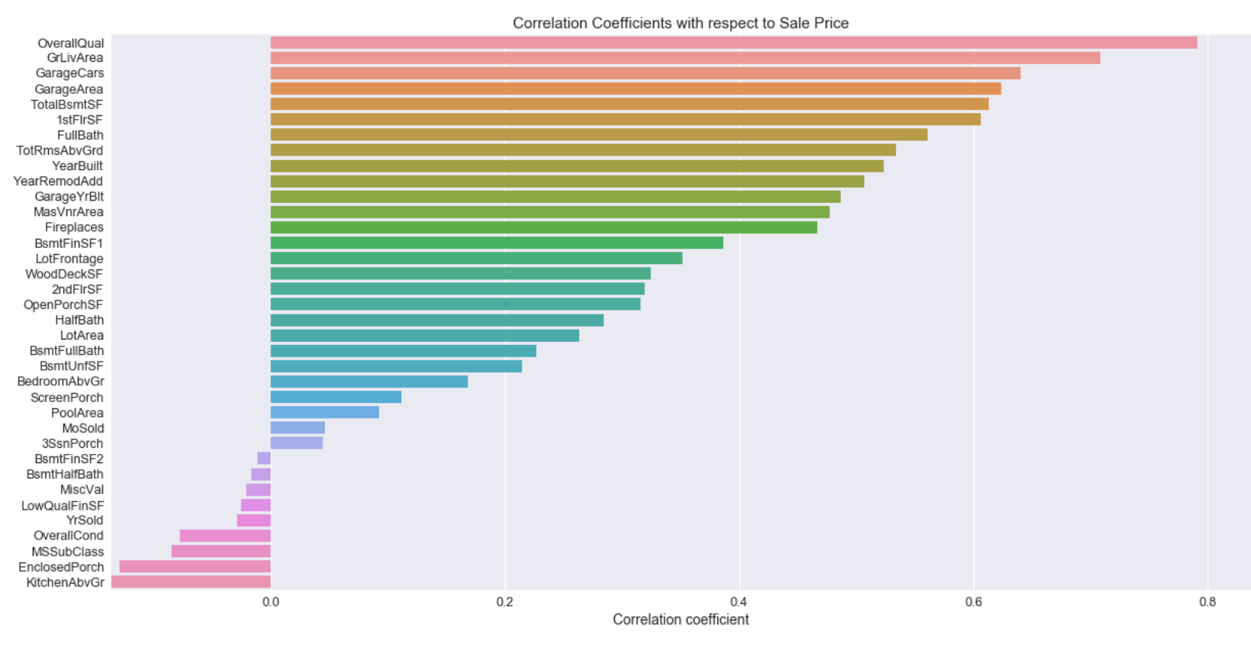

Top 5 features

* OverallQual Overall material and finish quality
* GrLivArea: Above grade (ground) living area square feet
* GarageCars: Size of garage in car capacity
* GarageArea: Size of garage in square feet
* TotalBsmtSF: Total square feet of basement area

Overall quality is a categorical value. Next four features describing a size of a property part. This is an evidence that size of house usually has the highest influence on the price.

Next chart shows correlation heatmap. Investigation shows that high correlated features usually describe the same thing. As for example ‘GarageArea’ and ‘GarageCars’.

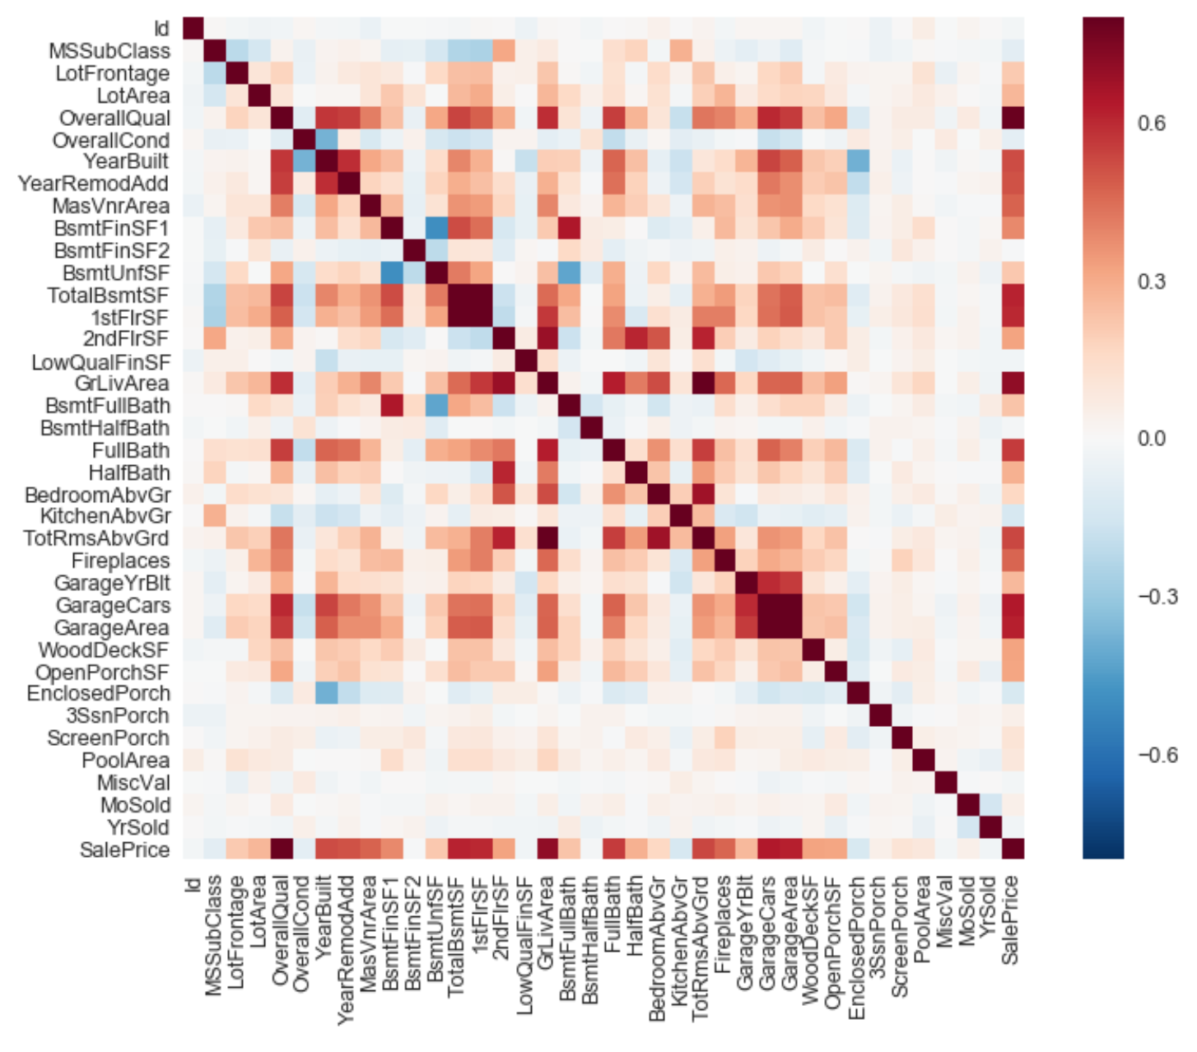

**Algorithms and Techniques**

For this project I chose three ensemble models based on decision tree regression techniques.

To describe how decision tree model works I will reuse my explanation from the project ‘CharityML’ were the goal was to identify possible donors:

*Decision Tree model mirrors human decision making very closely. In this case we can imagine the learner is asking data questions about the donors with their income over 50K similar to this:*

*Q1: Do they have family? Model remembers the answer yes or no*

*Q2: Do they have positive capital gain?*

*Q3: Do they have the bachelor education level?*

*Learner can also ask question like this:*

*Q4: If they don't have family is their work class 'self-employed'?*

*Q5: If they don't have family and their work class is 'self-employed' is their education level 'HS-grad'?*

*By asking questions this way we create a tree of questions. We can create different trees which have different sequence of questions asked. We are looking for the best tree which delivers best predictions on our training and test data. During the training, we can decide maximum depth of the tree.*

*Gradient Boosting works this way: To create a complex questionnaire which is should help to decide if person has income over 50K is huge effort for one guy. Therefore, we engage number of other guys. Each of them will get only subset of data. We also restrict guys to create limited number of questions. For example, only 8. To be fair, we put all the records (aka data points) in a hat. First guy will draw his subset randomly from the hat. He will note down the data from these records and put them back into the hat. Based on the data he has, he creates his own questionnaire. This questionnaire will be tested on all records in the hat. Records which were false predicted will be multiplied in the hat. The size of the multiplication will determine the learning rate. The reason for multiplication is, that we want the next guy to have bigger chance to draw records from the hat, where previous guy was unsuccessful. To give him a chance to make questionnaire which can evaluate the data better. The same way we will continue with third guy, with forth guy and so on. We will evaluate the prediction success of each guy. We will stop adding new guys if the average prediction success will stop growing. We can also trust more to the guys which individual predictions are more successful than of the others. Predictions of these guys will be taken more into account before the final result of the group will be delivered.*

Decision Tree technique builds models in the form of a tree structure. It breaks down a dataset into smaller and smaller subsets. The model creates for this subset trees. These small trees we call **weak learners** because the can ‘answer’ only simple questions and their overall prediction success isn’t great. Ensemble models using the collective power of large number of the week learners, which together can make more accurate predictions.

Strengths of decision trees are:

* they are easy to interpret
* are able to handle both numerical and categorical data
* performs well even if its assumptions are somewhat violated by the true model from which the data were generated.

and the weaknesses:

* prone to overfitting
* small changes in the dataset can lead to different trees

**Random Forest** **Regressor** is an ensemble classifier made using many decision tree models. Creates multiple trees with randomly selected data.

**Gradient Boosting Regressor** takes many week learners and combine results of them.

**XGBoost Regressor** is an optimized implementation of Gradient Boosting technique. More details are to be found at <https://github.com/dmlc/xgboost>

**Support Vector Machine** supervised learning algorithm is mostly used in classification problems but it also works for regression. This algorithm takes values of feature as points in n-dimensional space (where n is number of features) and tries to find hyper-planes which separate the points best. If the data points are not linearly separable, SVM can use technique called the kernel trick which is able to solve non-linear problem.

**Neural Networks**

Neural network is good candidate for the problem solution. It will follow the idea that price of the house is influenced by the features. Some features have large influence on the price some are weaker. Some features have positive influence on the price some negative. This may work like weights in neural network. The architecture will be simple: number of input neurons equal to the number of features, next layer with 100 neurons and output layer with one neuron.

I have in plan to use 5 different algorithms to create a model which is able to predict price of a house.

The selection of these algorithms was based on the requirements:

* target variable (house price) is continues variable and the algorithm must be able to solve the regression problem
* must work well with relative small data set and larger number of features
* must accept continues features as also as categorical features
* proved implementation of algorithms are freely available

Anyhow there are other possible techniques. May be one worth to mention is:

**Logistic Regression**

Strengths:

* Agnostic to correlations
* Fast and works well with small number of features
* Provides class probability

Weaknesses:

* Presumes a linear relationship between the features and the log-odds of the response
* Does not perform well with many features
* No more than two classes
* non-linear class separations are not well handled

**Benchmark**

The property price strongly correlates with square footage, the simple model will be linear regression of square footage with respect to sale price.

Prediction of linear regression of ‘SalePrice’ with respect to ‘GrLivArea’ (above ground living area square feet) deliver following results:

RMSE : 56034.3039

RMSE of logarithms : 0.2756

R2 score : 0.502149

Summing square footage of overall basement area with first and second floor creates new feature ‚TotalSF‘. ‘TotalSF’ is a sum of basement, 1st floor, and 2nd floor square footage.

Prediction of linear regression of ‘SalePrice’ with respect to ‘TotalSF‘ deliver even better results:

RMSE : 49471.9159

RMSE of logarithms : 0.2406

R2 score : 0.611931

**III. Methodology**

**Data Preprocessing**

#### Basic preprocessing

Data from Kaggle’s come in two sets. One part are data to be used for training and the second part are the test data to be used for prediction and is to be submitted to Kaggle competition.

Both sets consist of ‘Id’ column, which is only sequence number and doesn’t hold any information about the house.

Basic preprocessing will include

* separation of ‘SalePrice’
* dropping of the ‘Id’ column
* joining of the training and testing sets together

#### Missing Data

Missing data will be proceed following way:

* numeric data – if missing, imputed by zero
* categorical data – if missing, imputed by ‘None’
* features 'Electrical', 'Functional', 'KitchenQual', 'MSZoning', 'Exterior1st', 'Exterior2nd' and 'SaleType' were imputed by most frequent values in the data set

#### Removing Outliers

I will use simple rule for an elimination of outliers

'GrLivArea' > 4000 SF

and

'SalePrice' <300000

#### Processing categorical data

It will be necessary to transform categorical values to numbers. I will use label encoders and one hot encoding.

#### Dealing with skewness

Investigating of data shows number of features with skewed distribution.

**Implementation**

For the implementation, I used jupyter notebooks. Notebooks are excellent in mixing text-code-graph but (at current version) are not very practical if the document grew large and solution is not only sequential. Therefore, I created more notebooks:

**data_analysis.ipynb**   
primary for data analysis

**model_tuning.ipynb**  
preprocessing routines and tuning of decision trees based models – Random Forest Regression, Gradient Boost Regression and XGBoost.

**svm_regression.ipynb**tuning the Support Vector Machine Regression model (SVR)

**keras_regression.ipynb**tuning the Neural Network Regression model using Keras

My goal was to create procedures for data preprocessing which I can freely ‘turn off and on’ without the need to change a code. Disadvantage of these notebooks is, that I need to run all the fields with the code which is necessary to proceed. Moving some procedures into separate .py files solved this.

Data are processed and model is created in Python 2.7 programming language using libraries

* pandas - data analysis toolkit v0.20.3
* scikit learn – machine learning library in Python
* matplotlib
* seaborn
* XGBoost Library

Python 3.6 and Keras for Neural Network regression

Some procedures are implemented in separate files

* usefull_methods.py
* do_actions.py
* stopwatch.py

**Implementation of data preprocessing**

The data preprocessing required to do a number of steps in defined sequence. The necessity to join the training and testing set created a complication in the preprocessing sequence. The data transformation as label encoding, one hot encoding and also scaling must be done together, but outliers can be removed only from the training set.

Finally, I have coded a section called ‘Model’ where the whole preprocessing is implemented. The code allows by setting variables to true and false simply include or exclude some steps in preprocessing sequence.

list of possible preprocessing steps:

* drop_columns - reducing number of features
* do_dummies – one hot enconding (after label enconding)
* unskew_data – apply boxcox1p function to the data
* do_scaling - standardize features by removing the mean and scaling to unit variance

Implementation also consist of procedures for the inverse transformation which are necessary for calculation of RMSE and house prices.

There were no other complicated or custom preprocessing procedures implemented.

**Implementation of SVR Model**

SVR uses RBF kernel to find or non-linear dependencies. Data preprocessing used following procedures:

* eliminating outliers – deletion of data points with very untypical values
* label encoding – transformation of categorical data into numerical values
* unskewing – transforming features with skewed distribution using *boxcox1p* algorithm
* scaling – transforming values that the set will have mean value equal to zero

**Implementation of Neural Network Model**

Neural Network is implemented as a multilayer neural network with 297 inputs. The number of inputs is based on the number of features. There are one or two hidden layers and finally one output layer as one neuron output. Data preprocessing used following procedures:

* eliminating outliers – deletion of data points with very untypical values
* label encoding – transformation of categorical data into numerical values
* unskewing – transforming features with skewed distribution using *boxcox1p* algorithm
* scaling – transforming values that the set will have mean value equal to zero

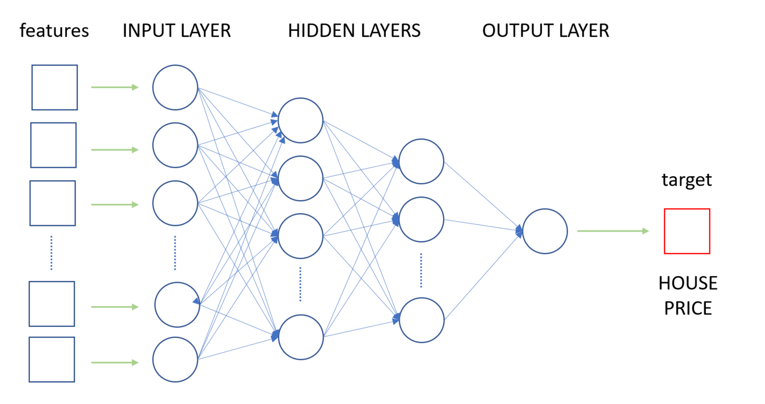

Figure 3: Architecture of Neural Network

The model was coded in Keras using standard Sequential() model with adding layers. Data preprocessing and postprocessing used the same implementation as other models in this project.

**Refinement of Decision Trees Models**

I used two techniques how to tune the model. I will implement each preprocessing procedure in separate function, that I can simply include or exclude it in data preprocessing. I will observe which combination of preprocessing steps deliver best results. The possible actions which can be turned on and of:

* elimination of outliers
* eliminate skew
* remove non-significant features

Second technique is tuning hyperparameters for chosen regressors. I will use grid search technique to tune *max_depth* and *n_estimators*.

*max_depth* is maximal depth of decision tree  
*n_estimators* is number of estimators used by the ensemble regressor

Looking for best hyperparameters also with GridSearch is time consuming process. Therefore I proceed this action in three basic steps.

* for *max_depth* define 5 values from the range of 2 to 100
* for *n_estimators* define 5 values from the range of 100 to 3000
* run GridSearch
* evaluate results and create new ranges of 5 values for the next run

new ranges

* + extend the range toward smallest or largest value if the first or the last value has been reached
  + try to precise parameters if best parameter is within the range
* run GridSearch with new ranges
* repeat this till best parameters found

A visualization of the performance with different settings help me also to learn in which direction to move

Excerpt from the code showing parameter ranges for the last GridSearch run. Bold values are values with the best performance.

RandomForestRegressor   
param_grid = {'max_depth': [ 20, **25**, 30, 32 ], 'n_estimators':[375, 400, **500**, 600, 700 ]}

GradientBoostingRegressor  
param_grid = {'max_depth': [ **2**, 5, 25, 30 ], 'n_estimators':[ 800, 900, 1000, 1100, 1200 ]}

XGBRegressor  
param_grid = {'max_depth': [ **2**, 3, 4], 'n_estimators':[ 1200, 1400, 1600, **1800**, 2000 ]}

The best performance the model without data transformation.

**Refinement of SVR Model**

GridSearch technique was used to find best values for ‘C’ and ‘gamma’ parameters.

param_grid={ "C": [1e0, 1e1, 1e2, 1e3], "gamma": np.logspace(-2, 2, 5) }

best values: {'C': 10.0, 'gamma': 0.01}

**Refinement of Neural Network**

Neural network model was done by

* changing the number of hidden layers
* changing the number of neurons in hidden layers

Basically, there were no special strategy how to tune model. I tried to change something and waited for a result. The first attempt with one hidden layer with 100 neurons already reached a comparable result (r2 ~ 0.90). The second attempt with two hidden layers (100 and 50) neurons resulted with better score, but not very significant. Last attempt with three hidden layers (297, 100, 50) ended with r2 score ~ 0.914.

The model was trained with 100 epochs. It took around 1 hour minutes to train the model on the AWS E2C p2.xlarge/ udacity-aind2 instance with Keras running on the top of Theano.

**IV. Results**

Tuning model by changing actions and searching for best hyperparameters delivered slightly different results. Best results delivered a combination of:

* elimination of outliers ON
* eliminate skew OFF
* remove non-significant features OFF (all features active)

**Best results on training data**

XGBoost

RMSE : 21546.7702

RMSE of logarithms : 0.1181

R2 score : 0.926484

Gradient Boost

RMSE : 22004.9835

RMSE of logarithms : 0.1224

R2 score : 0.923324

Random Forest

RMSE : 25372.8165

RMSE of logarithms : 0.1352

R2 score : 0.898058

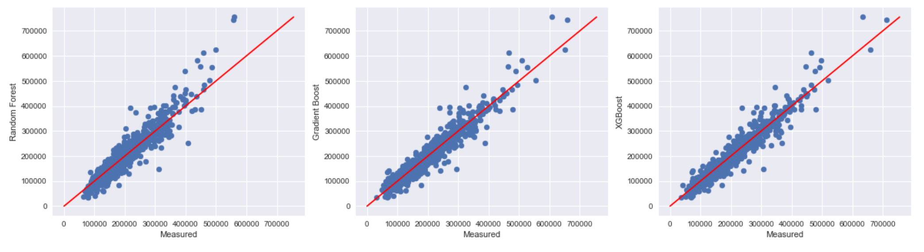

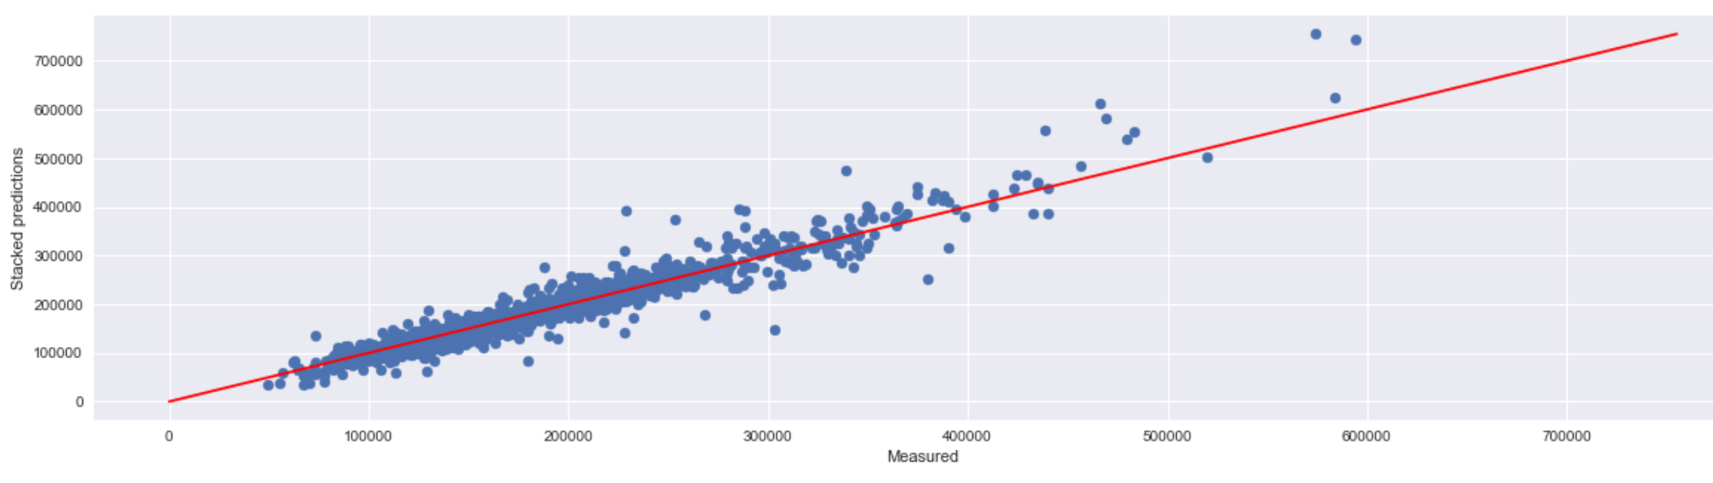

Weights calculation for stacked regressions is calculated as relation of particular r2 score to sum of all r2 scores.

sum_r2 = xgb_r2 + gbr_r2 + rfr_r2

xgb_w = xgb_r2/sum_r2

gbr_w = gbr_r2/sum_r2

rfr_w = rfr_r2/sum_r2

**Best results on Kaggle test data**

Result of stacked regressions gives better result in Kaggle competition: RMSE

* 0.06629 this best result so far on Kaggle (valid August 12th 2017)
* 0.10567 2nd best result on Kaggle
* ….
* ….
* **0.12723** my best result which I was not able reproduce later
* **0.12900** my result for stacked Decision Tree regressions
* **0.13289** for XGBoost, the best individual model

**Comparison of the performance**

Finally, some words regarding the results of the different models:

On the performance of both the linear regression models it can be seen that square footage of living area strongly correlates with the price. But this is not enough.

Models based on decision trees were strong candidates for the best performance and didn’t disappoint. XGBoost beat all other models. It is interesting that stacked decision tree model created the best result in the Kaggle competition, better than XGBoost alone. It looks like XGBoost is overfitting a bit.

The result of Support vector regression shows that this model isn’t good for this kind of problem. The performance wasn’t far away from simple linear regression.

Neural Network didn’t achieve the best performance, but this model is definitely the strongest competitor. This model landed between decision tree models already on the first attempt. I believe further tuning will bring it to the top. I would like to discuss which direction to go in with an expert, because a ‘try & find’ method is a very time and money consuming process.

|  |  |  |  |
| --- | --- | --- | --- |
| **Model** | **RMSE** | **RMSE log** | **R2 score** |
| Linear Regression SalePrice/GrLivArea | 56034.3039 | 0.2756 | 0.502149 |
| Linear Regression SalePrice/TotalSF | 49471.9159 | 0.2406 | 0.611931 |
| Random Forest Regression | 25899.3463 | 0.1325 | 0.893783 |
| Gradient Boost Regression | 22624.9584 | 0.1199 | 0.918942 |
| XGBoost Regression | 21935.7116 | 0.1144 | 0.923806 |
| Stacked RFR/GBR/XGB | 22240.0829 | 0.1153 | 0.921677 |
| SupportVectorMachine Regression | 46093.9603 | 0.2018 | 0.663561 |
| Neural Network Keras | 23296.8237 | 0.1239 | 0.914057 |

**Robustness**

Robustness is a metric which evaluates the model from the perspective of prediction stability if some changes in dataset occur. To test robustness I randomly selected 80% of data points of the training set to train the model. I chose one row from the test set which represents the features of the house I want to predict the price for. For the next round, I selected another 80% of the training set to train the model and predicted the price again. I repeated the prediction 100 times. It is expected, if the model is stable, that the prediction will be equal in the best case. Here is the result of the winning stacked decision tree models:

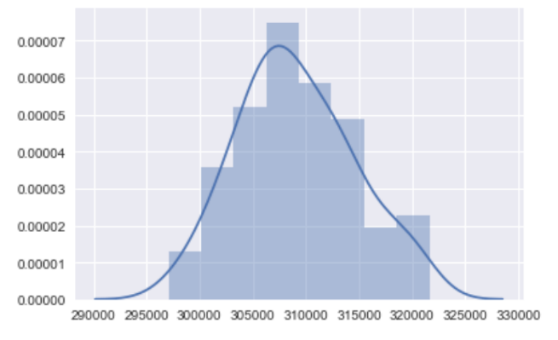Statistics:

count 100.000000

mean 309091.106541

std 5453.008362

min 297072.573801

25% 305339.227960

50% 308121.698208

75% 313013.769929

max 321611.550310

It shows that the standard deviation of the predicted prices is around 1.7 % which is good enough to use this model in practice.

**V. Conclusion**

Estimating the price of a house is a chancy task. The price of a house is a result of a negotiation between buyer and seller. Usually they both have opposite interests. The seller wants to get the highest price, the buyer wants to pay the lowest possible price. The final price is a result of this deal and it is the number in the contract and the amount of money transferred. And nobody in the universe is able to estimate the final price with 100% accuracy. Neither real estate expert nor a ML model. There are a number of features which are not in the feature list but can influence the price. For example if the seller wants to sell his house quickly, he may be prone to accepting a lower price.

From this perspective, the simple linear regression model also shed more light on the problem defined by a question: “How much does this house cost?”

Because of the uncertainty of all features which may influence the final price we are able to define a curve which real prices will always fluctuate around. I believe in reality the performance of the best model can’t be beaten by any model significantly.

**Free-Form Visualization**

Following visualization shows the differences between predicted values and target values. Basically the predicted values follow the target variable, anyway there are some data points which are quite distant from the target curve. In case we would like to improve the model, I would suggest to investigate these points.

Set is sorted in respect to target values

* red dots: predicted values
* blue dots: target values
* x-axis: position in sorted dataset
* y-axise: price of the house

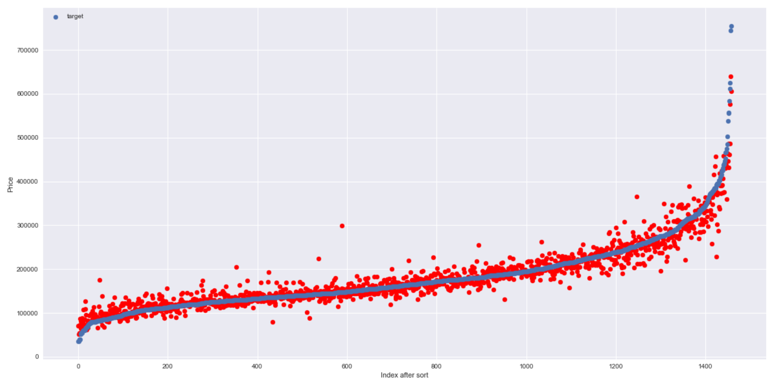

Figure 4: Real vs Predicted of stacked Decision Tree regressions

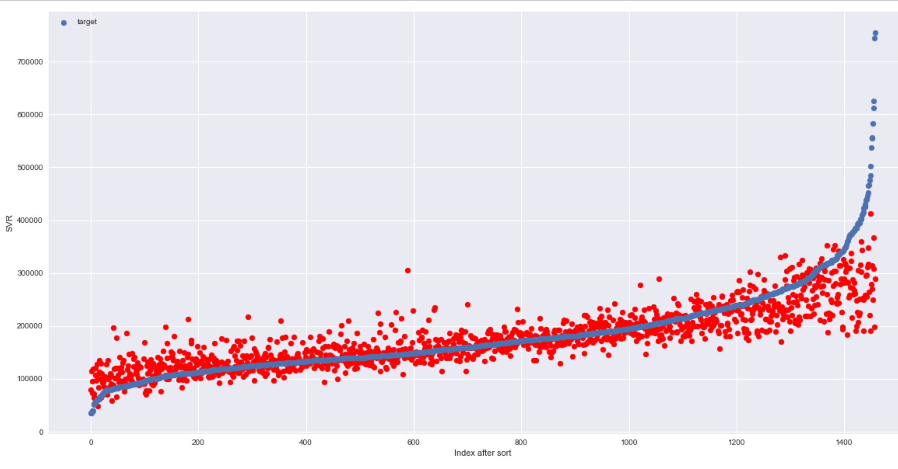

Figure 5: Real vs Predicted of Support Vector regression

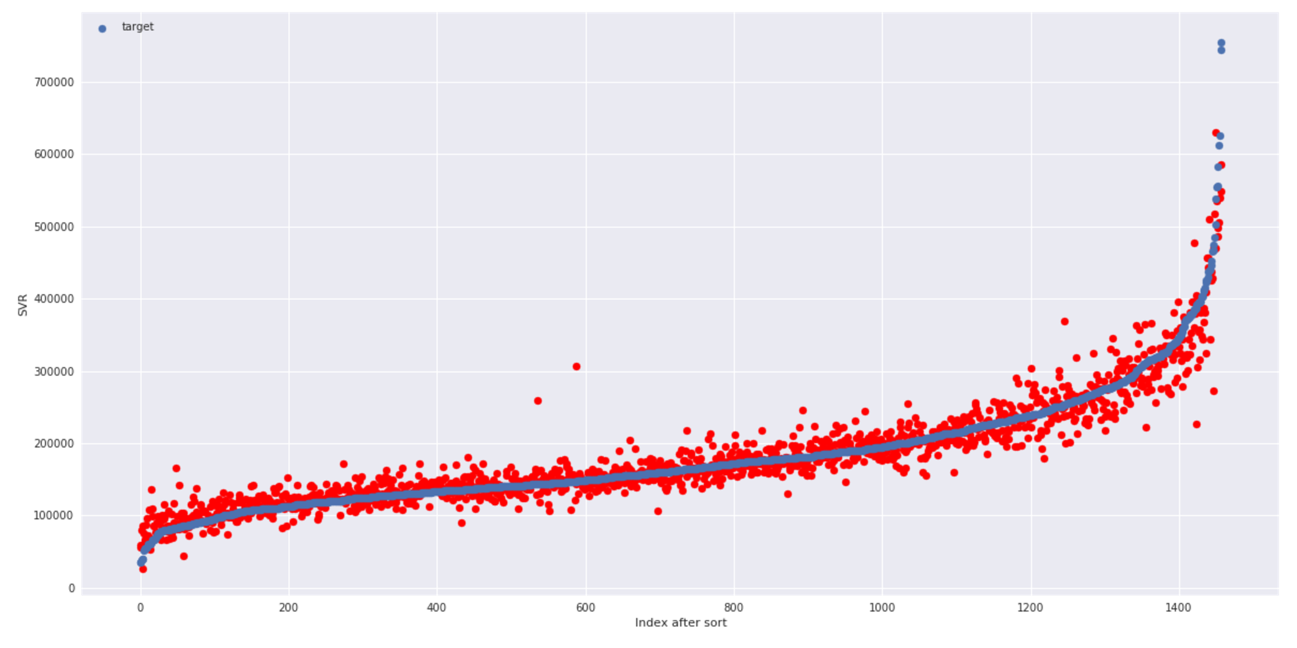

Figure 6: Real vs Predicted of Neural Network Model

**Reflection**

This project uses 5 different techniques to solve the house price prediction problem. The solution starts with data analysis, which is common for all techniques. The next step – data preprocessing – is different for each model. Three decision tree models (Random Forest, Gradient Boost, XGBoost) delivered better results if data weren’t transformed. In opposite the Support Vector Regression and Neural Network required data scaling and the predictions had to be inversely transformed to calculate RMSE properly. Each model has different parameters which were possible to tune and it required an individual approach to each model. At the and I found model which I would recommend to use for practical purpose: stacked Decision Tree regressors. This model has a good tradeoff between results delivered and computational effort.

**Improvement**

There is a number of possible ways how to improve the model. One way is to use other methods of machine learning as for example:

* use other regressors
* tune more or other hyperparameters

There are still open possibilities how to tune current model (based on ensamble decision trees). Some ideas are:

* use another function to unskew data
* precise selection of data to be dropped
* tuning of weights of models stacking
* data transformation – data normalization
* use other numeric data as categorical (yearBuild, yearSold)
* and for NN model – changing layers, number of neurons, activation function, number of epochs, different types of layers …..