August 23, 2010
SPRERS management team (in attention to project coordinator) West University of Timisoara Dept. of Computer Science Bd. V. Parvan 4, 300223 Timisoara, Romania

Application for complete expense coverage
Dear team,
I kindly ask you to cover my expenses bound to the WoSS conference as an part of the SPRERS event. I'm a co-author of a paper called “Web-based Service for Collaborative Organization of Academic Events – Case Study of ”TakePlace”” which was accepted on the WoSS workshop. Thank you in advance.
Yours faithfully,
Jiri Slaby
PhD researcher
Faculty of Informatics, Masaryk University, Brno, Czech Republic
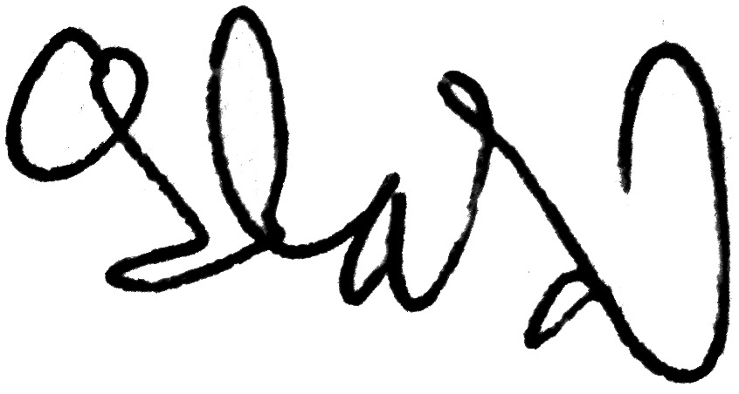

_________________
signature

