MET CS662 - Assignment #3
Joseph Rissman
U0945917
- For $∑=\{a, b\},$ construct deterministic finite automata that accept the sets consisting of
  - All strings with at least one a.
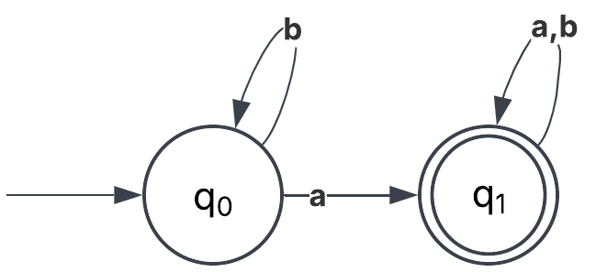
  - All strings with no more than three a’s.
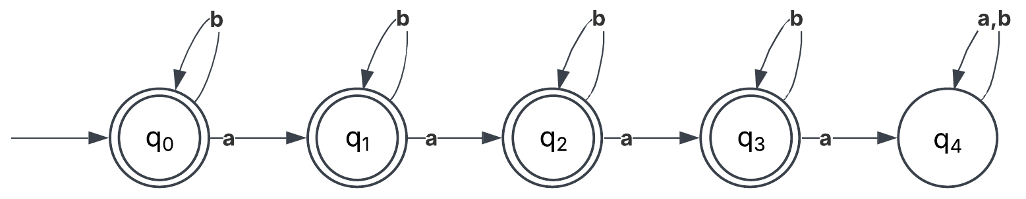
- Give a set notation description of the language accepted by the automaton depicted in the following diagram. Can you think of a simple verbal characterization of the language?
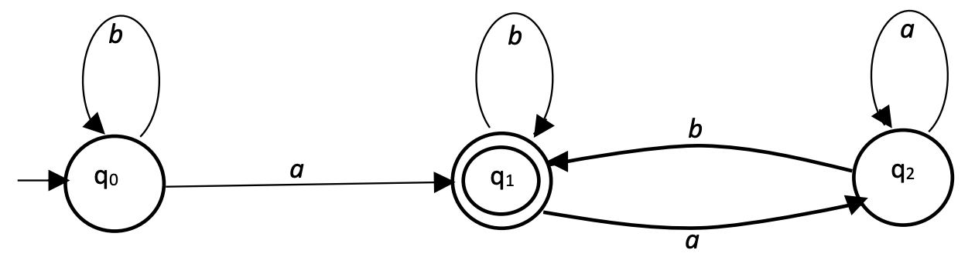
$$L=\left\{b^{n}a | n≥0\right\}∪\left\{wawb | w∈{\left\{a,b\right\}}^{*}\right\}$$
This language contains strings where there is exactly one $a$ if the string ends with $a$ or there is at least one $a$ if the string ends with $b$.
- Find a deterministic finite automaton for the following language on $∑ = \{a, b\}$
$$L=\{ω | (n_{a}(ω)-n_{b}(ω)) mod 3 > 0 \}$$

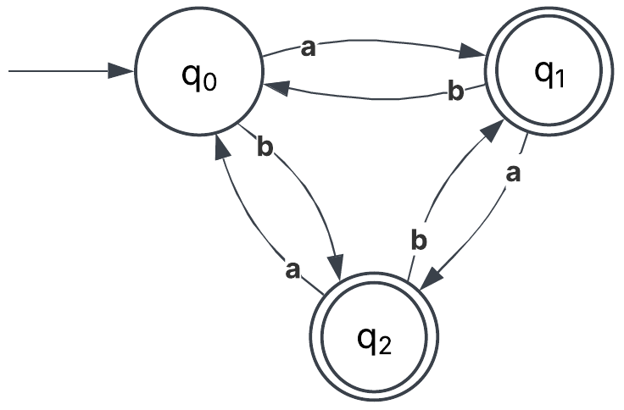

- Consider the number of strings on $\{0, 1\}$ defined by the requirement below. For each construct a dfa.
  - Every 00 is followed by a 1. For example, the strings 101, 0010, 0010011001 are in the language, but 0001 and 00100 are not.
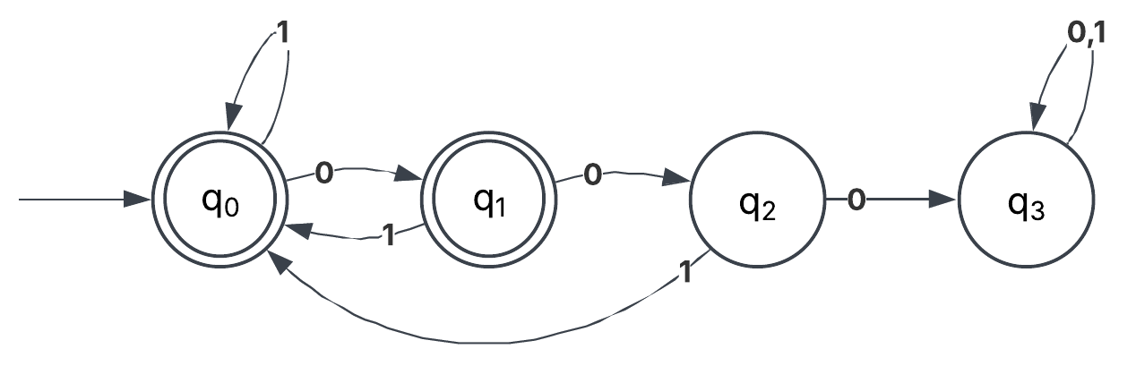
  - The leftmost symbol differs from the rightmost one.
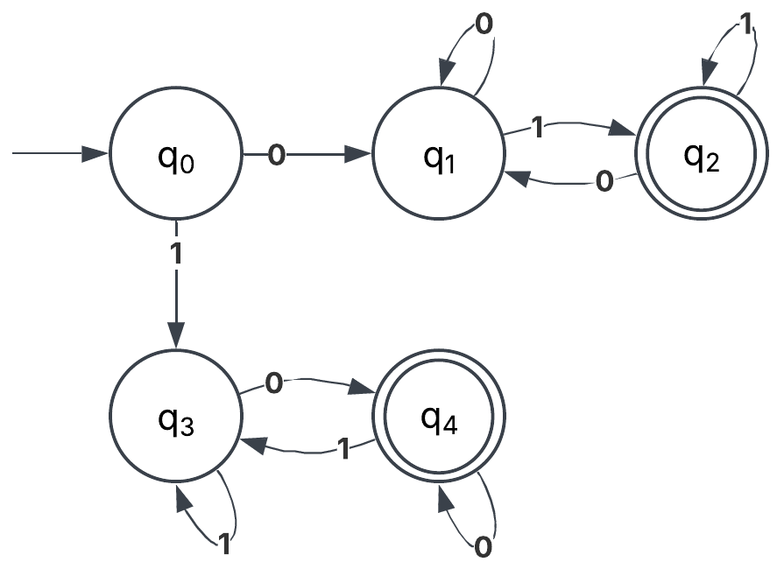
- Construct a dfa that accepts strings on $\{0, 1\}$ if and only if the value of the string, interpreted as a binary representation of an integer, is zero modulo five. For example, 0101 and 1111, representing the integers 5 and 15, respectively, are to be accepted.
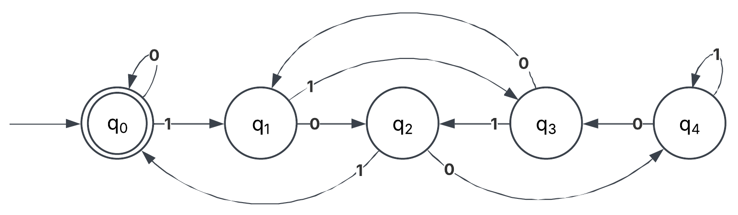

- Show that if $L$ is regular, so is $L-\{λ\}$.
Suppose that an automaton $M$ exists that recognizes $L$. One must exist because $L$ is assumed to be a regular language.
$$M=(Q,Σ,δ,q_{0},F)$$
Where $Q$ is the set of states,$Σ$ is the alphabet$,δ$ is the transition function$,q_{0}$ is the start state, and $F$ is the set of accepting states. Set $L^{'}=L-\left\{λ\right\}$.
If $δ\left(q_{0},λ\right)∉F$, then $λ∉L$. So $L^{'}=L$, and $L$ is regular. Therefore, $L-\{λ\}$ is also regular.
If $δ\left(q_{0},λ\right)∈F$, then $λ∈L$. So $L^{'}≠L$. Construct a new automaton
$$M^{'}=\left(Q',Σ,δ',q_{0}^{'},F\right)$$
where $Q^{'}=Q∪\{q_{0}^{'}\}$ and $δ^{'}=δ∪\left\{{δ^{'}}^{*}\left(q_{0}^{'},w\right)=δ^{*}\left(q_{0},w\right) | ∀w∈Σ^{+}\right\}∪\{δ^{'}\left(q_{0}^{'},λ\right)=q_{0}^{'}\}$. The automaton $A'$ has been constructed so that $δ^{'}\left(q_{0}^{'},w\right)∈F, ∀w∈Σ^{+}$, but $δ^{'}\left(q_{0}^{'},λ\right)∉F$. Therefore, $M'$ recognizes $L'$, which proves that $L-\{λ\}$ is a regular language.
This proof relies upon constructing a modified automaton $M'$, that is the same as $M$ except that there is a new start state $q_{0}^{'}∉F$. The transition function is modified to maintain the original transitions but add in transitions to ensure that $q_{0}^{'}×Σ→Q=q_{0}×Σ→Q$ for any symbol other than $λ$, adding that $q_{0}^{'}×λ→q_{0}^{'}∉F$. Therefore, all the words in $L$ are still recognized by $M'$, except for $λ$.
For the next few questions, design a DFA for the defined languages…
- $L=\{w∈Σ^{*}| w$ does not contain an equal number of occurrences of the substrings 01 and 10$\}$ with $Σ=\{0, 1\}$. Examples of accepted strings: 10, 01, 1010, 1110110, 000011101, etc. notice for example in 1010 there 2 substrings 10 and a single substring 01.

- The set of all strings whose 1st, 3rd, 5th, … characters are the same, $∑=\{a, b\}$. Examples of accepted strings: a, a, aa, ab, aba, bbb, bb, ba, ababab, bbbbbbbbb, bbbabbbab…etc.
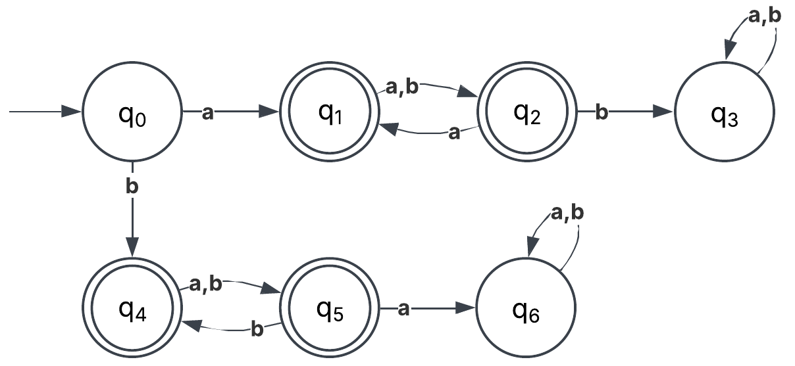
- Set of all strings that are at least of length 4 and contains even number of 1’s.
$∑=\{0, 1\}$. For example: 1010, 11011, 0000, 11100111, …etc.
