Assignment 7
Problem 1.
(1)
L1:
Itemset | 1 | 2 | 4 | 5 | 6 | 7
Count | 3 | 4 | 4 | 4 | 3 | 2

C2:
Itemset | 1,2 | 1,4 | 1,5 | 1,6 | 1,7 | 2,4 | 2,5 | 2,6 | 2,7 | 4,5 | 4,6 | 4,7 | 5,6 | 5,7 | 6,7
Count | 2 | 2 | 2 | 2 | 2 | 3 | 3 | 3 | 1 | 4 | 2 | 2 | 2 | 2 | 1

L2:
Itemset | 1,2 | 1,4 | 1,5 | 1,6 | 1,7 | 2,4 | 2,5 | 2,6 | 4,5 | 4,6 | 4,7 | 5,6 | 5,7
Count | 2 | 2 | 2 | 2 | 2 | 3 | 3 | 3 | 4 | 2 | 2 | 2 | 2

C3:
Itemset | 1,2,4 | 1,2,5 | 1,2,6 | 1,4,5 | 1,4,6 | 1,4,7 | 1,5,6 | 1,5,7 | 2,4,5 | 2,4,6 | 2,5,6 | 4,5,6 | 4,5,7
Count | 1 | 1 | 2 | 2 | 1 | 2 | 1 | 2 | 3 | 2 | 2 | 2 | 2

L3:
Itemset | 1,2,6 | 1,4,5 | 1,4,7 | 1,5,7 | 2,4,5 | 2,4,6 | 2,5,6 | 4,5,6 | 4,5,7
Count | 2 | 2 | 2 | 2 | 3 | 2 | 2 | 2 | 2

C4:
Itemset | 1,4,5,7 | 2,4,5,6
Count | 2 | 2

L4:
Itemset | 1,4,5,7 | 2,4,5,6
Count | 2 | 2

C5 is empty.

(2)
First frequent 4-itemset: {1,4,5,7}
R1: {1,4} → {5,7} conf(R1) = (sup({1,4,5,7})) / sup({1,4}) = 2/2 = 100%
R2: {1,5} → {4,7} conf(R2) = (sup({1,4,5,7})) / sup({1,5}) = 2/2 = 100%
R3: {1,7} → {4,5} conf(R3) = (sup({1,4,5,7})) / sup({1,7}) = 2/2 = 100%
R4: {4,5} → {1,7} conf(R4) = (sup({1,4,5,7})) / sup({4,5}) = 2/4 = 50%
R5: {4,7} → {1,5} conf(R5) = (sup({1,4,5,7})) / sup({4,7}) = 2/2 = 100%
R6: {5,7} → {1,4} conf(R6) = (sup({1,4,5,7})) / sup({5,7}) = 2/2 = 100%
Strong rules: R1, R2, R3, R5, R6
Problem 2.
Skip problem 2 this week.
Problem 3.
(1).
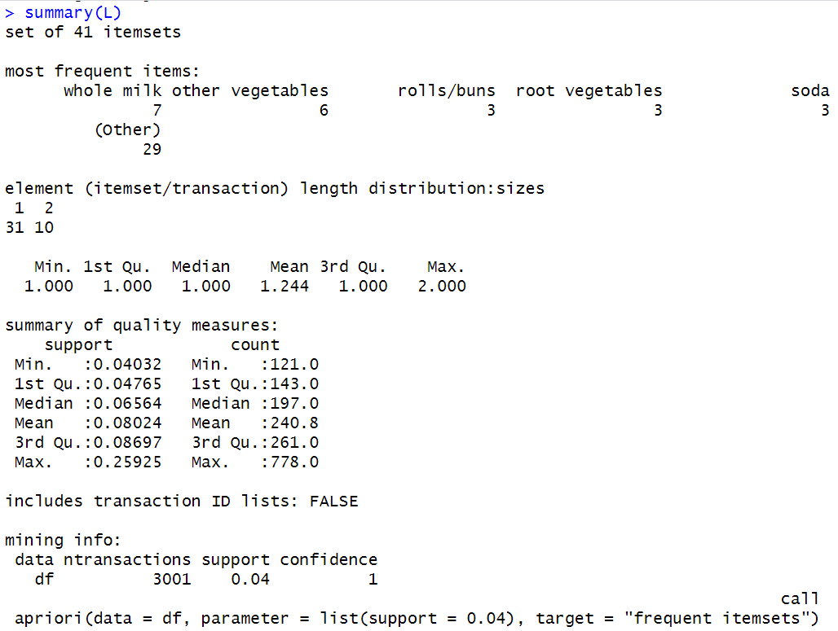
(2). 41 total frequent itemsets.
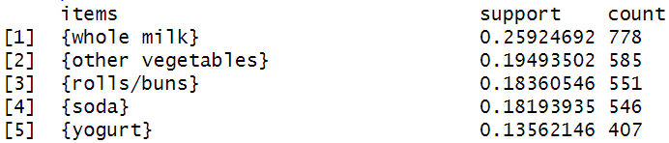
(3). 31 total frequent 1-itemsets.
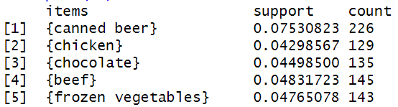
(4). 10 total frequent 2-itemsets.
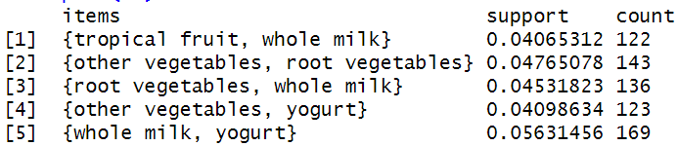
(5). Zero frequent 3-itemsets.
(6). Zero frequent 4-itemsets.
(7).
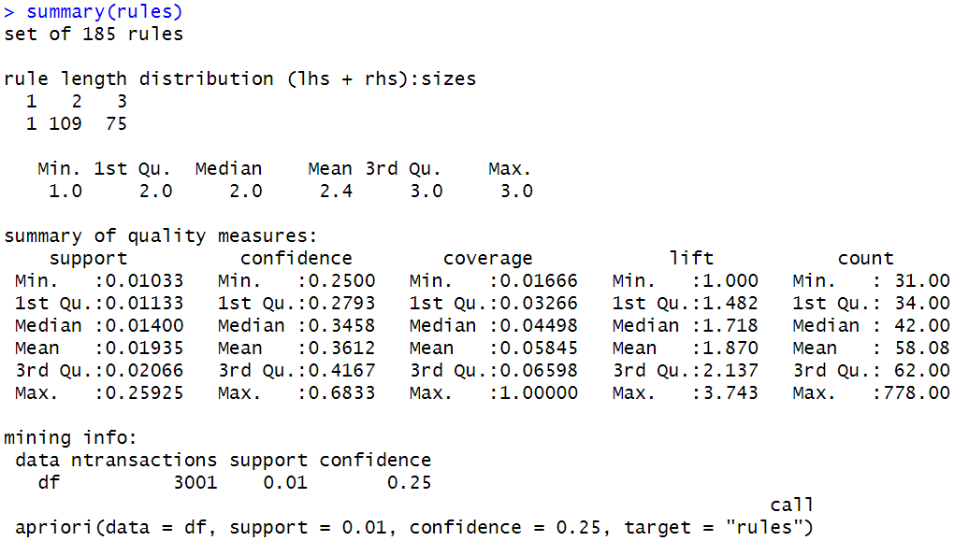
(8). 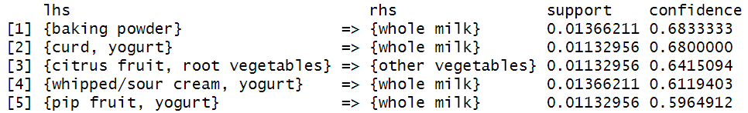 (9).
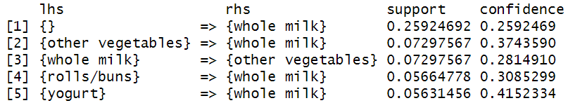
(10). See next page

