MET CS662 - Assignment #4
Joseph Rissman
U09545917
- Convert the following nfa into an equivalent dfa.
Note for TA: The professor didn’t specify to use $λ$-closure or not. I’m guessing from his response that the intended solution is without $λ$-closure, but I’m submitting both solutions to be safe.
0, 1
1
0, $λ$
0
1
0
q₂
q₁
q₀

Without $λ$-closure
 | 0 | 1
$$\left\{q_{0}\right\}$$ | $$\left\{q_{1}\right\}$$ | $$∅$$
$$\left\{q_{1}\right\}$$ | $$\left\{q_{0},q_{2}\right\}$$ | $$\left\{q_{1},q_{2}\right\}$$
$$\left\{q_{2}\right\}$$ | $$\left\{q_{2}\right\}$$ | $$\left\{q_{1}\right\}$$
$$\{q_{0},q_{1}\}$$ | $$\left\{q_{0},q_{1},q_{2}\right\}$$ | $$\left\{q_{1},q_{2}\right\}$$
$$\left\{q_{1},q_{2}\right\}$$ | $$\left\{q_{0},q_{2}\right\}$$ | $$\left\{q_{1},q_{2}\right\}$$
$$\left\{q_{0},q_{2}\right\}$$ | $$\left\{q_{1},q_{2}\right\}$$ | $$\left\{q_{1}\right\}$$
$$\left\{q_{0},q_{1},q_{2}\right\}$$ | $$\left\{q_{0},q_{1},q_{2}\right\}$$ | $$\left\{q_{1},q_{2}\right\}$$
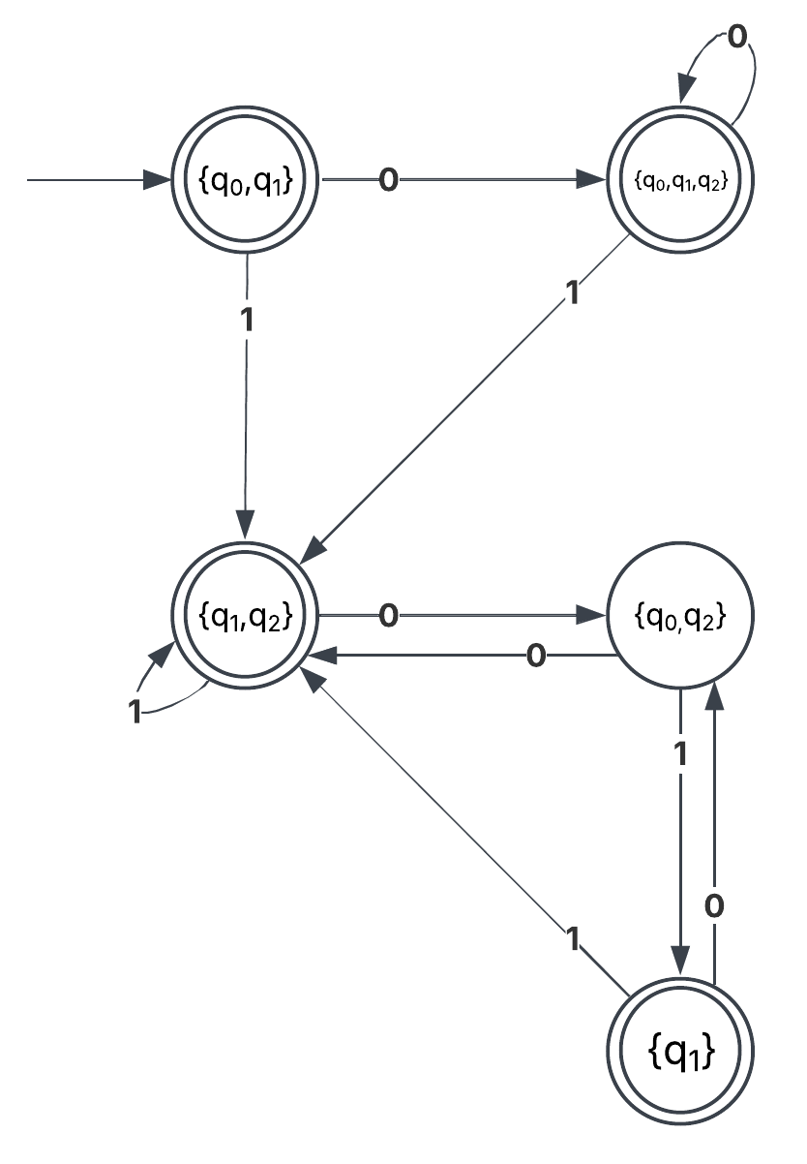
With $λ$-closure
 | $$λ$$ | 0 | 1
$$\left\{q_{0}\right\}$$ | $$\left\{q_{0},q_{1}\right\}$$ | $$\left\{q_{1}\right\}$$ | $$∅$$
$$\left\{q_{1}\right\}$$ | $$\left\{q_{1}\right\}$$ | $$\left\{q_{0},q_{1},q_{2}\right\}$$ | $$\left\{q_{1},q_{2}\right\}$$
$$\left\{q_{2}\right\}$$ | $$\left\{q_{2}\right\}$$ | $$\left\{q_{2}\right\}$$ | $$\left\{q_{1}\right\}$$
$$\{q_{0},q_{1}\}$$ | $$\left\{q_{0},q_{1}\right\}$$ | $$\left\{q_{0},q_{1},q_{2}\right\}$$ | $$\left\{q_{1},q_{2}\right\}$$
$$\left\{q_{1},q_{2}\right\}$$ | $$\left\{q_{1},q_{2}\right\}$$ | $$\left\{q_{0},q_{1},q_{2}\right\}$$ | $$\left\{q_{1},q_{2}\right\}$$
$$\left\{q_{0},q_{1},q_{2}\right\}$$ | $$\left\{q_{0},q_{1},q_{2}\right\}$$ | $$\left\{q_{0},q_{1},q_{2}\right\}$$ | $$\left\{q_{1},q_{2}\right\}$$
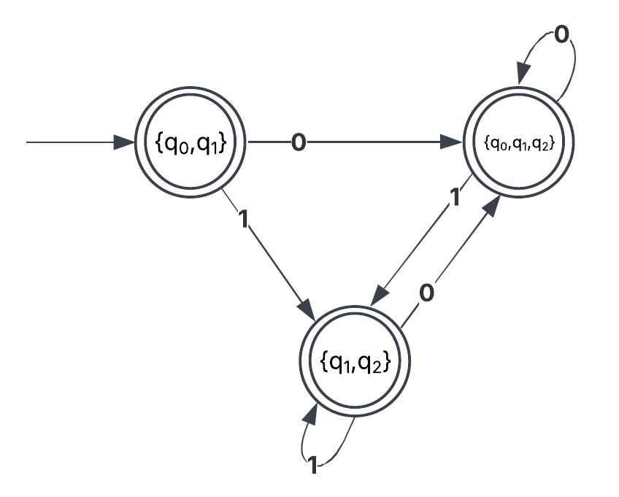

- Find an nfa without $λ$-transitions and with a single final state that accepts the set $\left\{a\right\}\bigcup{ \left\{b^{n} | n ≥1\right\}}$.
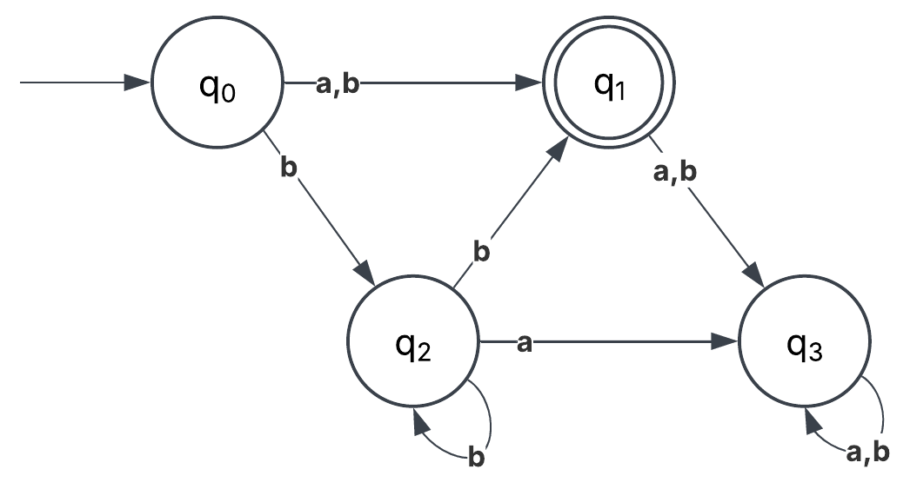
- Find a regular expression for the set $\left\{a^{n}b^{m} | \left(n+m\right) is even\right\}$
$${\left(aa\right)}^{*}{\left(ab\right)}^{*}{\left(bb\right)}^{*}$$
- Find a regular expression for
$$L= \left\{ω∈{\left\{0, 1\right\}}^{*} | ω has exactly one pair of consecutive zeros\right\}$$
(Two 0’s in a row appear exactly once: examples 1001011111010111 is OK, 10010001 is not)
$${\left(\left(0+λ\right)1\right)}^{*}\left(00\right){\left(1\left(0+λ\right)\right)}^{*}$$

- Give a nfa that accepts the language $L= \left({\left(a+b\right)}^{*}b {\left(a+bb\right)}^{*}\right)$

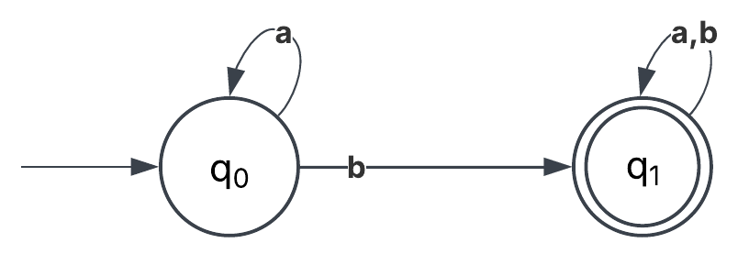
- Find all strings in $L= \left({\left(a+b\right)}^{*}b {\left(a+ab\right)}^{*}\right)$ of length three or less.

$$b,ab,ba,bb,aab,aba,abb,baa,bab,bba,bbb$$
- Find a regular expression for the following language defined on $\left\{a, b\right\}$.
$$L= \left\{ω | n_{a}\left(ω\right) and n_{b}\left(ω\right) are both even\right\}$$

$${\left(aa+bb+\left(ab+ba\right){\left(aa+bb\right)}^{*}\left(ab+ba\right)\right)}^{*}$$

______________________________

