MET CS662 - Assignment #5
Joseph Rissman
U09545917
- Consider the following generalized transition graph
a. Find an equivalent generalized transition graph with only two states.
aa + b
a
b
a
$λ$
ab
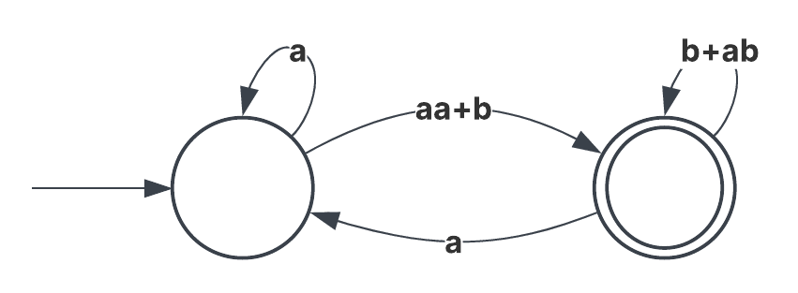
b. What is the language accepted by this graph?
$$L\left(a^{*}\left(aa+b\right){\left({\left(b+ab\right)}^{*}+aa^{*}\left(aa+b\right)\right)}^{*}\right)$$

- Construct right and left grammars for the language $L=\left\{a^{n}b^{m}\right| n≥2, m≥3\}$.
Right grammar:
$$S→aaA$$
$$A→aA|B$$
$$B→bB|bbb$$
Left grammar:
$$S→Abbb$$
$$A→Ab|B$$
$$B→Ba|aa$$

- Construct a right linear grammar for the language $L({\left(aab^{*}ab\right)}^{*})$.
Right linear grammar:
$$S→aaA|λ$$
$$A→bA|abS$$
Left linear grammar:
$$S→Aab|λ$$
$$A→Ab|Saa$$
- Find a regular grammar that generates the language on $\sum{=\{a, b\}}$ consisting of all strings with no more than three a’s.
$$S→aA|bS|λ$$
$$A→bA\left|aB\right|λ$$
$$B→bB\left|aC\right|λ$$
$$C→bC|λ$$

- Find a regular grammar for the language $L=\left\{a^{n}b^{m}\right| n+m is even\}$
$$S→aaS\left|abA\right|A$$
$$A→bbA|λ$$

- The symmetric difference of two sets $S_{1}$ and $S_{2}$ is defined as
$$S_{1}⊝S_{2}= \left\{x | x∈S_{1} or x∈S_{2}, but x is not in both S_{1} and S_{2}\right\} \\ Show that the family of regular languages is closed under symmetric difference.$$
- Suppose we know that $L_{1}∪ L_{2}$is regular and that $L_{1}$ is finite. Can we conclude from this that $L_{2}$is regular?
- Which of the following are true for all regular languages and all homomorphisms?
a) ${h(L}_{1}∪ L_{2})=h{(L}_{1})∪h(L_{2})$
b) ${h(L}_{1}∩ L_{2})=h{(L}_{1})∩h(L_{2})$
c) ${h(L}_{1}L_{2})=h{(L}_{1})h(L_{2})$
- If $L$ is a regular language, prove that $L_{1}=\left\{uv\right| u∈L, \left|v\right|=2\}$ is also regular.

_______________________________

