Assignment 8
Due: 4/1

Note: Show all your work.

Problem 1 (10 points). Consider the following contingency table.
 | C (buys coffee = Yes) | $\overline{C}$ (buys coffee = No)
T (buys tea = Yes) | 742 | 136
$\overline{T}$ (buys tea = No) | 66 | 469
Compute the lift, all-confidence, cosine, Kulczynski and imbalance ratio measure, and determine whether buying coffee and buying tea are positively correlated, negatively correlated, or not correlated.

$$lift\left(T,C\right)=\frac{\frac{742}{1413}}{\frac{808}{1413}×\frac{878}{1413}}=1.478$$
$$all-confidence\left(T,C\right)=\frac{742}{\max\left\{808,878\right\}}=0.845$$
$$cosine\left(T,C\right)=\frac{742}{\sqrt{808×878}}=0.881$$
$$Kulczynski\left(T,C\right)=\frac{1}{2}\left(\frac{742}{808}+\frac{742}{878}\right)=0.882$$
$$imbalance ratio \left(T,C\right)=\frac{\left|878-808\right|}{878+808-742}=0.074$$

Buying coffee and buying tea are positively correlated according to all measures.

Problem 2 (10 points). Suppose you have the following transactional database:
CID | Time | Items
1 | 1 | 10,30
1 | 4 | 80
1 | 6 | 60,70
2 | 3 | 10
2 | 7 | 30,40
2 | 20 | 60,70,80
3 | 2 | 30,50
3 | 8 | 70,80
4 | 2 | 70
4 | 10 | 80
5 | 1 | 30,50
5 | 5 | 70
Show all frequent 2-sequences along with their supports. Assume that the minimum support is 40% (or two data-sequences). You must not use any data mining software including R. You must find all frequent 2-sequences yourself.

CID | Data-sequence
1 | <{10,30},{80},{60,70}>
2 | <{10},{30,40},{60,70,80}>
3 | <{30,50},{70,80}>
4 | <{70},{80}>
5 | <{30,50},{70}>

C1 (candidate 1-sequences):
<{10}>:2
<{30}>:4
<{40}>:1
<{50}>:2
<{60}>:2
<{70}>:5
<{80}>:4
L1 (frequent 1-sequences):
<{10}>:2
<{30}>:4
<{50}>:2
<{60}>:2
<{70}>:5
<{80}>:4

C2 (candidate 2-sequences):

<{10},{30}>:1
<{10},{50}>:0
<{10},{60}>:2
<{10},{70}>:2
<{10},{80}>:2
<{30},{50}>:0
<{30},{60}>:2
<{30},{70}>:4
<{30},{80}>:3
<{50},{60}>:0
<{50},{70}>:2
<{50},{80}>:1
<{60},{70}>:0
<{60},{80}>:0
<{70},{80}>:1
<{30},{10}>:0
<{50},{10}>:0
<{60},{10}>:0
<{70},{10}>:0
<{80},{10}>:0
<{50},{30}>:0
<{60},{30}>:0
<{70},{30}>:0
<{80},{30}>:0
<{60},{50}>:0
<{70},{50}>:0
<{80},{50}>:0
<{70},{60}>:0
<{80},{60}>:1
<{80},{70}>:1
<{10,30}>:1
<{10,50}>:0
<{10,60}>:0
<{10,70}>:0
<{10,80}>:0
<{30,50}>:2
<{30,60}>:0
<{30,70}>:0
<{30,80}>:0
<{50,60}>:0
<{50,70}>:0
<{50,80}>:0
<{60,70}>:2
<{60,80}>:1
<{70,80}>:1

L2 (frequent 2-sequences):
<{10},{60}>:2 (40%)
<{10},{70}>:2 (40%)
<{10},{80}>:2 (40%)
<{30},{60}>:2 (40%)
<{30},{70}>:4 (80%)
<{30},{80}>:3 (60%)
<{50},{70}>:2 (40%)
<{30,50}>:2 (40%)
<{60,70}>:2 (40%)

Problem 3 (10 points). This problem is about mining strong rules from a transactional dataset using R. Use hw8_p3.csv data for this problem. It is a slightly modified version of the groceries.csv data that is included in R.
(1). Mine all rules with minimum support = 0.5% and minimum confidence = 50% and include the screenshot of the summary in your submission. How many rules are there? 128
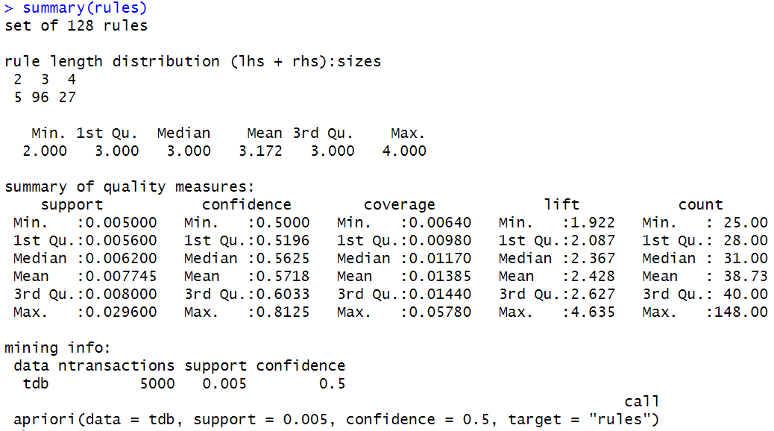
(2). Mine only length 4 rules with minimum support = 0.5% and minimum confidence = 50% and include the screenshot of the summary in your submission. How many rules are there? 27
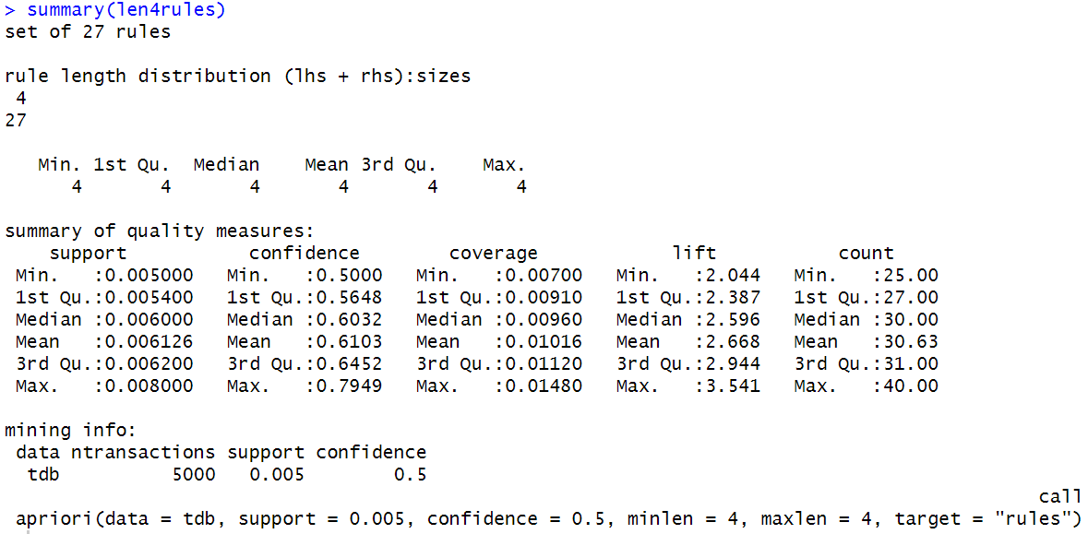
(3). Show top 5 rules based on coverage.
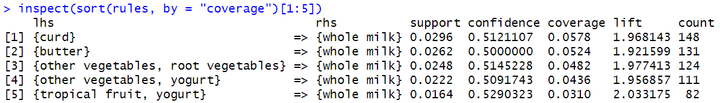
(4). Show top 5 rules based on lift.
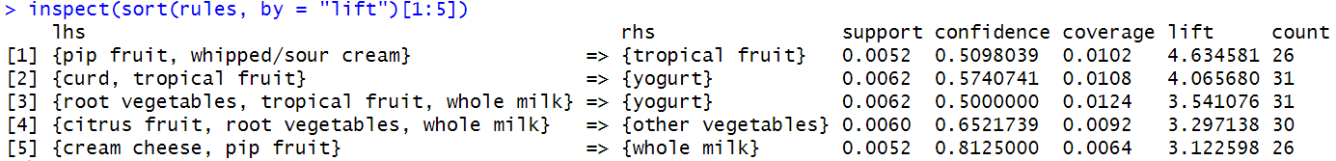

Problem 4 (10 points). This problem is about mining frequent sequences and induced temporal rules from a transactional database using R. Use hw8_p4.csv data for this problem.
(1). Mine all frequent sequences with minimum support = 40% and include the screenshot of the summary in your submission.
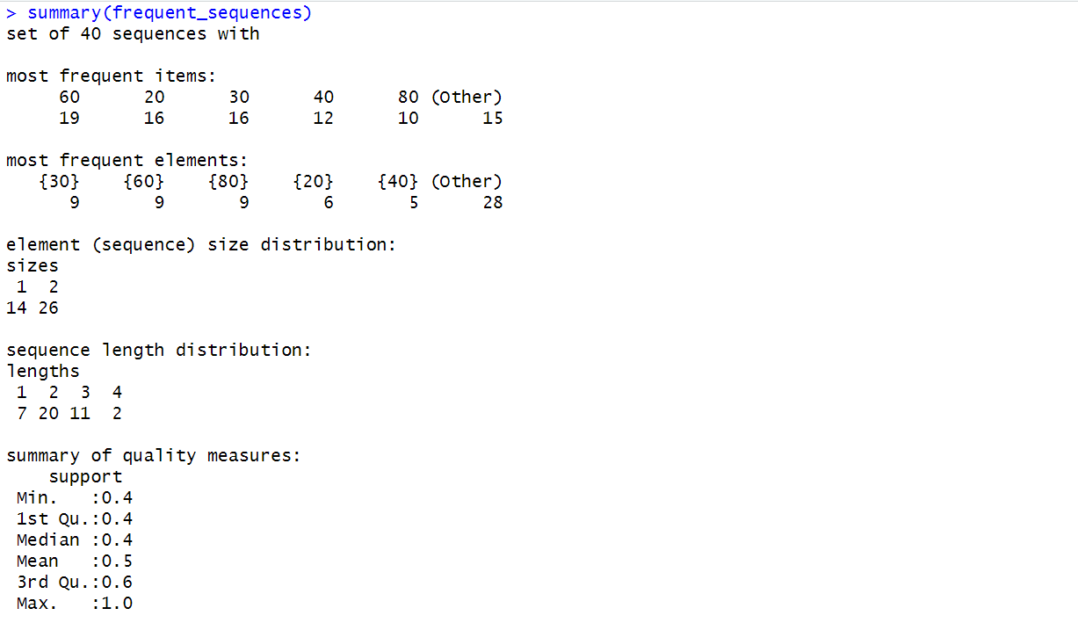
(1)-1. How many frequent 1-sequences are there? 7
(1)-2. How many frequent 2-sequences are there? 20
(1)-3. How many frequent 3-sequences are there? 11
(1)-4. How many frequent 4-sequences are there? 2
(2). From the above frequent sequences, mine all induced temporal rules. How many rules are there? 26
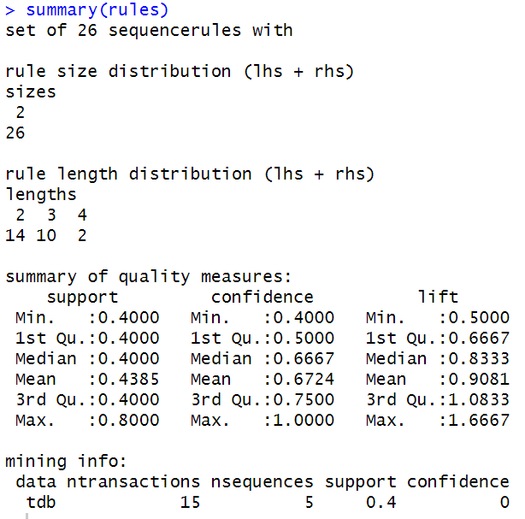
(3). Show top 5 rules based on confidence.
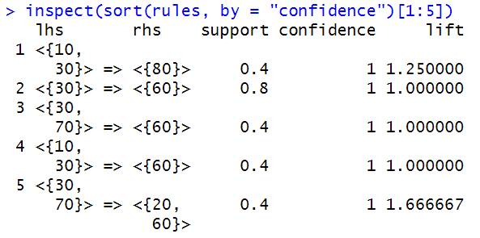
(4). Show top 5 rules based on lift.
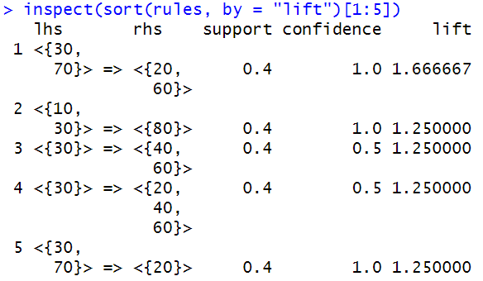

Submission:
Submit all solutions in a single Word or PDF document and upload it to Blackboard. Use
LastName_FirstName_hw8.docx or LastName_FirstName_hw8.pdf as the file name. You
must also submit your R code file. Name it hw8.R.

