Assignment 9
Due: 4/8
Problem 1 (10 points). The k-means algorithm, which we discussed in the class, is being run on a small two-dimensional dataset. After a certain number of iterations, you have two clusters as shown below:
ID | x | y | Cluster
a | 2 | 4 | Cluster 1
b | 3 | 2 | Cluster 1
c | 5 | 3 | Cluster 1
d | 1 | 3 | Cluster 2
e | 3 | 1 | Cluster 2
f | 4 | 5 | Cluster 2
g | 6 | 2 | Cluster 2
Run one more iteration of the k-Means clustering algorithm and show the two clusters at the end of the iteration. Use the Euclidean distance when calculating the distance between objects.
$$C1.x=\frac{2+3+5}{3}=3.33$$
$$C1.y=\frac{4+2+3}{3}=3$$
$$C2.x=\frac{1+3+4+6}{4}=3.5$$
$$C2.y=\frac{3+1+5+2}{4}=2.75$$
$$dist\left(a,C1\right)=\sqrt{{\left(3.33-2\right)}^{2}+{\left(3-4\right)}^{2}}=1.67$$
$$dist\left(a,C2\right)=\sqrt{{\left(3.5-2\right)}^{2}+{\left(2.75-4\right)}^{2}}=1.95$$
$$dist\left(b,C1\right)=\sqrt{{\left(3.33-3\right)}^{2}+{\left(3-2\right)}^{2}}=1.05$$
$$dist\left(b,C2\right)=\sqrt{{\left(3.5-3\right)}^{2}+{\left(2.75-2\right)}^{2}}=0.90$$
$$dist\left(c,C1\right)=\sqrt{{\left(3.33-5\right)}^{2}+{\left(3-3\right)}^{2}}=1.67$$
$$dist\left(c,C2\right)=\sqrt{{\left(3.5-5\right)}^{2}+{\left(2.75-3\right)}^{2}}=1.52$$
$$dist\left(d,C1\right)=\sqrt{{\left(3.33-1\right)}^{2}+{\left(3-3\right)}^{2}}=2.33$$
$$dist\left(d,C2\right)=\sqrt{{\left(3.5-1\right)}^{2}+{\left(2.75-3\right)}^{2}}=2.51$$
$$dist\left(e,C1\right)=\sqrt{{\left(3.33-3\right)}^{2}+{\left(3-1\right)}^{2}}=2.03$$
$$dist\left(e,C2\right)=\sqrt{{\left(3.5-3\right)}^{2}+{\left(2.75-1\right)}^{2}}=1.82$$
$$dist\left(f,C1\right)=\sqrt{{\left(3.33-4\right)}^{2}+{\left(3-5\right)}^{2}}=2.11$$
$$dist\left(f,C2\right)=\sqrt{{\left(3.5-4\right)}^{2}+{\left(2.75-5\right)}^{2}}=2.30$$
$$dist\left(g,C1\right)=\sqrt{{\left(3.33-6\right)}^{2}+{\left(3-2\right)}^{2}}=2.85$$
$$dist\left(g,C2\right)=\sqrt{{\left(3.5-6\right)}^{2}+{\left(2.75-2\right)}^{2}}=2.61$$
ID | x | y | Cluster
a | 2 | 4 | Cluster 1
b | 3 | 2 | Cluster 2
c | 5 | 3 | Cluster 2
d | 1 | 3 | Cluster 1
e | 3 | 1 | Cluster 2
f | 4 | 5 | Cluster 1
g | 6 | 2 | Cluster 2

Problem 2 (10 points). Consider the following two clusters:
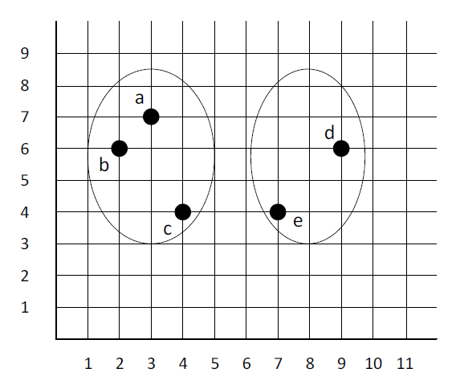
(1). Compute the distance between the two clusters using the mean method (or centroid method) that we discussed in the class. Use the Euclidean distance measure when calculating the distance between objects.
ID | x | y | Cluster
a | 3 | 7 | Cluster 1
b | 2 | 6 | Cluster 1
c | 4 | 4 | Cluster 1
d | 9 | 6 | Cluster 2
e | 7 | 4 | Cluster 2
$$C1.x=\frac{3+2+4}{3}=3$$
$$C1.y=\frac{7+6+4}{3}=5.67$$
$$C2.x=\frac{9+7}{2}=8$$
$$C2.y=\frac{6+4}{2}=5$$
$$d\left(C1,C2\right)=\sqrt{{\left(8-3\right)}^{2}+{\left(5-5.67\right)}^{2}}=5.04$$
(2). Compute the distance between the two clusters using the Ward's method that we discussed in the class. Use the Euclidean distance measure when calculating the distance between objects.
$$SSE_{C1}={\left(3-3\right)}^{2}+{\left(3-2\right)}^{2}+{\left(3-4\right)}^{2}+{\left(5.67-7\right)}^{2}+{\left(5.67-6\right)}^{2}+{\left(5.67-4\right)}^{2}=6.67$$
$${SSE}_{C2}={\left(8-9\right)}^{2}+{\left(5-6\right)}^{2}+{\left(8-7\right)}^{2}+{\left(5-4\right)}^{2}=4$$
$$CM.x=\frac{3+2+4+9+7}{5}=5$$
$$CM.y=\frac{7+6+4+6+4}{5}=5.4$$
$$SSE_{CM}={\left(5-3\right)}^{2}+{\left(5.4-7\right)}^{2}+{\left(5-2\right)}^{2}+{\left(5.4-6\right)}^{2}+{\left(5-4\right)}^{2}+{\left(5.4-4\right)}^{2}+{\left(5-9\right)}^{2}+{\left(5.4-6\right)}^{2}+{\left(5-7\right)}^{2}+{\left(5.4-4\right)}^{2}=41.2$$
$$ΔSSE=41.2-\left(6.67+4\right)=30.53$$
$n_{1}=3$ $n_{2}=2$
$$d\left(C1,C2\right)=\frac{3×2×30.53}{3+2}=36.636$$
Problem 3 (10 points). Use hw9_p3.csv file.
(1). Standardize all columns using the scale function.
(2). Run the k-means algorithm using fviz_nbclust 10 times (this is default) with the wss method. Use 31 as a seed.
(3). Show all 10 wss values.
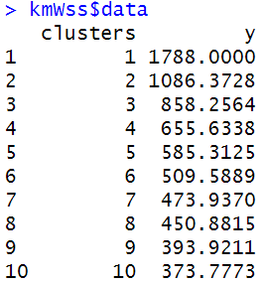
(4). Plot wss-k graph. Can you see an obvious elbow?
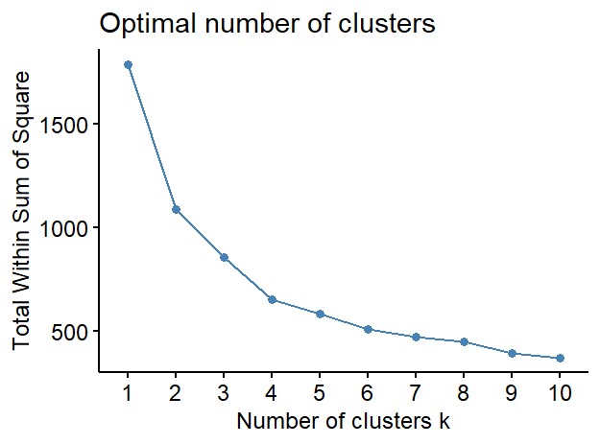
There isn’t a clear elbow in the graph but it appears to be around k=4.
(5). Run the k-means algorithm using fviz_nbclust 10 times (this is default) with silhouette method and plot silhouette-k graph. What is the optimal number of clusters?
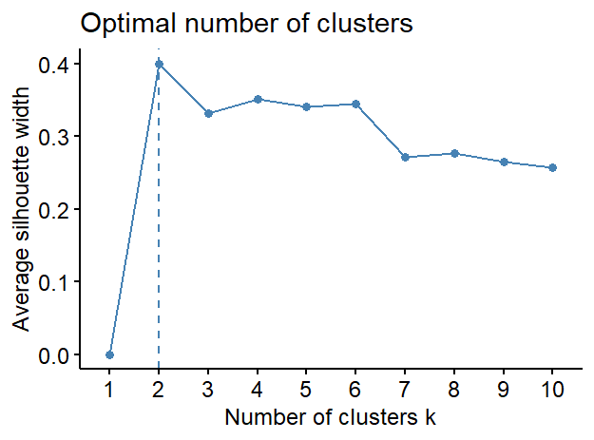
The optimal number of clusters is 2.
(6). Run the k-means algorithm once more with the following code segment:
$$set.seed(31)$$
$$k3 <- kmeans(task.df, centers = 3, nstart = 25)$$
From the clustering result, prepare the following table, which is a cluster profile:
 |  | Cluster
 |  | 1 | 2 | 3
Age | mean | 0.934673564 | 0.227532315 | -0.48267791
 | max | 2.71115036 | 2.549290637 | 2.144641329
 | min | -0.445114238 | -1.254412853 | -1.254412853
Years_Current_Employer | mean | 1.134941494 | 0.141974582 | -0.555182309
 | max | 4.891796622 | 2.745580737 | 1.553238579
 | min | -0.950679953 | -0.950679953 | -1.069914169
Years_Current_Position | mean | 1.213039505 | -0.158171031 | -0.522046742
 | max | 2.637961052 | 2.445233304 | 1.674322311
 | min | -0.638410665 | -1.023866162 | -1.023866162
Salary | mean | -0.082739169 | 1.906472741 | -0.400757202
 | max | 2.26542024 | 4.467419257 | 1.265807058
 | min | -1.037578285 | 0.315078253 | -1.037578285
Note that you may not get all values in the above table using the example R code we used in the class. You may have to write your own code segment to obtain all necessary values.
Problem 4 (10 points). Use h9_p4.csv.
Run the pam (k-medoids) algorithm using the Gower distance 9 times with k = 2 through 10 and plot the silhouette-k graph. What is an optimal k?
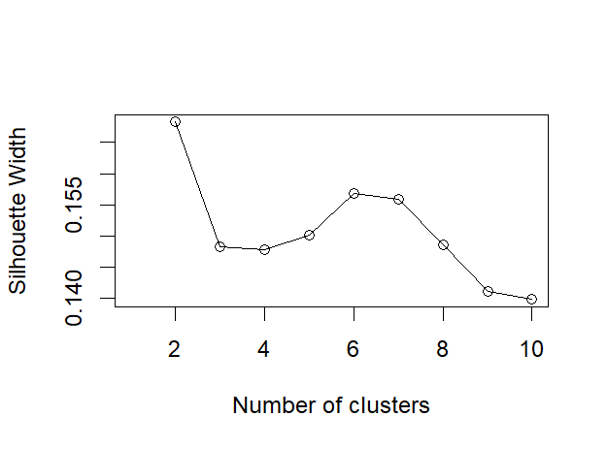
The optimal number of clusters is 2.
Problem 5 (10 points). Use hw9_p5.csv
(1). Run the agnes hierarchical clustering algorithm using the Gower distance 4 times with average, single, complete, and ward methods.
(2). Collect agglomerative coefficients and plot a bar graph of the coefficients. Which method has the highest coefficient?
The ward method had the highest coefficient.
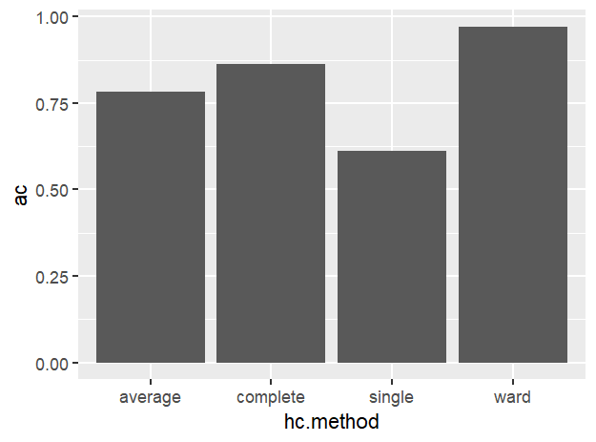
(3). Run the agnes algorithm once more with the best method you identified in the above Problem 5-(2).
(4). Cut the tree with k = 3.
(5). Show the row numbers for each cluster, which shows cluster membership. The format of your answer should look like:
Cluster 1: rows {1, 3, 8, 9, 19, 23, 24, 29, 33, 34, 40, 41, 46, 47, 54, 56, 57, 65, 66, 67, 72, 75, 76, 79, 81, 84, 89, 96, 98, 99, 102, 105, 107, 109, 118, 122, 124, 127, 128, 130, 134, 137, 139, 143, 147, 151, 152, 154, 155, 156, 157, 160, 164, 169, 170, 180, 202, 203, 206, 210, 218, 228, 233, 236, 239, 244, 253, 262, 264, 268, 272, 283, 284, 294, 297, 299, 303, 310, 319, 325, 330, 337, 340, 344, 364, 365, 366, 368, 370, 379, 381, 386, 389, 390, 396, 400, 401, 402, 408, 415, 416, 417, 422, 425, 427, 429, 430, 443, 466, 473, 475, 477, 495, 499}
Cluster 2: rows {2, 4, 7, 12, 13, 21, 22, 26, 27, 31, 35, 42, 43, 45, 51, 52, 53, 55, 58, 59, 60, 62, 63, 69, 71, 74, 85, 86, 90, 91, 92, 93, 103, 104, 106, 110, 111, 112, 114, 115, 116, 117, 121, 126, 129, 131, 132, 133, 135, 136, 140, 141, 146, 148, 149, 150, 158, 159, 166, 167, 172, 175, 176, 177, 181, 183, 184, 185, 186, 187, 190, 197, 198, 208, 209, 211, 212, 214, 216, 217, 219, 220, 222, 223, 226, 227, 229, 230, 238, 240, 242, 243, 245, 247, 252, 254, 256, 257, 258, 259, 261, 263, 266, 267, 270, 273, 275, 277, 278, 279, 280, 281, 285, 286, 287, 288, 290, 293, 295, 300, 301, 305, 308, 309, 312, 315, 316, 318, 322, 323, 331, 332, 333, 335, 336, 338, 339, 341, 342, 343, 345, 347, 349, 350, 352, 356, 357, 360, 362, 363, 367, 369, 372, 374, 376, 377, 378, 380, 383, 384, 385, 387, 391, 398, 399, 403, 404, 405, 407, 409, 410, 411, 412, 413, 414, 418, 419, 420, 423, 424, 426, 428, 431, 432, 440, 442, 444, 445, 446, 447, 448, 449, 454, 457, 463, 467, 469, 471, 474, 481, 482, 484, 485, 486, 487, 488, 491, 496, 497}
Cluster 3: rows {5, 6, 10, 11, 14, 15, 16, 17, 18, 20, 25, 28, 30, 32, 36, 37, 38, 39, 44, 48, 49, 50, 61, 64, 68, 70, 73, 77, 78, 80, 82, 83, 87, 88, 94, 95, 97, 100, 101, 108, 113, 119, 120, 123, 125, 138, 142, 144, 145, 153, 161, 162, 163, 165, 168, 171, 173, 174, 178, 179, 182, 188, 189, 191, 192, 193, 194, 195, 196, 199, 200, 201, 204, 205, 207, 213, 215, 221, 224, 225, 231, 232, 234, 235, 237, 241, 246, 248, 249, 250, 251, 255, 260, 265, 269, 271, 274, 276, 282, 289, 291, 292, 296, 298, 302, 304, 306, 307, 311, 313, 314, 317, 320, 321, 324, 326, 327, 328, 329, 334, 346, 348, 351, 353, 354, 355, 358, 359, 361, 371, 373, 375, 382, 388, 392, 393, 394, 395, 397, 406, 421, 433, 434, 435, 436, 437, 438, 439, 441, 450, 451, 452, 453, 455, 456, 458, 459, 460, 461, 462, 464, 465, 468, 470, 472, 476, 478, 479, 480, 483, 489, 490, 492, 493, 494, 498, 500}
Submission:
Include all answers in a single file and name it LastName_FirstName_hw9.EXT. Here, “EXT” is an appropriate file extension (e.g., docx or pdf). If you have multiple files, then combine all files into a single archive file and name it LastName_FirstName_hw9.EXT.
Here, “EXT” is an appropriate archive file extension (e.g., zip or rar). Upload the file to Blackboard. You also need to submit your R code file.

