Boston University MET College 2025
Department of Computer Science

Advanced Machine Learning and Neural Networks (CS 767)

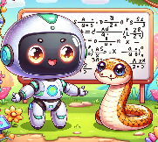

Syllabus

Time & Location: Tue 9 AM - 11:45 AM, MET 101 (1010 Commonwealth Avenue)

Instructor: Avi Mohan (avimohan@bu.edu)
TA: Rajesh Chandra (rj21@bu.edu)

Syllabus (tentative)
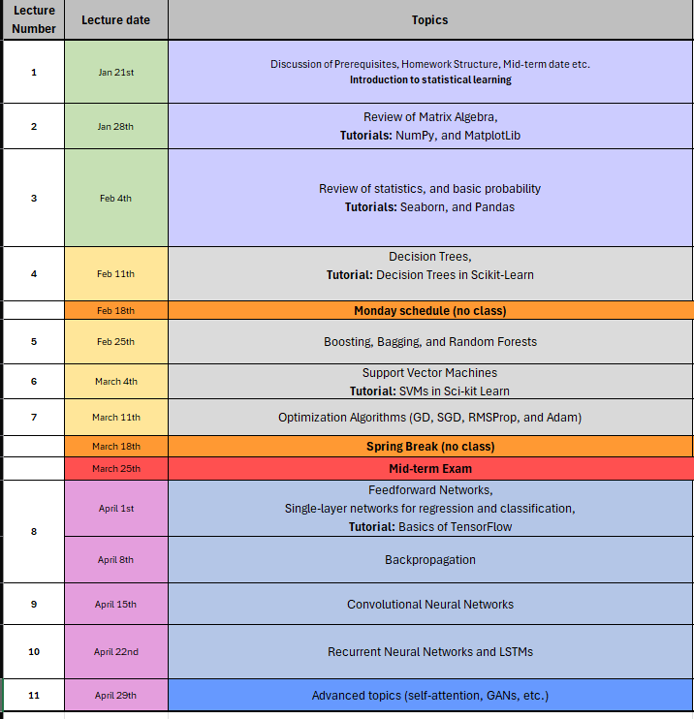

Required Textbook:
[G22] Géron, A., 2022. “Hands-on machine learning with Scikit-Learn, Keras, and TensorFlow.” O'Reilly Media, Inc.
ISBN-13: 978-1098104030

Additional Material
- [GBC16] Ian Goodfellow, Yoshua Bengio, and Aaron Courville, “Deep learning,” The MIT Press, 2016.
ISBN- 13: 978-0262035613

- [ZLLS21] Zhang, A., Lipton, Z.C., Li, M. and Smola, A.J., 2021. “Dive Into Deep Learning.” arXiv preprint arXiv:2106.11342.
Link: https://d2l.ai/index.html

- [BB22] Bishop, C.M. and Bishop, H., 2024, “Deep Learning: Foundations and Concepts.” Springer Nature.
Online version available for free at: https://www.bishopbook.com/
ISBN- 13: 978-3031454677

- [DFO20] Deisenroth, Marc Peter, A. Aldo Faisal, and Cheng Soon Ong. Mathematics for Machine Learning. Cambridge University Press, 2020.
ISBN- 13: 978-1108455145

- [J24] James, Gareth, Daniela Witten, Trevor Hastie, Robert Tibshirani, and Jonathan Taylor. An Introduction to Statistical Learning: With Applications in Python. Springer Nature, 2024.
ISBN- 13: 978-3031387463

- [NFI21] Navlani, Avinash, Armando Fandango, and Ivan Idris. Python Data Analysis: Perform data collection, data processing, wrangling, visualization, and model building using Python. Packt Publishing Ltd, 2021.
ISBN- 13: 978-1787127487

