MET CS662 - Assignment #6

- Draw the derivation tree corresponding to the derivation in Example 5.1, that is
$S⇒aSa⇒aaSaa⇒aabSbaa⇒aabbaa$
where the grammar is $S →aSa$ $S →bSb$ $S →λ$
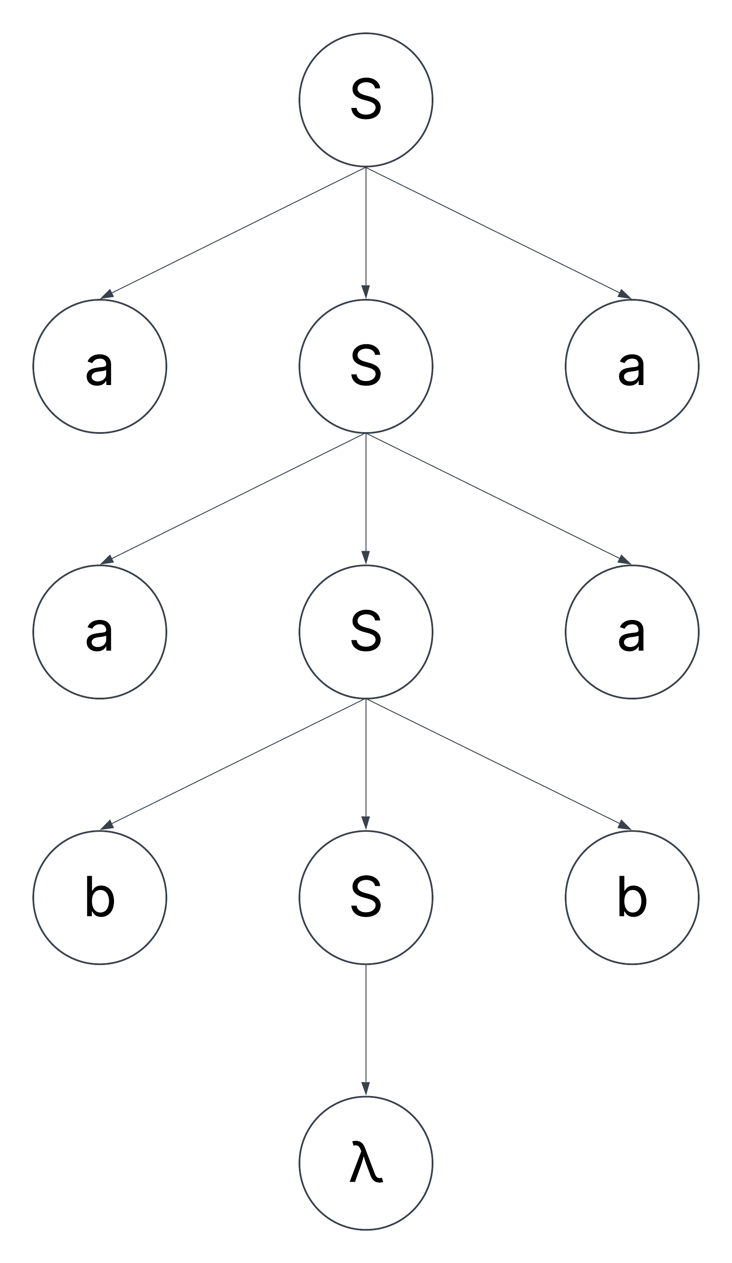
- Find context-free grammars for the language$L=\left\{a^{n}b^{m}c^{k}\right| n=m or m≤k\}$, (with also, $n≥0, m≥0, k≥0)$
$$S→AB|CD$$
$$A→aAb|λ$$
$$B→Bc|λ$$
$$C→aC|λ$$
$$D→bDc|E$$
$$E→Ec|c$$

- Let $L=\left\{a^{n}b^{n}\right| n≥0\}.$
a) Show that $L^{2}$ is context-free.

$$S→S_{1}S_{1}$$
$$S_{1}→aSb|λ$$

b) Show that $L^{k}$ is context-free for any given $k≥1$.

$$S→S_{1}S_{1}S_{1}…S_{1}S_{1}S_{1};k times$$
$$S_{1}→aSb|λ$$

c) Show that $\overline{L}$ and $L^{*}$ are context-free.
$$\overline{L}=\{awb|w∉L\}∪\left\{bw | w∈{\left\{a,b\right\}}^{*}\right\}∪\left\{wa | w∈{\left\{a,b\right\}}^{*}\right\}$$
$$S→aSb|bA|Aa$$
$$A→aA\left|bA\right|λ$$

$$L^{*}=\left\{a^{n}b^{n}a^{m}b^{m}a^{l}b^{l}…a^{k}b^{k} | n≥0,m≥0,l≥0,…,k≥0\right\}$$
$$S→SaSbS|λ$$
- Find an s-grammar for the language $L\left(aaa^{*}b+b\right)$.

$$S→aAB|b$$
$$A→a$$
$$B→aB|b$$
- Show that the following language is ambiguous.
$S →AB|aaB$ $A →a|Aa$ $B→b$

$$S→aaB→aab$$
$$S→AB→AaB→aaB→aab$$
- Construct an unambiguous grammar equivalent to the grammar
$S →AB|aaB$ $A →a|Aa$ $B→b$

$$S→AB$$
$$A→a|Aa$$
$$B→b$$

- Prove the following result. Let $G=\left(V, T, S, P\right)$ be a context-free grammar in which every $A∈V$ occurs on the left side of at most one production. Then G is unambiguous.
If every $A∈V$ occurs on the left side of at most one production, then there is no choice when parsing the grammar. If there is no choice when parsing the grammar, then there is only one possible derivation tree. If there is only one possible derivation tree, then the grammar is unambiguous.
- Transform the grammar with productions $S →abAB$, $A →bAB|λ$, $B→BAa|A|λ$
into Chomsky normal form.
$$S→CE$$
$$A→DF|b$$
$$B→AC|BG|DF|a|b$$
$$C→a$$
$$D→b$$
$$E→DF|b$$
$$F→AB|AC|BG|DF|a|b$$
$$G→AC|a$$

- Convert the grammar $S →aSb|bSa$|a|b
into Greibach form.

$$S→aSB\left|bSA\right|a|b$$
$$A→a$$
$$B→b$$
_______________________________

