CS699 A1 – Spring 2024
Homework 2
Due: 2/5

- You must show all calculations and important intermediate steps/results. Otherwise, you will lose points even if your answers are correct.
- If you use R, you must submit the R code file.

Problem 1 (10 points). Use the hw2_p1.csv file for this problem.

(1). Calculate the mean, standard deviation, minimum, and maximum of wind.
mean 4.462
standard deviation 1.907 (sample) 1.888 (population)
minimum 0.9
maximum 9.4
(2). Calculate the 25th, 50th, and 75th percentiles of wind using the percentiles formula that we discussed in the class.
25th rank = 0.25 * (1 + 50) = 12.75 12th item = 3.1
50th rank = 0.50 * (1 + 50) = 25.5 25th item = 4.5
75th rank = 0.75 * (1 + 50) = 38.25 38th item = 5.4
25th percentile = 3.1 + 0.75 * (3.1 – 3.1) = 3.1
50th percentile = 4.5 + 0.50 * (4.5 – 4.5) = 4.5
75th percentile = 5.4 + 0.25 * (5.4 – 5.4) = 5.4
(3). Plot the boxplot of wind.
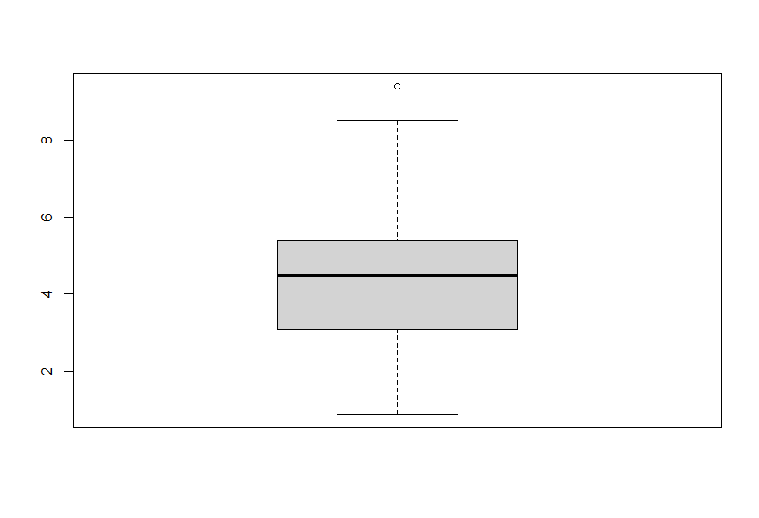
(4). For this problem, consider only the temp attribute. Detect outliers using the IQR method that we discussed in the class and show all outlier values.
25th rank = 0.25 * (1 + 50) = 12.75 12th item = 18.0
75th rank = 0.75 * (1 + 50) = 38.25 38th item = 30.2
25th percentile = 18.0 + 0.75 * (18.2 – 18.0) = 18.15
75th percentile = 30.2 + 0.25 * (30.2 – 30.2) = 30.2
IQR = Q3 – Q1 = 12.05
Outliers smaller than Q1 – 1.5 * IQR = 18.15 – 1.5 * 12.05 = 0.075; there are none
Outliers greater than Q3 + 1.5 * IQR = 30.2 + 1.5 * 12.05 = 48.275; there is one (49.2)

For problems (2) and (4), you should not use a data analysis or a data mining tool that automatically determines the required values. However, you may use a spreadsheet software just for calculations and you may write a R code that does calculations. In this case, your own code must do the calculations. For example, you should not use the quantile function for problem (2) but you can write a R code that does calculations. For problem (1) and (3), you may use any tool.

Problem 2 (10 points). Consider the following two objects with 7 binary attributes:

OID | A1 | A2 | A3 | A4 | A5 | A6 | A7
O1 | P | N | N | P | N | P | P
O2 | N | P | N | P | P | N | N

(1). Calculate the distance between O1 and O2 assuming all attributes are symmetric attributes.
d(O1, O2) = (# mismatches / # attributes) = 5/7 = 0.71
(2). Calculate the distance O1 and O2 assuming all attributes are asymmetric attributes with P being more important than N.
d(O1, O2) = (# mismatches / # attributes with at least one P) = 5/6 = 0.83

Problem 3 (10 points)

Consider the following dataset with two objects.

Object | A1 | A2 | A3 | A4
O1 | 3 | first | silver | xlarge
O2 | 4 | third | bronze | medium

Here, all attributes are ordinal attributes and ranks of their values are shown below (lowest rank on the left):

A1: {1, 2, 3, 4, 5}
A2: {first, second, third}
A3: {bronze, silver, gold}
A4: {small, medium, large, xlarge}
Calculate the distance between O1 and O2 using the method discussed in the class. Use the Euclidean distance measure.

Reassign numeric values.

Object | A1 | A2 | A3 | A4
O1 | 0.5 | 0 | 0.5 | 1
O2 | 0.75 | 1 | 0 | 0.33

Calculate Euclidean distance measure.
$$d\left(O1,O2\right)=\sqrt{{\left(0.5-0.75\right)}^{2}+{\left(0-1\right)}^{2}+{\left(0.5-0\right)}^{2}+{\left(1-0.33\right)}^{2}}=1.327$$

Problem 4 (10 points). Consider the following dataset:

OID | A1 | A2 | A3 | A4 | A5 | A6 | A7 | A8 | A9 | A10
O1 | 1 | 1 | 4 | 1 | 3 | 1 | 4 | 1 | 0 | 2
O2 | 3 | 2 | 5 | 5 | 0 | 4 | 0 | 3 | 5 | 2
O3 | 2 | 0 | 5 | 2 | 1 | 3 | 2 | 0 | 3 | 3

(1). Calculate the cosine similarity between O1 and O2, cosine(O1, O2).
$$cosine\left(O1,O2\right)=\frac{O1⋅O2}{\left\|O1\right\|\left\|O2\right\|}$$
$$O1⋅O2=\left(1*3\right)+\left(1*2\right)+\left(4*5\right)+\left(1*5\right)+\left(3*0\right)+\left(1*4\right)+\left(4*0\right)+\left(1*3\right)+\left(0*5\right)+\left(2*2\right)=41$$
$$\left\|O1\right\|=\sqrt{\left(1*1\right)+\left(1*1\right)+\left(4*4\right)+\left(1*1\right)+\left(3*3\right)+\left(1*1\right)+\left(4*4\right)+\left(1*1\right)+\left(0*0\right)+\left(2*2\right)}=\sqrt{50}=7.071$$
$$\left\|O2\right\|=\sqrt{\left(3*3\right)+\left(2*2\right)+\left(5*5\right)+\left(5*5\right)+\left(0*0\right)+\left(4*4\right)+\left(0*0\right)+\left(3*3\right)+\left(5*5\right)+\left(2*2\right)}=\sqrt{117}=10.817$$
$$cosine\left(O1,O2\right)=\frac{O1⋅O2}{\left\|O1\right\|\left\|O2\right\|}=\frac{41}{7.071*10.817}=0.536$$

(2). Calculate the cosine similarity between O1 and O3, cosine(O1, O3).
$$cosine\left(O1,O3\right)=\frac{O1⋅O3}{\left\|O1\right\|\left\|O3\right\|}$$
$$O1⋅O3=\left(1*2\right)+\left(1*0\right)+\left(4*5\right)+\left(1*2\right)+\left(3*1\right)+\left(1*3\right)+\left(4*2\right)+\left(1*0\right)+\left(0*3\right)+\left(2*3\right)=44$$
$$\left\|O1\right\|=\sqrt{\left(1*1\right)+\left(1*1\right)+\left(4*4\right)+\left(1*1\right)+\left(3*3\right)+\left(1*1\right)+\left(4*4\right)+\left(1*1\right)+\left(0*0\right)+\left(2*2\right)}=\sqrt{50}=7.071$$
$$\left\|O3\right\|=\sqrt{\left(2*2\right)+\left(0*0\right)+\left(5*5\right)+\left(2*2\right)+\left(1*1\right)+\left(3*3\right)+\left(2*2\right)+\left(0*0\right)+\left(3*3\right)+\left(3*3\right)}=\sqrt{65}=8.062$$
$$cosine\left(O1,O3\right)=\frac{O1⋅O3}{\left\|O1\right\|\left\|O3\right\|}=\frac{44}{7.071*8.062}=0.772$$

(3). Is O1 closer to O2 or O3?

O1 is closer to O3 than O2 because $cosine\left(O1,O3\right)>cosine\left(O1,O2\right)$.

You must do all calculations yourself.

Problem 5 (10 points). Consider the following dataset, which has attributes of mixed types.

Object ID | A1 | A2 | A3 | A4 | A5 | A6 | A7
O1 | 47 | 0 | No | Yes | No | Low | cool
O2 | 32 | 1 | No | No | No | High | hot
O3 | 29 | 0 | No | No | Yes | Low | cool
O4 | 35 | 0 | Yes | No | No | Middle | mild
O5 | 73 | 1 | No | No | No | High | hot
O6 | 27 | 0 | Yes | No | No | High | mild
O7 | 52 | 1 | No | Yes | No | Low | cool
O8 | 36 | 1 | No | No | Yes | High | mild
O9 | 12 | 0 | Yes | No | Yes | High | hot

- A1 is a numeric attribute.
- A2 A3 are symmetric binary attributes.
- A4 and A5 are asymmetric binary attributes, where Yes is more important than No
- A6 is a categorical (nominal) attribute.
- A7 is an ordinal attribute. The order of values is {cold, cool, mild, hot}, where cold had the lowest rank and high has the highest rank.

Calculate the distance between O1 and O2, d(O1, O2), and the distance between O1 and O3, d(O1, O3), using the method that we discussed in the class. Is O1 closer to O2 or closer to O3? You must do all calculations yourself.

Distance between O1 and O2:
A1: $\frac{\left|47-32\right|}{73-12}=0.246$
A2: 1
A3: 0
A4: 1
A5: ignore
A6: 1
A7: $\frac{\left|0.33-1\right|}{1-0.33}=1$
$$d\left(O1,O2\right)=\frac{0.246+1+0+1+1+1}{6}=0.708$$

Distance between O1 and O3:
A1: $\frac{\left|47-29\right|}{73-12}=0.295$
A2: 0
A3: 0
A4: 1
A5: 1
A6: 0
A7: $\frac{\left|0.33-0.33\right|}{1-0.33}=0$
$$d\left(O1,O3\right)=\frac{0.295+0+0+1+1+0+0}{7}=0.328$$

O1 is closer to O3 than O2 because $d\left(O1,O2\right)>d\left(O1,O3\right)$.
You must do all calculations yourself.

Include all answers in a single Word or PDF document and upload it to Blackboard. Use LastName_FirstName_hw2.docx or LastName_FirstName_hw2.pdf as the file name. If you have additional files, such as an Excel file or a R code file, then combine all of them into a single archive file and name it LastName_FirstName_hw2.EXT, where EXT is an appropriate archive file extension such as zip or rar.

