Assignment 6
Due: 3/18
Note: Show all your work.
Problem 1 (10 points). Using the glm model in R, build a logistic model from the hw6_p1.csv dataset.
(1). Show all coefficients of the model for Class 1.
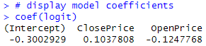
(2). Suppose you are classifying a new object O = <ClosePrice = 30, OpenPrice = 15.00> yourself (not using R). Calculate the probability of the new object belonging to Class 1 and classify it assuming the classification threshold is 0.5. You must do calculation yourself (i.e., do not use R or any other software that calculates probabilities for you).
$$P\left(class=1 | ClosePrice=X_{1}, OpenPrice=X_{2}\right)=\frac{1}{1+e^{0.3002929-0.1037808X_{1}+0.1247768X_{2}}}$$
$$P\left(class=1 | ClosePrice=30, OpenPrice=15\right)=\frac{1}{1+e^{0.3002929-0.1037808×30+0.1247768×15}}=\frac{1}{1+e^{0.3002929-3.113424+1.871652}}=\frac{1}{1+e^{-0.9414791}}=\frac{1}{1+0.3900505}=0.7193983$$
The new object is classified as belonging to Class 1.

The following three problems are practice of parameter tuning in R.

Problem 2 (10 points). Use hw_p2.csv dataset for this problem. This dataset was downloaded from the UCI ML Repository and modified for this assignment.
Build and test a J48 model according to the following requirements:
- Split the dataset into train and test sets with the 66%-34% ratio.
- Perform 10-fold cross-validations 5 times (to find the best parameter values).
- Use trainControl, tuneGrid, and train functions.
- Find the best parameter values (J48 has two parameters – C and M).
- Test the model on the test dataset.
In your submission file, you must include the following:
- Best values of C and M
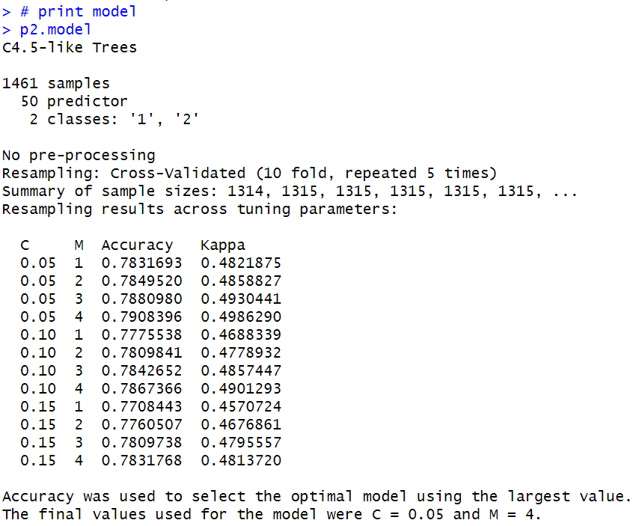
- Confusion matrix resulting from the test on the test dataset.
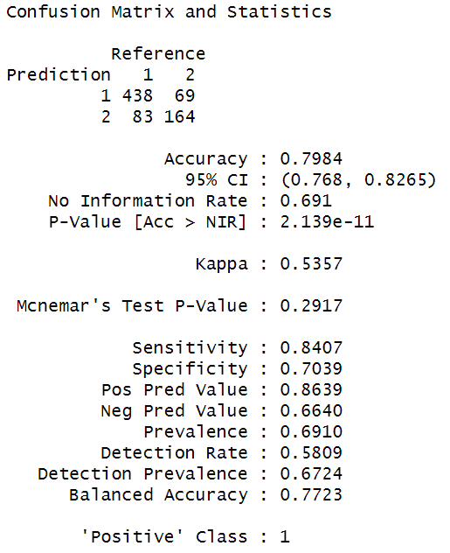
Problem 3 (10 points). Use hw6_p2.csv dataset for this problem (the same dataset used for Problem 3). This dataset was downloaded from the UCI ML Repository and modified for this assignment.
Build and test a rpart decision tree model according to the following requirements:
- Split the dataset into train and test sets with the 66%-34% ratio.
- Perform 10-fold cross-validations 5 times (to find the best parameter value).
- Use trainControl, tuneLength, and train functions.
- Find the best parameter value (rpart has one parameter – cp).
- Test the model on the test dataset.
In your submission file, you must include the following:
- Best value of cp
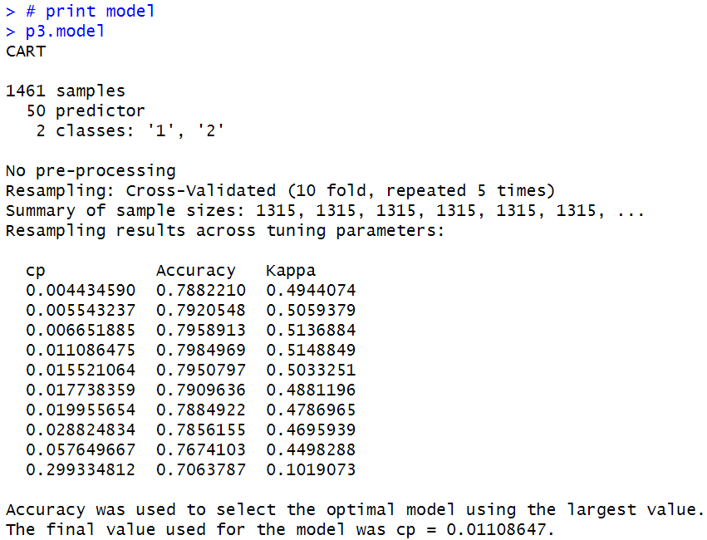
- Confusion matrix resulting from the test on the test dataset
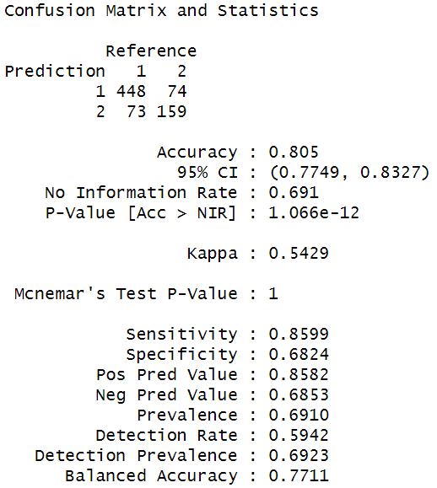
Problem 4 (10 points). Use hw6_p2.csv dataset for this problem (the same dataset used for Problem 3). This dataset was downloaded from the UCI ML Repository and modified for this assignment.
Build and test a KNN model according to the following requirements:
- Split the dataset into train and test sets with the 66%-34% ratio.
- Perform 10-fold cross-validations 5 times (to find the best parameter values).
- Use trainControl, tuneGrid, and train functions.
- Find the best parameter value (knn has one parameter – k).
- Test the model on the test dataset.
In your submission file, you must include the following:
- Best value of k
> # print model
> p4.model
k-Nearest Neighbors
1461 samples
50 predictor
2 classes: '1', '2'
Pre-processing: centered (50), scaled (50)
Resampling: Cross-Validated (10 fold, repeated 5 times)
Summary of sample sizes: 1315, 1315, 1315, 1315, 1315, 1315, ...
Accuracy was used to select the optimal model using the largest value.
The final value used for the model was k = 19.
- Confusion matrix resulting from the test on the test dataset
