Homework 10
Due: 4/15
Problem 1 (10 points). This problem is about forecasting time series using a regression model with exponential trend, which we discussed in the class.
The following table shows Y_{t} and predicted logY_{t}:
X_{t} | Y_{t} | Predicted logY_{t}
1 | 1242 | 7.28
2 | 1263 | 7.32
3 | 1292 | 7.21
4 | 1316 | 7.38
5 | 1378 | 7.49
6 | 1428 | 7.56
7 | 1492 | 7.52
8 | 1612 | 7.43
9 | 1783 | 7.47
10 | 2005 | 7.67

Calculate the RMSE for the initial Y_{t}.
X_{t} | Y_{t} | Predicted logY_{t} | Predicted Y_{t} | Error
1 | 1242 | 7.28 | 1450.988025 | -208.988
2 | 1263 | 7.32 | 1510.20397 | -247.204
3 | 1292 | 7.21 | 1352.892267 | -60.8923
4 | 1316 | 7.38 | 1603.589768 | -287.59
5 | 1378 | 7.49 | 1790.052092 | -412.052
6 | 1428 | 7.56 | 1919.845513 | -491.846
7 | 1492 | 7.52 | 1844.567294 | -352.567
8 | 1612 | 7.43 | 1685.807573 | -73.8076
9 | 1783 | 7.47 | 1754.606686 | 28.39331
10 | 2005 | 7.67 | 2143.081445 | -138.081

RMSE = 274.32

Problem 2 (10 points). Use the hw10_p1.csv dataset for this problem. Suppose that you forecast the time series using the single exponential smoothing method that we discussed in the class.
(1). Calculate the RMSE for α = 0.2
RMSE = 1.422975
(2). Calculate the RMSE for α = 0.7
RMSE = 0.830623
(3). Which one is better?
RMSE is lower when α = 0.7 so it is better.
For this problem, you must do all calculations yourself and you must not use any data mining or data analysis software. However, you may use spreadsheet, such as Excel, software for calculations.
Problem 3 (10 points). For this problem, use hw10_p2.csv dataset.
(1). Plot the time plot.
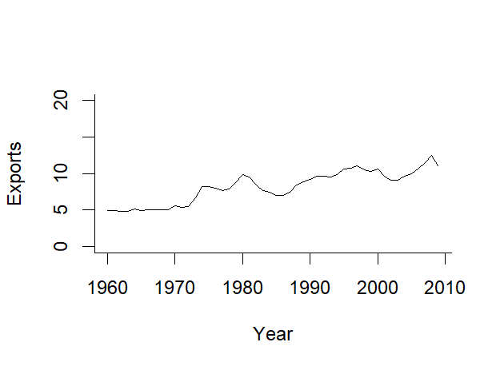
(2). Split the time series into a training set and a validation set with the validation set size = 10.
(3). Build a linear trend model from the training set and test it on the validation set. Plot the actual vs. predicted graph and calculate the RMSE.
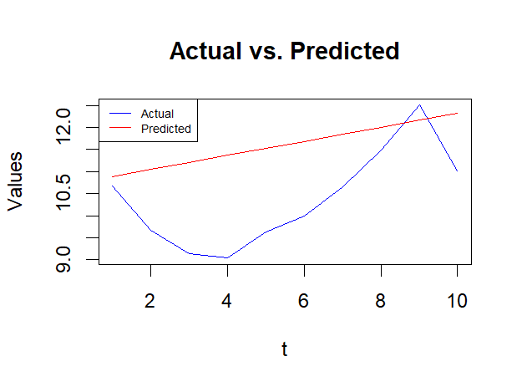
RMSE = 1.473003 for the linear model.

(4). Build an exponential trend model from the training set and test it on the validation set. Plot the actual vs. predicted graph and calculate the RMSE.
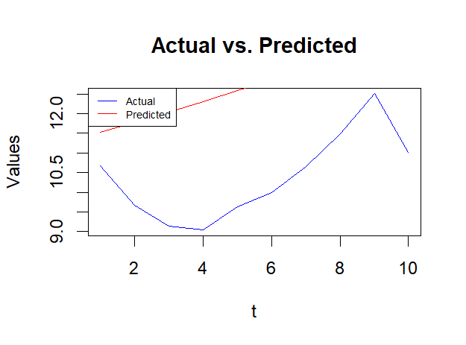
RMSE = 2.488111 for the exponential model.

(5). Build a quadratic trend model from the training set and test it on the validation set. Plot the actual vs. predicted graph and calculate the RMSE.
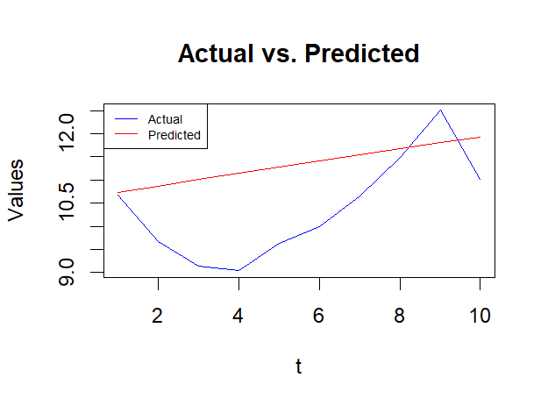
RMSE = 1.27785 for the quadratic model.

(6). Which model is the best?
The quadratic model has the lowest RMSE so it is the best.

Problem 4 (10 points). For this problem, use hw10_p3.csv dataset.
(1). Plot the time plot.
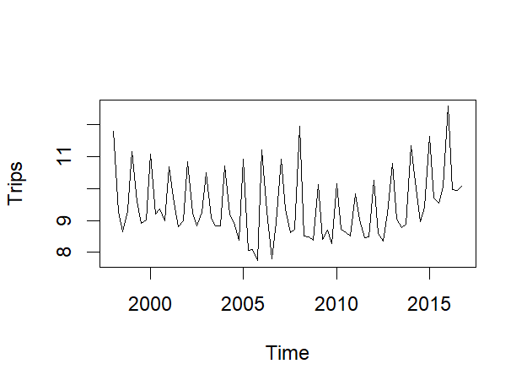

(2). Decompose the time series and plot the components.
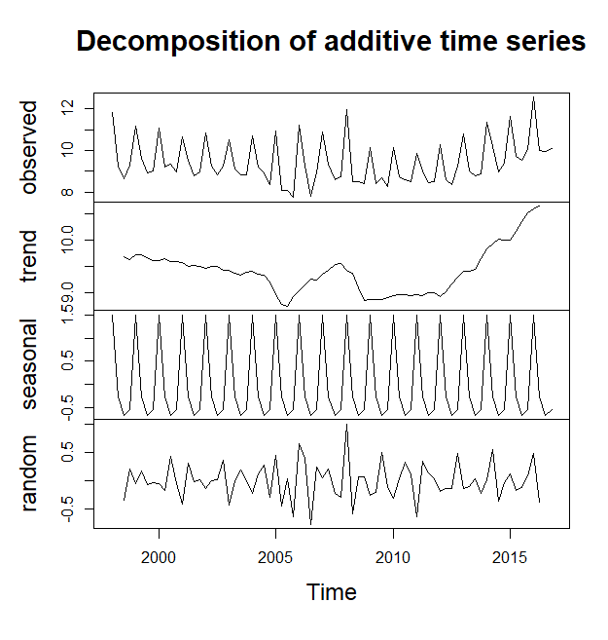
(3). Split the time series into a training set and a validation set with the validation set size = 12.

(4). Build a model with quadratic trend and seasonality (refer to Slide 43) from the training set and test it on the validation set. Plot the actual vs. predicted graph and calculate the RMSE.
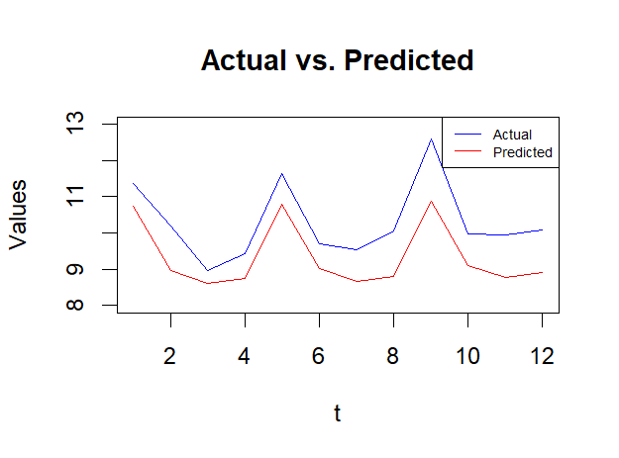
RMSE = 1.0234209 for quadratic trend and seasonal model.

(5). Build a Holt-Winter's triple exponential smoothing model (refer to Slide 57) from the training set and test it on the validation set. Plot the actual vs. predicted graph and calculate the RMSE.
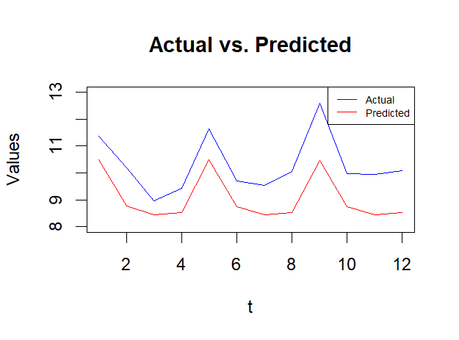
RMSE = 1.3025783 for Holt-Winter's triple exponential smoothing model.
(6). Run the auto.arima function to find "best" parameters. Show the parameters in your answer.

(7). Build an arima model using the above "best" parameters. Plot the actual vs. predicted graph and calculate the RMSE.
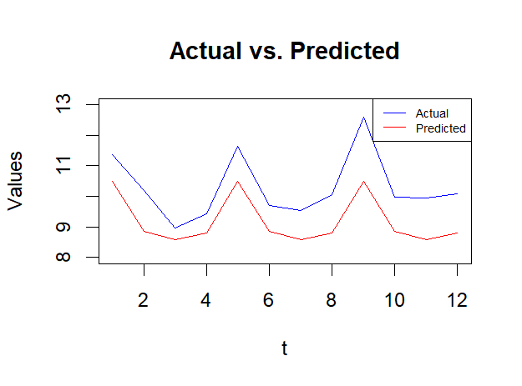
RMSE = 1.1832995 for ARIMA method.

Submission:
Include all answers in a single file and name it LastName_FirstName_HW10.EXT. Here, “EXT” is an appropriate file extension (e.g., docx or pdf). You also need to submit an R code file, hw10.R. Combine all files into a single archive file. Name it LastName_FirstName_HW10.EXT. Here, “EXT” is an appropriate archive file extension (e.g., zip or rar). Upload the file to Blackboard.

