Assignment 5
Due date: 2/26

Problem 1 (10 points) Consider the following confusion matrix.
 |  | predicted class
 |  | C1 (positive) | C2 (negative)
actual class | C1 (positive) | 132 | 29
 | C2 (negative) | 87 | 218
Compute sensitivity, specificity, precision, accuracy, F-meassure, F2, and MCC measures. You
must do all calculations yourself and must show all your calculation steps.
$$sensitivity=\frac{TP}{P}=\frac{132}{132+29}=\frac{132}{161}=0.820$$
$$specificity=\frac{TN}{N}=\frac{218}{87+218}=\frac{218}{305}=0.715$$
$$precision=\frac{TP}{TP+FP}=\frac{132}{132+87}=\frac{132}{219}=0.603$$
$$accuracy=\frac{TP+TN}{All}=\frac{132+218}{132+29+87+218}=\frac{350}{466}=0.751$$
$$F\text{-}measure=\frac{2×precision×recall}{precision+recall}=\frac{2×0.603×0.820}{0.603+0.820}=\frac{0.988}{1.423}=0.695$$
$$F_{2}=\frac{(1+2^{2})×precision×recall}{2^{2}×precision+recall}=\frac{(1+4)×0.603×0.820}{4×0.603+0.820}=\frac{5×0.603×0.820}{2.411+0.820}=\frac{2.471}{3.231}=0.765$$
$$MCC=\frac{TP×TN-FP×FN}{\sqrt{\left(TP+FP\right)\left(TP+FN\right)\left(TN+FP\right)\left(TN+FN\right)}}=\frac{132×218-87×29}{\sqrt{\left(132+87\right)\left(132+29\right)\left(218+87\right)\left(218+29\right)}}=\frac{28776-2523}{\sqrt{\left(219\right)\left(161\right)\left(305\right)\left(247\right)}}=\frac{26253}{\sqrt{2656236765}}=\frac{26253}{51538.69}=0.509$$

Measure | Value
sensitivity | 0.820
specificity | 0.715
precision | 0.603
accuracy | 0.751
F-measure | 0.695
F2 | 0.765
MCC | 0.509
Problem 2 (10 points) Suppose you built two classifier models M1 and M2 from the same
training dataset and tested them on the same test dataset using 10-fold cross-validation. The error
rates obtained over 10 iterations (in each iteration the same training and test partitions were used
for both M1 and M2) are given in the table below. Determine whether there is a significant
difference between the two models using the t-test that we discussed in the class. Use a
significance level of 1%. If there is a significant difference, which one is better?

Iteration | M1 | M2 | M1 – M2
1 | 0.12 | 0.08 | 0.04
2 | 0.08 | 0.11 | -0.03
3 | 0.1 | 0.12 | -0.02
4 | 0.13 | 0.05 | 0.08
5 | 0.05 | 0.09 | -0.04
6 | 0.09 | 0.13 | -0.04
7 | 0.1 | 0.19 | -0.09
8 | 0.08 | 0.04 | 0.04
9 | 0.25 | 0.2 | 0.05
10 | 0.19 | 0.12 | 0.07

Note: When you calculate var(M1 – M2), calculate a sample variance (not a population
variance).
You must do all calculations yourself and must show all calculation steps.
$$\overline{err}\left(M_{1}\right)=\frac{0.12+0.08+0.10+0.13+0.05+0.09+0.10+0.08+0.25+0.19}{10}=0.119$$
$$\overline{err}\left(M_{2}\right)=\frac{0.08+0.11+0.12+0.05+0.09+0.13+0.19+0.04+0.20+0.12}{10}=0.113$$
$$\overline{err}\left(M_{1}-M_{2}\right)=\overline{err}\left(M_{1}\right)-\overline{err}\left(M_{2}\right)=0.119-0.113=0.006$$

$$var\left(M_{1}-M_{2}\right)=\frac{\sum_{i=1}^{n}{{\left(err{\left(M_{1}-M_{2}\right)}_{i}-\overline{err}\left(M_{1}-M_{2}\right)\right)}^{2}}}{n-1}=((0.04-0.006)^2+(-0.03-0.006)^2+(-0.02-0.006)^2+(0.08-0.006)^2+(-0.04-0.006)^2+(-0.04-0.006)^2+(-0.09-0.006)^2+(0.04-0.006)^2+(0.05-0.006)^2+(0.07-0.006)^2)/9=({0.034}^{2}-{0.036}^{2}-{0.026}^{2}+{0.074}^{2}-{0.046}^{2}-{0.046}^{2}-{0.096}^{2}+0.034^2+0.044^2+0.064^2)/9=(0.00116+0.00130+0.00068+0.00548+0.00212+0.00212+0.00922+0.00116+0.00194+0.00410)/9=0.0292/9=0.00325$$
$$k=10$$
$$t_{0}=\frac{\overline{err}\left(M_{1}\right)-\overline{err}\left(M_{2}\right)}{\sqrt{\frac{var\left(M_{1}-M_{2}\right)}{k}}}=\frac{0.119-0.113}{\sqrt{\frac{0.00325}{10}}}=\frac{0.006}{\sqrt{0.000325}}=\frac{0.006}{0.018}=0.333$$
$$α=0.01$$
$$df=k-1=9$$
$$t_{α/2,df}=t_{0.005,9}=3.250$$

$$3.250>0.333=t_{α/2,df}>t_{0}∴not significant$$
There is no significant difference between the two models at significance level of 1%.

Problem 3 (10 points). The following table shows a test result of a classifier on a dataset.
Tuple_id | Actual Class | Probability
1 | P | 0.75
2 | N | 0.32
3 | N | 0.87
4 | P | 0.93
5 | P | 0.84
6 | P | 0.48
7 | N | 0.95
8 | P | 0.59
9 | N | 0.63
10 | P | 0.74

(1). For each row, compute TP, FP, TN, FN, TPR, and FPR.
Tuple_id | Actual Class | Probability | TP | FP | TN | FN | TPR | FPR
7 | N | 0.95 | 0 | 1 | 3 | 6 | 0.00 | 0.25
4 | P | 0.93 | 1 | 1 | 3 | 5 | 0.17 | 0.25
3 | N | 0.87 | 1 | 2 | 2 | 5 | 0.17 | 0.50
5 | P | 0.84 | 2 | 2 | 2 | 4 | 0.33 | 0.50
1 | P | 0.75 | 3 | 2 | 2 | 3 | 0.50 | 0.50
10 | P | 0.74 | 4 | 2 | 2 | 2 | 0.67 | 0.50
9 | N | 0.63 | 4 | 3 | 1 | 2 | 0.67 | 0.75
8 | P | 0.59 | 5 | 3 | 1 | 1 | 0.83 | 0.75
6 | P | 0.48 | 6 | 3 | 1 | 0 | 1.00 | 0.75
2 | N | 0.32 | 6 | 4 | 1 | 0 | 1.00 | 1.00

(2). Plot the ROC curve for the dataset. You must draw the curve yourself (i.e., don’t use R or any other software to generate the curve).
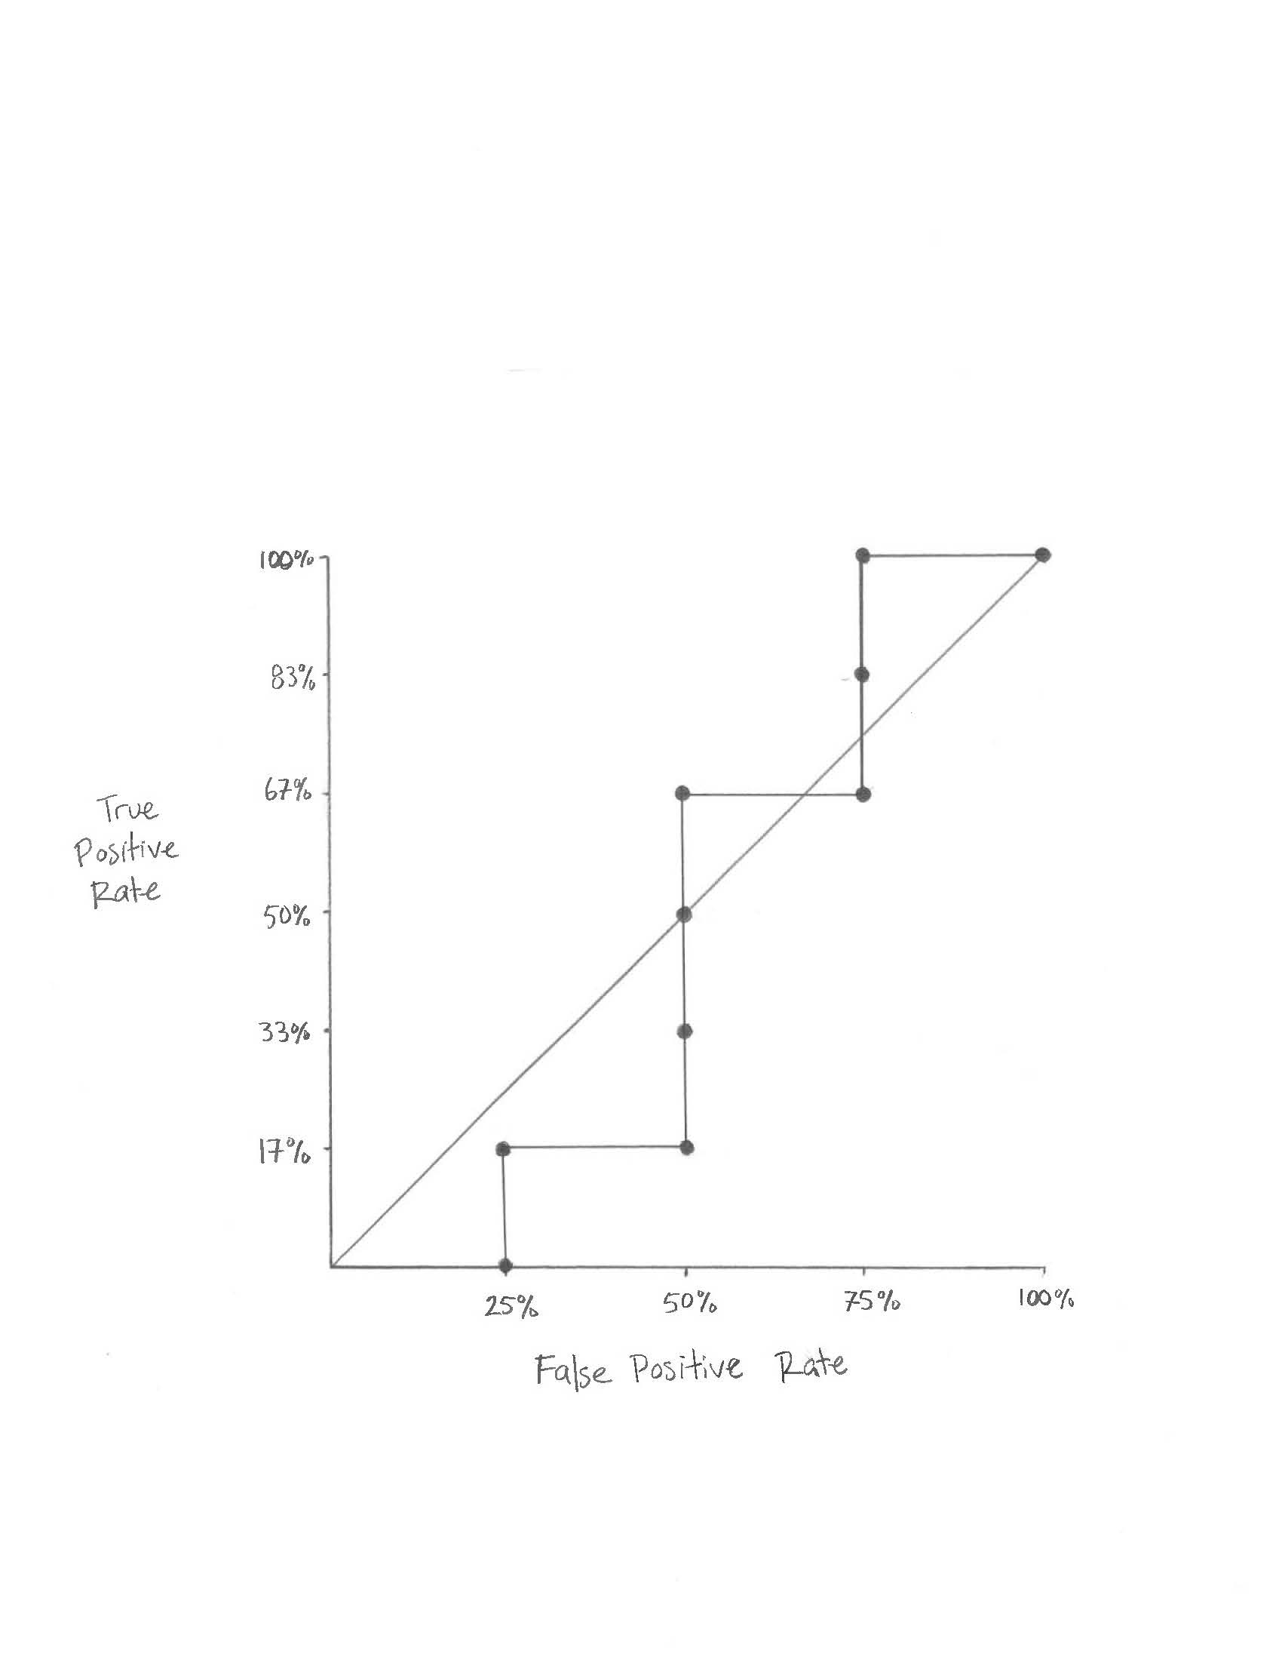
Problem 4 (10 points). This problem is a small experiment of handling an unbalanced dataset for classification. Use hw5_p4_train.csv and hw5_p4_test.csv files. You must use the rpart algorithm in R to build decision trees.
(1). Build a decision tree model from hw5_p4_train.csv and test it on hw5_p4_test.csv. Include the resulting confusion matrix in your submission.
Confusion Matrix and Statistics

Reference
Prediction no yes
no 1331 128
yes 29 49

Accuracy : 0.8979
95% CI : (0.8816, 0.9125)
No Information Rate : 0.8848
P-Value [Acc > NIR] : 0.05776

Kappa : 0.3377

Mcnemar's Test P-Value : 5.23e-15

Sensitivity : 0.9787
Specificity : 0.2768
Pos Pred Value : 0.9123
Neg Pred Value : 0.6282
Prevalence : 0.8848
Detection Rate : 0.8660
Detection Prevalence : 0.9493
Balanced Accuracy : 0.6278

'Positive' Class : no

(2). Create an undersampled training dataset from hw5_p4_train.csv and name it hw5_p4_train_undersampled.csv. Build a decision tree model from this undersampled dataset and test it on hw5_p4_test.csv. Include the resulting confusion matrix in your submission.

I used the downSample method from caret to create my undersampled dataset. This method works by randomly sampling the dataset so that all classes will have the same frequency as the minority class. In this case the minority class is ‘yes’, so all of the ‘yes’ tuples are left intact and the ‘no’ tuples are sampled with simple random sampling until the number equals the number of ‘yes’ tuples.

Confusion Matrix and Statistics

Reference
Prediction no yes
no 966 27
yes 394 150

Accuracy : 0.7261
95% CI : (0.7031, 0.7483)
No Information Rate : 0.8848
P-Value [Acc > NIR] : 1

Kappa : 0.2933

Mcnemar's Test P-Value : <2e-16

Sensitivity : 0.7103
Specificity : 0.8475
Pos Pred Value : 0.9728
Neg Pred Value : 0.2757
Prevalence : 0.8848
Detection Rate : 0.6285
Detection Prevalence : 0.6461
Balanced Accuracy : 0.7789

'Positive' Class : no

(3). Create an oversampled training dataset from hw5_p4_train.csv and name it hw5_p4_train_oversampled.csv. Build a decision tree model from this oversampled dataset and test it on hw5_p4_test.csv. Include the resulting confusion matrix in your submission.

I used the upSample method from caret to create my oversampled dataset. This method works by randomly sampling the dataset so that all classes will have the same frequency as the majority class. In this case the majority class is ‘no’, so all of the original tuples are left intact and the ‘yes’ tuples are sampled with simple random sampling with replacement until the number equals the number of ‘no’ tuples.

Confusion Matrix and Statistics

Reference
Prediction no yes
no 1016 28
yes 344 149

Accuracy : 0.758
95% CI : (0.7358, 0.7792)
No Information Rate : 0.8848
P-Value [Acc > NIR] : 1

Kappa : 0.3315

Mcnemar's Test P-Value : <2e-16

Sensitivity : 0.7471
Specificity : 0.8418
Pos Pred Value : 0.9732
Neg Pred Value : 0.3022
Prevalence : 0.8848
Detection Rate : 0.6610
Detection Prevalence : 0.6792
Balanced Accuracy : 0.7944

'Positive' Class : no

(4). What conclusion can you draw from this experiment?

The original unbalanced dataset gave the model the best overall accuracy (0.8979 vs 0.7261 vs 0.758) and the best sensitivity (0.9787 vs 0.7103 vs 0.7471).
Both undersampling and oversampling provided much better specificity compared to the original dataset (0.8475 vs 0.8418 vs 0.2768).
Both undersampling and oversampling improved positive predictive value at the expensive of negative predictive value compared to the original dataset.
Both undersampling and oversampling reduced the number of false positives at the cost of increasing false negatives. (this is a bit hard to see because ‘no’ is the positive class)
Overall, there is a not a large difference between undersampling and oversampling. In this case the oversampling method has slightly better metrics. Both methods improved the model’s accuracy when predicting the minority class (the negative class) but with a small decrease in accuracy when predicting the majority class (the positive class).

Note: You may use any methods to create undersampled and oversampled training
datasets. You must include in your submission name(s) of the methods/functions you used
and brief description of these methods/functions.
Submission:
Include all files in a single archive file and name it LastName_FirstName_HW5.EXT. Here,
“EXT” is an appropriate file extension (e.g., zip or rar).

