CS566 A3 Final Exam
Due – Dec 21, 2023, 6:00 PM

Student’s Name: Joseph Rissman

All work must be your own.
No extensions or late submissions for anything.

(1) [20 pts.]
Describe an efficient algorithm that, given n integers in the range of 1 to k, preprocess the in- put and then answers any query about how many of the n integers fall into the range [a, b] in O(1) time.
An algorithm like counting sort could be used, but instead of a simple array, a 2-dimensional matrix could be used instead. The integer values would be ordered along one axis from 1 to k, then the range size would be along the other axis from 1 to k. The algorithm would preprocess the integers by first creating an array of size k which records the number of occurrences of each integer. This step would take O(n) time. The pseudocode for this step is:
count ← array of size k with all zeros
for i = 0 to n – 1
key = input[i]
count[key]++
Then the 2D matrix is computed by summation of each successive integer count in the range, which would take O(k^2) time. The pseudocode for this step is:
total ← k x k size matrix with all zeros
for i = 1 to k
for j = i to k
if (i = j)
total[i,j] = count[i]
else
total[i,j] = total[i,j-1] + count[j] //(add to previous total)
Once the preprocessing is complete, the matrix of values contains the number of integers in the range [a, b] at the (a, b) term of the total matrix. The matrix can be used to answer any query by performing a direct lookup in the matrix, which takes O(1) time.

(2) [25 pts.]
a) Compute a min spanning tree using KRUSCAL’s algorithm for graph below.
Each vertex is labeled by integer number, each edge has signed weight.
Show the spanning tree and cite its total weight.

7
8
9
1
6
8
9
5
4
6
3
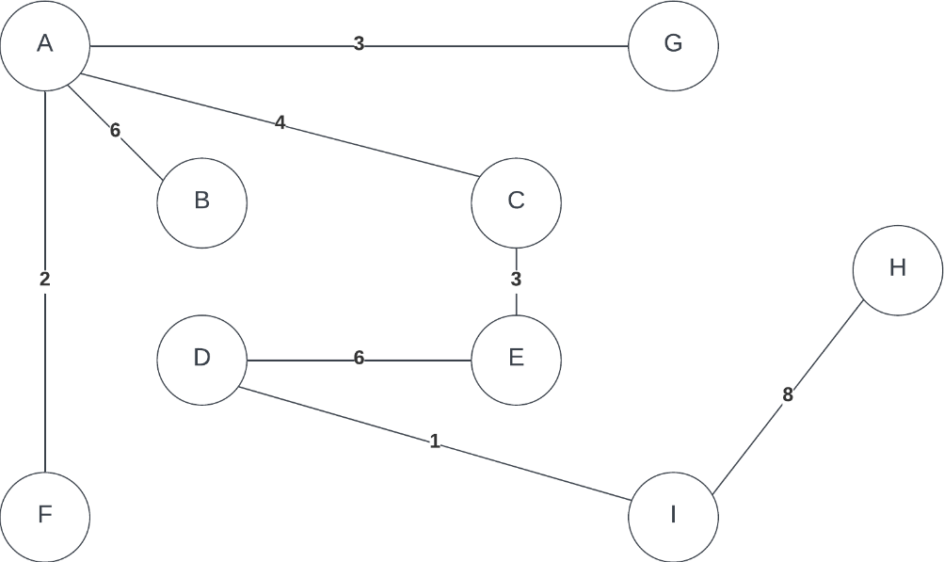
The total weight of the minimum spanning tree is 33.

b) Use PRIM’S ALGORITHM and compute a min spanning tree starting at VERTEX A. Show the spanning tree and cite its total weight. The graph is the same as for a).

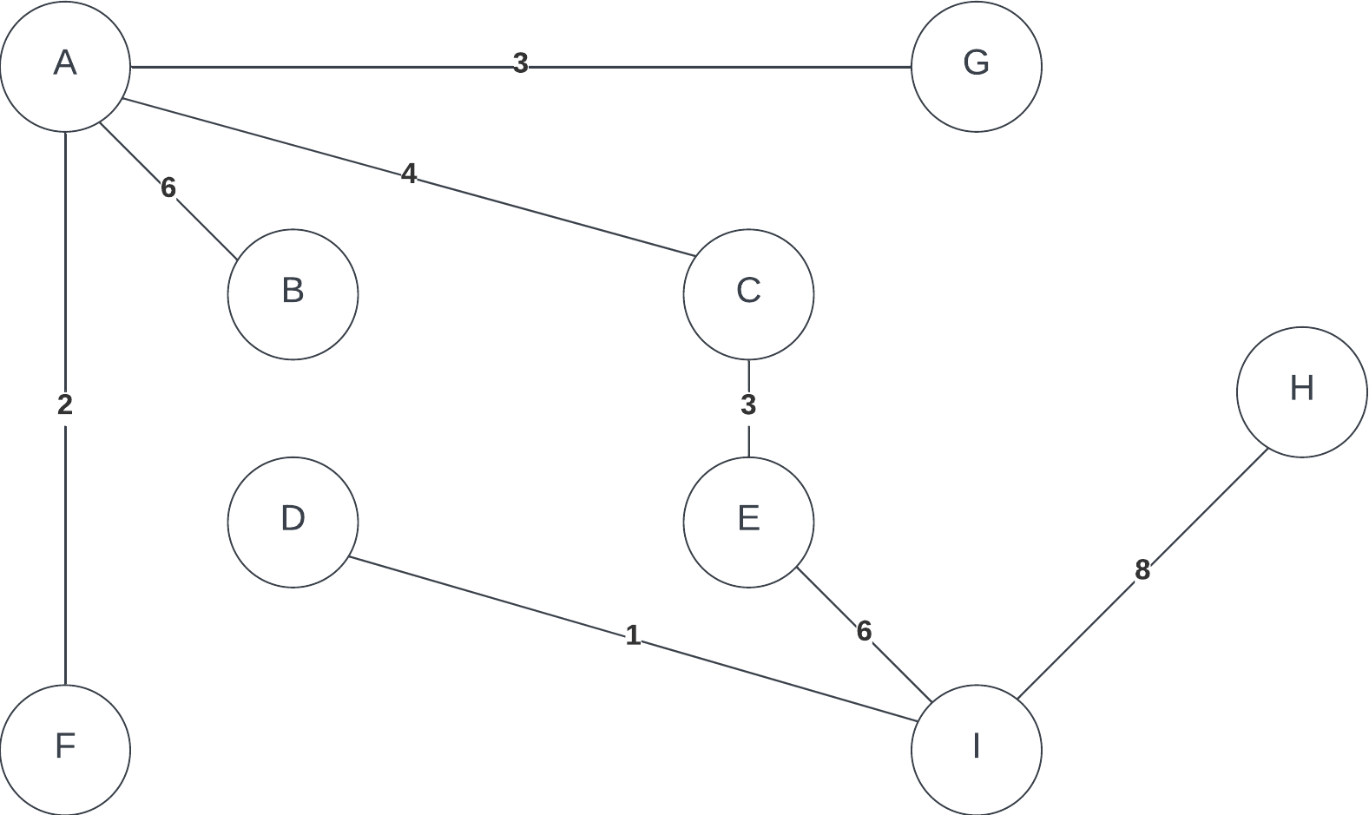
The total weight of the minimum spanning tree is 33.

(3) [25 pts] Run the Dijkstra algorithm on the following directed graph. Begin with node A. You need to show all steps. At each step show, list of not yet visited vertices, distances from A to graph vertices and paths

Numbers above vertexes are distance from starting vertex.
Numbers on edges indicate the order in which edges are added to the shortest-path tree.
Step 0: Initialize at vertex A.
Q = {A, B, C, D, E}
dist = {0, ∞, ∞, ∞, ∞}
S = {}
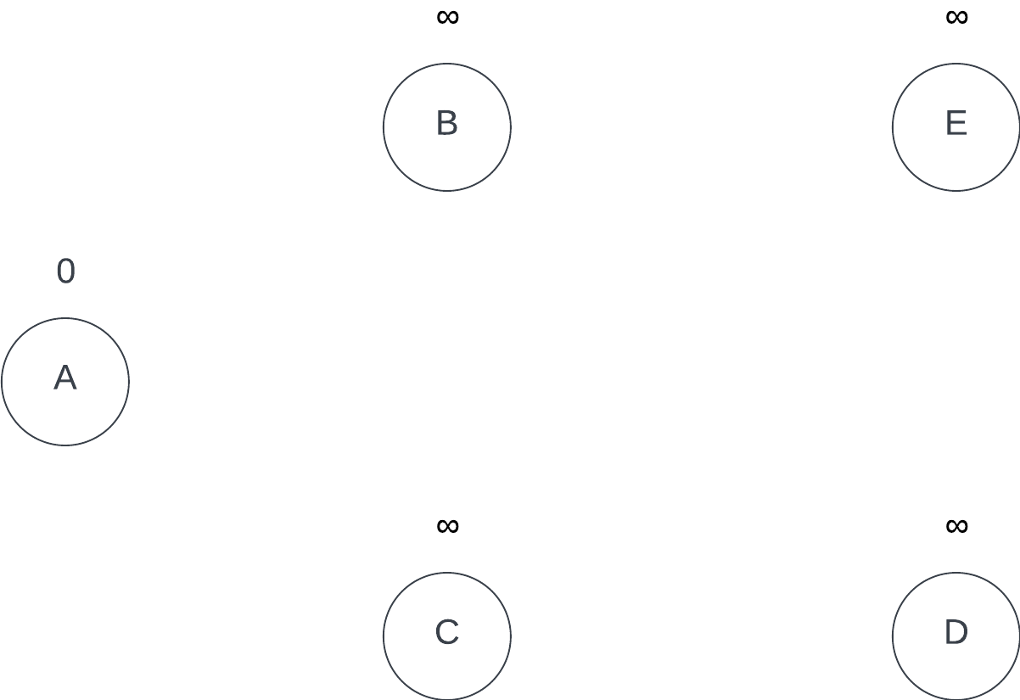

Step 1: Set vertex A as current node. Update distances and shortest-path tree.
Q = {B, C, D, E}
dist = {0, 4, 2, ∞, ∞}
S = {A}
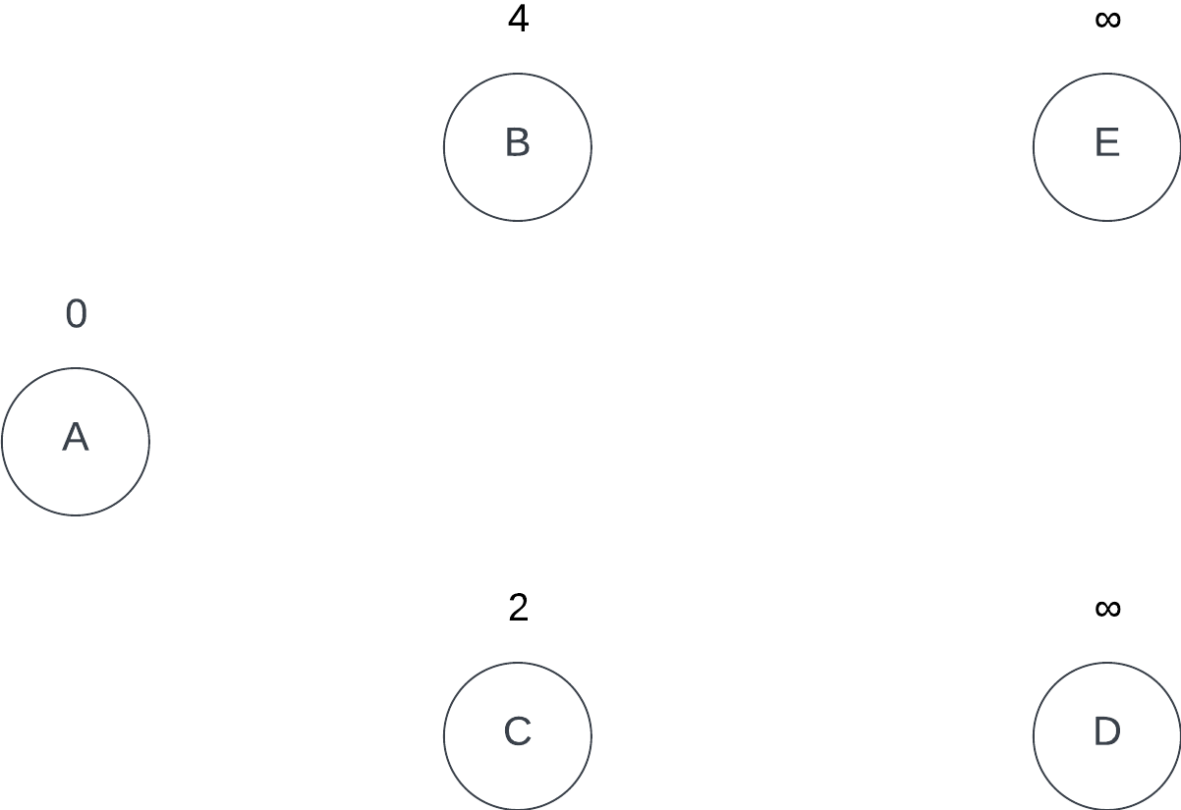

Step 2: Set vertex C as current node. Update distances and shortest-path tree.
Q = {B, D, E}
dist = {0, 4, 2, 7, 6}
S = {A, C}
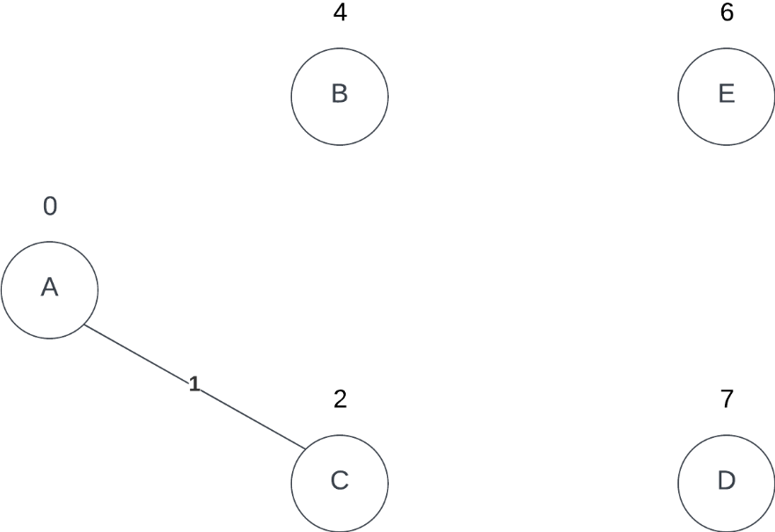

Step 3: Set vertex B as current node. Update distances and shortest-path tree.
Q = {D, E}
dist = {0, 4, 2, 7, 6}
S = {A, C, B}
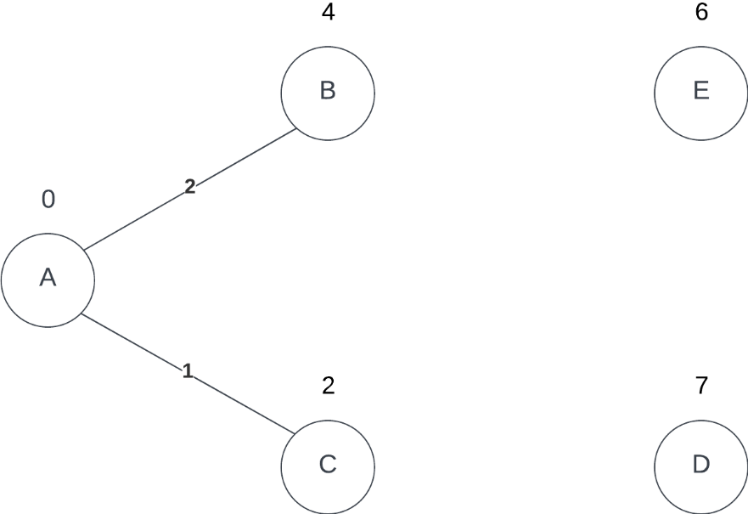

Step 4: Set vertex E as current node. Update distances and shortest-path tree.
Q = {D}
dist = {0, 4, 2, 7, 6}
S = {A, C, B, E}
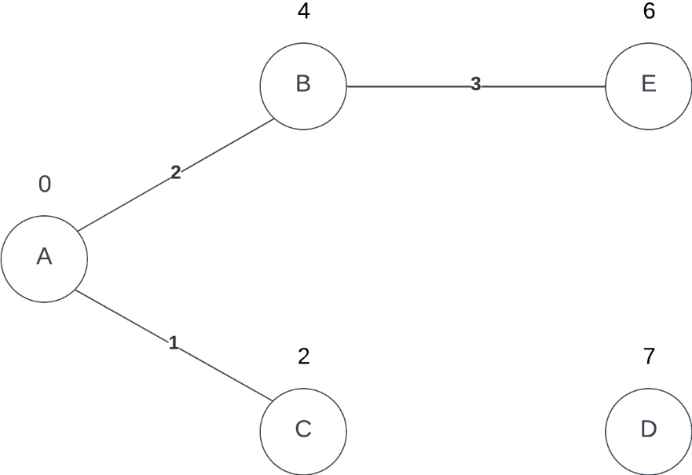

Step 5: Set vertex D as current node. Update distances and shortest-path tree.
Q = {}
dist = {0, 4, 2, 7, 6}
S = {A, C, B, E, D}
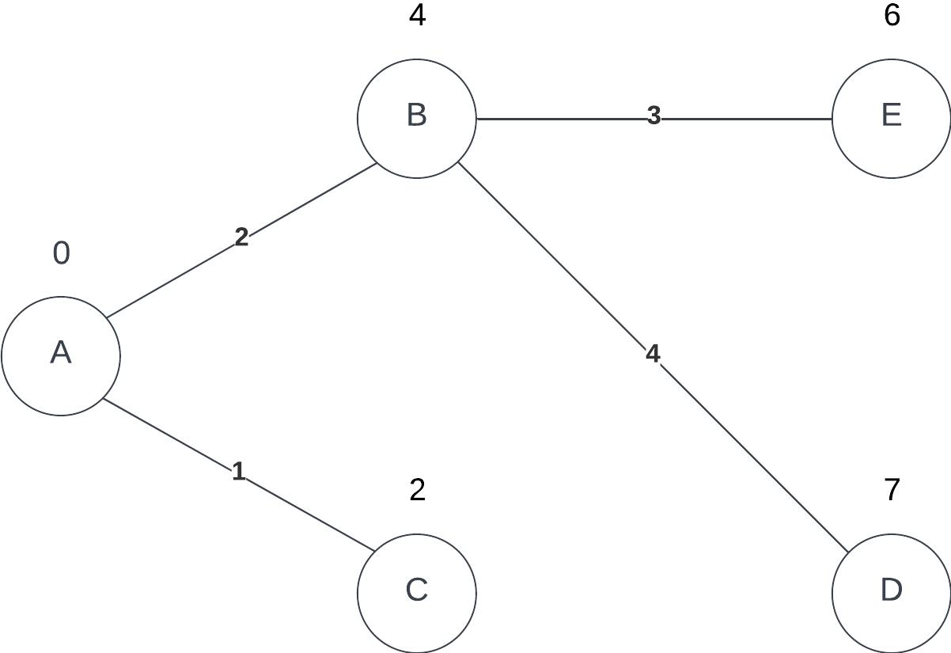

(4) [30 pts.]

Run the Ford-Fulkerson algorithm on the following flow network. Show step by step all augmenting paths, the best path, max flow value. The numbers on graph give the capacitance of each flow network segment.
Explain why the flow value you found is the max value for this case.


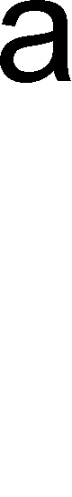



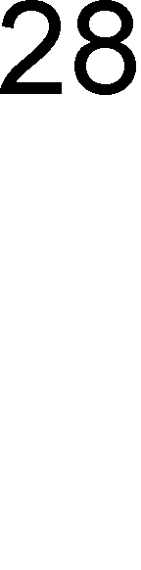
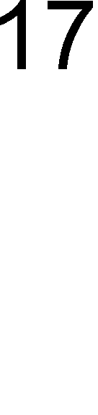
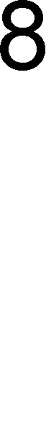
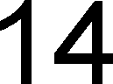

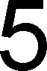
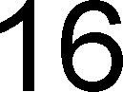
13
24

22

Hint: You should start with 0 flow and then augment the paths. Each time check that flow entering the node is equal to flow exiting the node.
Remember that you are modeling the “pipe” network. You may reverse direction of the flow through the pipes if you think it helps to increase flow through the network. The only obvious exceptions are flows exiting Source and entering Target (Sink).

Step 0: Initialize flow to 0.
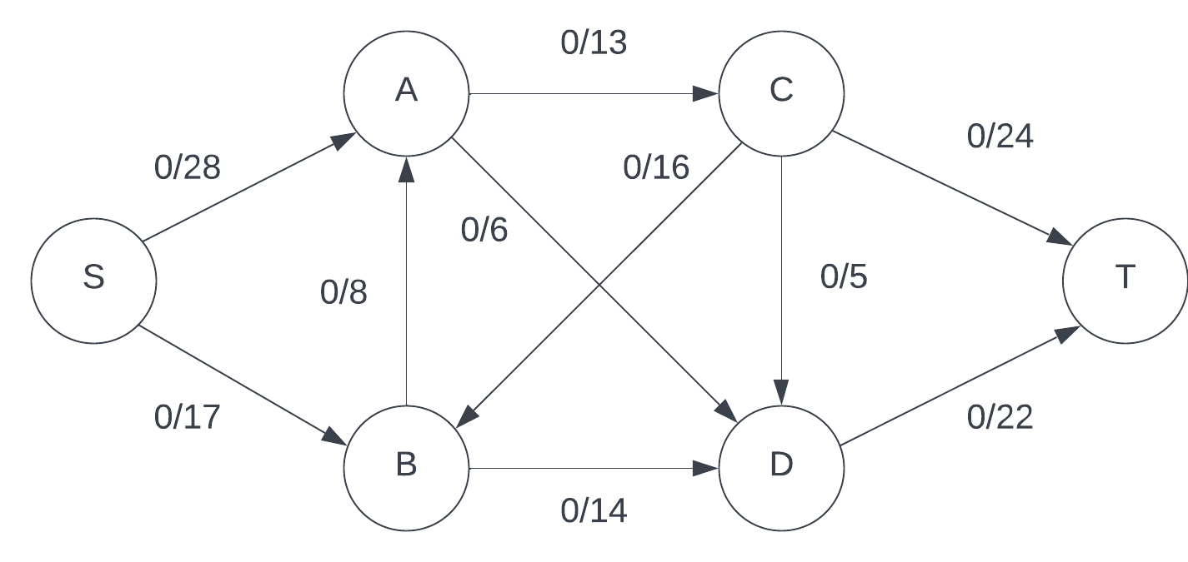
Step 1: Use augmenting path S → A → C → T with maximum flow 13.
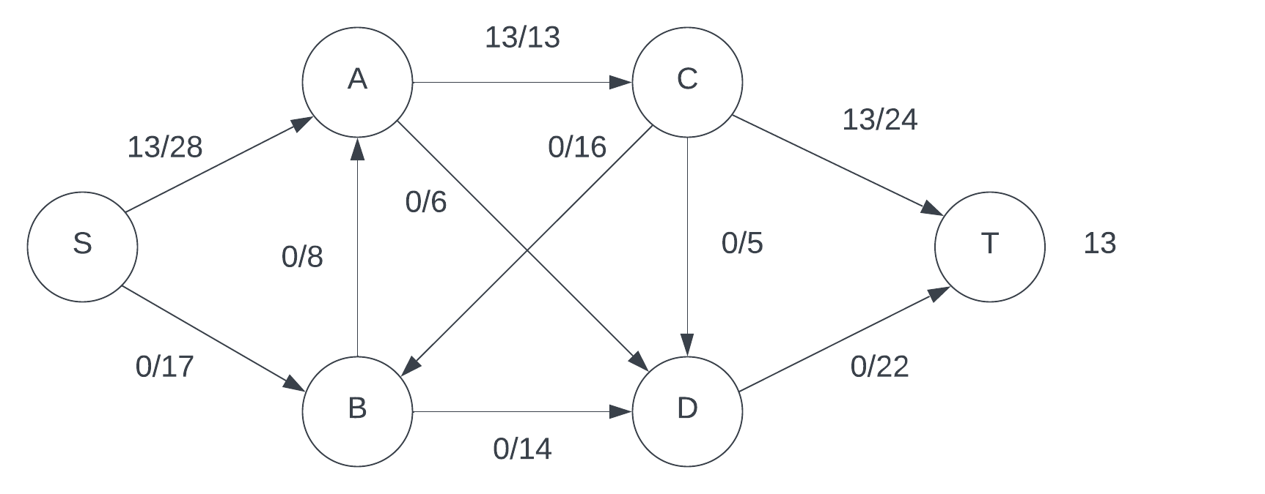
Step 2: Use augmenting path S → B → D → T with maximum flow 14.
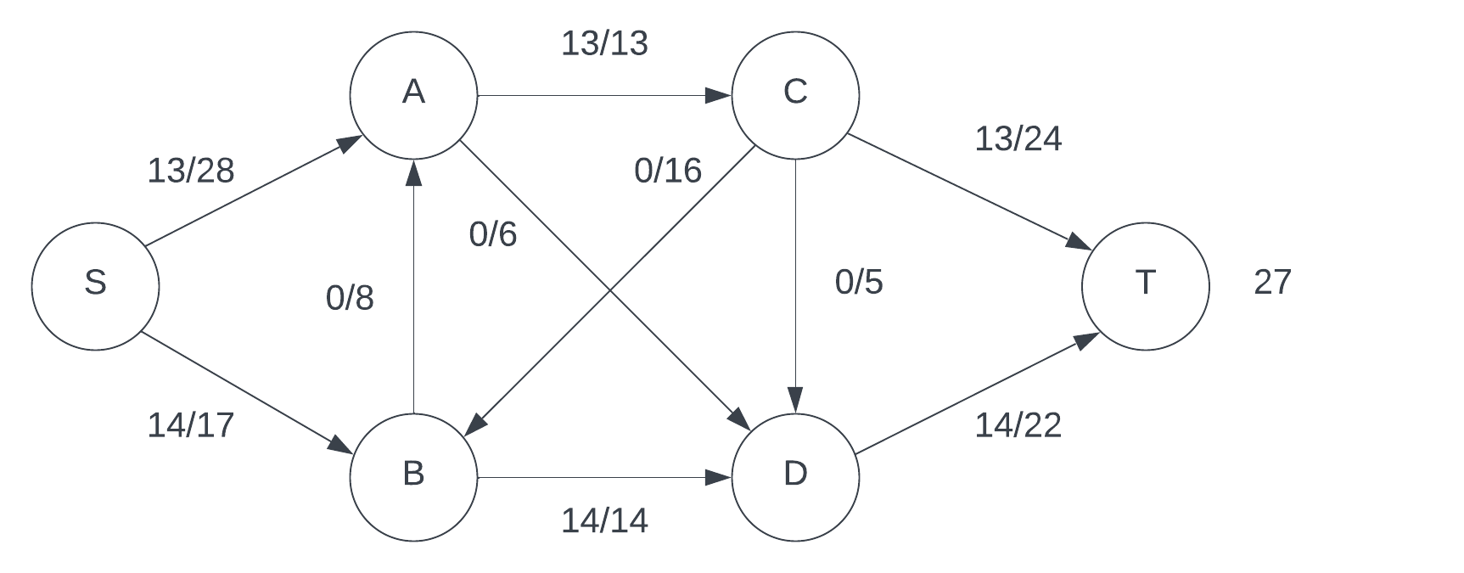

Step 3: Use augmenting path S → A → D → T with maximum flow 6.
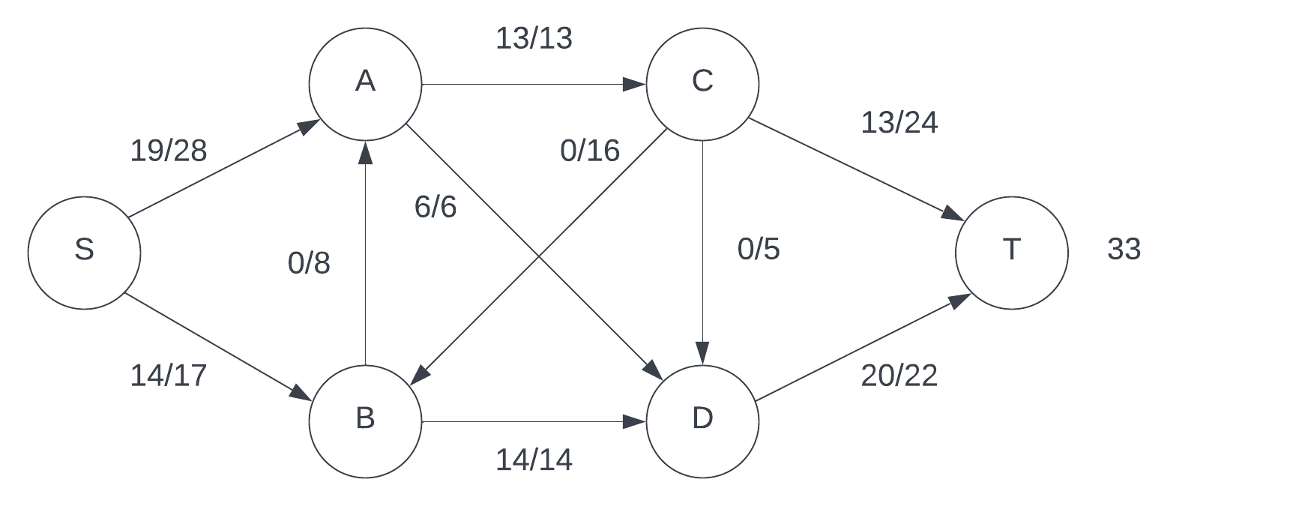
Step 4: Use augmenting path S → B → C → T with maximum flow 3.
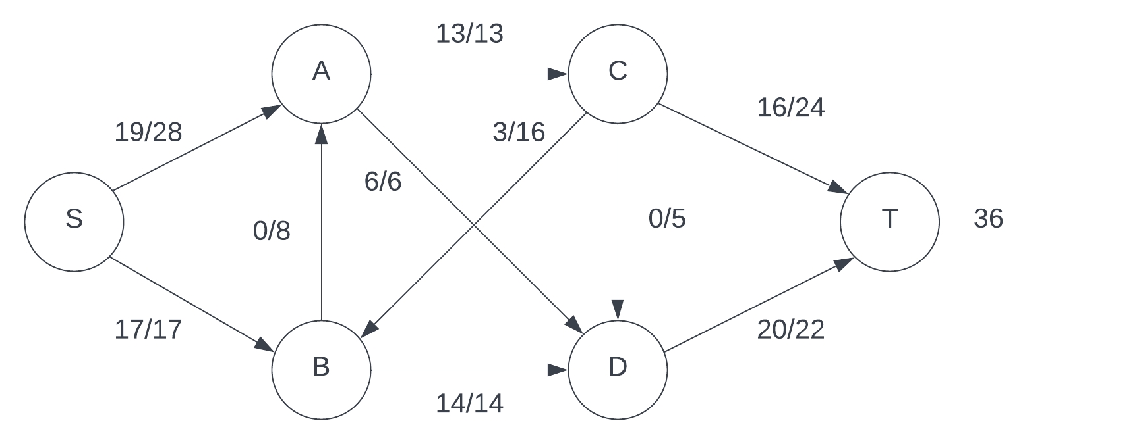
Step 5: Use augmenting path S → A → B → C → T with maximum flow 8.
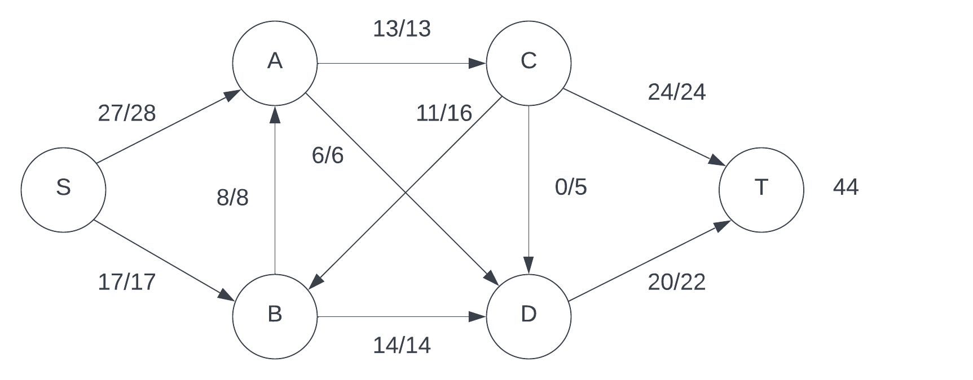
There are no more augmenting paths, so the total flow of the network is 44. This is the maximum flow possible for this network because the maximum flow possible through node A is 27 and the maximum flow from the source through node B is 17. The max flow through A is 27 because all pipes connected to A (other than the source) total 27 so there is no way to get more flow through A. Since the flow can only come from the source through nodes A and B, the max flow through those pipes determines the flow through the entire network, therefore the total sum must be 44.

