CS566 Homework-3
Due – Oct 12, 6:00 PM, at the class beginning

Student’s Name: Joseph Rissman

(1) [20 pts.]
Take as input a sequence of 2n real numbers. Design an O(n log n) algorithm that partitions the numbers into n pairs, with the property that the partition minimizes the maximum sum of a pair.

For example, say we are given the numbers (1,3,5,9). The possible partitions are ((1,3),(5,9)), ((1,5),(3,9)), and ((1,9),(3,5)). The pair sums for these partitions are (4,14), (6,12), and (10,8). Thus the third partition has 10 as its maximum sum, which is the minimum over the three partitions.

To minimize sums of pairs, we observe that the largest number must always be paired with the smallest number. If the largest number were paired with any other number, the sum would be greater than if it was paired with the smallest number. Once these numbers have been paired, they can be removed from the set of input numbers. We then must observe that this same property holds for the subset of input numbers that we just created. This continues until all numbers are assigned to a pair. This implies that if the input numbers were already sorted, then the first and last numbers can be paired, then the second and second-to-last numbers, and so on until all numbers are paired. Therefore, the algorithm that achieves this pairing in O(n log n) time is as follows:

Assign the numbers to an array of size 2n.
Utilize a sorting algorithm with O(n log n) to sort the array, such as merge sort.
For i from 0 to n-1: create a pair of the numbers at indexes i and 2n – 1 - i

Because sorting takes O(n log n) and creating the pairs takes O(n), the total time complexity of the algorithm is O(n log n) + O(n) = O(n log n).

(2) [20 pts] You wish to store a set of n numbers in either a max-heap or a sorted array.
For each application below, state which data structure is better, or if it does not
matter. Explain your answers.
- Want to find the maximum element quickly.
Both data structures as equally as good for finding the maximum element. In a max-heap, the maximum element is the root, which is found in constant time. In a sorted array, the maximum element is at the last index, which can also be found in constant time.
- Want to be able to delete an element quickly.
A max-heap is better for deletions because after deleting an element in a max-heap, the heapify algorithm needs to be used on the node that was swapped with the deleted node to return the structure to the correct state, which takes O(log n) time. The sorted array needs to update each element after the deleted element which takes O(n) time, which is longer.
- Want to be able to form the structure quickly.
Both data structures are equally as good in this case as well. Heapifying an array takes O(n log n) time, which is the same as the time complexity as merge sort.
- Want to find the minimum element quickly.
It is better to store the data as a sorted array because the minimum element of a sorted array is always the first index, which can be found in constant time, O(1). The minimum element of a max-heap is always a leaf at the bottom of the tree and takes O(log n) time to identify.

(3) [20 pts] Implement an external sort, which uses intermediate files to sort files bigger
than main memory. Why Mergesort is a better algorithm than Heapsort or Quicksort to base such an implementation on? Test your program both on files with small records and on files with large
records.
Merge sort is better for this sort of algorithm because it applies the principle of dividing the files into smaller files then sorting those files. It recursively does this to smaller and smaller files then merging them back into the large file. It’s this principle that I based my implementation on.

Source code and test cases for a small file (50 elements) and large file (10,000 elements) are attached.
(4) [20 pts.] Given the following file:

26,5,77,1,61,11,59,15,48,19

Sort this file by hand using Heapsort and answer the following questions:
(a) Draw the initial COMPLETE tree representation of the file BEFORE the HEAP is created.
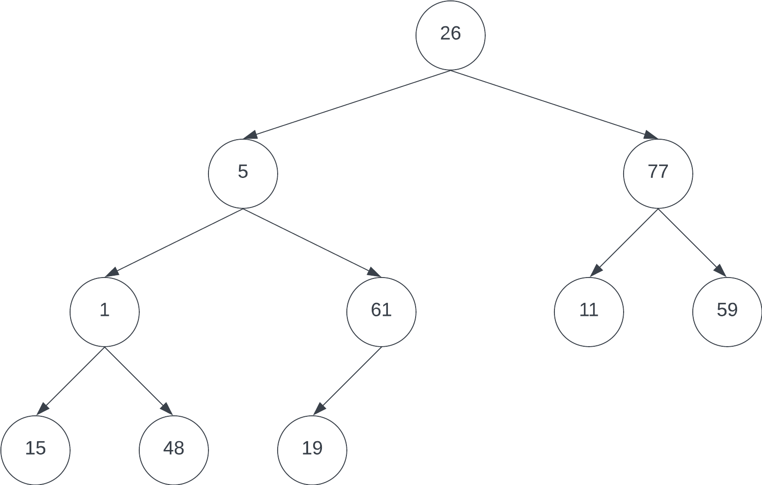
(b) Draw the initial heap.
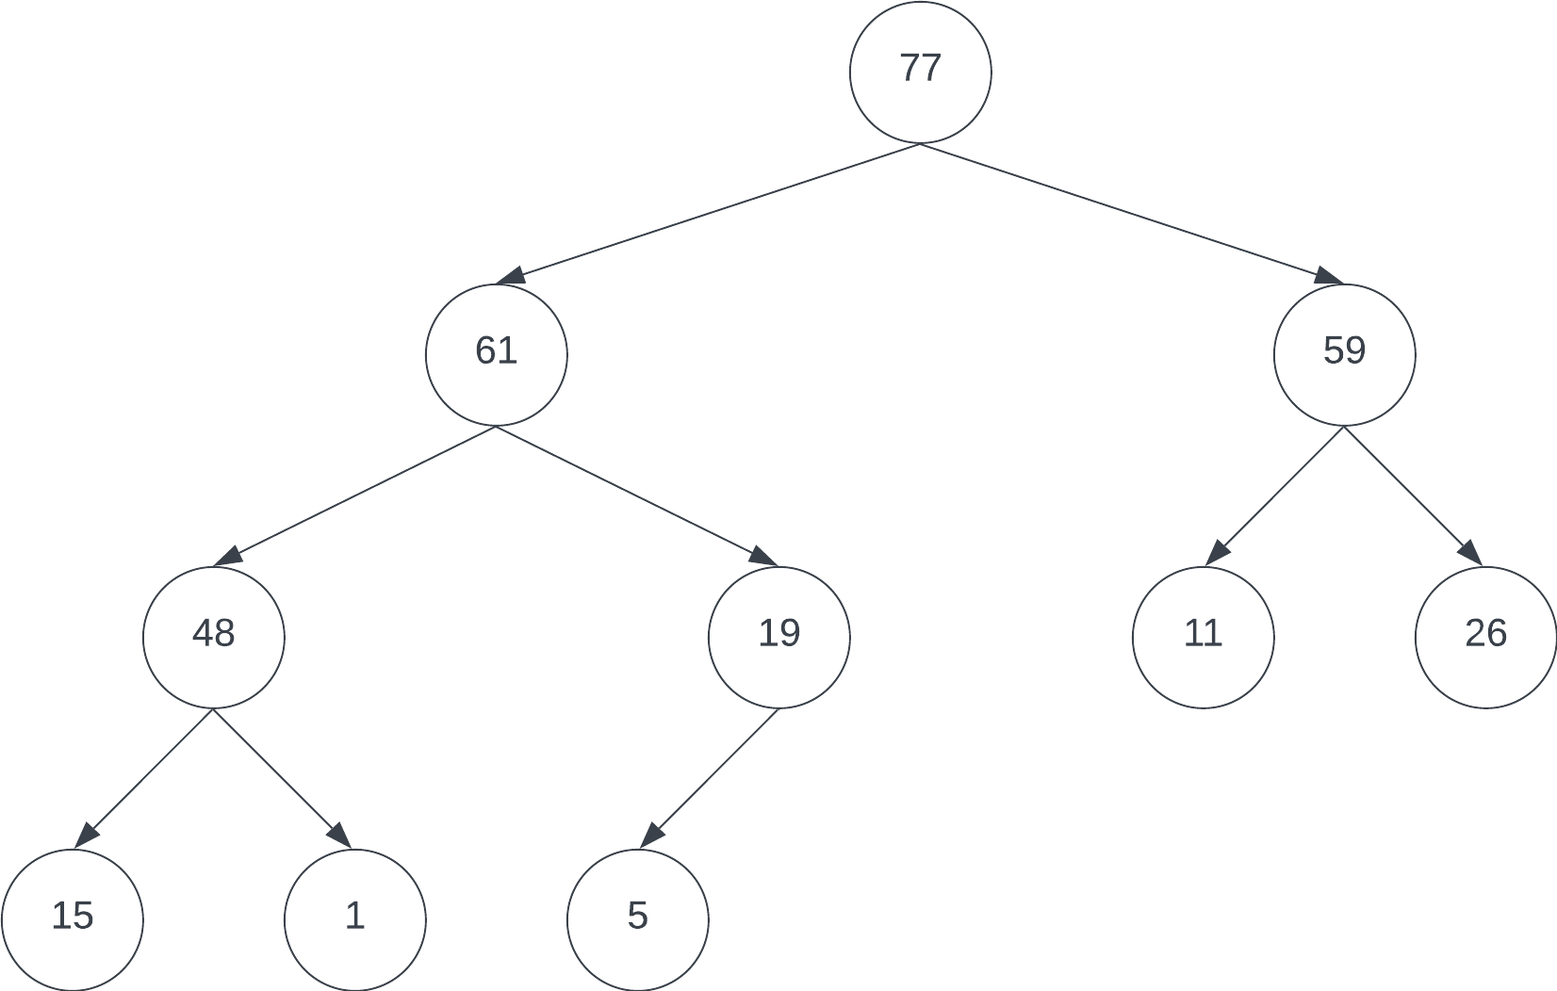
(c) Continue with the sort for two iterations PAST the initial heap – i.e., you pop off 77 and 61 from the root. NOW RESTRUCTURE THE HEAP AFTER 61 is popped – what is the NEW ROOT?
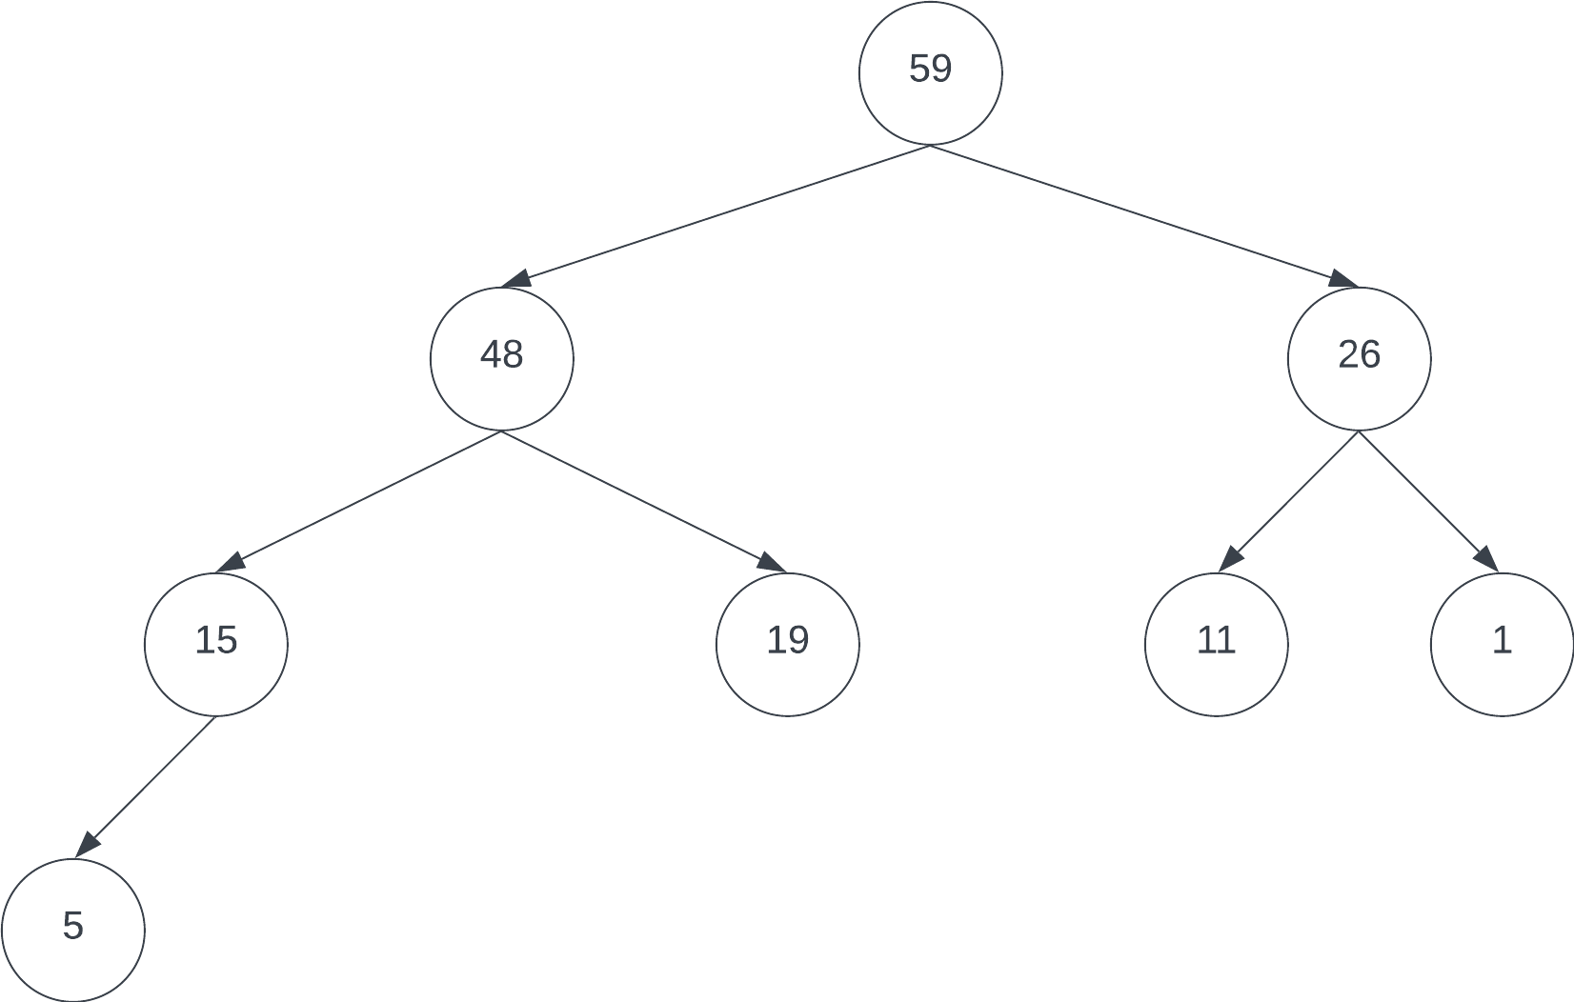

The new root is 59.
(5) [20 pts.] Use Quicksort as shown in class and sort the following file by hand and selectin the first element as the split element:

72,20,73,42,11,80,39,30,100,46,88,32,21

72 | 20 | 73 | 42 | 11 | 80 | 39 | 30 | 100 | 46 | 88 | 32 | 21

72 | 20 | 73 | 42 | 11 | 80 | 39 | 30 | 100 | 46 | 88 | 32 | 21

72 | 20 | 73 | 42 | 11 | 80 | 39 | 30 | 100 | 46 | 88 | 32 | 21

72 | 20 | 42 | 73 | 11 | 80 | 39 | 30 | 100 | 46 | 88 | 32 | 21

72 | 20 | 42 | 11 | 73 | 80 | 39 | 30 | 100 | 46 | 88 | 32 | 21

72 | 20 | 42 | 11 | 73 | 80 | 39 | 30 | 100 | 46 | 88 | 32 | 21

72 | 20 | 42 | 11 | 39 | 80 | 73 | 30 | 100 | 46 | 88 | 32 | 21

72 | 20 | 42 | 11 | 39 | 30 | 73 | 80 | 100 | 46 | 88 | 32 | 21

72 | 20 | 42 | 11 | 39 | 30 | 73 | 80 | 100 | 46 | 88 | 32 | 21

72 | 20 | 42 | 11 | 39 | 30 | 46 | 80 | 100 | 73 | 88 | 32 | 21

72 | 20 | 42 | 11 | 39 | 30 | 46 | 80 | 100 | 73 | 88 | 32 | 21

72 | 20 | 42 | 11 | 39 | 30 | 46 | 32 | 100 | 73 | 88 | 80 | 21

72 | 20 | 42 | 11 | 39 | 30 | 46 | 32 | 21 | 73 | 88 | 80 | 100

21 | 20 | 42 | 11 | 39 | 30 | 46 | 32 | 72 | 73 | 88 | 80 | 100

21 | 20 | 42 | 11 | 39 | 30 | 46 | 32 | 72 | 73 | 88 | 80 | 100

21 | 20 | 42 | 11 | 39 | 30 | 46 | 32 | 72 | 73 | 88 | 80 | 100

21 | 20 | 42 | 11 | 39 | 30 | 46 | 32 | 72 | 73 | 88 | 80 | 100

21 | 20 | 11 | 42 | 39 | 30 | 46 | 32 | 72 | 73 | 88 | 80 | 100

21 | 20 | 11 | 42 | 39 | 30 | 46 | 32 | 72 | 73 | 88 | 80 | 100

21 | 20 | 11 | 42 | 39 | 30 | 46 | 32 | 72 | 73 | 88 | 80 | 100

21 | 20 | 11 | 42 | 39 | 30 | 46 | 32 | 72 | 73 | 88 | 80 | 100

21 | 20 | 11 | 42 | 39 | 30 | 46 | 32 | 72 | 73 | 88 | 80 | 100

11 | 20 | 21 | 42 | 39 | 30 | 46 | 32 | 72 | 73 | 88 | 80 | 100

11 | 20 | 21 | 42 | 39 | 30 | 46 | 32 | 72 | 73 | 88 | 80 | 100

11 | 20 | 21 | 42 | 39 | 30 | 46 | 32 | 72 | 73 | 88 | 80 | 100

11 | 20 | 21 | 42 | 39 | 30 | 46 | 32 | 72 | 73 | 88 | 80 | 100

11 | 20 | 21 | 42 | 39 | 30 | 46 | 32 | 72 | 73 | 88 | 80 | 100

11 | 20 | 21 | 42 | 39 | 30 | 46 | 32 | 72 | 73 | 88 | 80 | 100

11 | 20 | 21 | 42 | 39 | 30 | 46 | 32 | 72 | 73 | 88 | 80 | 100

11 | 20 | 21 | 42 | 39 | 30 | 46 | 32 | 72 | 73 | 88 | 80 | 100

11 | 20 | 21 | 42 | 39 | 30 | 32 | 46 | 72 | 73 | 88 | 80 | 100

11 | 20 | 21 | 32 | 39 | 30 | 42 | 46 | 72 | 73 | 88 | 80 | 100

11 | 20 | 21 | 32 | 39 | 30 | 42 | 46 | 72 | 73 | 88 | 80 | 100

11 | 20 | 21 | 32 | 39 | 30 | 42 | 46 | 72 | 73 | 88 | 80 | 100

11 | 20 | 21 | 32 | 30 | 39 | 42 | 46 | 72 | 73 | 88 | 80 | 100

11 | 20 | 21 | 30 | 32 | 39 | 42 | 46 | 72 | 73 | 88 | 80 | 100

11 | 20 | 21 | 30 | 32 | 39 | 42 | 46 | 72 | 73 | 88 | 80 | 100

11 | 20 | 21 | 30 | 32 | 39 | 42 | 46 | 72 | 73 | 88 | 80 | 100

11 | 20 | 21 | 30 | 32 | 39 | 42 | 46 | 72 | 73 | 88 | 80 | 100

11 | 20 | 21 | 30 | 32 | 39 | 42 | 46 | 72 | 73 | 88 | 80 | 100

11 | 20 | 21 | 30 | 32 | 39 | 42 | 46 | 72 | 73 | 88 | 80 | 100

11 | 20 | 21 | 30 | 32 | 39 | 42 | 46 | 72 | 73 | 88 | 80 | 100

11 | 20 | 21 | 30 | 32 | 39 | 42 | 46 | 72 | 73 | 88 | 80 | 100

11 | 20 | 21 | 30 | 32 | 39 | 42 | 46 | 72 | 73 | 88 | 80 | 100

11 | 20 | 21 | 30 | 32 | 39 | 42 | 46 | 72 | 73 | 88 | 80 | 100

11 | 20 | 21 | 30 | 32 | 39 | 42 | 46 | 72 | 73 | 88 | 80 | 100

11 | 20 | 21 | 30 | 32 | 39 | 42 | 46 | 72 | 73 | 80 | 88 | 100

11 | 20 | 21 | 30 | 32 | 39 | 42 | 46 | 72 | 73 | 80 | 88 | 100

11 | 20 | 21 | 30 | 32 | 39 | 42 | 46 | 72 | 73 | 80 | 88 | 100

11 | 20 | 21 | 30 | 32 | 39 | 42 | 46 | 72 | 73 | 80 | 88 | 100

(a) After the initial swapping, there are two subfiles – one to the left of 72 and one to the right of 72. Are they in order?

The subfiles are not in order. There are a few elements out of order in each subfile.

(b) Continue sorting the entire file until totally sorted. During the entire sort – what was the maximum number of inversions removed by a single comparison and swap?

If swapping the pivot with the last element less than the pivot at the end of the partition counts, then swapping 72 and 21 removed a total of 12 inversions (8 inversions involving 72 and 5 inversions involving 21, minus one extra inversion introduced).

If only a comparison and swap between elements that are not the pivot count, then swapping 21 and 100 removed a total of 6 inversions, 3 inversions per element swapped.

