CS566 Homework-4
Due – Nov 16, 6:00 PM, at the class beginning

Student’s Name: Joseph Rissman

All work must be your own. Upload copy of your homework and any supporting materials (source code and test cases) online to Assignment4 in the CS566_A3 course site
No extensions or late submissions for anything other than major emergency. Show your work in detail.

Q1 [10 pts.]: Given the following key sequence (6,22,9,14,13,1,8) build the dynamic binary search tree WITHOUT BALANCING IT. How many probes (i.e., comparisons) does it take to determine that key 100 is not in the tree? (In this study case, the root is 6; the next element 22 > 6, so it goes to the right, etc).

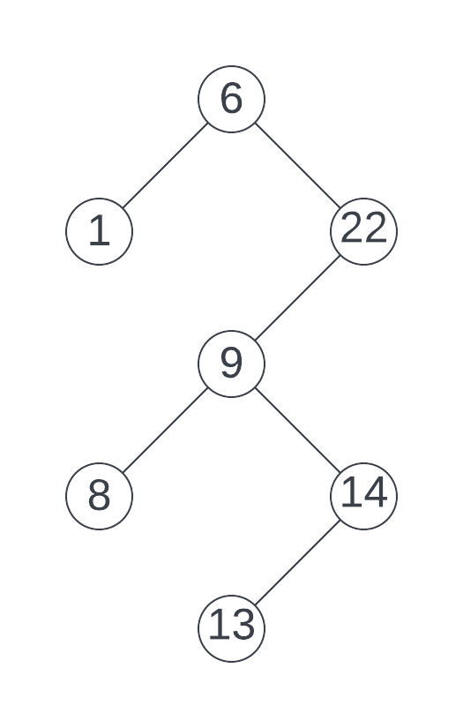
It only takes 2 comparisons to determine that 100 is not in the tree. First, 100 is compared to 6 and since it’s bigger, the right subtree is queried. Next, 100 is compared to 22 and since it’s bigger, the right subtree is queried but does not exist, therefore 100 is not in the tree.

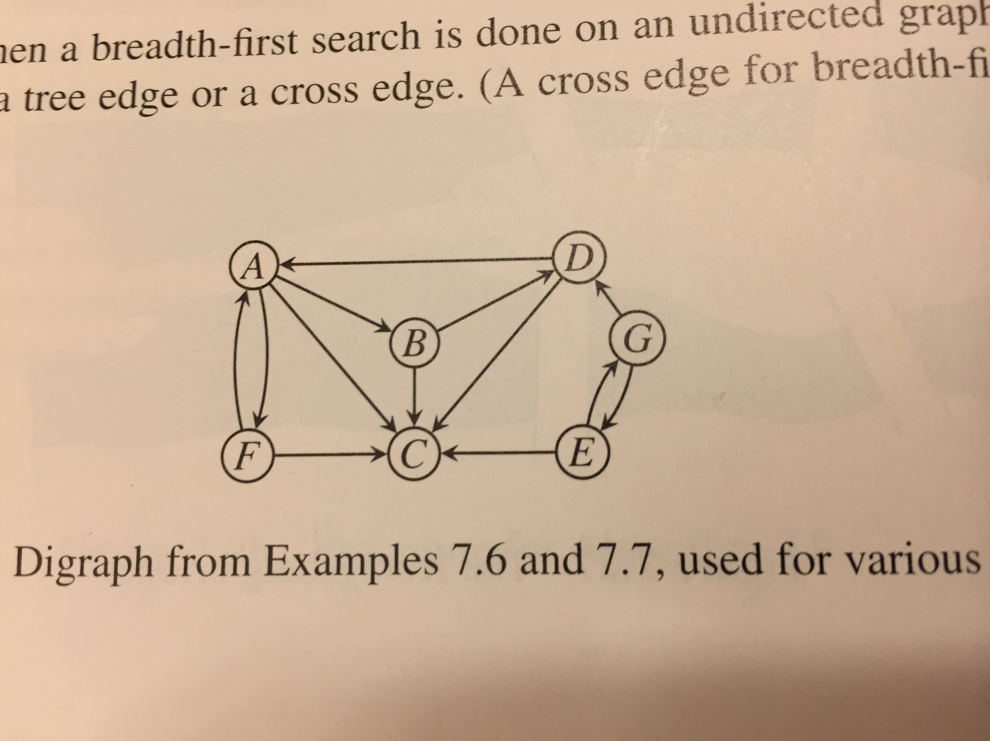 Fig.1
Q2 [15 pts.]: Find the depth-first search tree for the graph Fig.1 with G as the starting vertex. Assume that each adjacency list is in alphabetical order.
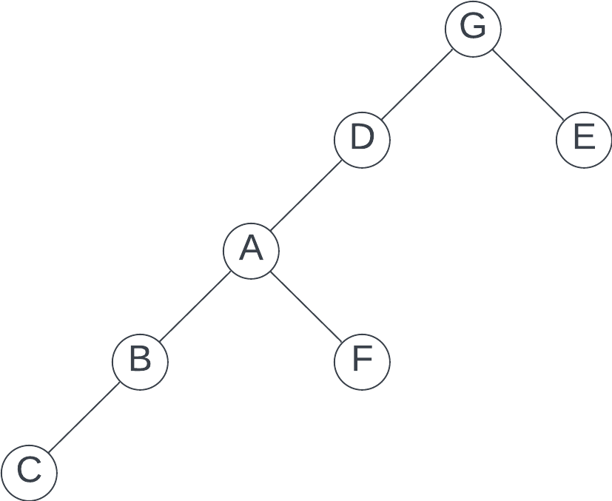

Q3 [15 pts.]: Find the breadth-first search tree for the graph Fig.1 with G as the starting vertex. Assume that each adjacency list is in reverse alphabetical order.
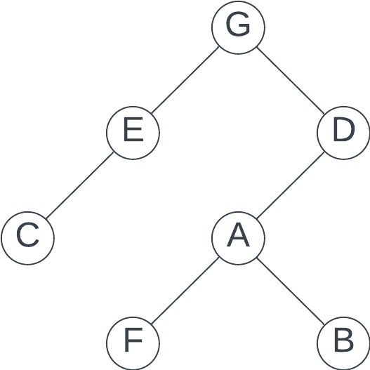

Q4 [20 pts.]: Execute Prim’s minimum spanning tree algorithm by hand on the graph in Fig.2, showing how the data structures evolve. Clearly indicate which edge s become part of minimum spanning tree and in what order. Start at vertex H.
Step 0: Initialize at vertex H.
Q = {A, B, C, D, E, F, G, H, I}
key = {∞, ∞, ∞, ∞, ∞, ∞, ∞, 0, ∞}
π = {null, null, null, null, null, null, null, null, null}
Step 1: Select min cost edge from 0, ∞. Add vertex H to MST.
Q = {A, B, C, D, E, F, G, I}
key = {∞, ∞, 2, 8, ∞, ∞, 3, 0, 4}
π = {null, null, H, H, null, null, H, null, H}
MST =

Step 2: Select min cost edge from 2, 3, 4, 8. Add vertex C and edge C,H to MST.
Q = {A, B, D, E, F, G, I}
key = {∞, 4, 2, 2, ∞, ∞, 3, 0, 4}
π = {null, C, H, C, null, null, H, null, H}
MST =
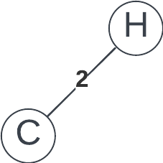
Step 3: Select min cost edge from 2, 3, 4, 4. Add vertex D and edge D,C to MST.
Q = {A, B, E, F, G, I}
key = {∞, 4, 2, 2, 1, ∞, 3, 0, 4}
π = {null, C, H, C, D, null, H, null, H}
MST =
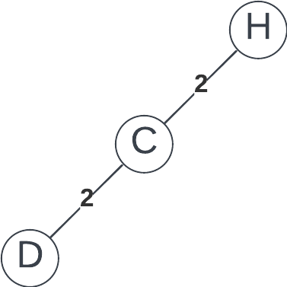
Step 4: Select min cost edge from 1, 3, 4, 4. Add vertex E and edge E,D to MST.
Q = {A, B, F, G, I}
key = {∞, 4, 2, 2, 1, 6, 3, 0, 2}
π = {null, C, H, C, D, E, H, null, E}
MST =
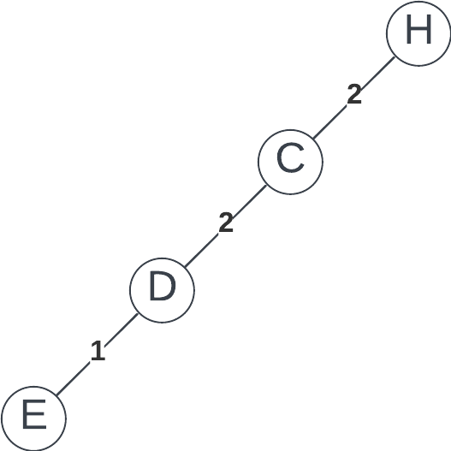

Step 5: Select min cost edge from 2, 3, 4, 6. Add vertex I and edge I,E to MST.
Q = {A, B, F, G}
key = {∞, 4, 2, 2, 1, 5, 1, 0, 2}
π = {null, C, H, C, D, I, I, null, E}
MST =
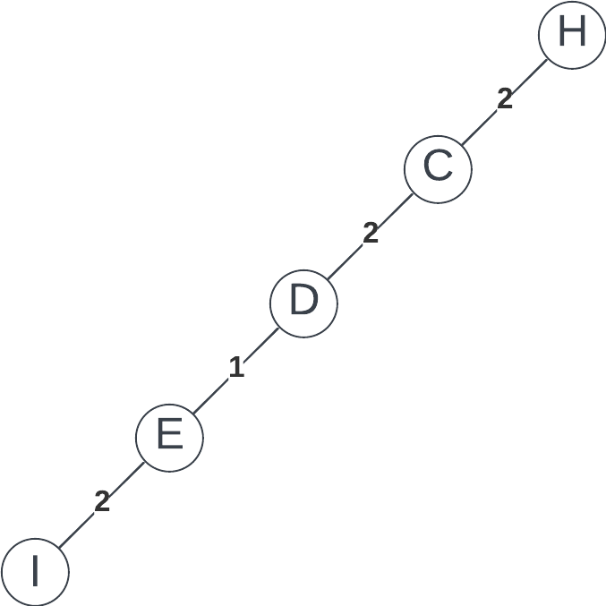
Step 6: Select min cost edge from 1, 4, 5. Add vertex G and edge G,I to MST.
Q = {A, B, F}
key = {3, 4, 2, 2, 1, 5, 1, 0, 2}
π = {G, C, H, C, D, I, I, null, E}
MST =
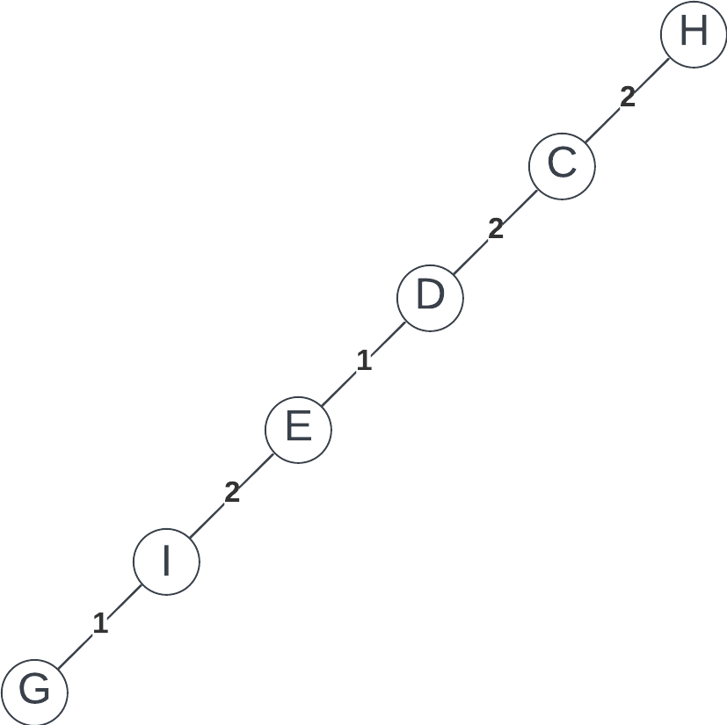

Step 7: Select min cost edge from 3, 4, 5. Add vertex A and edge A,G to MST.
Q = {B, F}
key = {3, 2, 2, 2, 1, 5, 1, 0, 2}
π = {G, A, H, C, D, I, I, null, E}
MST =
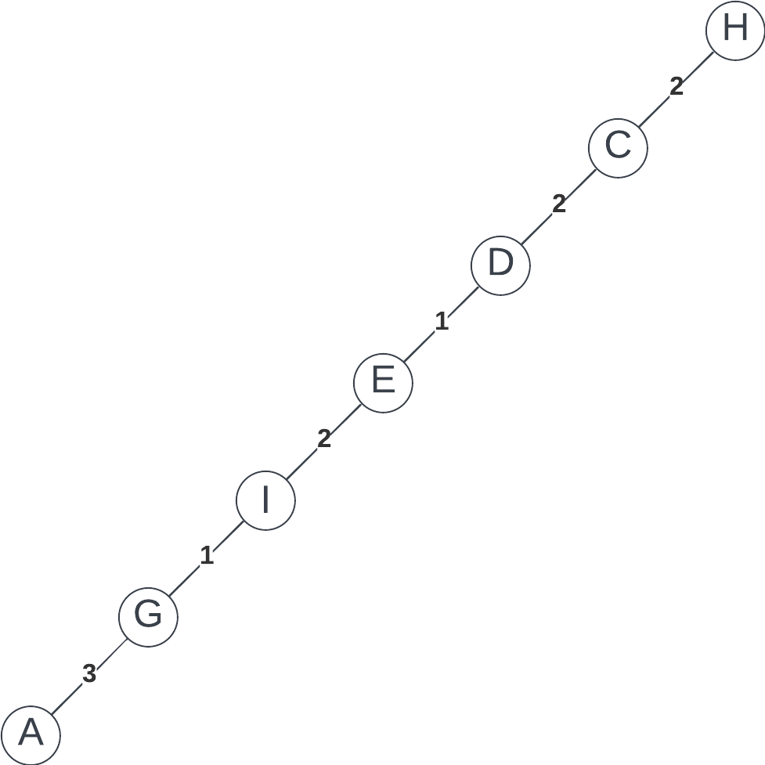
Step 8: Select min cost edge from 2, 5. Add vertex B and edge B,A to MST.
Q = {F}
key = {3, 2, 2, 2, 1, 5, 1, 0, 2}
π = {G, A, H, C, D, I, I, null, E}
MST =
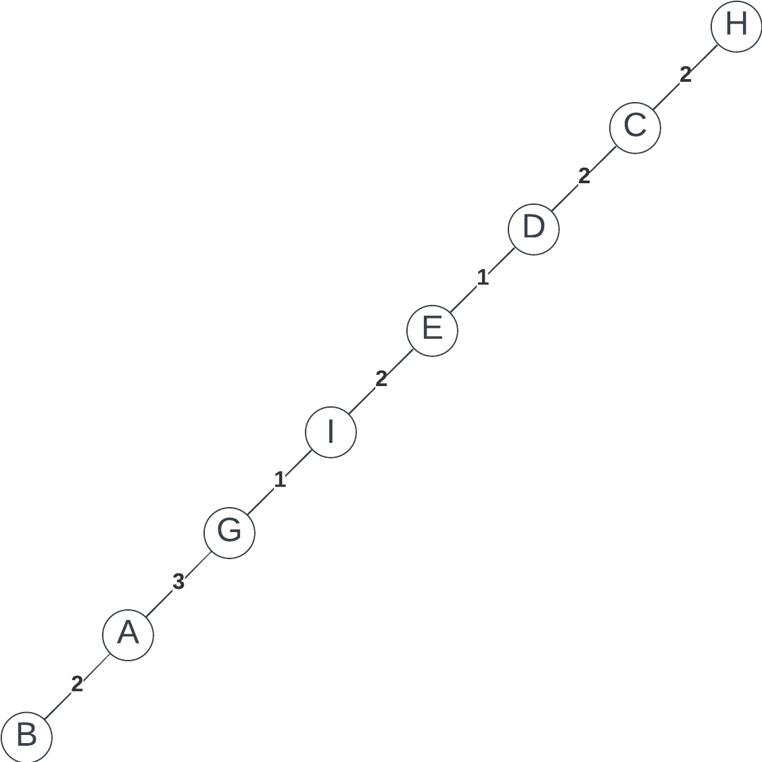

Step 9: Select min cost edge from 5. Add vertex F and edge F,I to MST.
Q = {}
key = {3, 2, 2, 2, 1, 5, 1, 0, 2}
π = {G, A, H, C, D, I, I, null, E}
MST =
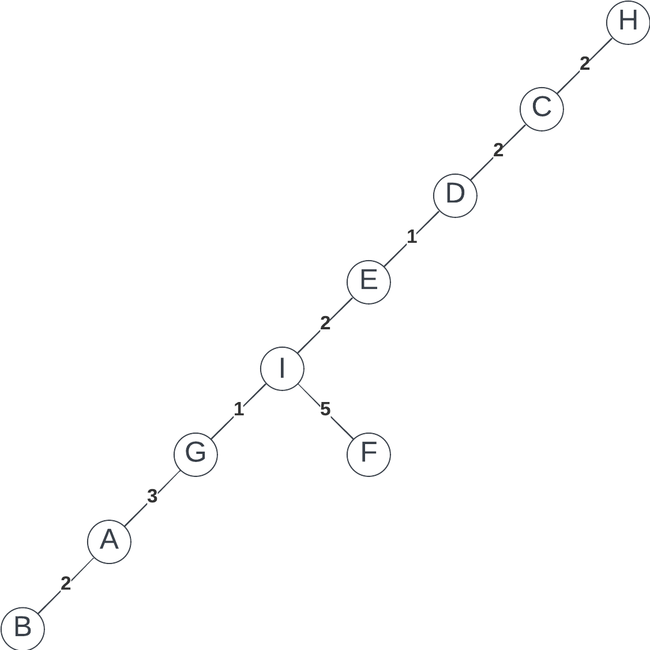
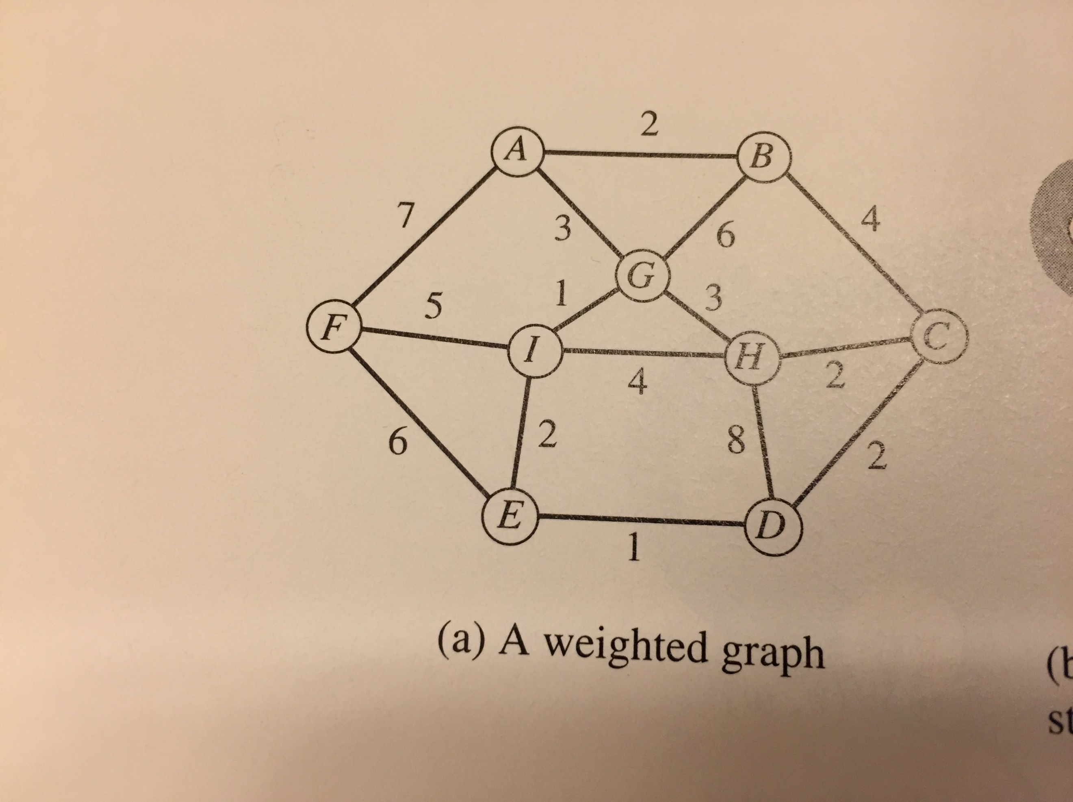
Fig.2
Q5 [20 pts.]: Dijkstra’s shortest path algorithm.
Here are the adjacency list with edge weights in parentheses for a digraph Fig.3
A: B (4.0), F (2.0)
B: A (1.0), C (3.0), D (4.0)
C: A (6.0), B(3.0), D(7.0)
D: A (6.0), E(2.0)
E: D (5.0)
F: D(2.0), E(3.0)

Execute Dijkstra’s shortest-path algorithm by hand on this graph, showing how the data structures evolve, with s = A. Clearly indicate which edge become part of the shortest –path tree in what order.

Numbers above/below vertexes are distance from starting vertex.
Numbers on edges indicate the order in which edges are added to the shortest-path tree.
Step 0: Initialize at vertex A.
Q = {A, B, C, D, E, F}
dist = {0, ∞, ∞, ∞, ∞, ∞}
S = {}
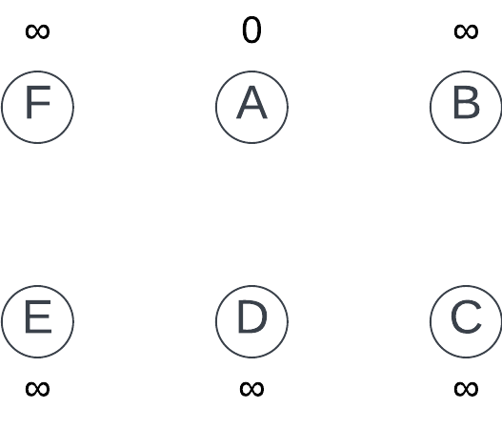
Step 1: Set vertex A as current node. Update distances and shortest-path tree.
Q = {B, C, D, E, F}
dist = {0, 4, ∞, ∞, ∞, 2}
S = {A}
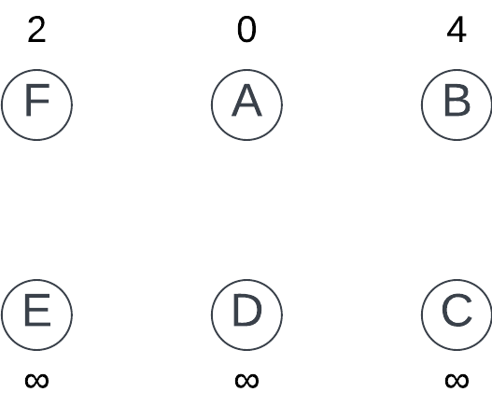
Step 2: Set vertex F as current node. Update distances and shortest-path tree.
Q = {B, C, D, E}
dist = {0, 4, ∞, 4, 5, 2}
S = {A, F}
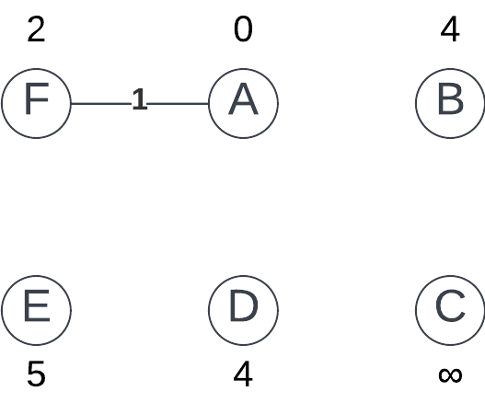
Step 3: Set vertex B as current node (vertex D has same dist value but B is chosen arbitrarily). Update distances and shortest-path tree.
Q = {C, D, E}
dist = {0, 4, 7, 4, 5, 2}
S = {A, F, B}
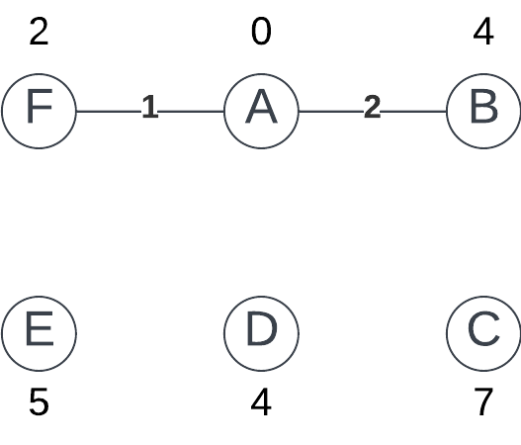
Step 4: Set vertex D as current. Update distances and shortest-path tree.
Q = {C, E}
dist = {0, 4, 7, 4, 5, 2}
S = {A, F, B, D}
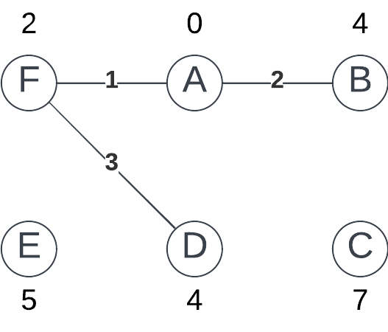
Step 5: Set vertex E as current. Update distances and shortest-path tree.
Q = {C}
dist = {0, 4, 7, 4, 5, 2}
S = {A, F, B, D, E}
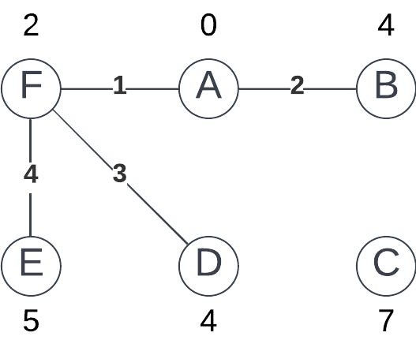
Step 5: Set vertex C as current. Update distances and shortest-path tree.
Q = {}
dist = {0, 4, 7, 4, 5, 2}
S = {A, F, B, D, E, C}
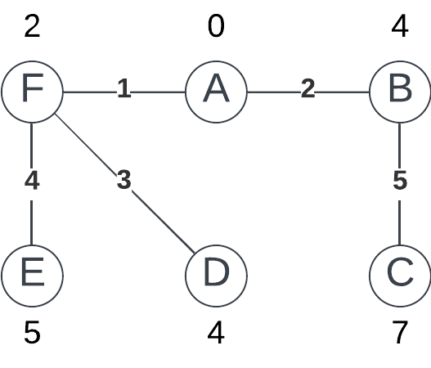

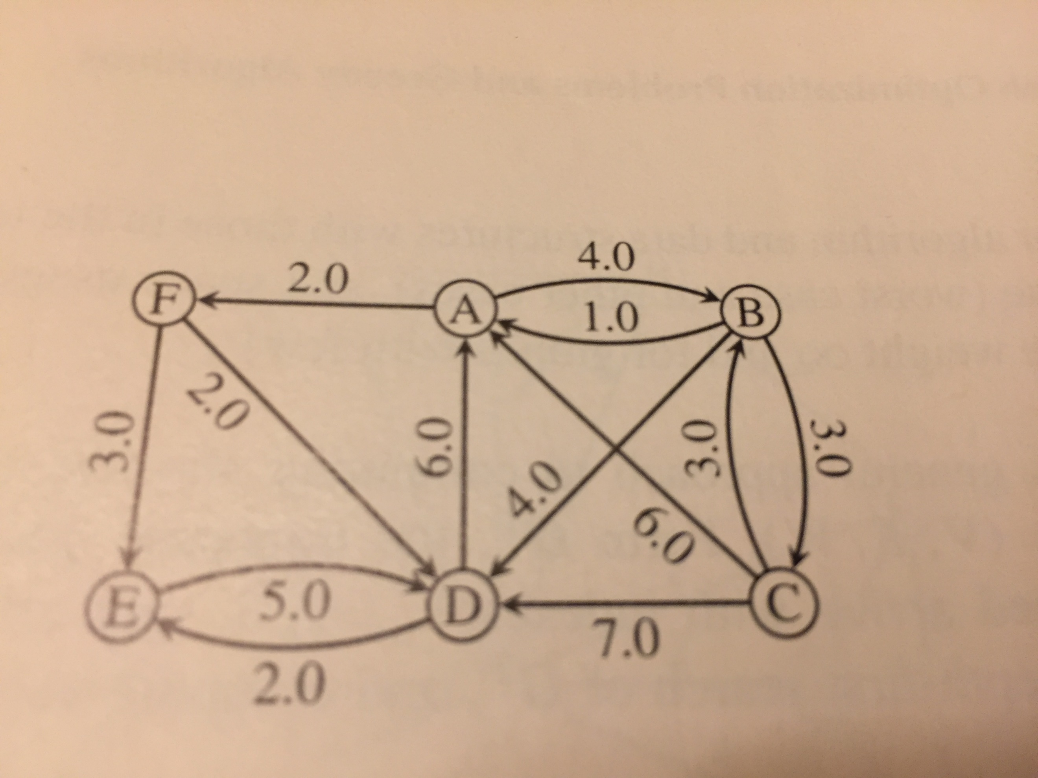

Fig.3

Q6 [20 pts.]: [Kruskal’s minimum spanning tree algorithm]
Find the minimum spanning tree for the graph in Fig.4 that would be the output by Kruscal’s algorithm, assuming that edges are sorted as shown on Fig.4

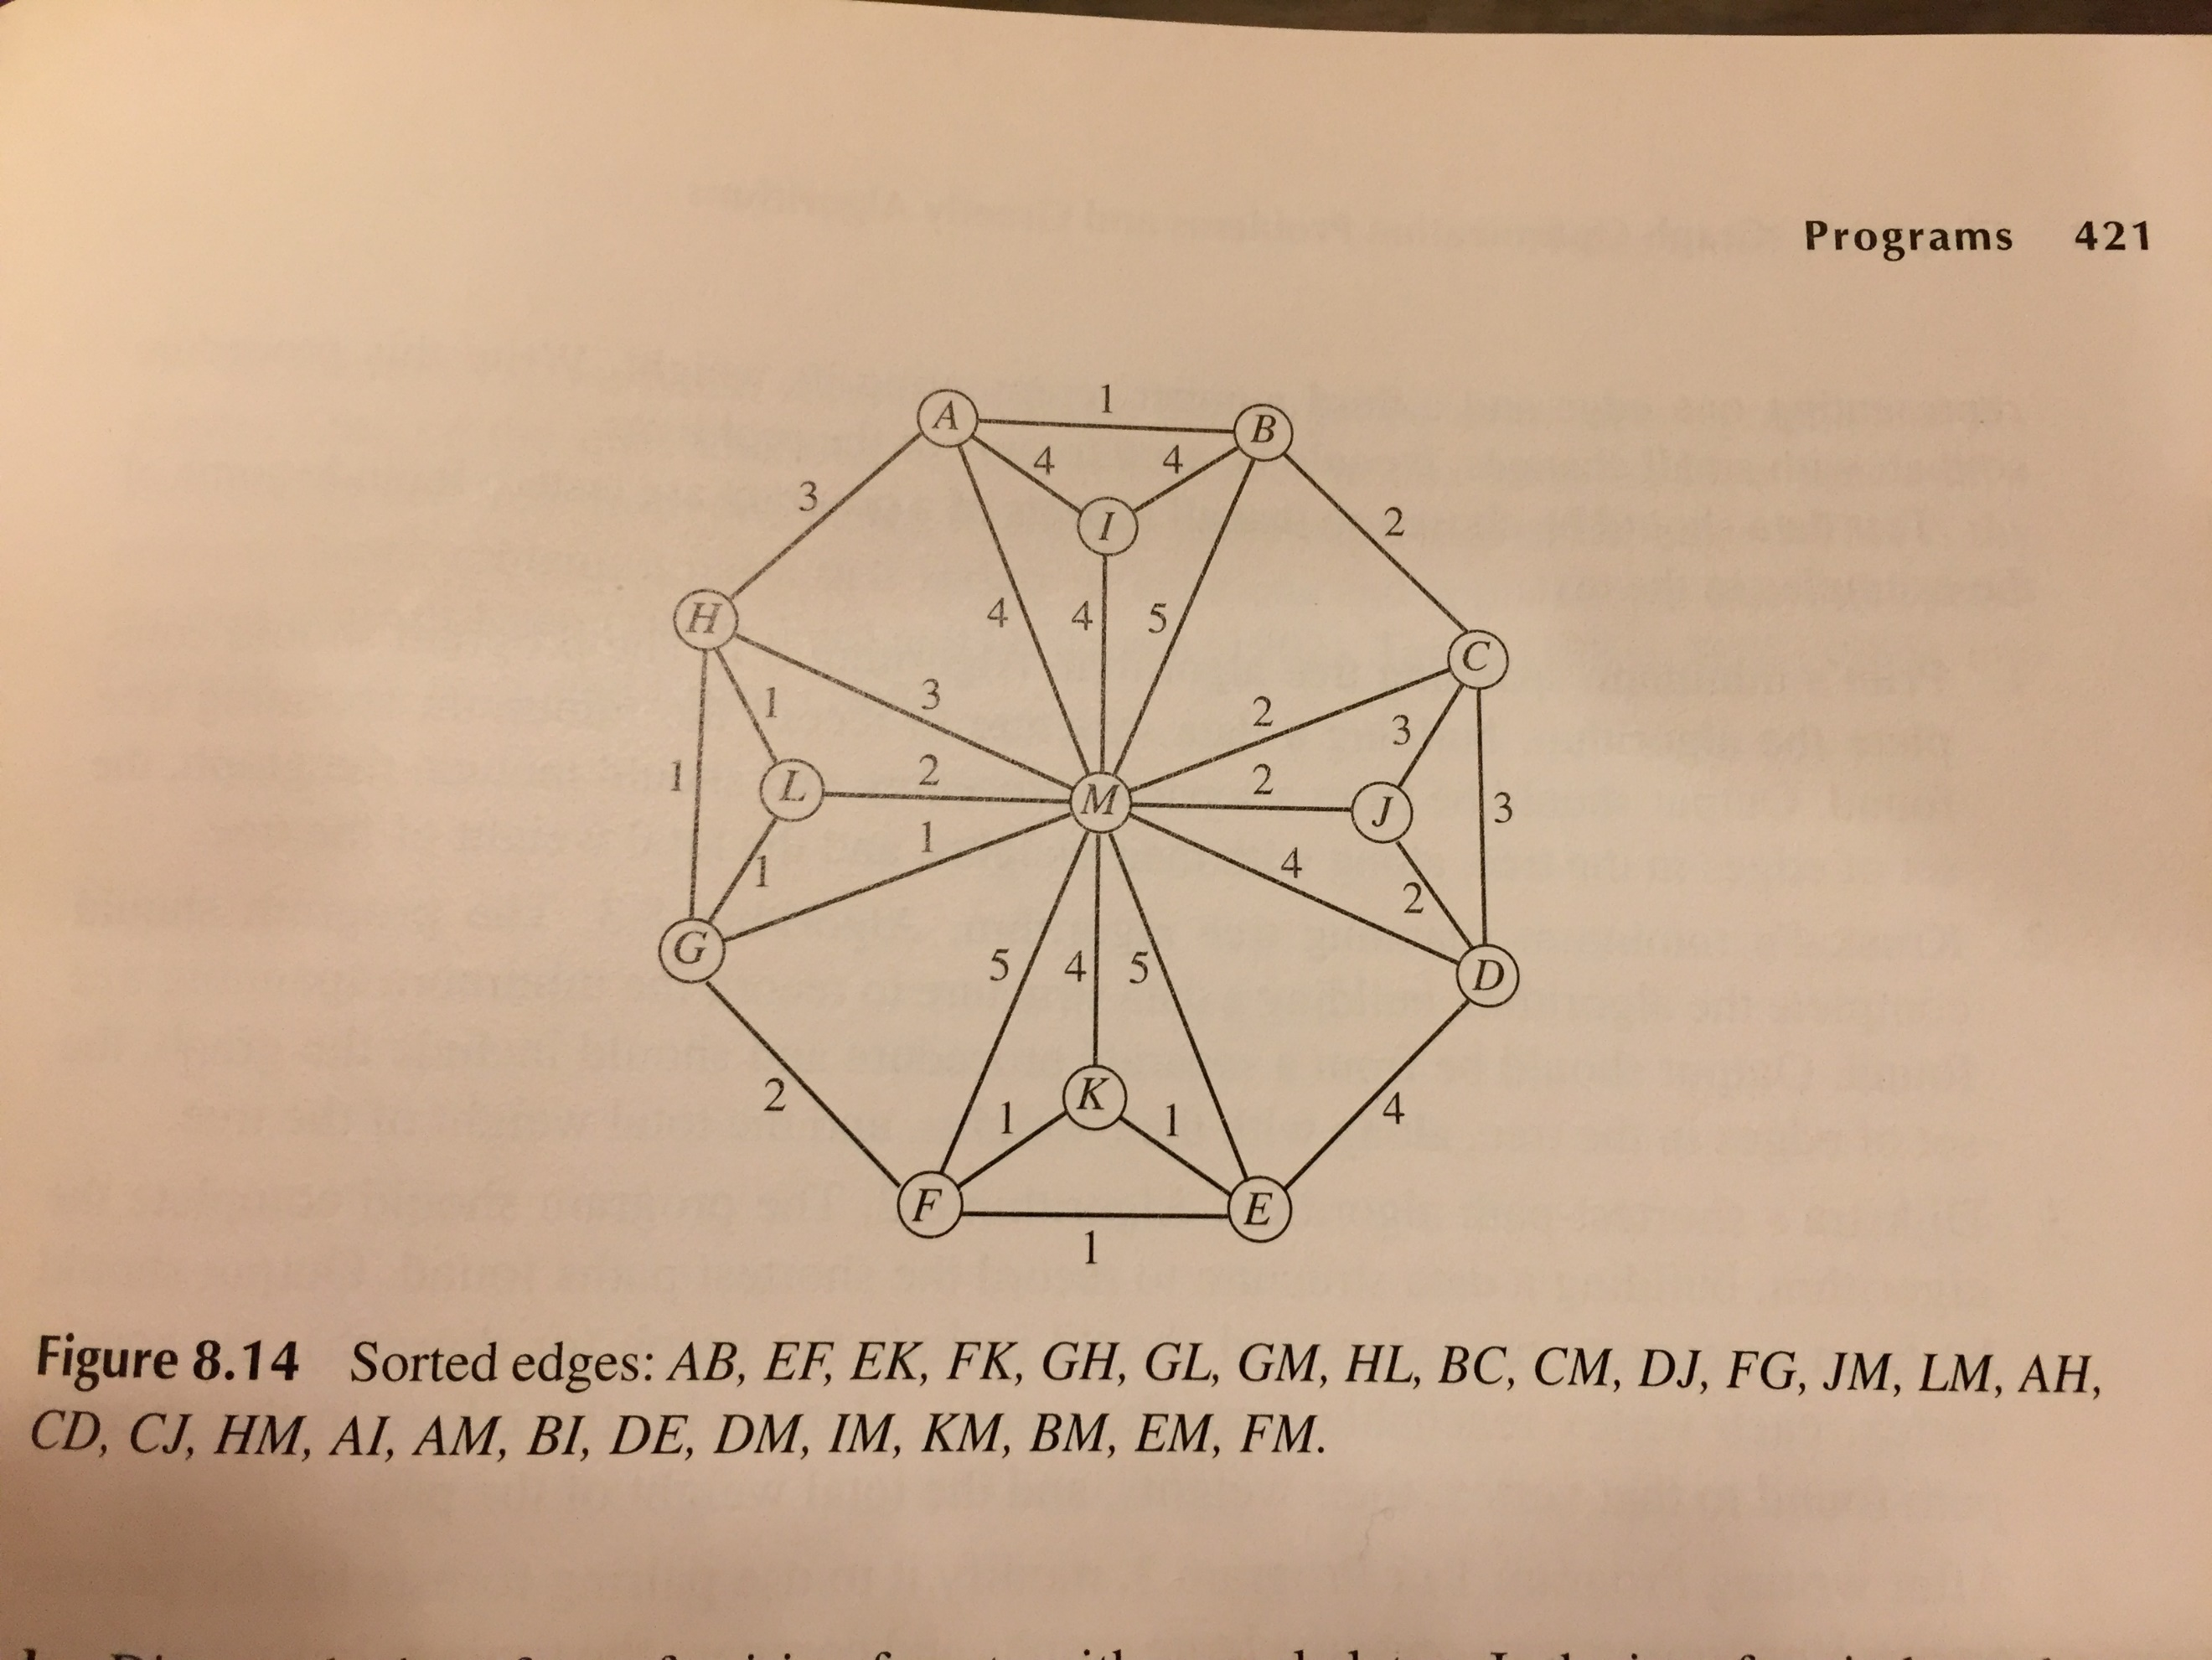
Fig.4

Below is the MST for the graph in Fig 4 using Kruskal’s algorithm. The numbers on the edges indicate the order in which they are added to the forest.
