Problem 1
- Describe the difference between composite attribute and multi-valued attribute. Show one example of each type.
  - A composite attribute is an attribute which can be broken down into smaller parts which can be attributes themselves. An example of a composite attribute would be an address because it can be divided into the smaller parts of street, city, state, and zip code.
  - A multi-valued attribute is a type of attribute which can take on multiple values for a single entity. An address could be used an example of a multi-valued attribute as well. For example, there could be a multi-valued attribute called previous_addresses which contain all previous addresses of the entity. Whenever the main address gets changed, the previous value would get added to the previous_addresses attribute.
- Describe the difference between stored attribute and derived attribute. Show one example of each type.
  - A stored attribute is an attribute that has one or more values stored in the database. An example of a stored attribute would be a name, which would be stored for each entity.
  - A derived attribute is an attribute that must calculate its value from other attributes in the database. A student’s grade in a class would be an example of a derived attribute because the letter grade of the class would be calculated based on the grades received for each assignment and test.
- Describe the difference between entity and entity type.
  - An entity type is the general case where the entity name and attributes are defined, it is the set of entities. An entity is a specific instance where the attributes of that entity type take on actual values. To use an analogy to object-oriented programing languages, an entity type is equivalent to a class while an entity is equivalent to an object.
- Describe the difference between relationship instance and relationship type.
  - A relationship type is the general case of a relationship where the name, participating entities, and constraints are defined. A relationship instance describes the current state of one specific relationship. To use an analogy to high-level programing languages, a relationship type is like function template while a relationship instance is like what the same function at compile time when the data type is defined.
Problem 2
- Explain what a recursive relationship type means.
  - A recursive relationship type is one that describes a relationship between the same entity type participating in distinct roles.
- Show a real-world example of recursive relationship type (don't use examples in the textbook).
  - An ANIMAL entity type could be involved in a PREYS_ON relationship type which would be recursive because the animals are involved in the relationship in two distinct roles: the predator and the prey.
Problem 3
- A weak entity type can have more than one owner entity type. Show a real-world example of a weak entity type that has two owner entity types.
  - An example of a weak entity type that would need two owner entity types could be a piece in a fashion show. In this example, a piece is a garment or accessory that is part of a collection. The piece entity type would be a weak entity type because it cannot be uniquely defined by its own attributes, there may be several pieces with the same color, material, type of garment, etc. The owner entity types would be the collection that the piece belongs to and the designer of the piece. This assumes that a designer does not make multiple pieces with the exact same attributes for the same collection, however a piece could be reused for multiple collections. This allows each piece to be uniquely defined by the collection it belongs to, the designer of the piece, and the other attributes of the piece itself. The piece entity type is weak because it cannot exist without the collection or the designer.
Problem 4
- Convert the constraints in the following diagrams to (min, max) notation.
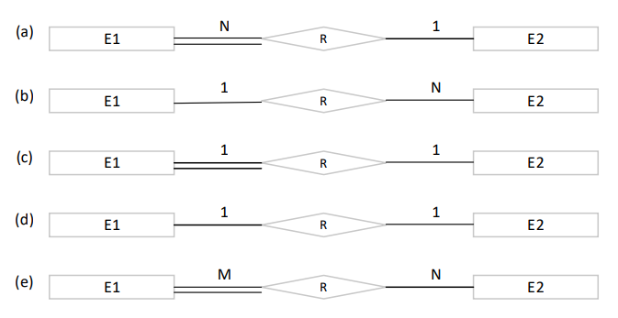
- E1 (1,1) R (0,N) E2
- E1 (0,N) R (0,1) E2
- E1 (1,1) R (0,1) E2
- E1 (0,1) R (0,1) E2
- E1 (1,N) R (0,M) E2

