Homework Assignment 4
Due: 10/31
Write the following queries in SQL, all of which are issued to the Company database. Write each query on MySQL (in Workbench), capture the screenshots of your queries and their results, and include the image(s) in your submission file. Each query must be written as a single SQL statement.
Total points are 15 points (3 points for each query).
(1). Show the name of every project which is not controlled by Administration department.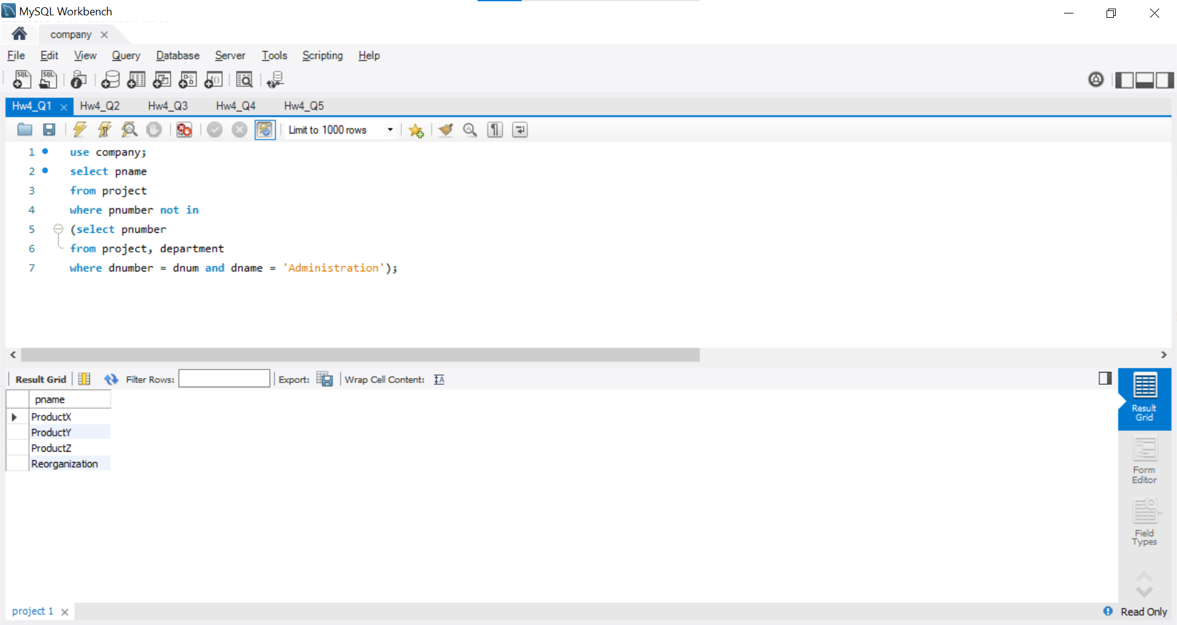
(2). Show the SSN, the first name, and last name of every employee who does not work on any project.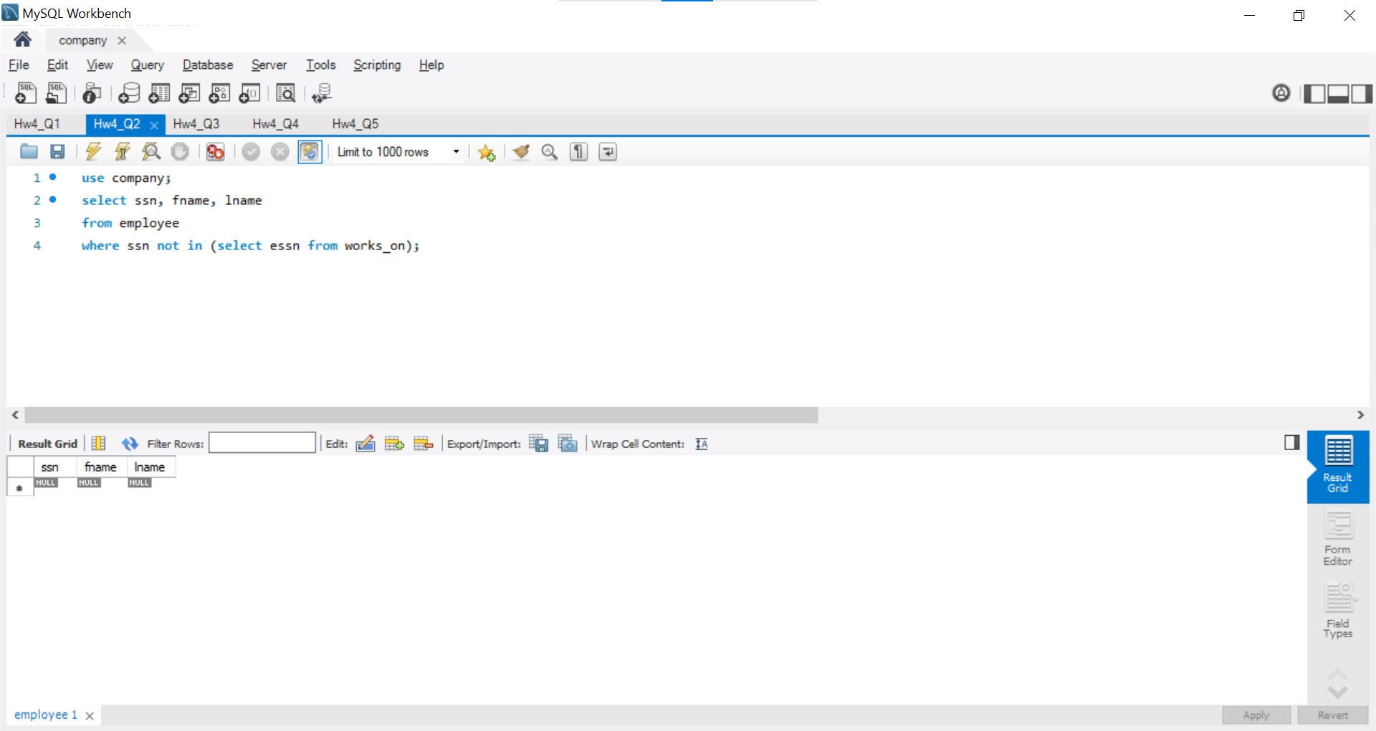
(3). Show the first name and the last name of each employee who works on Computerization project and works for the department which has a location in Stafford.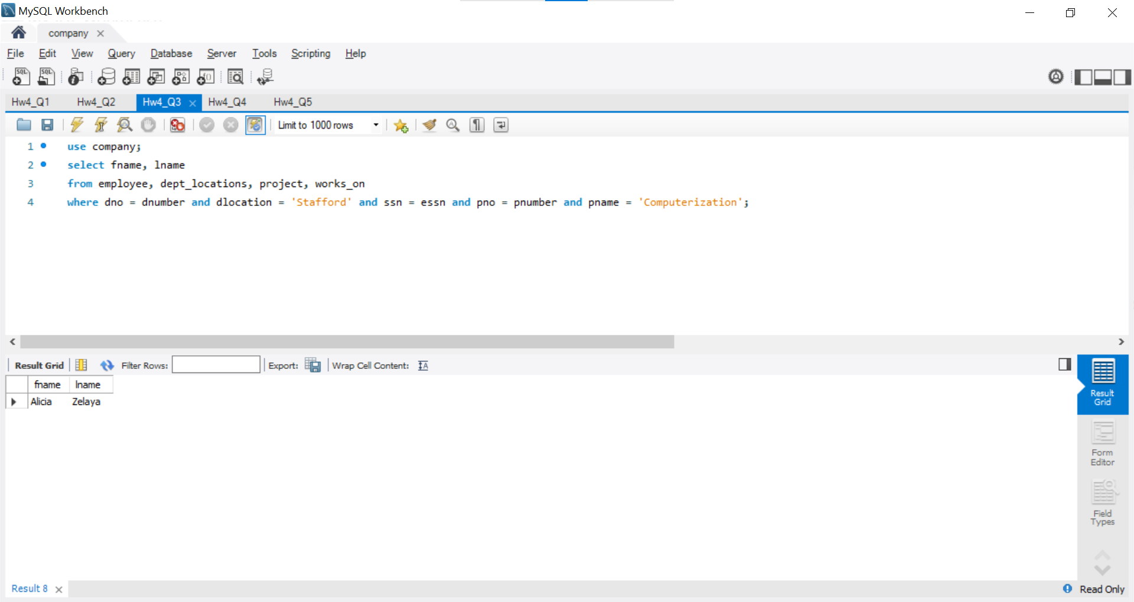
(4). Show the name of every dependent whose parent or spouse is a manager of some department.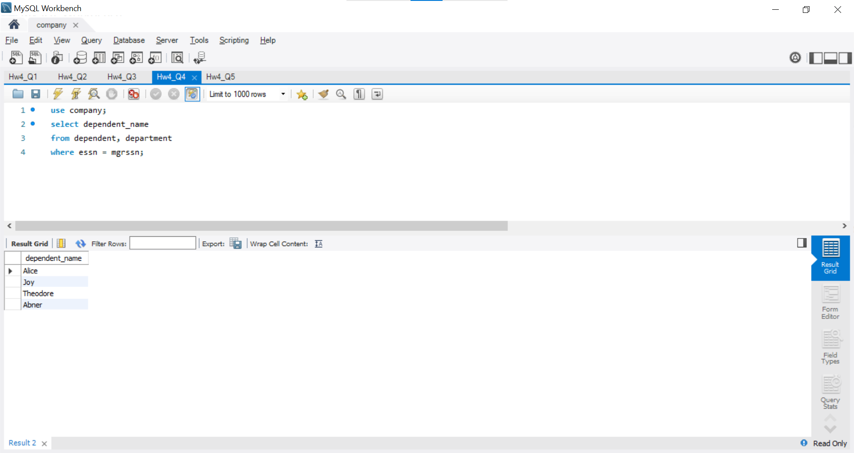
(5). Show the first names and the last names of all employees. If an employee has a dependent, then show the dependent’s name too.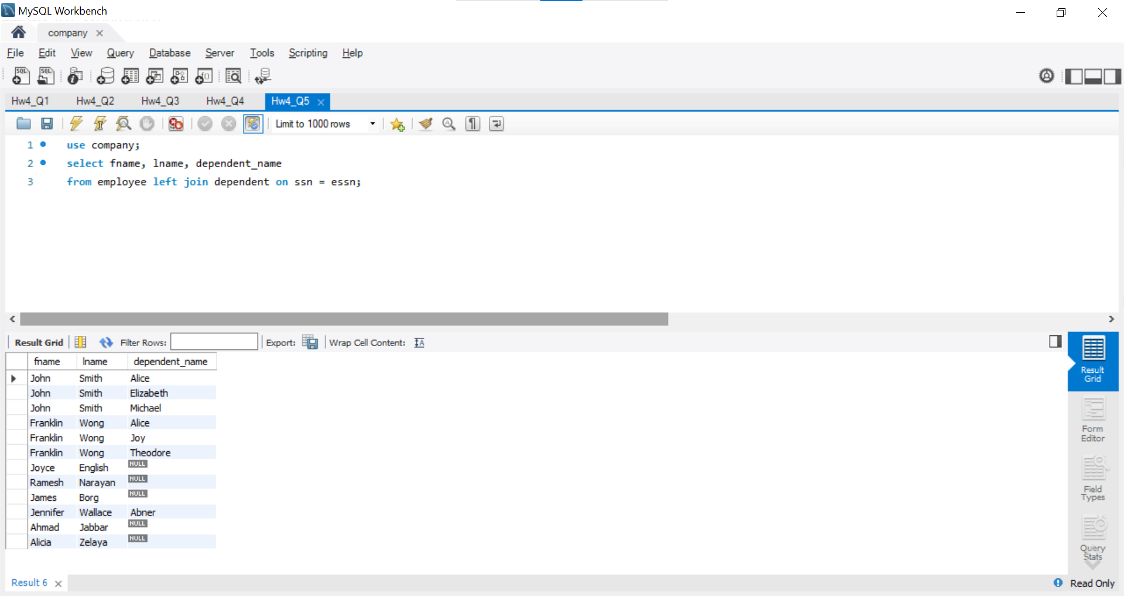
Include all your answers in a single file and name it LastName_FirstName_hw4.EXT, where EXT is an appropriate file extension. Do not submit individual image files and make sure that your screenshots are clear and easily legible.

