Homework Assignment 5
Due: 11/14
(1). Consider the following relations instance:
A | B | C | D
10 | b1 | c1 | d1
10 | b2 | c2 | d2
11 | b4 | c1 | d3
14 | b3 | c4 | d4
13 | b1 | c1 | d5
14 | b3 | c4 | d6
For each of the following functional dependencies, indicate whether the functional dependency may hold or cannot hold. If a functional dependency cannot hold, explain why.
(a). A → B
This cannot hold because the value 10 in A is associated with values b1 and b2 in B.
(b). B → C
This may hold.
(c). B → A
This cannot hold because the value b1 in B is associated with values 10 and 13 in A.
(d). C → A
This cannot hold because the value c1 in C is associated with values 10, 11 and 13 in A.
(e). D → B
This may hold.

(2). Consider a universal relation R = {A, B, C, D, E, F, G, H, I, J}. {A, B} is the primary key and there are four additional functional dependencies specified on R: fd1: {A} → {F}, fd2: {B} → {H, I}, fd3: {E} → {J}, and fd4: {C} → {D}. Normalize R to 2NF first and then to 3NF. For each step, show the normalized RDB schema and indicate all primary keys and foreign keys. Use the original definitions of 2NF and 3NF.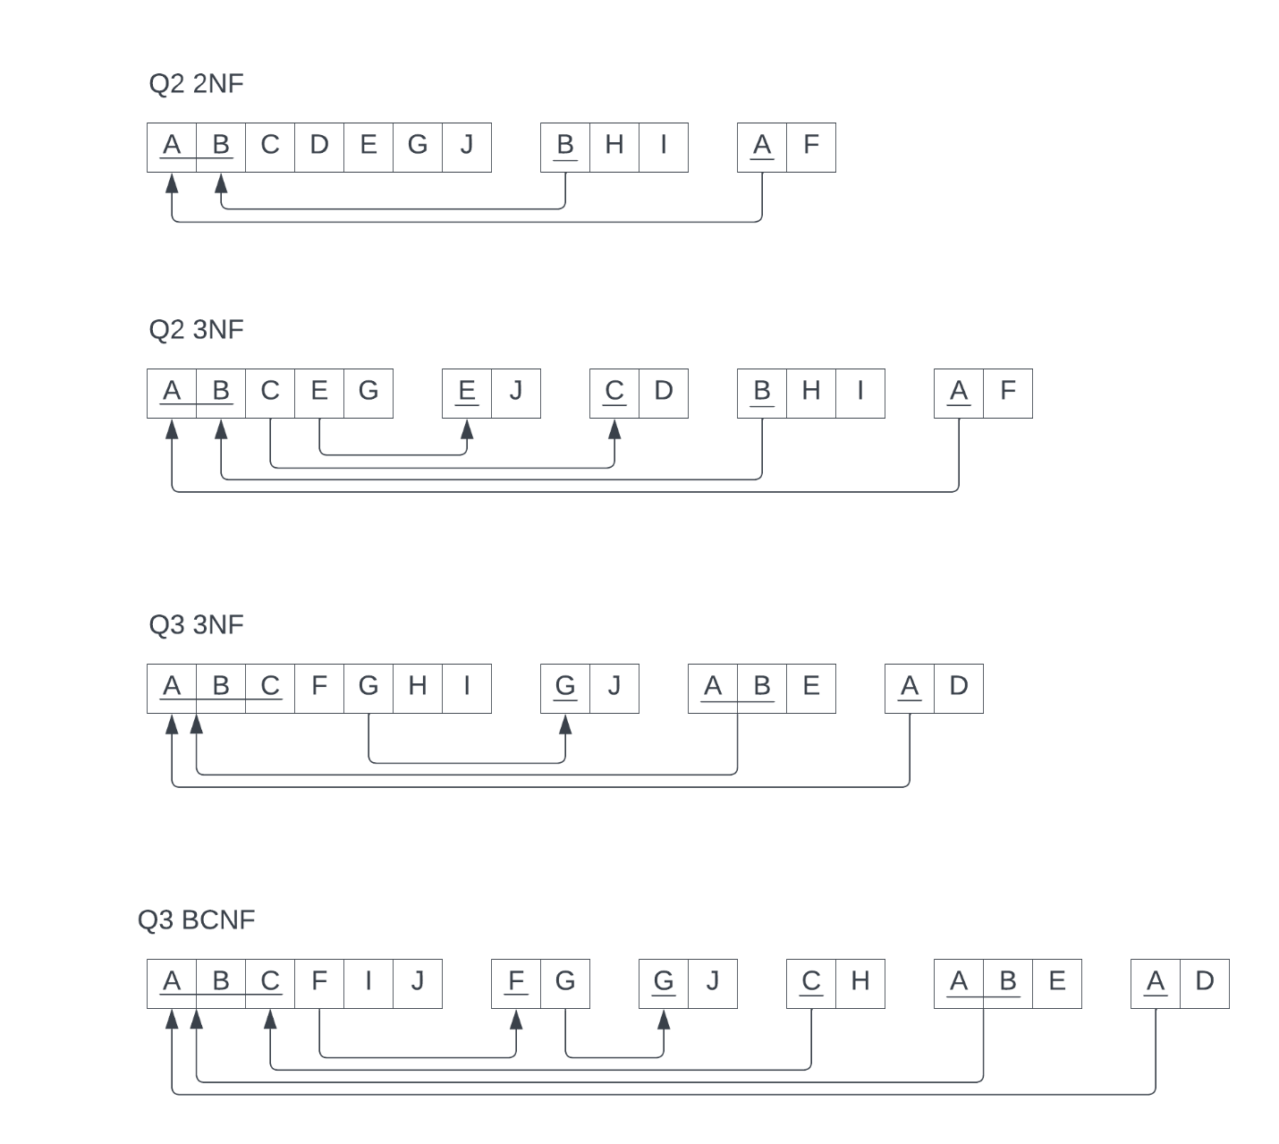
(3). Consider a relation R = {A, B, C, D, E, F, G, H, I, J}. {A, B,C} is the primary key of R and {G, H} is an alternate key (or a candidate key). There are five additional functional dependencies specified on it: fd1 = {A} → {D}, fd2 = {A,B} → {E}, fd3 = {F} → {G}, fd4 = {G} → {J}, fd5 = {C} → {H}. Normalize R into first 3NF and then to BCNF. Use the general definition of 3NF. At each step, show the normalized RDB schema and indicate all primary keys and foreign keys. 

