Homework Assignment 6
Due: 11/21
Problem 1. Answer the following questions.
(1). Can we build two primary indexes on a file? Why?
A primary index is specified on the ordering key field of an ordered file of records. Since the file can only be ordered with a single key field at a time, only one primary index may be used for the file. Different primary indexes can be built for the same file, but the file must be reordered based on the new key field, so multiple primary indexes cannot exist at the same time.
(2). Can we build two clustering indexes on a file? Why?
Like primary indexes, clustering indexes are specified on ordered fields. Since one field must be chosen to order the file, only one clustering index may exist at a time, but there may be several choices of field to order the file. This means different clustering indexes could be possible for a file, but one of them must be chosen.
(3). Can we build two secondary indexes on a file? Why?
Secondary indexes are specified on any non-ordering fields of a file, therefore multiple secondary indexes can be used on the same file at the same time.
Here, a file refers to a data file that stores a relational table
Problem 2. This problem is a small experiment that illustrates an effect of indexes on query performance. Before you start this problem, you must do a preparation described in the " homework6-preparation.docx" file.
(1). Start MySQL Workbench (or any other interface you are using) and enter the following query in the query window (do not execute it):
select *
from table_A
where b = 5000;
At the top of the query window, there is a horizontal bar with various icons, a part of which is shown below:

Click the icon highlighted in green (see above). This icon is usually referred to as "EXPLAIN plan icon or "EXPLAIN icon." Capture the screenshot of the visual execution plan and record the query cost, which is shown on top of the execution plan.
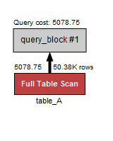
(2). Create an index on the column b of table_A with the following sql statement:
create unique index table_A_b_ix on table_A(b);
Enter the same query again and the click the EXPLAIN plan icon again. Capture the screenshot of the visual execution plan and record the query cost, which is shown on top of the execution plan.
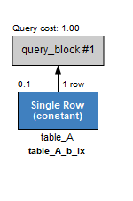
(3). Compare the query cost from (1) and the query cost from (2). What conclusion can you draw?
A “Full Table Scan” is very costly because no usable indexes were found for the table, which forces a search of every row. When there is a usable index, the query can find the row to return in constant time because there is only one row that matches the condition, and the index provides the exact location of it in the table.
(4). Enter the following query in the query window (do not execute it):
select *
from table_B
where y like 'abc%';
Click the EXPLAIN plan icon. Capture the screenshot of the visual execution plan and record the query cost, which is shown on top of the execution plan.
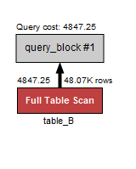
(5). Create an index on the column y of table_B with the following sql statement:
create index table_B_y_ix on table_B(y);
Enter the same query again and the click the EXPLAIN plan icon again. Capture the screenshot of the visual execution plan and record the query cost, which is shown on top of the execution plan.
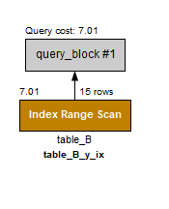
(6). Compare the query cost from (4) and the query cost from (5). What conclusion can you draw?
Without a usable index, the query performs a Full Table Scan which is very slow, as all 50,000 rows must be examined for the condition. When the index has been created, the index can be used to limit the scan to a subset of the full table, which greatly reduces the number of rows examined and the total query cost.

