Homework Assignment 7
Due: 12/12
Problem 1. This question is about the heuristic query optimization algorithm we discussed in the class. Show a step-by-step optimization process of the following query. You must show a sequence of trees.
select Fname, Lname
from Project p, Works_on w, Employee e
where p.Pnumber = w.Pno AND w.Essn = e.Ssn AND p.Plocation = 'Houston' and e.Ssn = '123456789';

Step 1. Initial tree with cartesian products and one selection & projection at the end.
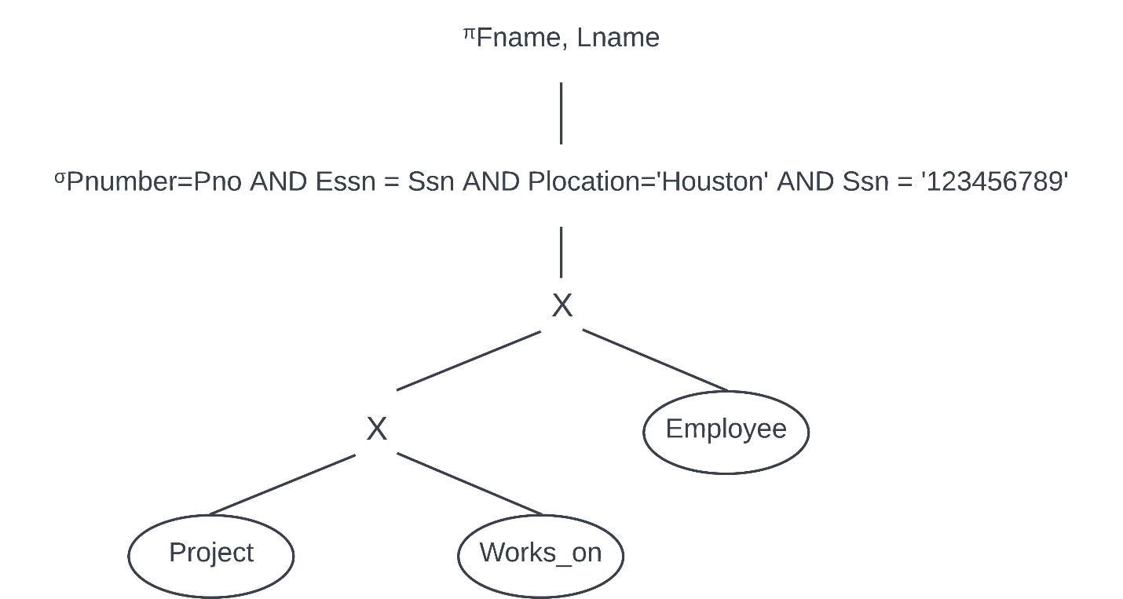

Step 2. Moving selection operations down the query tree.
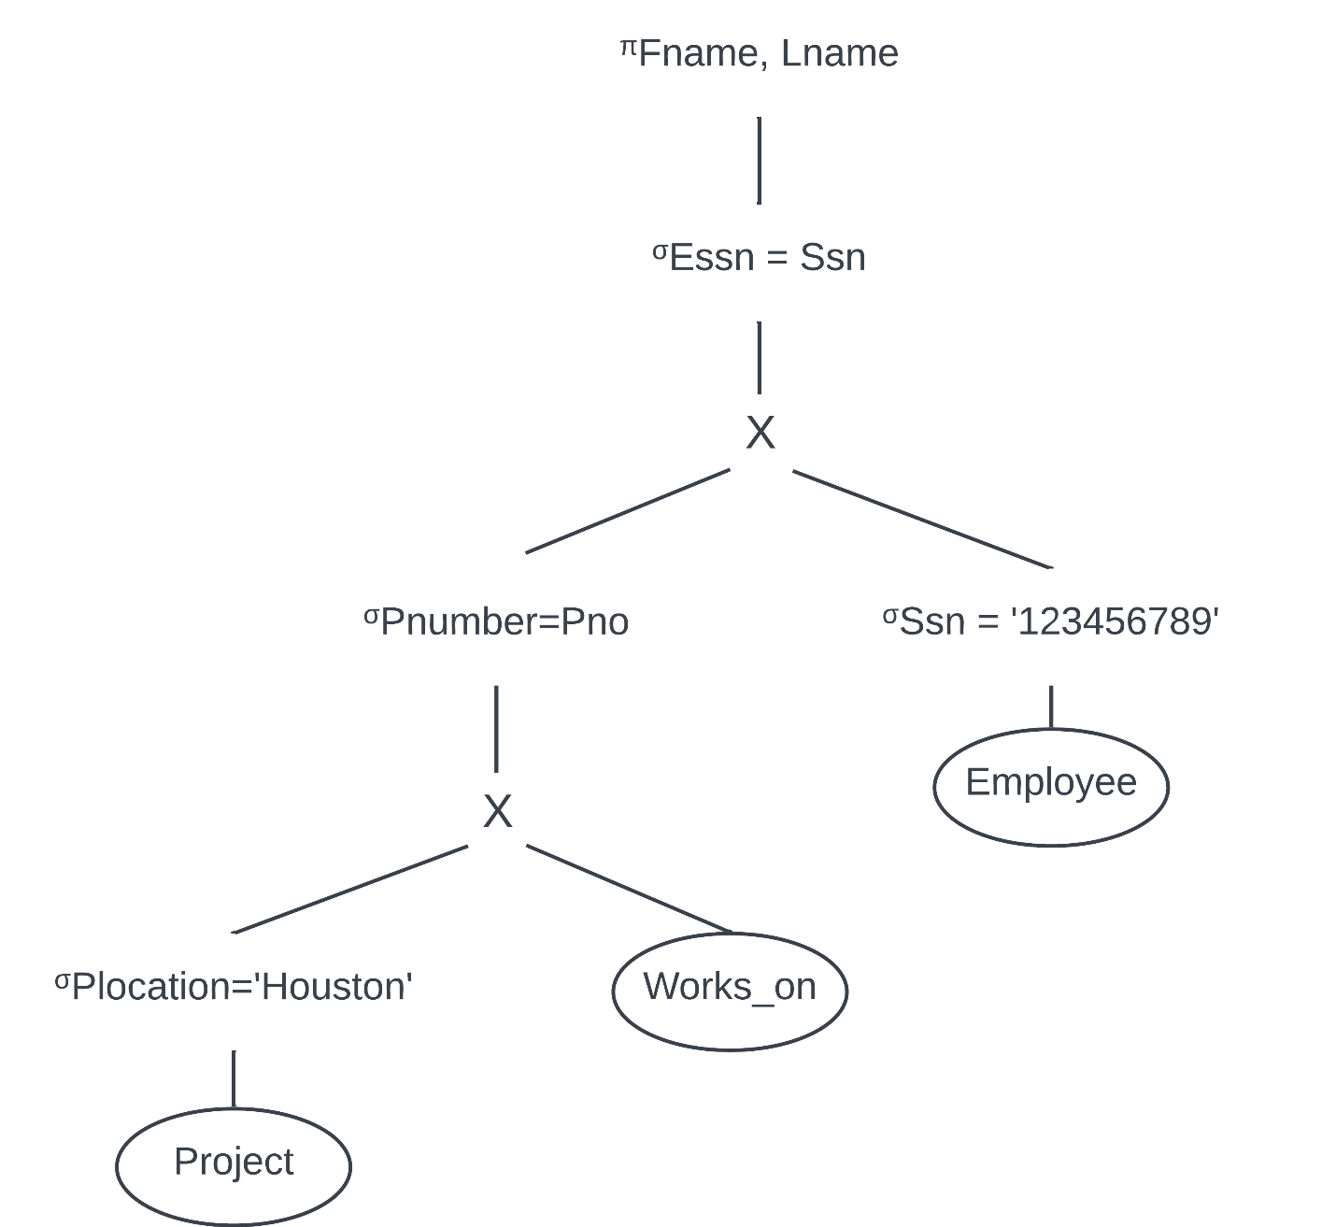

Step 3. Apply the more restrictive select operation first. (Ssn is primary key, so only 1 tuple can be returned whereas multiple projects can have a location in Houston)
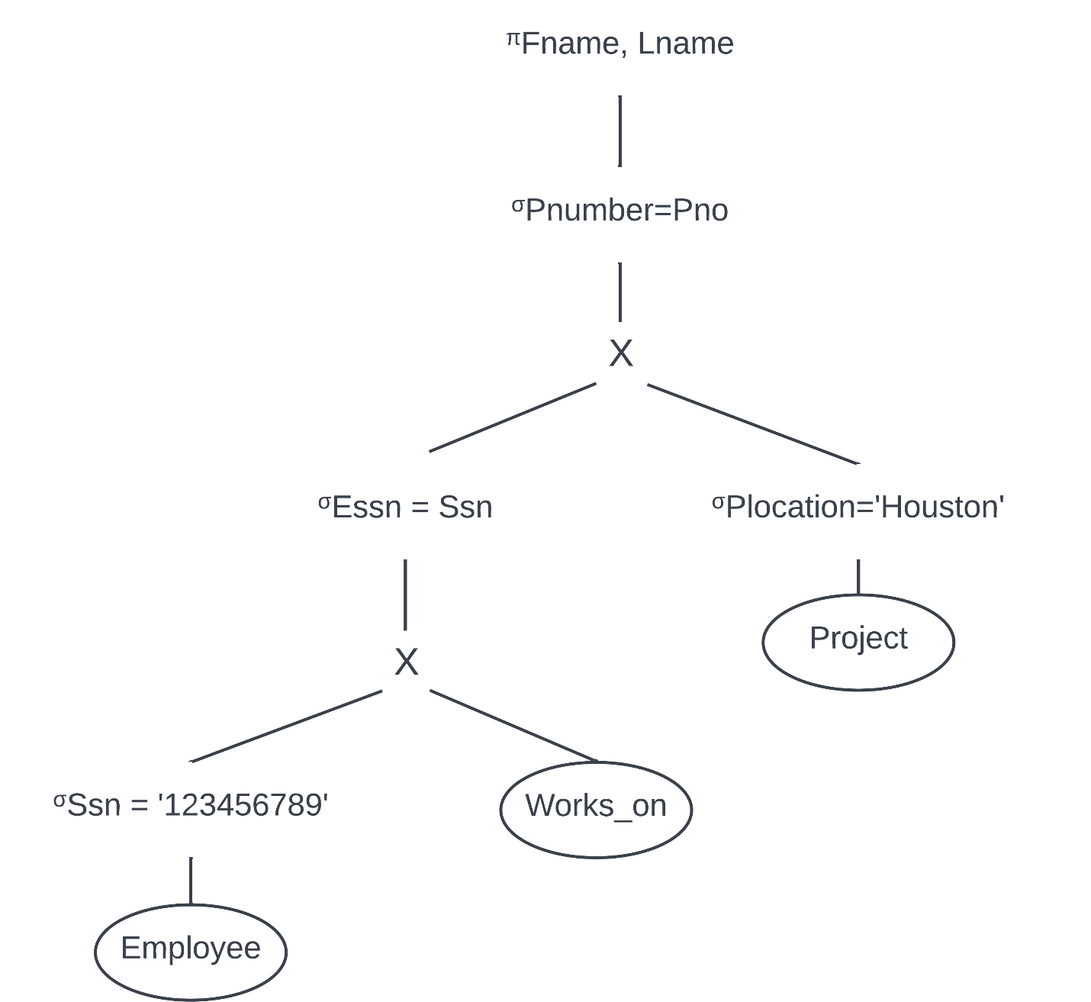

Step 4. Replace the cartesian product and select operations with join operations.
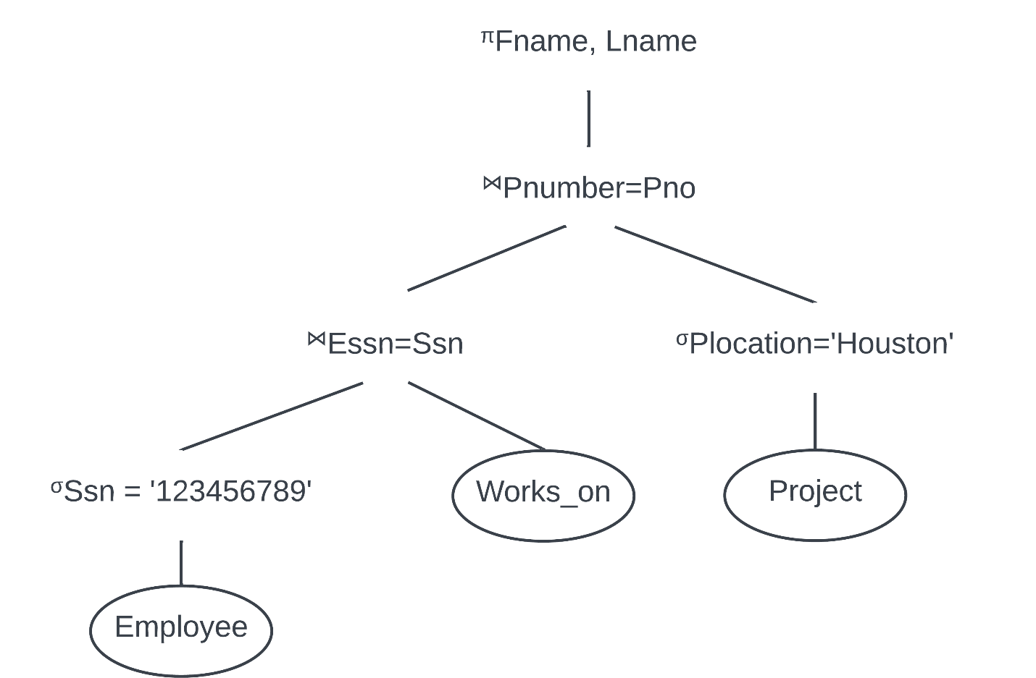

Step 5. Move project operations down the query tree.
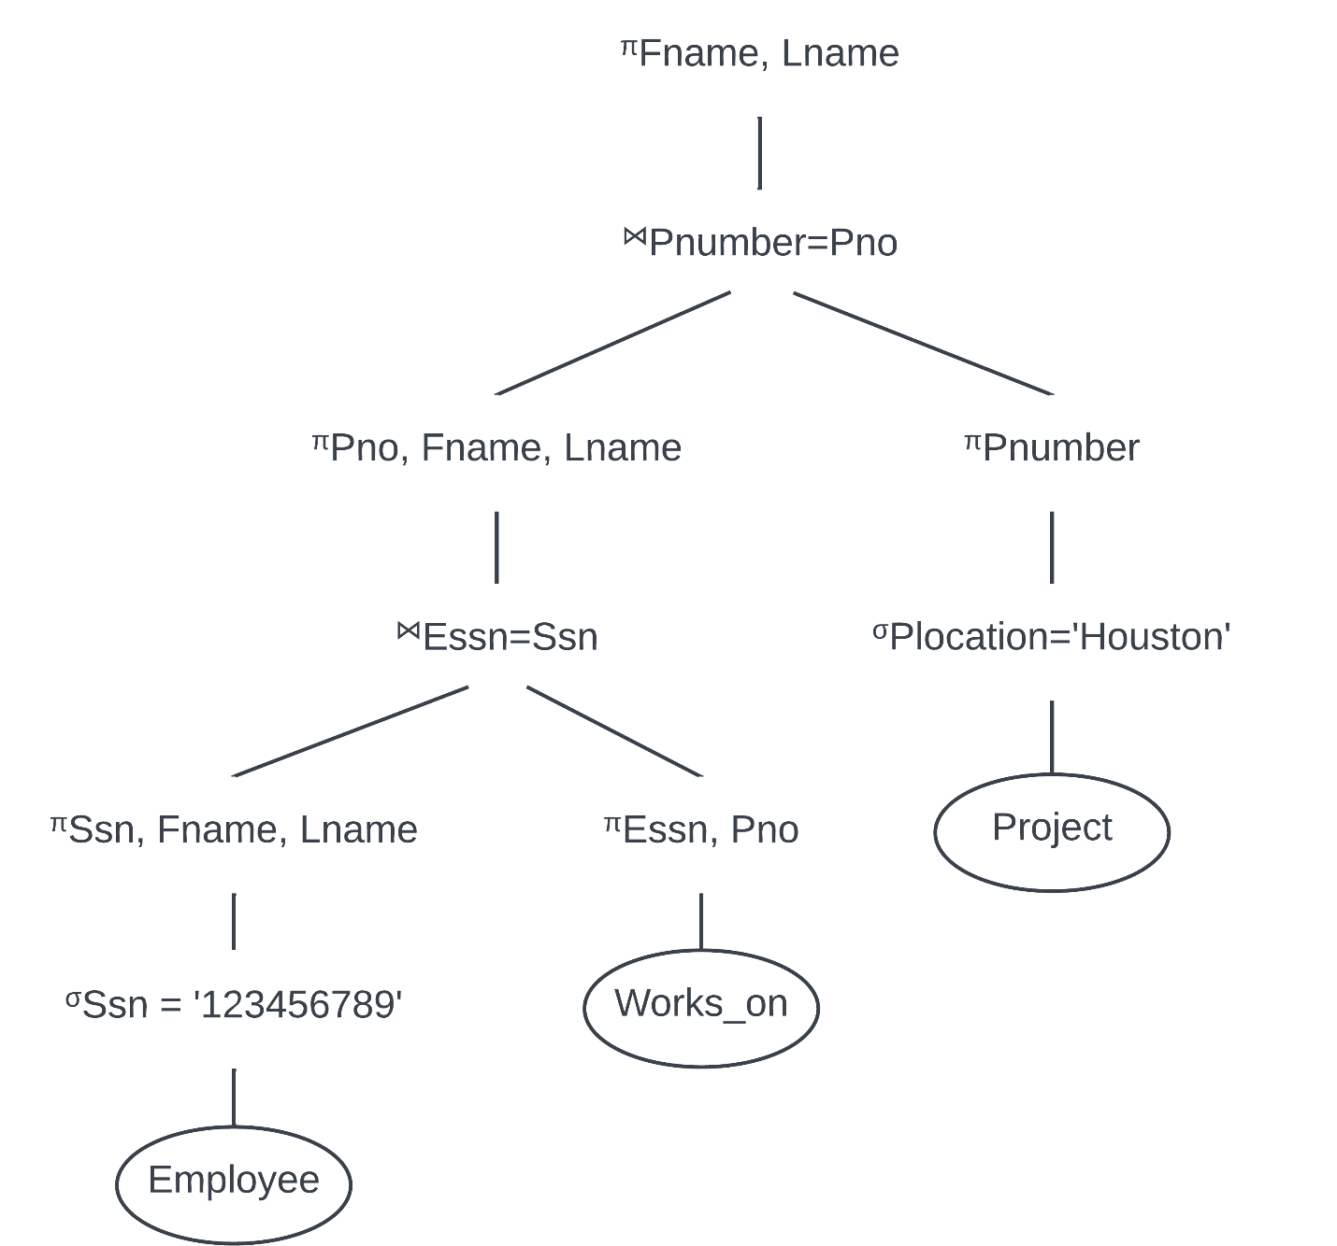
Problem 2. Suppose that two customers, John and Susan, shares a bank account. Consider the following scenario:
- The current balance of the account is $1,000.
- John is depositing $100 to the account. Let T1 denote this transaction.
- Susan is withdrawing $200 from the account. Let T2 denote this transaction.
If the two transactions are executed concurrently and no concurrency control mechanism is implemented, a "lost update" problem may occur. Show one possible schedule that illustrates this problem. Your answer should look like the Figure 20.3 in Slide 20-13.
Time | T1 | T2
1 | Read(X)
2 | x = X + 100
3 |  | Read(X)
4 |  | X = X – 200
5 | Write(X)
6 |  | Write(X)
7 | Read(X)

The account value (X) has the wrong value at time 6 and 7 because the value from T1 is overwritten. The account should have $900 ($1000 + $100 - $200) but would only show having $800 from time 6 onward due to the “lost update” problem. Effectively, John’s deposit is completely lost.

Problem 3. Consider the following two transactions, T1 and T2. Both transactions are accessing the data item X and they are run in an interleaved manner. Assume that the initial value of X is 1000.
Time | T1 | T2
1 | Read(X)
2 |  | Read(X)
3 |  | X = X – 200
4 |  | Write(X)
5 |  | commit;
6 | Read(X)
7

- What is the value of X read by T1 at time 6 if the transaction isolation level is read uncommitted?
X = 800
- What is the value of X read by T1 at time 6 if the transaction isolation level is read committed?
X = 800
- What is the value of X read by T1 at time 6 if the transaction isolation level is repeatable read?
X = 1000
- What is the value of X read by T1 at time 6 if the transaction isolation level is serializable?
X = 1000

