# Republic of the Philippines



# Province of Batangas

# City of Tanauan

BARANGAY DARASA

**OFFICE OF THE SANGGUNIANG BARANGAY**

CERTIFICATION OF

SOLO PARENT

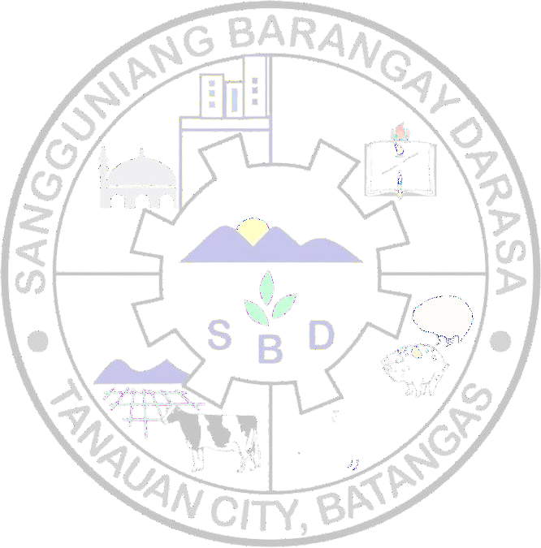TO WHOM IT MAY CONCERN:

This is to certify that (COMPLETE NAME), (AGE) years old and with postal address (STREET ADDRESS OR SUBD.) Barangay Darasa, Tanauan City, Batangas.

Further certified, that, (COMPLETE NAME), she is a solo parent with (NUMBER) child Named (CHILDREN’S NAME) with the same address above.

This certification is being issued upon the request of the above named person for SOLO PARENT purposes it may serve him/ her best.

Issued this (DAY of MONTH, YEAR) at Barangay Hall Barangay Darasa, Tanauan City, Batangas.

Signed by,

# Hon. Wilson P. Arguilles

Barangay Kagawad

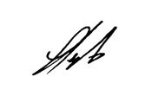

Approved by,

**Hon. Gregorio F. Llanto**

Punong Barangay

***Not valid without the official Seal***

**VALID until (Month DD, YYYY)**

Barangay Police: 0917 - 157 - 4731 / Barangay Health Center: 0917 - 308 - 8456 / Barangay Office: 0928 - 363 - 8664