# **README - Streamlit kickoff**

Working in our chosen text editor e.g. Notepad, Notepad++, VS Code, Atom, etc (many more) we can open the template *.py file and execute it as is.

From bash (Windows) or Terminal (MAC), navigate to the folder containing your file and execute the file using the **streamlit run** command:

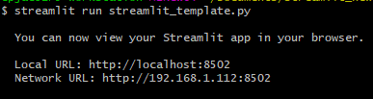

A local instance of the new app will open in your browser:

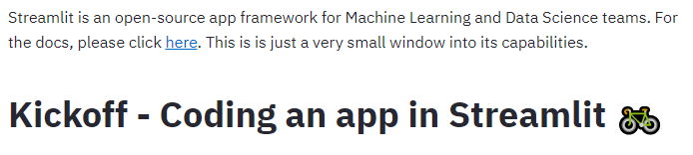

From then on, the app can be refreshed by clicking the ‘Rerun’ button that will appear every time the *.py is saved in the text editor. Both can be kept open at the same time!

Further instructions for teaching this kickoff can be found in the completed *.py file.

Students can also explore other demos by executing **streamlit hello** in the terminal.