

**Tertiary:**

**Dalubhasaan ng Lungsod ng Lucena**

Isabang, Lucena City

**Secondary:**

**Senior High School**

**Lucena City National High School**

Ibabang Dupay, Lucena City

TVL - Electrical Installation and Maintenance

**Junior High School**

**Lucena City National High School**

Ibabang Dupay, Lucena City

**Primary:**

**Kanlurang Mayao Elementary School**

Kanlurang Mayao, Lucena City

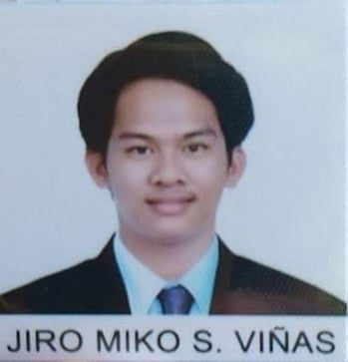

**Jiro Miko S. Viñas**

**ADDRESS**

Gate 3 Extension Calmar Homes Subdivision, Barangay Kanlurang Mayao, Lucena City

**Cellphone No.:** 09917706386

**Email Address:** jiromikovinas@gmail.com

**Career Objectives**

Dedicated and focused Student Assistant who excels at prioritizing and completing multiple tasks in a timely manner. Ability to prepare complex written reports and other documents. Ability to comprehend complex verbal and written instructions.

**Personal Information**

**Age: 19**

**Birthdate: August 5, 2004**

**Birthplace: Lucena City**

**Sex: Male**

**Civil Status: Single**

**Nationality: Filipino**

**Religion: Roman Catholic**

**Language: Filipino and English**

**EDUCATION**

**Boy/Helper**

AVA Coco Lumber Shop

Brgy. Kanlurrang Mayao, Lucena City

**WORKING EXPERIENCE**

**SEMINARS AND TRAINING PARTICIPATED**

* IT Paradigm Hardware Assembly and Disassembly

**SKILLS**

* Hardworking
* Reliable and responsible
* Can balance time schedule and manage potential stress problems
* Basic electrical installation

**Hibirson Lagrosa**

TVL Teacher

Lucena City National High School, Lucena City

**Rey Christian A. Navela**

IT Professor

Dalubhasaan ng Lungsod ng Lucena, Lucena City,

**REFERENCES**

*I do hereby certify that the above information is true and correct to the best of my* knowledge *and beliefs.*

**Jiro Miko S. Viñas**

Applicant