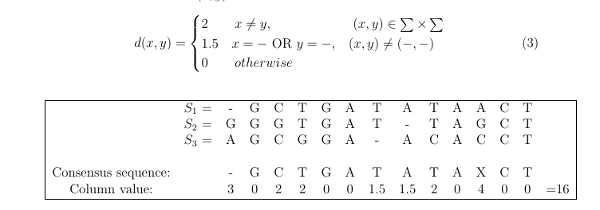
For column 1
The cost of selecting “-“ = d(−, A[1][1]) + d(−, A[2][1]) + d(−, A[3][1]) = 0 + 1.5 + 1.5 = 3
The cost of selecting “G” = A[2][1] is: d(G, A[1][1]) + d(G, A[2][1]) + d(G, A[3][1]) = 1.5 + 0 + 2 = 3.5 7
Similarly, the cost of selecting “A” = A[3][1] is: d(A, A[1][1]) + d(A, A[2][1]) + d(A, A[3][1]) = 1.5 + 2 + 0 = 3.5
So, the minimum cost is 3 and this happen when choosing “-“

For column 3
The cost of selecting “C” = A[1][3] is: d(C, A[1][3]) + d(C, A[2][3]) + d(C, A[3][3]) = 0 + 2 + 0 = 2 Similarly, the cost of selecting “C” = A[3][3] is: d(C, A[1][3]) + d(C, A[2][3]) + d(C, A[3][3]) = 0 + 2 + 0 = 2
The cost of selecting “G” = A[2][3] is: d(G, A[1][3]) + d(G, A[2][3]) + d(G, A[3][3]) = 2 + 0 + 2 = 4
So, the minimum cost is 2 and this happen when choosing A[1][3] = C.

