Group 2

Chelsea Hefferin, Miqueas Herrera, Jacob Isdell, Jimmy Jones

CSD 310-320M

Module 10.1

27th of September 2024

**Bacchus Wine Milestone 2**

ERD: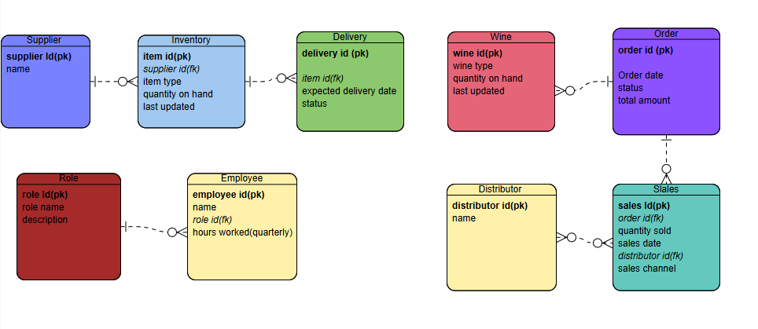

Table Data Display:

