Group 2

Chelsea Hefferin, Miqueas Herrera, Jacob Isdell, Jimmy Jones

CSD 310-320M

Module 11.1

2nd of October 2024

**Bacchus Wine Milestone 3**

Report 1 Supplier Deliveries:

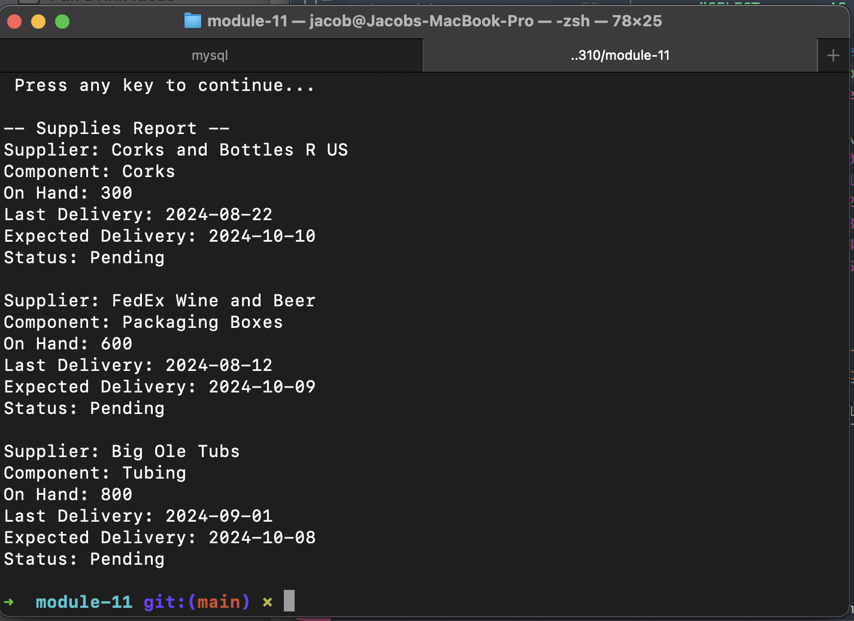

Report 2 Wine Sales

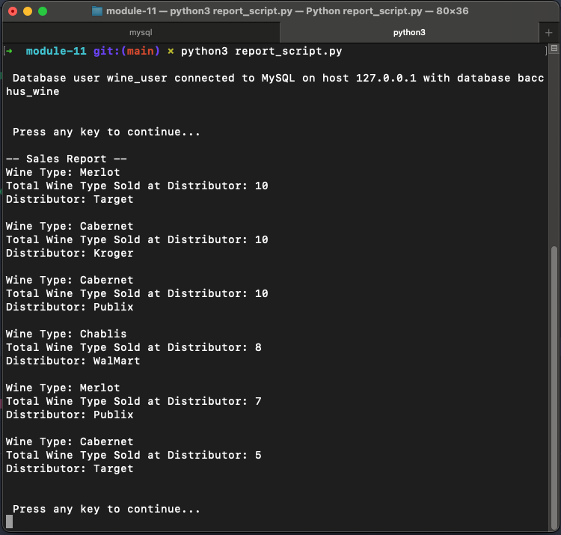

Report 3 Employee Hours

