Jacob Isdell

CSD 310

Module 2.3

08/25/2024

**ERD Model vs NoSQL Model**

ERD:

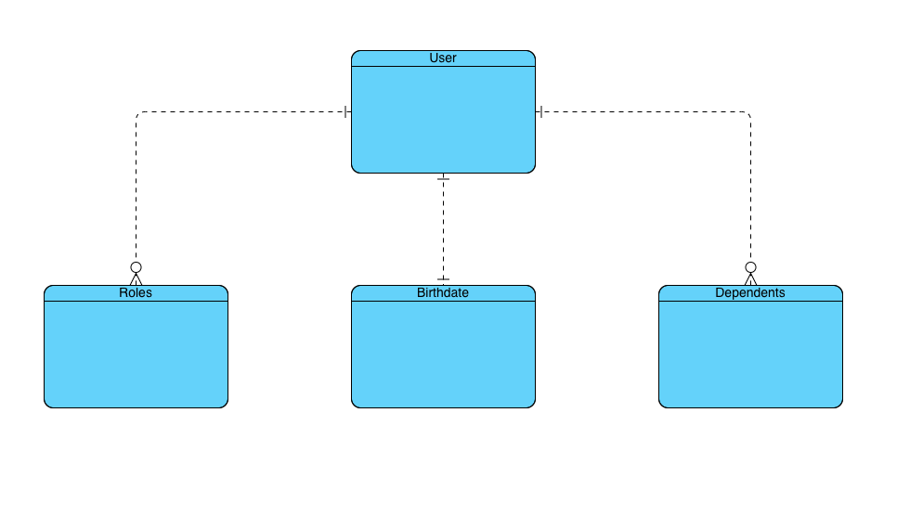

NoSQL:

