Jacob Isdell

CSD 310

Module 3.2

09/01/2024

**Third Normal Form**

Table Example:

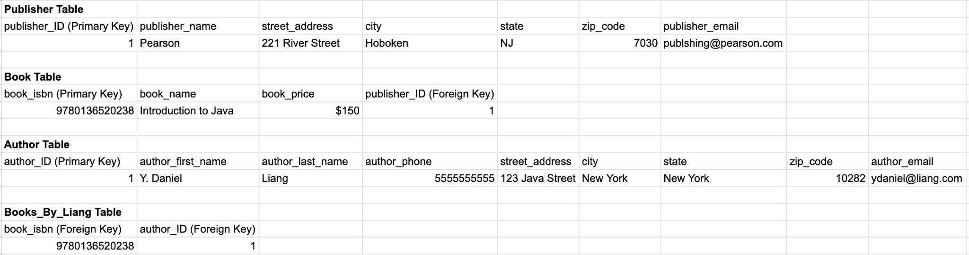

Assumptions:

* A table for books by an author could be created with foreign keys in both columns
* Street address would not be divisible
* Cities with more than one word are not divisible
* ISBN can be used as a primary ID for books since they are unique