Jacob Isdell

CSD 310

Module 4.2

09/08/2024

**MYSQL Install**

Terminal Initial Login:

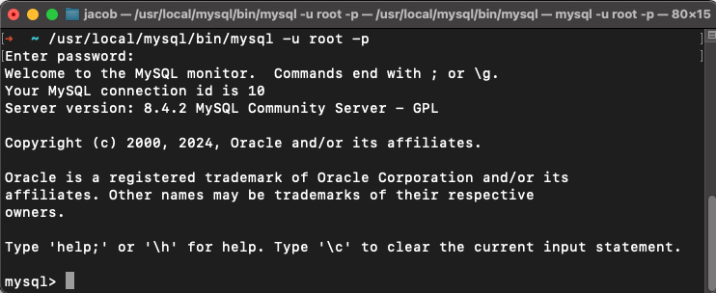

Terminal Database Created:

