Jacob Isdell

CSD 310

Module 5.2

09/08/2024

**MySQL Functions**

MySQL CURDATE() Function:

* Might be used to get the current date in order to make a time passed calculation.
* 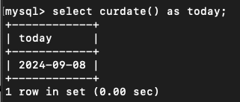

MySQL CONCAT_WS() Function:

* Combines different fields in order to make the date more accessible. Like an address or a date and time.
* 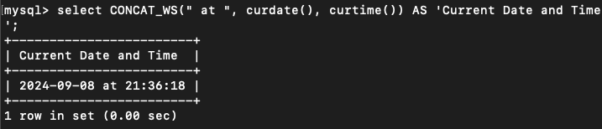

MySQL UPPER() Function:

* Can be used for string matching. It might be more handy to convert the string in the database to uppercase or lowercase to be sure that case does not cause missed results.
* 