Jacob Isdell

CSD 310

Module 6.2

09/15/2024

**MySQL Movies Table Build**

Script Results:

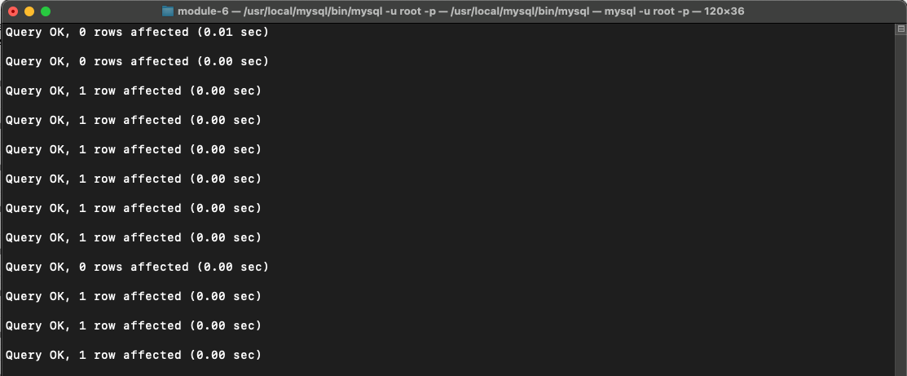

SHOW TABLES; Result:

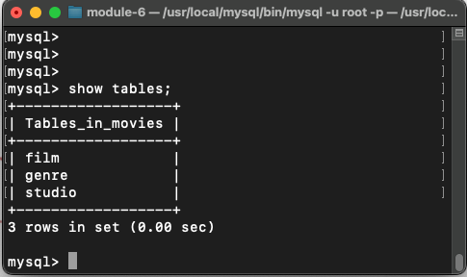

Python Script Results:

