 **BloodBridge**

link between donors and receivers

We are pleased to issue this certificate of appreciation to confirm that <username> generously donated <units> units of blood to <blood bank name> on <appointment> at <timing>. The selfless act of donating blood is crucial in ensuring that our blood banks have adequate supplies to meet the needs of patients in critical need of transfusions. Your contribution is invaluable, and we want to express our sincere gratitude for your support. Your donation may help save a life, and we hope that it inspires others to follow in your footsteps and donate blood as well. Thank you once again for your altruistic act, and we hope to see you soon for your next blood donation.

BloodBridge Director,

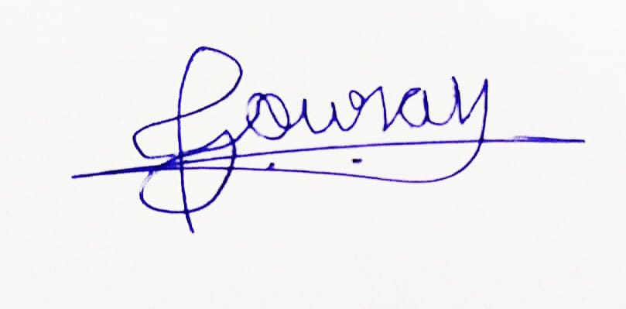

Gourav Midya