The **process.env** global variable is injected by the Node at runtime for your application to use and it represents the state of the system environment your application is in when it starts. For example, if the system has a PATHvariable set, this will be made accessible to you through process.env.PATHwhich you can use to check where binaries are located and make external calls to them if required.

------********************---------------

**Data returned from mongodb database is in json , hence we need to convert it into javascript object**

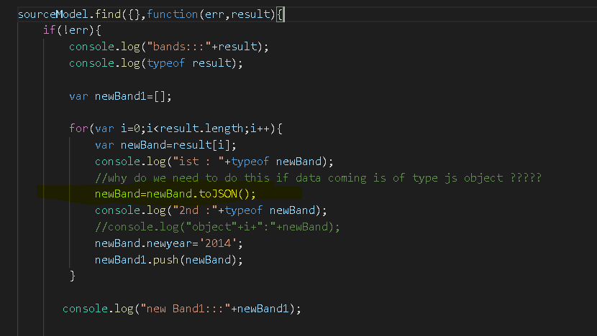

-************************---------

Node.js Built-in Module

Node.js has a set of built-in modules which you can use without any further installation.

Here is a list of the built-in modules of Node.js version 6.10.3:

|  |  |
| --- | --- |
| **Module** | **Description** |
| [assert](https://www.w3schools.com/nodejs/ref_assert.asp) | Provides a set of assertion tests |
| [buffer](https://www.w3schools.com/nodejs/ref_buffer.asp) | To handle binary data |
| child_process | To run a child process |
| [cluster](https://www.w3schools.com/nodejs/ref_cluster.asp) | To split a single Node process into multiple processes |
| [crypto](https://www.w3schools.com/nodejs/ref_crypto.asp) | To handle OpenSSL cryptographic functions |
| [dgram](https://www.w3schools.com/nodejs/ref_dgram.asp) | Provides implementation of UDP datagram sockets |
| [dns](https://www.w3schools.com/nodejs/ref_dns.asp) | To do DNS lookups and name resolution functions |
| domain | Deprecated. To handle unhandled errors |
| [events](https://www.w3schools.com/nodejs/ref_events.asp) | To handle events |
| [fs](https://www.w3schools.com/nodejs/ref_fs.asp) | To handle the file system |
| [http](https://www.w3schools.com/nodejs/ref_http.asp) | To make Node.js act as an HTTP server |
| [https](https://www.w3schools.com/nodejs/ref_https.asp) | To make Node.js act as an HTTPS server. |
| [net](https://www.w3schools.com/nodejs/ref_net.asp) | To create servers and clients |
| [os](https://www.w3schools.com/nodejs/ref_os.asp) | Provides information about the operation system |
| [path](https://www.w3schools.com/nodejs/ref_path.asp) | To handle file paths |
| punycode | Deprecated. A character encoding scheme |
| [querystring](https://www.w3schools.com/nodejs/ref_querystring.asp) | To handle URL query strings |
| [readline](https://www.w3schools.com/nodejs/ref_readline.asp) | To handle readable streams one line at the time |
| [stream](https://www.w3schools.com/nodejs/ref_stream.asp) | To handle streaming data |
| [string_decoder](https://www.w3schools.com/nodejs/ref_string_decoder.asp) | To decode buffer objects into strings |
| [timers](https://www.w3schools.com/nodejs/ref_timers.asp) | To execute a function after a given number of milliseconds |
| [tls](https://www.w3schools.com/nodejs/ref_tls.asp) | To implement TLS and SSL protocols |
| tty | Provides classes used by a text terminal |
| [url](https://www.w3schools.com/nodejs/ref_url.asp) | To parse URL strings |
| [util](https://www.w3schools.com/nodejs/ref_util.asp) | To access utility functions |
| v8 | To access information about V8 (the JavaScript engine) |
| [vm](https://www.w3schools.com/nodejs/ref_vm.asp) | To compile JavaScript code in a virtual machine |
| [zlib](https://www.w3schools.com/nodejs/ref_zlib.asp) | To compress or decompress files |