<https://expressjs.com/en/guide/routing.html>

# Routing

**Routing** refers to how an application’s endpoints (URIs) respond to client requests.

You define routing using methods of the Express app object that correspond to HTTP methods; for example, app.get() to handle GET requests and app.post to handle POST requests. For a full list, see [app.METHOD](https://expressjs.com/en/4x/api.html" \l "app.METHOD). **You can also use [app.all()](https://expressjs.com/en/4x/api.html" \l "app.all) to handle all HTTP methods** **and [app.use()](https://expressjs.com/en/4x/api.html" \l "app.use) to specify middleware as the callback function** (See [Using middleware](https://expressjs.com/en/guide/using-middleware.html) for details).

These routing methods specify a callback function (sometimes called “handler functions”) called when the application receives a request to the specified route (endpoint) and HTTP method. In other words, the application “listens” for requests that match the specified route(s) and method(s), and when it detects a match, it calls the specified callback function.

In fact, the routing methods can have more than one callback function as arguments. With multiple callback functions, it is important to provide next as an argument to the callback function and then call next() within the body of the function to hand off control to the next callback.

The following code is an example of a very basic route.

var express = require('express')

var app = express()

// respond with "hello world" when a GET request is made to the homepage

app.get('/', function (req, res) {

res.send('hello world')

})

## Route methods

A route method is derived from one of the HTTP methods, and is attached to an instance of the express class.

The following code is an example of routes that are defined for the GET and the POST methods to the root of the app.

// GET method route

app.get('/', function (req, res) {

res.send('GET request to the homepage')

})

// POST method route

app.post('/', function (req, res) {

res.send('POST request to the homepage')

})

Express supports methods that correspond to all HTTP request methods: get, post, and so on. For a full list, see [app.METHOD](https://expressjs.com/en/4x/api.html" \l "app.METHOD).

There is a special routing method, app.all(), used to load middleware functions at a path for **all** HTTP request methods. For example, the following handler is executed for requests to the route “/secret” whether using GET, POST, PUT, DELETE, or any other HTTP request method supported in the [http module](https://nodejs.org/api/http.html#http_http_methods).

app.all('/secret', function (req, res, next) {

console.log('Accessing the secret section ...')

next() // pass control to the next handler

})

## Route paths

Route paths, in combination with a request method, define the endpoints at which requests can be made. Route paths can be strings, string patterns, or regular expressions.

The characters ?, +, *, and () are subsets of their regular expression counterparts. The hyphen (-) and the dot (.) are interpreted literally by string-based paths.

If you need to use the dollar character ($) in a path string, enclose it escaped within ([ and ]). For example, the path string for requests at “/data/$book”, would be “/data/([\$])book”.

Express uses [path-to-regexp](https://www.npmjs.com/package/path-to-regexp) for matching the route paths; see the path-to-regexp documentation for all the possibilities in defining route paths. [Express Route Tester](http://forbeslindesay.github.io/express-route-tester/) is a handy tool for testing basic Express routes, although it does not support pattern matching.

Query strings are not part of the route path.

Here are some examples of route paths based on strings.

This route path will match requests to the root route, /.

app.get('/', function (req, res) {

res.send('root')

})

This route path will match requests to /about.

app.get('/about', function (req, res) {

res.send('about')

})

This route path will match requests to /random.text.

app.get('/random.text', function (req, res) {

res.send('random.text')

})

Here are some examples of route paths based on string patterns.

This route path will match acd and abcd.

app.get('/ab?cd', function (req, res) {

res.send('ab?cd')

})

This route path will match abcd, abbcd, abbbcd, and so on.

app.get('/ab+cd', function (req, res) {

res.send('ab+cd')

})

This route path will match abcd, abxcd, abRANDOMcd, ab123cd, and so on.

app.get('/ab*cd', function (req, res) {

res.send('ab*cd')

})

This route path will match /abe and /abcde.

app.get('/ab(cd)?e', function (req, res) {

res.send('ab(cd)?e')

})

Examples of route paths based on regular expressions:

This route path will match anything with an “a” in it.

app.get(/a/, function (req, res) {

res.send('/a/')

})

This route path will match butterfly and dragonfly, but not butterflyman, dragonflyman, and so on.

app.get(/.*fly$/, function (req, res) {

res.send('/.*fly$/')

})

### Route parameters

Route parameters are named URL segments that are used to capture the values specified at their position in the URL. The captured values are populated in the req.params object, with the name of the route parameter specified in the path as their respective keys.

Route path: /users/:userId/books/:bookId

Request URL: http://localhost:3000/users/34/books/8989

req.params: { "userId": "34", "bookId": "8989" }

To define routes with route parameters, simply specify the route parameters in the path of the route as shown below.

app.get('/users/:userId/books/:bookId', function (req, res) {

res.send(req.params)

})

The name of route parameters must be made up of “word characters” ([A-Za-z0-9_]).

Since the hyphen (-) and the dot (.) are interpreted literally, they can be used along with route parameters for useful purposes.

Route path: /flights/:from-:to

Request URL: http://localhost:3000/flights/LAX-SFO

req.params: { "from": "LAX", "to": "SFO" }

Route path: /plantae/:genus.:species

Request URL: http://localhost:3000/plantae/Prunus.persica

req.params: { "genus": "Prunus", "species": "persica" }

To have more control over the exact string that can be matched by a route parameter, you can append a regular expression in parentheses (()):

Route path: /user/:userId(\d+)

Request URL: http://localhost:3000/user/42

req.params: {"userId": "42"}

Because the regular expression is usually part of a literal string, be sure to escape any \ characters with an additional backslash, for example \\d+.

In Express 4.x, [the * character in regular expressions is not interpreted in the usual way](https://github.com/expressjs/express/issues/2495). As a workaround, use {0,} instead of *. This will likely be fixed in Express 5.

## Route handlers

You can provide multiple callback functions that behave like [middleware](https://expressjs.com/en/guide/using-middleware.html) to handle a request. The only exception is that these callbacks might invoke next('route') to bypass the remaining route callbacks. You can use this mechanism to impose pre-conditions on a route, then pass control to subsequent routes if there’s no reason to proceed with the current route.

Route handlers can be in the form of a function, an array of functions, or combinations of both, as shown in the following examples.

A single callback function can handle a route. For example:

app.get('/example/a', function (req, res) {

res.send('Hello from A!')

})

More than one callback function can handle a route (make sure you specify the next object). For example:

app.get('/example/b', function (req, res, next) {

console.log('the response will be sent by the next function ...')

next()

}, function (req, res) {

res.send('Hello from B!')

})

An array of callback functions can handle a route. For example:

var cb0 = function (req, res, next) {

console.log('CB0')

next()

}

var cb1 = function (req, res, next) {

console.log('CB1')

next()

}

var cb2 = function (req, res) {

res.send('Hello from C!')

}

app.get('/example/c', [cb0, cb1, cb2])

A combination of independent functions and arrays of functions can handle a route. For example:

var cb0 = function (req, res, next) {

console.log('CB0')

next()

}

var cb1 = function (req, res, next) {

console.log('CB1')

next()

}

app.get('/example/d', [cb0, cb1], function (req, res, next) {

console.log('the response will be sent by the next function ...')

next()

}, function (req, res) {

res.send('Hello from D!')

})

## Response methods

The methods on the response object (res) in the following table can send a response to the client, and terminate the request-response cycle. If none of these methods are called from a route handler, the client request will be left hanging.

| **Method** | **Description** |
| --- | --- |
| [res.download()](https://expressjs.com/en/4x/api.html#res.download) | Prompt a file to be downloaded. |
| [res.end()](https://expressjs.com/en/4x/api.html#res.end) | End the response process. |
| [res.json()](https://expressjs.com/en/4x/api.html#res.json) | Send a JSON response. |
| [res.jsonp()](https://expressjs.com/en/4x/api.html#res.jsonp) | Send a JSON response with JSONP support. |
| [res.redirect()](https://expressjs.com/en/4x/api.html#res.redirect) | Redirect a request. |
| [res.render()](https://expressjs.com/en/4x/api.html#res.render) | Render a view template. |
| [res.send()](https://expressjs.com/en/4x/api.html#res.send) | Send a response of various types. |
| [res.sendFile()](https://expressjs.com/en/4x/api.html#res.sendFile) | Send a file as an octet stream. |
| [res.sendStatus()](https://expressjs.com/en/4x/api.html#res.sendStatus) | Set the response status code and send its string representation as the response body. |

## app.route()

You can create chainable route handlers for a route path by using app.route(). Because the path is specified at a single location, creating modular routes is helpful, as is reducing redundancy and typos. For more information about routes, see: [Router() documentation](https://expressjs.com/en/4x/api.html#router).

Here is an example of chained route handlers that are defined by using app.route().

app.route('/book')

.get(function (req, res) {

res.send('Get a random book')

})

.post(function (req, res) {

res.send('Add a book')

})

.put(function (req, res) {

res.send('Update the book')

})

## express.Router

Use the express.Router() class to create modular, mountable route handlers. A Router instance is a complete middleware and routing system; for this reason, it is often referred to as a “mini-app”.

The following example creates a router as a module, loads a middleware function in it, defines some routes, and mounts the router module on a path in the main app.

Create a router file named birds.js in the app directory, with the following content:

var express = require('express')

var router = express.Router()

// middleware that is specific to this router

router.use(function timeLog (req, res, next) {

console.log('Time: ', Date.now())

next()

})

// define the home page route

router.get('/', function (req, res) {

res.send('Birds home page')

})

// define the about route

router.get('/about', function (req, res) {

res.send('About birds')

})

module.exports = router

Then, load the router module in the app:

var birds = require('./birds')

// ...

app.use('/birds', birds)

The app will now be able to handle requests to /birds and /birds/about, as well as call the timeLog middleware function that is specific to the route.

## Basic example of express.Router() –

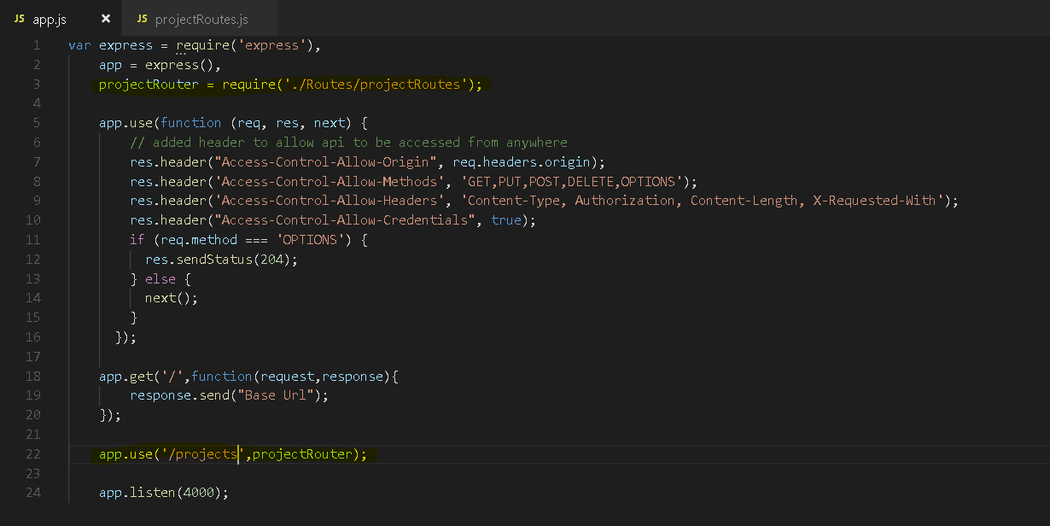

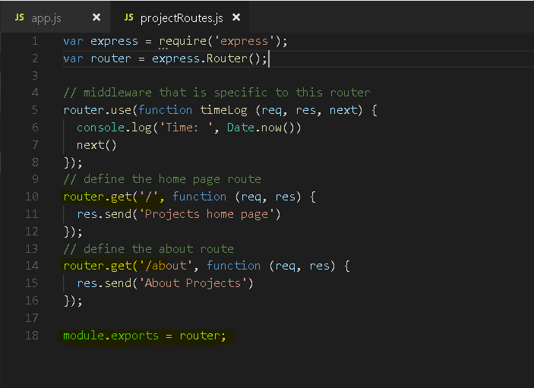

**Output –**

