# Lodash

<https://lodash.com/docs/4.17.11>

Lodash is a very popular NPM package.

Nodejs consist of huge community of developers contributing tons of package to the Node Package Manager repository.

Lodash is one such library which is successor of underscore.js. It is used to simplify your work of managing and editing objects and arrays by providing lots of utility methods to do so.

Some of the methods which I found quite handy and ease my development process are _pick, _map, _filter, _has.

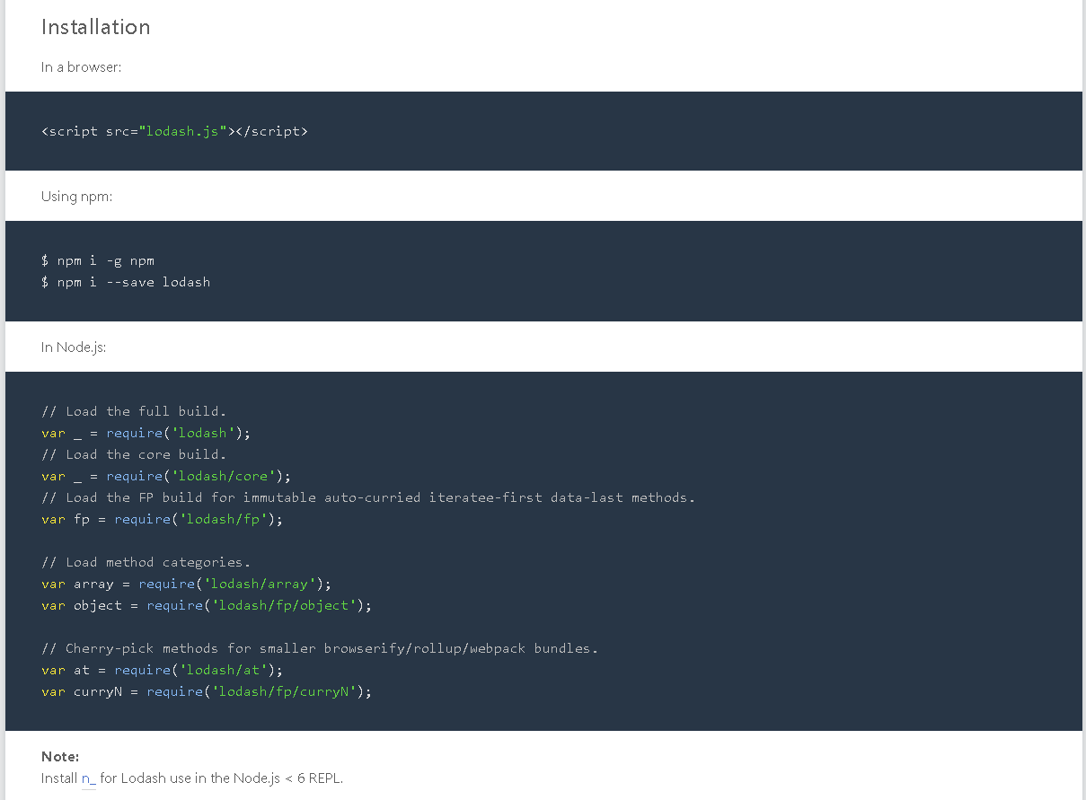

Why Lodash?

Lodash makes JavaScript easier by taking the hassle out of working with arrays, numbers, objects, strings, etc.Lodash’s modular methods are great for:

* Iterating arrays, objects, & strings
* Manipulating & testing values
* Creating composite functions

# Some Exampes

<http://zetcode.com/javascript/lodash/>

