<https://mongoosejs.com/docs/index.html>

# [How to access a preexisting collection with Mongoose?](https://stackoverflow.com/questions/5794834/how-to-access-a-preexisting-collection-with-mongoose)

Just give model name as your collection name

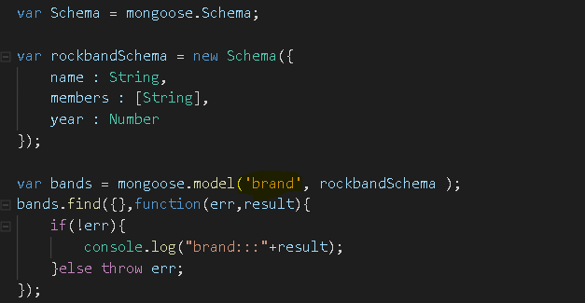

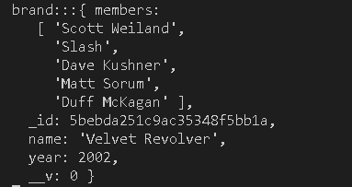

Also Alternative way – 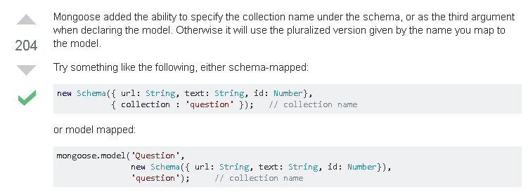

--------------------**************************

**Data returned from mongodb database is in json , hence we need to convert it into javascript object**

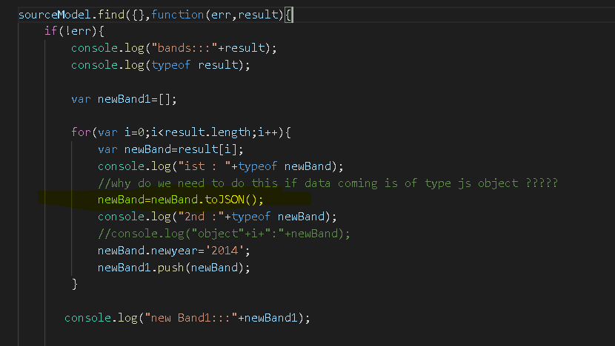

--------------------******************************----------------------

**Fetching only certain keys of documents -**

Let’s just say you have to get only the email and name of a user. As beginners we would simply do this

User.findById(id).exec(function (err, user) {  
 var item = {  
 name: user.name,  
 email: user.email  
 }  
 addToList(item);  
})

what you may not realise is that behind the scenes mongo had to work so as to fetch the complete document. How about improving it -

User.findById(id).**select**("name email").exec(function (err, user) {  
 var item = {  
 name: user.name,  
 email: user.email  
 }  
 addToList(item);  
})

The select property would tell mongo that it only needs to get the name and email from the document and thus makes for more efficient code.

Note — if you want to get all the keys except some you can prefix it with “-” . Eg-

select("-password -token")

code example –

sourceModel.find({},function(err,result){

}).select("name year -_id");