**Sass is a CSS pre-processor with syntax advancements. Style sheets in the advanced syntax are processed by the program, and turned into regular CSS style sheets. However, they do not extend the CSS standard itself.**

**Sass** (Syntactically awesome style sheets) is a [style sheet language](https://en.wikipedia.org/wiki/Style_sheet_language) initially designed by [Hampton Catlin](https://en.wikipedia.org/wiki/Hampton_Catlin) and developed by Natalie Weizenbaum.[[2]](https://en.wikipedia.org/wiki/Sass_(stylesheet_language)#cite_note-about-2)[[3]](https://en.wikipedia.org/wiki/Sass_(stylesheet_language)#cite_note-3) After its initial versions, Weizenbaum and Chris Eppstein have continued to extend Sass with SassScript, a simple scripting language used in Sass files.

Sass is a [preprocessor](https://en.wikipedia.org/wiki/Preprocessor) [scripting language](https://en.wikipedia.org/wiki/Scripting_language) that is [interpreted](https://en.wikipedia.org/wiki/Interpreted_language) or [compiled](https://en.wikipedia.org/wiki/Compiled_language) into [Cascading Style Sheets](https://en.wikipedia.org/wiki/Cascading_Style_Sheets) (CSS).

**Sass-loader is the preprocessor which converts sass to .css**

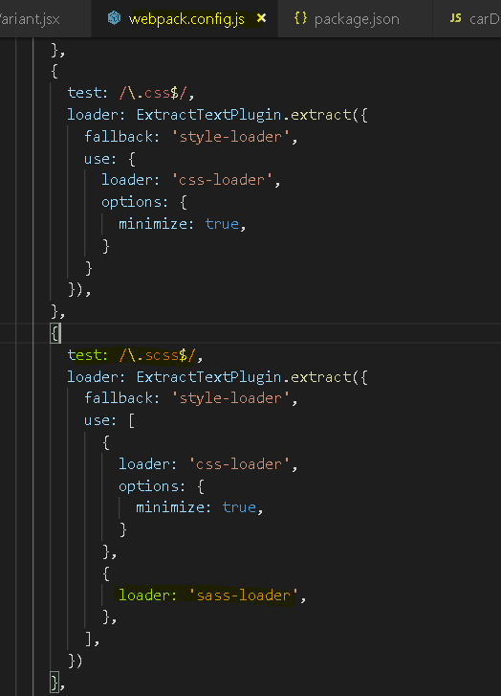

SassScript is the scripting language itself. Sass consists of two [syntaxes](https://en.wikipedia.org/wiki/Syntax_(programming_languages)). The original syntax, called "the indented syntax," uses a syntax similar to [Haml](https://en.wikipedia.org/wiki/Haml).[[4]](https://en.wikipedia.org/wiki/Sass_(stylesheet_language)#cite_note-main-4) It uses [indentation](https://en.wikipedia.org/wiki/Indent_style) to separate [code blocks](https://en.wikipedia.org/wiki/Block_(programming)) and [newline](https://en.wikipedia.org/wiki/Newline) characters to separate rules. The newer syntax, "SCSS" (Sassy CSS), uses block formatting like that of CSS. It uses braces to denote code blocks and semicolons to separate lines within a block. The indented syntax and SCSS files are traditionally given the [extensions](https://en.wikipedia.org/wiki/Filename_extension) .sass and .scss, respectively.

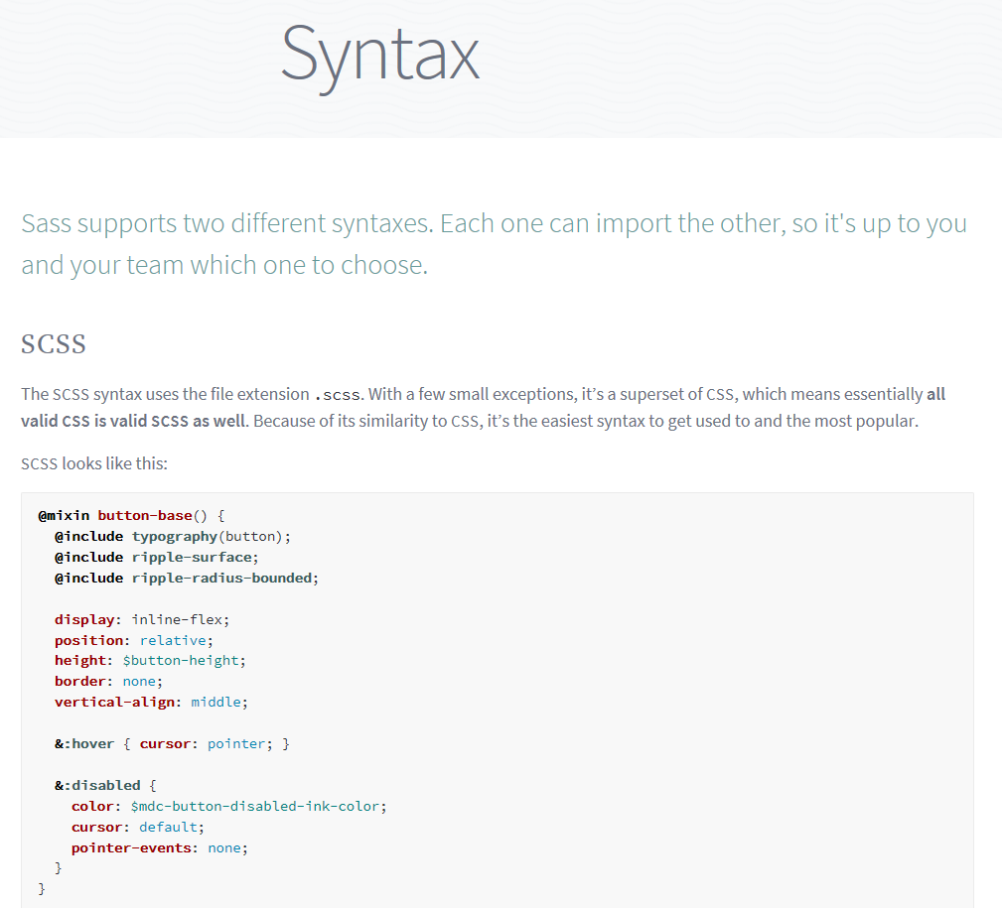

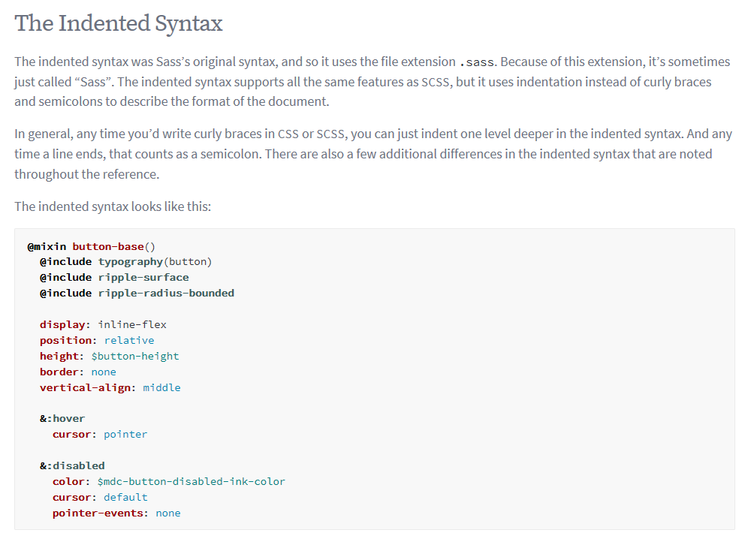

<https://sass-lang.com/guide>

