<https://uxlyric.com/server-side-redering-react/>

<https://medium.com/@baphemot/whats-server-side-rendering-and-do-i-need-it-cb42dc059b38>

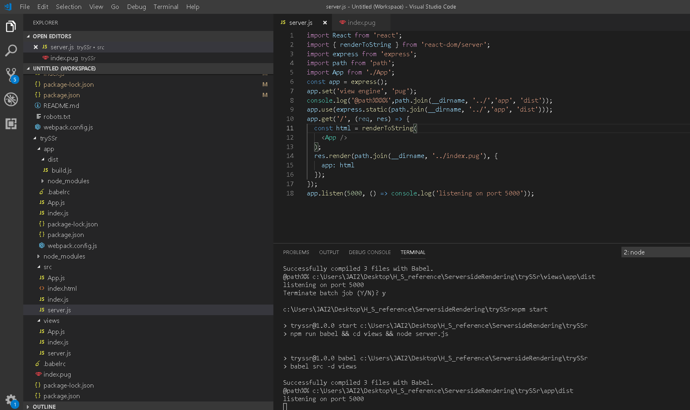

Node(server) package.json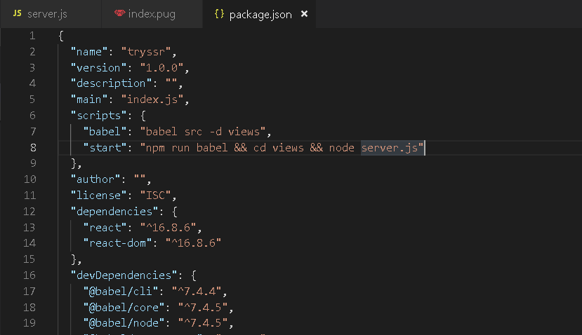

Client – react

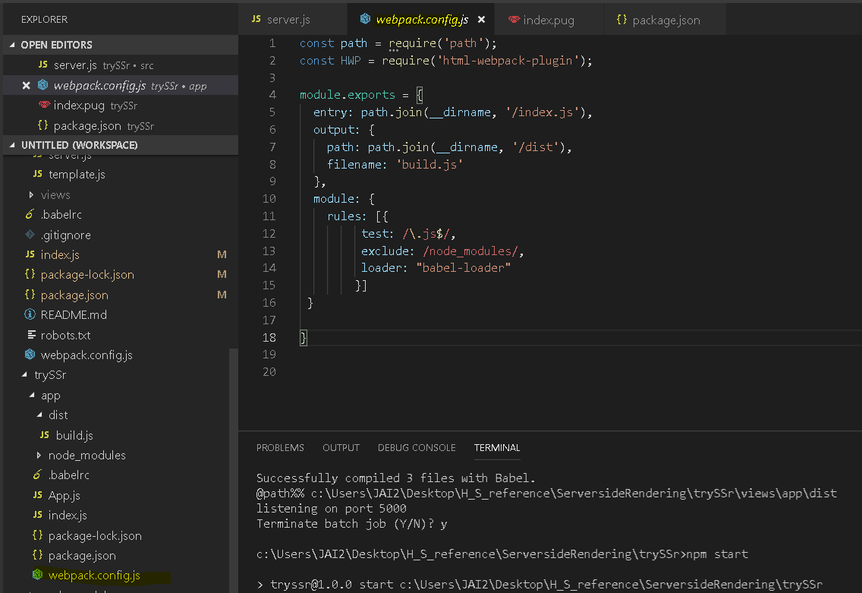

Client(React) package.json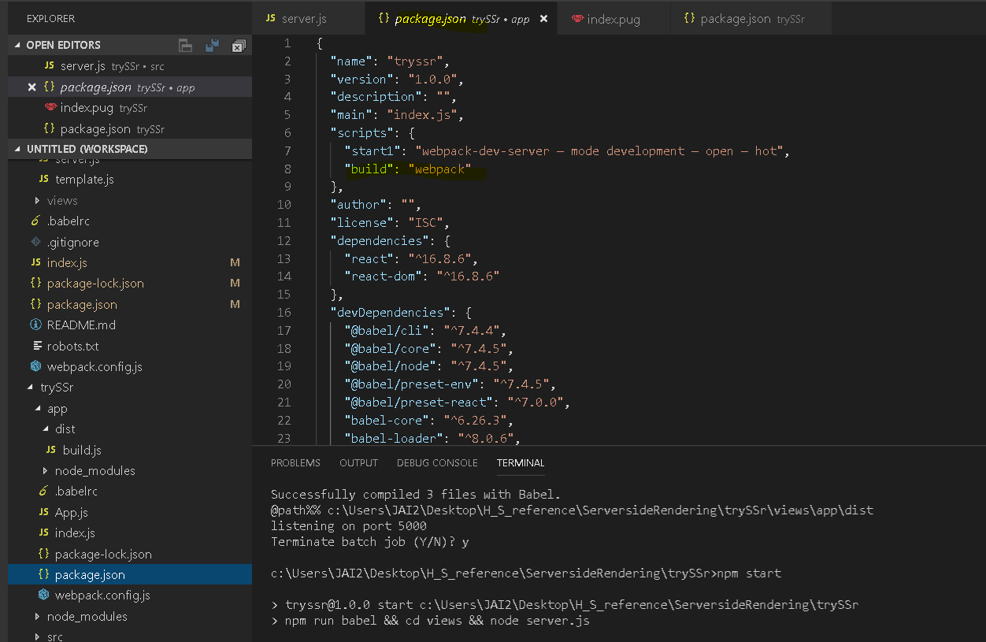

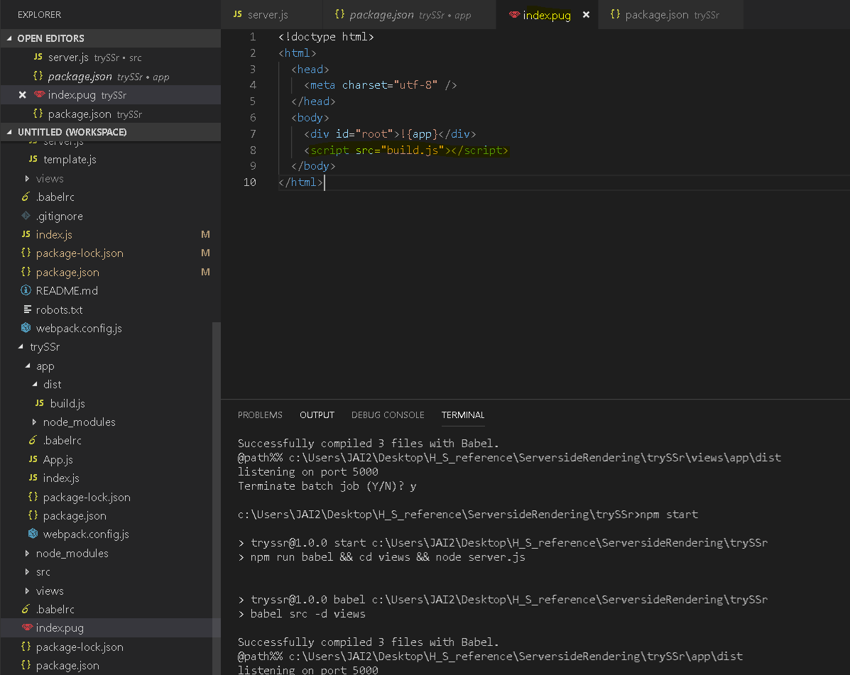

**Other references we should check**

<https://alligator.io/react/server-side-rendering/>

<https://flaviocopes.com/react-server-side-rendering/>

<https://itnext.io/server-side-rendering-with-react-redux-and-react-router-fa5b67d4965e?gi=52c55d4577d6>